Working title: “When Handedness Differs, Foragers Align: Task Complexity and the Social Consequences of Handedness in Wild Macaques”

Preliminary author list - Rohit Negi, Suchinda Malaivijitnond, Lydia Luncz

Results -

Guttman scaling of behavioral complexity

The Guttman scaling technique was used to arrange five pre-processing behaviors on a simple-to-complex continuum (Supplementary Table 1). The resulting structure was nearly cumulative (coefficient of reproducibility: CR = 0.84; four Guttman errors) indicating that complex tasks generally contained the features present in simpler ones. Complexity scores ranged from 0.00 for food rubbing, the simplest task, to 0.80 for stone-tool assisted oyster processing, the most complex task (see Supplementary Table 2). This scale served as the basis for examining how behavioural demands relate to hand use.

Task complexity and handedness

Handedness became stronger as tasks grew more demanding. Most macaques showed little or no preference for either hand during simple actions such as rubbing, but relied consistently on one hand once the task became more complex, especially during stone-tool-assisted nut-cracking and oyster processing (Figure 1). This pattern was supported by a positive association between task complexity and handedness strength (repeated-measures correlation: r = 0.36, df = 61, p = 0.004; 95% CI = 0.12–0.55). In other words, individuals who were flexible or ambidextrous in low-effort tasks relied consistently on one preferred hand when performing more complex behaviours.

Individual- and population-level patterns of handedness

Oyster processing revealed exceptionally strong individual hand preferences: all adults except one (BAB) almost always used the same hand when opening oysters with stone tools (binomial test: p < 0.001; Supplementary Table 3). These preferences were stable across complex tasks. Monkeys that used the right hand for stone-tool assisted oyster processing also used the right hand for nut-cracking, and the same held for left-handed individuals (stats.). Despite these strong individual biases, there was no population-level preference: right- and left-handed adults were nearly equally represented (~ 53% vs 47%, respectively). Males tended to be right-handed, whereas females were evenly split between right- and left-handed biases (~ 40% vs 60%, respectively; Supplementary Table 4). Together, these results show that long-tailed macaques express pronounced individual-level handedness during complex tool-use behaviours, but these biases do not align in a common left–right direction at the population level.

Effects of handedness on foraging partner composition

Hand preference also shaped how individuals associated during oyster foraging. Across all adult dyads, the likelihood that two neighbours differed in handedness depended both on the behavioural context (stone-tool assisted oyster foraging, non-tool foraging, and other activities) and on how closely they were positioned to one another (likelihood ratio test: χ² = 40.86, df = 4, p < 0.001). Dyads engaged in stone-tool assisted oyster processing were the most likely to consist of monkeys with opposite hand preferences, particularly when they were in close proximity. Pairs within one metre frequently differed in handedness, whereas this tendency decreased at greater distances: dyads within five metres were significantly less likely to be opposite-handed compared to those within one metre (estimate: β = 0.35, p = 0.006), and dyads within three metres resembled the one-metre pairs (p = 0.42). This pattern was specific to stone-tool assisted oyster foraging. During less demanding activities, dyads were far less likely to be different-handed. Compared to stone-tool assisted oyster processing, dyads showed reduced mismatches during non-tool foraging (β = –0.07, p < 0.001) and during other activities (β = –0.11, p < 0.001). Together, these results show that mismatched hand preferences were most common when monkeys forage on oysters using stone tools and were working in close proximity (see Table 2 for model formulation and estimates).

In the subset of male-female dyads, mismatched handedness showed a similar but more streamlined pattern (χ² = 18.41, df = 4, p < 0.001). Male-female dyads were again most likely to differ in hand preference during oyster processing, and this tendency dropped sharply in other contexts. Compared to stone-tool assisted oyster foraging, hand-use mismatches were much less common during foraging without tools (β = –0.17, p = 0.005) and during other activities (β = –0.07, p < 0.001). Unlike the full adult sample, spatial proximity did not influence whether mixed-sex pairs differed in hand use; the likelihood of being opposite-handed remained similar whether individuals were close together or several metres apart (all p > 0.14; Supplementary Table 4).

Tables -

Table 1 - Generalized linear model results for adult dyad handedness. The constant (intercept) represents the probability that a dyad was different-handed when foraging on oysters with stone tools at <1 m proximity. Estimates (β) are log-odds of a dyad being different-handed for each category.

Predictors | Categories | β | SE β | z | p
Model 1: dyad_handedness ~ behavioral.context + dyad.proximity
Constant | - | 0.6739 | 0.1244 | 5.417 | 6.08e-08 ***
Behavioral context | Foraging without tools | -0.7414 | 0.1661 | -4.464 | 8.06e-06 ***
 | Other | -0.5610 | 0.1062 | -5.280 | 1.29e-07 ***
Dyad proximity | <3m | -0.1040 | 0.1286 | -0.808 | 0.41899
 | <5m | -0.3212 | 0.1166 | -2.754 | 0.00588 **

Figures:
Figure 1 - Handedness index (HI) increased with task complexity across five behaviours (rubbing, pounding, washing, nut-cracking, and oyster processing). Each point represents an individual HI value, with bubble size and colour indicating the number of monkeys contributing to each task. The black line shows a simple linear regression added for visualization, and the shaded area depicts its 95% confidence interval. This trend shows that macaques who barely favoured either hand in the simple tasks shifted to a clear, consistent hand preference once the tasks became more demanding. Statistical support comes from a repeated-measures correlation (r = 0.36, df = 61, p = 0.004).
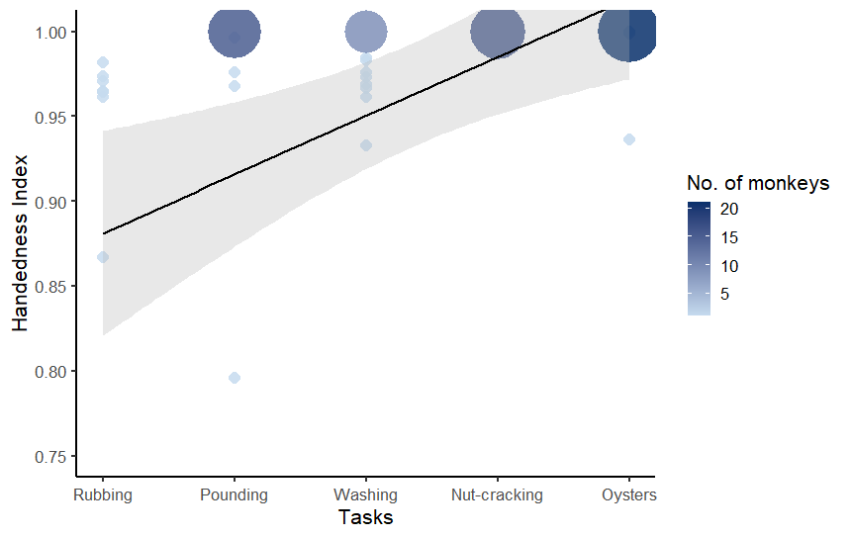

Supplementary Tables -

Table 1 - Task-feature indicators used in the Guttman cumulative scaling analysis, along with their definitions. Each feature is scored as present (1) or absent (0) and represents a specific motor or cognitive requirement of the pre-processing behaviors.

Behavior | Description
Transportation required | Food item or tool(s) must be moved to a separate processing location before manipulation (1/0)
Target-specific manipulation | Action is directed toward a specific structural point of the food item (1/0)
Tool use | Tool is actively used to act on or modify the food item (1/0)
Three-dimensional implementation | Manipulation requires coordinating hand or tool movements across multiple spatial directions and approach angles, rather than within a single plane (1/0)
Bimanual coordination | Both hands are used in a coordinated manner during the manipulation (1/0)

Table 2: Task-feature matrix for the five macaque pre-processing behaviors. This table presents the binary scoring of each behavior across the five task-feature indicators used to construct the cumulative complexity scale: transportation requirement, target-specific manipulation, tool use, three-dimensional implementation, and bimanual coordination.

Behavior | Transport | Target | Tool | 3D | Bimanual | Pattern | Sum of features | Guttman score
Rubbing | 0 | 0 | 0 | 0 | 0 | 00000 | 0 | 0.00
Food pounding | 0 | 1 | 0 | 0 | 0 | 01000 | 1 | 0.20
Washing | 1 | 0 | 0 | 0 | 1 | 10001 | 2 | 0.40
Nut-cracking | 1 | 0 | 1 | 0 | 1 | 10101 | 3 | 0.60
Oyster processing | 1 | 1 | 1 | 1 | 0 | 11110 | 4 | 0.80

Table 3: Individual hand-use patterns during oyster processing. The Handedness Index (HI) was calculated as (Right − Left) / (Right + Left), where values near +1 indicate strong right-handedness, values near −1 indicate strong left-handedness, and values near 0 indicate no clear bias. N denotes the number of independent observations or focal observations, while n represents the average number of oysters processed within the same focal observation. Individual lateralization was assessed with a binomial test comparing the dominant hand’s strike count against a 50:50 expectation. * represent the only ambidextrous monkey in the troop.

subj.id | sex | right | left | N | n | handedness index | p_value
ALI | m | 70 | 0 | 5 | 14 | 1 | 1.69E-21
AUR | f | 1242 | 0 | 32 | 38.81 | 1 | 0
*BAB | m | 187 | 138 | 15 | 31.73 | 0.15 | 0.007658867
BAT | m | 285 | 0 | 9 | 31.66 | 1 | 3.22E-86
BEL | m | 11 | 0 | 3 | 3.66 | 1 | 0.000976563
BET | f | 0 | 189 | 12 | 15.75 | -1 | 2.55E-57
CAC | f | 601 | 0 | 18 | 33.38 | 1 | 2.41E-181
DAN | f | 0 | 258 | 21 | 12.28 | -1 | 4.32E-78
FLA | f | 0 | 1183 | 28 | 42.25 | -1 | 0
GRA | f | 0 | 1005 | 30 | 33.5 | -1 | 5.83E-303
HAR | f | 0 | 622 | 19 | 32.73 | -1 | 1.15E-187
IYL | f | 426 | 0 | 22 | 19.36 | 1 | 1.15E-128
JIM | f | 0 | 642 | 27 | 23.77 | -1 | 1.10E-193
KAL | m | 206 | 0 | 5 | 41.20 | 1 | 1.94E-62
KAY | f | 0 | 1089 | 28 | 38.89 | -1 | 0
LIP | f | 0 | 2137 | 32 | 66.78 | -1 | 0
NAI | f | 0 | 686 | 29 | 23.65 | -1 | 6.23E-207
ORE | f | 0 | 299 | 12 | 24.91 | -1 | 1.96E-90
PAT | f | 129 | 0 | 11 | 11.72 | 1 | 2.94E-39
PIN | f | 599 | 0 | 18 | 33.27 | 1 | 9.64E-181
QUI | f | 1322 | 3 | 26 | 50.96 | 0.99 | 0
ROB | f | 0 | 608 | 23 | 26.43 | -1 | 1.88E-183
SAN | f | 0 | 532 | 19 | 28 | -1 | 1.42E-160
TAI | f | 792 | 0 | 15 | 52.8 | 1 | 7.68E-239
TED | m | 224 | 0 | 13 | 17.23 | 1 | 7.42E-68
TIN | m | 41 | 0 | 3 | 13.66 | 1 | 9.09E-13
TUT | m | 356 | 3 | 9 | 39.88 | 0.98 | 1.31E-101
VUL | f | 0 | 1492 | 26 | 57.38 | -1 | 0
WHI | f | 1087 | 5 | 28 | 39 | 0.99 | 0
YAI | f | 845 | 2 | 27 | 31.37 | 0.99 | 7.65E-250

Table 4 - Generalized linear model results for the male-female dyad handedness. The constant (intercept) represents the probability that a dyad was different-handed when foraging on oysters with stone tools at <1 m proximity. Estimates (β) are log-odds of a dyad being different-handed for each category.

Predictors | Categories | β | SE β | z | p
Model 1: dyad_handedness ~ beh.context + proximity
Constant | - | 0.8301 | 0.2761 | 3.006 | 0.002646 **
Beh.context | Foraging without tools | -0.9962 | 0.3570 | -2.790 | 0.005268 **
 | Other | -0.9000 | 0.2429 | -3.706 | 0.000211 ***
Proximity | <3m | -0.1661 | 0.2767 | -0.600 | 0.548312
 | <5m | 0.1932 | 0.2376 | 0.813 | 0.416040

Table 5 - This table presents the sample size of unique individuals contributing to each behavior, separated by sex. For each behavior, the number of female (Nf) and male (Nm) individuals is shown along with the total unique sample size (N).

Behavior | N_{f} | N_{m} | N
Rubbing | 16 | 1 | 17
Food pounding | 20 | 7 | 27
Washing | 20 | 5 | 25
Nut-cracking | 18 | 7 | 25
Oyster processing | 21 | 9 | 30

