Working title: “When Handedness Differs, Foragers Align: Task Complexity and the Social Consequences of Handedness in Wild Macaques”

Preliminary author list - Rohit Negi, Suchinda Malaivijitnond, Lydia Luncz

Results -

Data collection spanned over 380 days and included twenty-eight macaques, all adults or late juveniles. Oyster processing, one of the most complex hand-use tasks, revealed strict individual-level handedness: all adults except one (BAB) exhibited significant lateralization (Supplementary Table 1). Right- and left-handed monkeys were present in nearly equal proportions (~ 53% vs 47%, respectively), with most males being right-handed and females split uniformly between right- and left-handed biases (~ 40% vs 60%, respectively, Supplementary Table 4). The expression of handedness appeared closely linked to task demands: while simpler pre-processing behaviors often permitted ambidexterity or hand-switching, individuals seemed to adopt a clear hand preference once the task became more complex. Handedness also seemed to influence social foraging dynamics, particularly in determining partner composition during stone-tool-assisted oyster foraging (hereafter oyster foraging).

Guttman scaling of behavioral complexity

The Guttman scaling technique was used to arrange five pre-processing behaviors on a simple-to-complex continuum. The resulting structure was nearly cumulative (coefficient of reproducibility: CR = 0.84; four Guttman errors), slightly below the standard CR ≥ 0.85 cutoff. Complexity scores, calculated as the proportion of task features present, ranged from 0.00 for food rubbing to 0.80 for oyster processing (see Supplementary Table 2).

Task complexity and handedness

Handedness strength increased with task complexity (repeated-measures correlation: r = 0.356, df = 61, p = 0.004; 95% CI = 0.12–0.55). Across individuals, simpler behaviours such as rubbing and pounding showed lower handedness indices, whereas more complex tasks, such as nut-cracking and oyster processing, yielded higher indices (Fig. 1). The positive association indicates that individuals who were weakly lateralized in simple tasks tended to express stronger lateralization when performing more complex actions.

Effects of handedness on foraging partner composition

Across all adult dyads, differences in hand-use preferences were strongly influenced by the behavioral context (oyster foraging, non-tool foraging, or other activities) and by the monkeys’ spatial proximity to one another (likelihood ratio test: χ² = 40.86, df = 4, p < 0.001). Behavioral context was a strong predictor: compared to oyster foraging, dyads were significantly less likely to be different-handed during foraging without tools (estimate: β = –0.07, p < 0.001) and during other activities (β = 0.11, p < 0.001). Proximity to each other also played a role: dyads at <5 m were less likely to be different-handed than dyads at <1 m (β = 0.35, p = 0.006), while dyads at <3 m were as likely to be different handed as dyads within 1 m (p = 0.42). In other words, dyads were most likely to exhibit different hand-use preferences when they were in close proximity (see Table 2 for model formulation and estimates).

In the subset of male-female dyads, mismatched handedness was again primarily influenced by the behavioral context (oyster foraging, non-tool foraging, or other activities), but was unrelated to the monkeys’ spatial organisation (χ² = 18.41, df = 4, p < 0.001). Compared to oyster foraging, dyads were less likely to be different-handed during foraging without tools (β = -0.17, p = 0.005) and during other behaviors (β = -0.07, p < 0.001). Spatial proximity did not appear to influence handedness differences in mixed-sex pairs (all p > 0.14) (see Supplementary Table 6 for model formulation and estimates).

Tables -

Table 1 - Generalized linear model results for adult dyad handedness. The constant (intercept) represents the probability that a dyad was different-handed when foraging on oysters with stone tools at <1 m proximity. Estimates (β) are log-odds of a dyad being different-handed for each category.

Predictors | Categories | β | SE β | z | p
Model 1: dyad_handedness ~ behavioral.context + dyad.proximity
Constant | - | 0.6739 | 0.1244 | 5.417 | 6.08e-08 ***
Behavioral context | Foraging without tools | -0.7414 | 0.1661 | -4.464 | 8.06e-06 ***
 | Other | -0.5610 | 0.1062 | -5.280 | 1.29e-07 ***
Dyad proximity | <3m | -0.1040 | 0.1286 | -0.808 | 0.41899
 | <5m | -0.3212 | 0.1166 | -2.754 | 0.00588 **

Figures:
Figure 1 - Handedness index (HI) increased with task complexity across five behaviours (rubbing, pounding, washing, nut-cracking, and oyster processing). Each point represents an individual HI value, with bubble size and colour indicating the number of monkeys contributing to each task. The black line shows a simple linear regression added for visualization, and the shaded area depicts its 95% confidence interval. Statistical support comes from a repeated-measures correlation (r = 0.36, df = 61, p = 0.004).
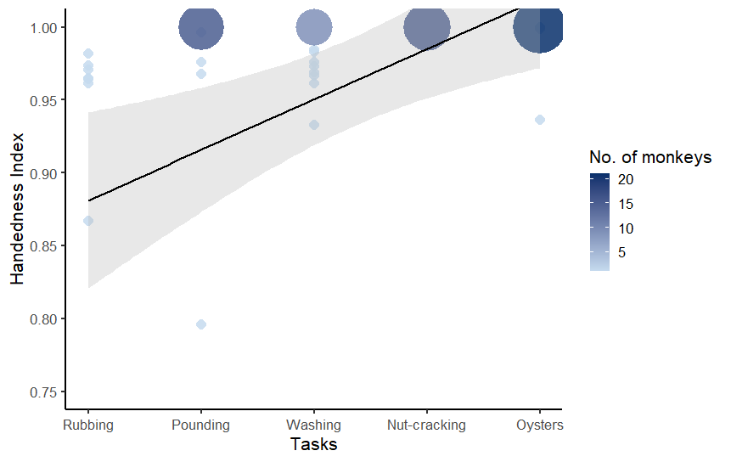

Supplementary Tables -

Table 1 - Task-feature indicators used in the Guttman cumulative scaling analysis, along with their definitions. Each feature is scored as present (1) or absent (0) and represents a specific motor or cognitive requirement of the pre-processing behaviors.

Behavior | Description
Transportation required | Food item or tool must be moved to a separate processing location before manipulation (1/0)
Target-specific manipulation | Action is directed toward a specific structural point of the food item (1/0)
Tool use | Tool is actively used to act on or modify the food item (1/0)
Three-dimensional implementation | Manipulation requires coordinating hand or tool movements across multiple spatial directions and approach angles, rather than within a single plane (1/0)
Bimanual coordination | Both hands are used in a coordinated manner during the manipulation (1/0)

Table 2: Task-feature matrix for the five macaque pre-processing behaviors. This table presents the binary scoring of each behavior across the five task-feature indicators used to construct the cumulative complexity scale: transportation requirement, target-specific manipulation, tool use, three-dimensional implementation, and bimanual coordination.

Behavior | Transport | Target | Tool | 3D | Bimanual | Pattern | Sum of features | Guttman score
Rubbing | 0 | 0 | 0 | 0 | 0 | 00000 | 0 | 0.00
Food pounding | 0 | 1 | 0 | 0 | 0 | 01000 | 1 | 0.20
Washing | 1 | 0 | 0 | 0 | 1 | 10001 | 2 | 0.40
Nut-cracking | 1 | 0 | 1 | 0 | 1 | 10101 | 3 | 0.60
Oyster processing | 1 | 1 | 1 | 1 | 0 | 11110 | 4 | 0.80

Table 3: Individual hand-use patterns during oyster processing. The Handedness Index (HI) was calculated as (Right − Left) / (Right + Left), where values near +1 indicate strong right-handedness, values near −1 indicate strong left-handedness, and values near 0 indicate no clear bias. N denotes the number of independent observations or focal observations, while n represents the average number of oysters processed within the same focal observation. Individual lateralization was assessed with a binomial test comparing the dominant hand’s strike count against a 50:50 expectation. * represent the only ambidextrous monkey in the troop.

subj.id | sex | right | left | N | n | handedness index | p_value
ALI | m | 70 | 0 | 5 | 14 | 1 | 1.69E-21
AUR | f | 1242 | 0 | 32 | 38.81 | 1 | 0
*BAB | m | 187 | 138 | 15 | 31.73 | 0.15 | 0.007658867
BAT | m | 285 | 0 | 9 | 31.66 | 1 | 3.22E-86
BEL | m | 11 | 0 | 3 | 3.66 | 1 | 0.000976563
BET | f | 0 | 189 | 12 | 15.75 | -1 | 2.55E-57
CAC | f | 601 | 0 | 18 | 33.38 | 1 | 2.41E-181
DAN | f | 0 | 258 | 21 | 12.28 | -1 | 4.32E-78
FLA | f | 0 | 1183 | 28 | 42.25 | -1 | 0
GRA | f | 0 | 1005 | 30 | 33.5 | -1 | 5.83E-303
HAR | f | 0 | 622 | 19 | 32.73 | -1 | 1.15E-187
IYL | f | 426 | 0 | 22 | 19.36 | 1 | 1.15E-128
JIM | f | 0 | 642 | 27 | 23.77 | -1 | 1.10E-193
KAL | m | 206 | 0 | 5 | 41.20 | 1 | 1.94E-62
KAY | f | 0 | 1089 | 28 | 38.89 | -1 | 0
LIP | f | 0 | 2137 | 32 | 66.78 | -1 | 0
NAI | f | 0 | 686 | 29 | 23.65 | -1 | 6.23E-207
ORE | f | 0 | 299 | 12 | 24.91 | -1 | 1.96E-90
PAT | f | 129 | 0 | 11 | 11.72 | 1 | 2.94E-39
PIN | f | 599 | 0 | 18 | 33.27 | 1 | 9.64E-181
QUI | f | 1322 | 3 | 26 | 50.96 | 0.99 | 0
ROB | f | 0 | 608 | 23 | 26.43 | -1 | 1.88E-183
SAN | f | 0 | 532 | 19 | 28 | -1 | 1.42E-160
TAI | f | 792 | 0 | 15 | 52.8 | 1 | 7.68E-239
TED | m | 224 | 0 | 13 | 17.23 | 1 | 7.42E-68
TIN | m | 41 | 0 | 3 | 13.66 | 1 | 9.09E-13
TUT | m | 356 | 3 | 9 | 39.88 | 0.98 | 1.31E-101
VUL | f | 0 | 1492 | 26 | 57.38 | -1 | 0
WHI | f | 1087 | 5 | 28 | 39 | 0.99 | 0
YAI | f | 845 | 2 | 27 | 31.37 | 0.99 | 7.65E-250

Table 4 - This table presents the sample size of unique individuals contributing to each behavior, separated by sex. For each behavior, the number of female (Nf) and male (Nm) individuals is shown along with the total unique sample size (N).

Behavior | N_{f} | N_{m} | N
Rubbing | 16 | 1 | 17
Food pounding | 20 | 7 | 27
Washing | 20 | 5 | 25
Nut-cracking | 18 | 7 | 25
Oyster processing | 21 | 9 | 30

Table 5 - Generalized linear model results for the male-female dyad handedness. The constant (intercept) represents the probability that a dyad was different-handed when foraging on oysters with stone tools at <1 m proximity. Estimates (β) are log-odds of a dyad being different-handed for each category.

Predictors | Categories | β | SE β | z | p
Model 1: dyad_handedness ~ beh.context + proximity
Constant | - | 0.8301 | 0.2761 | 3.006 | 0.002646 **
Beh.context | Foraging without tools | -0.9962 | 0.3570 | -2.790 | 0.005268 **
 | Other | -0.9000 | 0.2429 | -3.706 | 0.000211 ***
Proximity | <3m | -0.1661 | 0.2767 | -0.600 | 0.548312
 | <5m | 0.1932 | 0.2376 | 0.813 | 0.416040

