

**American University of Sharjah**

**College of Engineering**

---------------------------------------------------------------------------------------------------------------------

**CMP 333: Artificial Intelligence**

**Spring 2022**

---------------------------------------------------------------------------------------------------------------------

**Submitted to**

**Dr. Michel Bernard Pasquier**

**Department of Computer Science and Engineering**

---------------------------------------------------------------------------------------------------------------------

**Project 2**

---------------------------------------------------------------------------------------------------------------------

**Date of Submission: 17th April 2022**

---------------------------------------------------------------------------------------------------------------------

**Name & ID:**

|  |  |
| --- | --- |
| **Rohan Mitra** | **b00085023** |
| **Prem Rajendran** | **b00084833** |
| **Eesha Butt** | **g00085661** |
| **Amira Boudrai** | **g00077423** |

Q1) Structures Puzzle

Program in file “./Program Files/sculpturespuzzle.pl”

All Results:

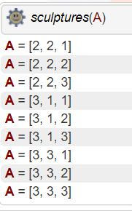

Q2) Map Coloring

Program in file “./Program Files/mapcoloring.pl”

All Results:

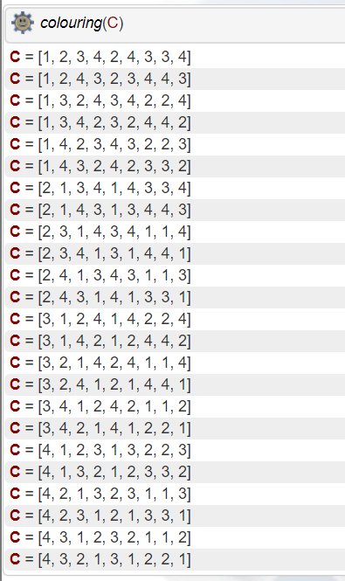

Q3) Cryptarithmetic puzzle with carries

Program in file “./Program Files/Cryptarithmetic with Carry.pl”

All Results:

**As** = [9, 5, 6, 7],  
**Bs** = [1, 0, 8, 5],  
**Cs** = [1, 0, 6, 5, 2]

Q4) Magic triangle

Program in file “./Program Files/magicTriangle.pl”

Given the format: [A,B,C,D,E,F], where:

All Results:

?- magicTriangle(9,Circles).

**Circles** = [1, 5, 3, 4, 2, 6]

?- magicTriangle(10,Circles).

**Circles** = [1, 4, 5, 2, 3, 6]

?- magicTriangle(11,Circles),

**Circles** = [2, 3, 6, 1, 4, 5]

?- magicTriangle(12,Circles).

**Circles** = [4, 2, 6, 1, 5, 3]

Q5) Interview scheduling

Program in file “./Program Files/Interview Scheduling.pl”

All Results:

People=[A,B,C,D,E]

**People** = [2, 4, 3, 1, 5]

**People** = [2, 4, 5, 1, 3]

**People** = [3, 2, 5, 1, 4]

**People** = [3, 4, 1, 2, 5]

Results with additional Constraint Don must follow right after Cam:

**People** = [3, 4, 1, 2, 5]

Q6) Zebra story

Program in file “./Program Files/Zebra.pl”

**zebra(Ans).**

**Ans** = [1, 1]

Q7) 4-queens problem

Program in file “./Program Files/4Queens.pl”

All Results:

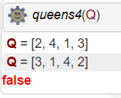

Q8) N-queens problem

Program in file “./Program Files/NQueens.pl”

Result for n=20:

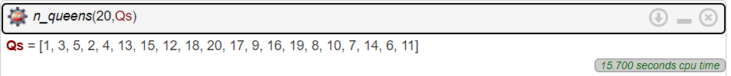

Largest Result in under 10 mins:

My poor laptop keeps exceeding time limit and stack limit