ShelfSense
Supermarket Shelf Sensor Monitor
Smart Inventory Management System Using OOP in C++
Student Name: ROSE NYAMBURA
Student reg_no: ENE211-0209/2024
Institution: JKUAT
Course: EEE
Unit code: EEE2216
Unit name: OOP
Date Submitted: 12 May 2026

Table of Contents
Chapter 1: Background and Requirements Analysis
Chapter 2: System Design
Chapter 3: OOP Class Design
Chapter 4: Hardware and Simulation Environment
Chapter 5: Dashboard Design

Chapter 1: Background and Requirements Analysis

1.1 Background
Supermarkets frequently experience out-of-stock situations because staff check shelves manually on fixed schedules — too infrequent to catch sudden stock drops during busy trading hours. This leads to lost sales, customer frustration, and wasted restocking labour.

A further complexity is that goods on supermarket shelves are owned by the supplying companies, not the supermarket. The supermarket manages the physical shelf and restocking action; the company owns the product and sets the minimum stock threshold. Neither party currently has real-time visibility into shelf levels.

This project implements an automated shelf sensor monitoring system in C++ using OOP principles. Weight and IR sensors on each shelf continuously track stock levels and alert both parties automatically when stock falls below the threshold. A barcode system tracks every inventory movement. An expiry monitoring module handles perishable goods. The system is built around a real scenario: FreshMart Nairobi (Westlands) stocking products from Brookside Dairy Ltd and Unga Group Ltd across three shelves.

1.2 Functional Requirements
Physical Stock Detection. Acceptance: Both sensors read a stock change within 1 second of an item being removed.
Threshold-Based Alert. Acceptance: Alert fires when stock is at or below the product threshold AND the IR sensor confirms the shelf is sparse. Both conditions must be true before an alert fire.
Dual-Tenant Alert Routing. Acceptance: Both dashboards show the shelf location, product name, and current stock count within 1 second of detection.
Barcode Inventory Tracking. Acceptance: Stock count updates correctly after every scan. Every event is logged with a timestamp and user ID.
Expiry Date Monitoring. Acceptance: Correct alert tier issued for each state — warning (1–3 days), urgent (today), critical (expired). Non-perishable products are skipped.
Two-Sided Restock Confirmation. Acceptance: RestockRequest moves through Pending → Dispatched → Acknowledged. Neither step can be skipped. Each transition is logged with a timestamp and the user ID of the acting party.
Role-Based Dashboards. Acceptance: A company rep can only access data filtered by their own companyId. Accessing another company's data returns empty results.
JSON Data Export. Acceptance: C++ simulation writes all shelves, products, sensor readings, alerts, restock requests, and the event log to data.json after every run.
Stock Event Logging. Acceptance: Every event appears in the log with the correct timestamp, event type, barcode, quantity, and user ID.

1.3 Non-Functional Requirements
Reliability. Acceptance: The simulation completes a full run without crashing. Sensor faults are logged without halting the system.
Performance. Acceptance: Sensor polling and alert generation complete within 1 second of a stock change.
Scalability. Acceptance: A new sensor type requires only a new subclass of Sensor. No changes to StockMonitor or any other class are needed.
Maintainability. Acceptance: Each class has a single well-defined responsibility. No class handles both business logic and presentation.
Security. Acceptance: A company rep receives only data filtered by their companyId. Cross-company data access is not possible.
Usability. Acceptance: A non-technical staff member can find and respond to an alert within 30 seconds without prior training.
Data Integrity. Acceptance: All stock mutations go through InventoryManager methods only. No partial updates are possible — a mutation either fully succeeds or does not happen.

Chapter 2: System Design

2.1 System Architecture
The system follows a layered architecture: a sensor layer for physical data acquisition, a C++ OOP processing layer for all business logic, a data exchange layer, and a web dashboard presentation layer.

The original design specified a REST API as the communication layer between the C++ backend and the HTML dashboards. During implementation this was replaced by a JSON file exchange approach: the C++ simulation writes a complete state snapshot to data.json after every run, and the dashboards read this file via the browser fetch() API. This achieves the same data separation and tenant filtering without requiring a running HTTP server, making the project fully portable and self-contained.

A REST API remains a straightforward upgrade path for a production deployment where the C++ backend would run continuously and the dashboards would poll live endpoints.

Architecture Diagram
+---------------------------------------------------+
| C++ OOP Processing Unit |
| StockMonitor | AlertManager |
| InventoryManager | ExpiryMonitor |
+---------------------------------------------------+
^ ^ ^
| | |
+-----------+ +--------+ +---------------+
|WeightSensor| |IRSensor| |BarcodeScanner |
|(simulated) | |(simul.)| |(simulated) |
+-----------+ +--------+ +---------------+
|
v
+-------------------------+
| data.json (snapshot) |
+-------------------------+
^ ^
| |
+--------------------+ +------------------+
| supermarket.html | | company.html |
| All shelves/prods | | Own products only|
+--------------------+ +------------------+

2.2 System Block Diagram
+------------+ +----------+ +--------------+
| Weight | | IR | | Barcode |
| Sensor | | Sensor | | Scanner |
+------------+ +----------+ +--------------+
| | |
+-------+-------+ |
v v
+-------------+ +---------------+
| StockMonitor| | InventoryMgr |
| (fuse+check)| | (stock mutns) |
+-------------+ +---------------+
| |
v v
+-------------+ +----------+
| AlertManager| | Logger |
+-------------+ +----------+
| |
v v
+-------+ +--------+
|Super | |Company |
|Dash | |Dash |
+-------+ +--------+

Weight and IR sensor data flows into StockMonitor, which fuses both readings before firing any alert. Barcode events flow independently through InventoryManager to update stock counts. All events pass through Logger to create a full audit trail. AlertManager routes alerts to the correct tenant dashboard by companyId.

2.3 Data Flow
The C++ simulation runs once and produces two outputs: data.json (read by the dashboards) and shelf_log.txt (persistent audit trail). The key modules and what they produce:

- WeightSensor — shelf weight in grams with ±1g noise. Auto-synced by Shelf.syncWeight() on every stock change.
- IRSensor — distance to nearest item in cm. Set in main.cpp to represent each shelf's stock state. StockMonitor checks this before firing any alert.
- BarcodeScanner — EAN-13 barcode string from simulateScan(). Matched against Product records by InventoryManager.
- StockMonitor — fused sensor values compared against threshold. Produces low_stock events when both conditions are met.
- ExpiryMonitor — days remaining from product expiry date. Produces tiered expiry alerts (warning / urgent / critical).
- AlertManager — stores all alert objects in memory. Written to data.json. Filtered by companyId for tenant isolation.
- InventoryManager — processes all stock mutations. Manages the RestockRequest lifecycle. Logs every event.
- data.json — complete snapshot: supermarket, companies, shelves, products, sensor readings, stock counts, alerts, restock requests, event log.

Chapter 3: OOP Class Design

3.1 OOP Principles Applied

Abstraction
Sensor, User, and Tenant are abstract base classes that define interfaces without implementation. StockMonitor only needs to know that a Sensor has a readValue() method — it does not care whether that sensor is a WeightSensor or an IRSensor. The HTML dashboards know nothing about the C++ classes; they only consume a JSON contract.

Encapsulation
Internal data is hidden behind private attributes. Stock counts can only be changed through InventoryManager.processSale(), processRestock(), and processExpiredRemoval(). No external class can directly modify Shelf.stockCounts. This directly enforces requirement NF-08 (data integrity).

Inheritance
WeightSensor and IRSensor extend Sensor. SupermarketManager and CompanyRep extend User. Supermarket and Company extend Tenant. Shared state — such as sensorId, shelfId, and the healthy flag in Sensor — is defined once in the base class and inherited by all subclasses.

Polymorphism
StockMonitor holds a vector<Sensor*>. Calling readValue() at runtime resolves to the correct subclass via C++ virtual functions. Adding a new sensor type — for example a temperature sensor for cold storage — requires only a new subclass of Sensor. StockMonitor, Shelf, and all other classes remain unchanged.

3.2 Class Descriptions

Hardware Layer
- Sensor (abstract) — base for all sensors. Attributes: sensorId, shelfId, healthy. Pure virtual: readValue(), isHealthy().
- WeightSensor : Sensor — simulates load cell + HX711. readValue() returns current weight plus ±1g noise. setWeight() is called by Shelf.syncWeight() after every stock change.
- IRSensor : Sensor — simulates Sharp GP2Y0A (10–80 cm). readValue() returns current distance. isEmpty() returns true when distance exceeds the empty threshold (default 25 cm).
- BarcodeScanner — simulates USB HID EAN-13 scanner. simulateScan() cycles through a preloaded barcode list, returning one barcode per call.

Core Domain Layer
- Product — barcode, SKU, name, threshold, expiryDate, companyId, perishable flag, weightPerUnit (grams).
- Shelf — owns one WeightSensor, one IRSensor, and a list of Products with stock counts. updateStock() is the only mutation path; it applies the delta and calls syncWeight().
- Tenant (abstract) — base for Supermarket and Company. Pure virtual: getTenantType().
- Supermarket : Tenant — owns a list of shared_ptr<Shelf>. Instance: FreshMart Nairobi, SM001.
- Company : Tenant — owns a list of product barcodes. ownsProduct() checks barcode ownership. Instances: Brookside Dairy (C001), Unga Group (C002).
- User (abstract) — base for all users. Pure virtual: login(), getPermissions().
- SupermarketManager : User — permissions: view all shelves, acknowledge restocks, remove expired, view event log. Instance: Alice Wanjiku, MGR001.
- CompanyRep : User — permissions: view own products, dispatch restocks, set threshold. Instances: James Mwangi REP001 (Brookside), Susan Otieno REP002 (Unga).

Logic Layer
- StockMonitor — polls all shelves. For each product where stock ≤ threshold, checks IR distance. If IR > 25 cm (sparse), fires low_stock alert. Both sensor and stock count must agree before any alert fires.
- ExpiryMonitor — iterates perishable products only. Fires expiry_critical (past expiry), expiry_urgent (today), or expiry_warning (1–3 days) via AlertManager.
- InventoryManager — the only class permitted to mutate stock. processSale(), processRestock(), processExpiredRemoval(). Also manages the full RestockRequest lifecycle: createRestockRequest(), dispatchRestock(), acknowledgeRestock().

Output Layer
- AlertManager — fires and stores alerts with auto-incremented IDs (ALT001…). getAlertsForCompany() filters by companyId for tenant isolation. acknowledgeAlert() marks alerts as read by either party.
- RestockRequest — struct tracking Pending → Dispatched → Acknowledged. dispatch() rejects if not Pending; acknowledge() rejects if not Dispatched. Neither step can be skipped.
- Logger — writes every event to both an in-memory vector (for data.json export) and shelf_log.txt (persistent audit trail). Each entry: timestamp, event type, barcode, quantity, userId, note.

Chapter 4: Hardware and Simulation Environment

4.1 Hardware Components
The system is designed around standard low-cost embedded hardware. All components are simulated in software in this implementation, but the class design maps directly to the real devices.

Weight Sensor — Load Cell + HX711
A strain gauge load cell sits under the shelf panel. The HX711 amplifies its millivolt output into a 24-bit digital value readable via two GPIO pins. Capacity: 5–50 kg depending on shelf load. Simulated by WeightSensor.h.

IR Proximity Sensor — Sharp GP2Y0A
Measures distance to the nearest object (10–80 cm). Mounted at the front of the shelf facing inward. Short distance means items are present; long distance means the shelf is sparse. Provides a physical cross-check against the weight reading. Simulated by IRSensor.h.

Barcode Scanner
POS till: USB HID scanner. Shelf unit: TTL UART module. Standard format: EAN-13. Simulated by BarcodeScanner.h via simulateScan().

Processing Platform — Raspberry Pi 4
Runs Linux, compiles C++17 natively via GCC. GPIO header connects HX711 and IR sensor. USB ports connect the barcode scanner. In this implementation the processing unit is a PC running the C++ simulation via VS Code.

4.2 Simulation Environment

C++ Class Simulation (Primary — Implemented)
The main simulation runs entirely within the C++ OOP class system. main.cpp sets up all shelves, products, and sensors with realistic values, runs the full monitoring cycle, and writes the complete state to data.json. This is the authoritative output of the system.

Browser-Based Simulation (Implemented)
simulation.html provides a live visual demonstration of the sensor system running directly in the browser. It uses the same products, shelf configuration, thresholds, and expiry dates as the C++ simulation.
The browser simulation was implemented as a self-contained JavaScript demonstration rather than a live connection to the C++ backend. This was a deliberate choice to keep the simulation fully portable — no server or compilation required — while still showing the sensor logic, alert generation, and restock workflow to a non-technical audience. It is a companion demonstration tool, not a replacement for the C++ simulation.
- Auto mode: random sales fire every few seconds, stock drops, weight and IR gauges update, alerts fire automatically when thresholds are crossed.
- Manual controls: per-product sale and restock buttons, a barcode scan button mirroring BarcodeScanner.simulateScan(), pause/resume, and speed control.
- Links to supermarket.html and company.html so viewers can compare the simulation against the full dashboard.

Wokwi Online Simulator (Referenced — Not Used)
Wokwi (wokwi.com) was identified during the design phase as the intended hardware circuit simulation platform. It supports Arduino and Raspberry Pi Pico circuits in the browser with built-in HX711 and IR sensor components.
Wokwi was not used in the final implementation. The C++ class simulation and simulation.html together cover the same demonstration scope without requiring an external platform. Wokwi remains the recommended tool if physical circuit verification is needed in a future iteration.

Chapter 5: Dashboard Design
The presentation layer consists of three HTML files — index.html (role selector), supermarket.html (manager view), and company.html (company rep view). All three read data.json via fetch(). No frameworks are used — vanilla HTML, CSS, and JavaScript only. The supermarket view uses a cyan accent; the company view uses amber, making the two roles visually distinct at a glance.

5.1 Supermarket Manager Dashboard (supermarket.html)
The manager sees the full system state across all shelves and all products regardless of which company supplies them.

- Stats bar — total shelves, active low-stock alerts, active expiry alerts, pending restock requests.
- Active alerts — all low-stock and expiry alerts with type, message, shelf, barcode, and timestamp. Ack Alert button marks an alert as acknowledged.
- Shelf cards — one card per shelf showing weight reading (grams), IR reading (cm), and sensor health. Each card lists all products with stock count, threshold, and colour-coded status badge (OK / Low / Critical).
- Expiry badges — expiry date and status badge (Warning / Urgent / Critical) shown per perishable product. A Remove Expired button appears for urgent and critical items.
- Restock requests — all requests across all companies with status, quantity dispatched, and ETA. Acknowledge button appears when status is Dispatched.
- Event log — full timestamped log in reverse chronological order: event type (colour-coded), barcode, quantity, user, and note.

5.2 Company / Supplier Dashboard (company.html)
The company rep sees only their own products. The page opens with a company selector; all data is filtered by companyId after selection, enforcing tenant isolation at the JavaScript layer.

- Company selector — card for each company in data.json. Rep clicks their company to enter their filtered view.
- Stats bar — my product count, low/critical count, active alert count, pending restock count — all filtered to this company.
- My alerts — active alerts for this company's products only.
- My products — all products belonging to this company across all shelves: stock, threshold, stock status, expiry date, expiry status.
- Restock requests — requests for this company's products only. Dispatch button opens a modal for quantity and ETA. Tracks Pending → Dispatched → Acknowledged.

5.3 Restock Confirmation Flow
- StockMonitor detects stock ≤ threshold AND IR confirms sparse shelf. AlertManager fires a low_stock alert. Both dashboards display it.
- InventoryManager.createRestockRequest() creates a RestockRequest linked to the alertId. Status: Pending.
- Company rep clicks Dispatch on company.html, enters quantity and ETA. RestockRequest.dispatch() moves status to Dispatched.
- Goods arrive. Staff scan batch barcodes. InventoryManager.processRestock() adds stock. RestockRequest.acknowledge() records who acknowledged and when. Status: Acknowledged.
- Next StockMonitor poll verifies new sensor readings. A discrepancy alert fires if readings do not match the expected quantity.
- All events — request creation, dispatch, scans, acknowledgement — are written to the event log with timestamps and user IDs from both parties.

CHAPTER 6: OUTPUT

Manager dashboard

Active alert:

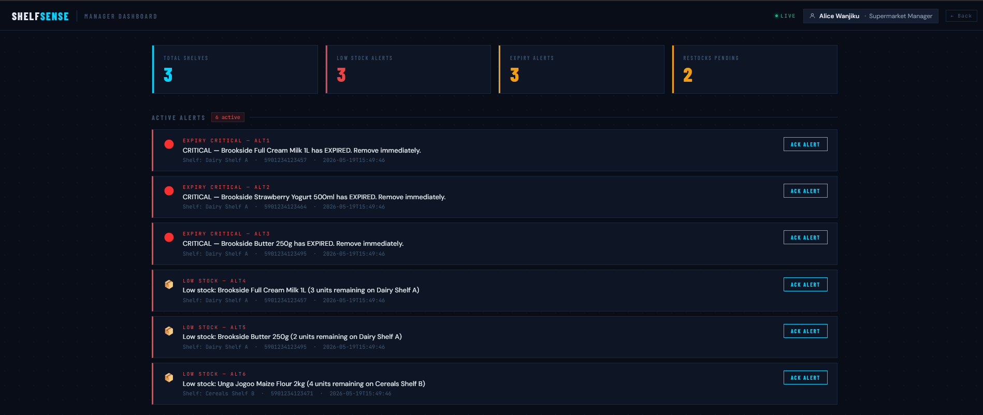

Shelf status and restock request:

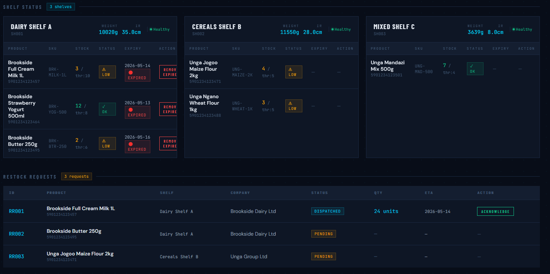

Event log:

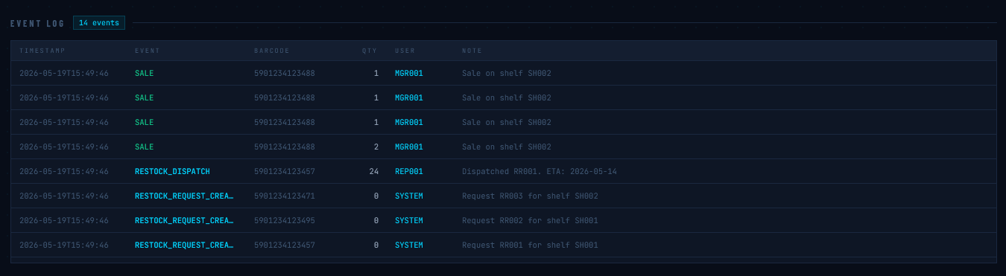

Company dashboard (brookside dairy ltd)

Alert:

