Web 2

lab sheet 3

Task 2: 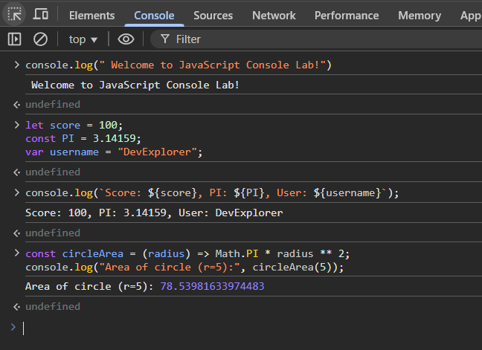

Task 3:

Task 4:

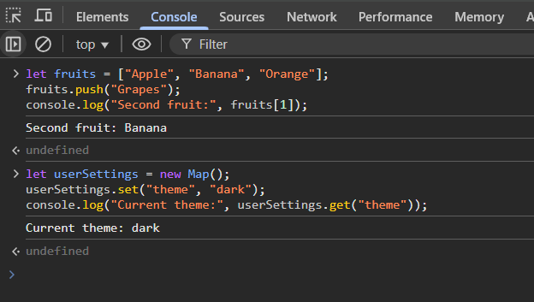

رؤى عبداللله محمود مغربي

320230602046

حوسبه اجهزه ذكيه