Software Architecture Document

Distributed Team Collaboration Processes II Tool (DTCPII tool)

Ivan Dontsov, Andy Phenix, Maureen Rottschaefer

Version 1.4

March 2012
Revision History

The revision history cycle begins once changes or enhancements are requested after the initial version of the Software Architecture Document has been completed.

Date | Version | Description | Author
02/12/2012 | 1.0 | Initial version of SAD for comments by team | Ivan Dontsov
02/22/2012 | 1.1 | Some changes after Maureen Rottschaefer review | Ivan Dontsov
02/28/2012 | 1.2 | More changes after team review | Ivan Dontsov
03/04/2012 | 1.3 | Ready for the next review | Ivan Dontsov
03/14/2012 | 1.4 | Number of changes after review and online discussions,  Ready for final review | Ivan Dontsov
Table of Contents

1. Introduction 1
1.1. Purpose 1
1.2. Scope 1
1.3. Definitions, Acronyms, and Abbreviations 2
1.4. References 2
1.5. Overview 2
2. Architectural Representation 3
3. Architectural Goals and Constraints 4
3.1. Security 4
3.2. Persistence 4
3.3. Reliability/Availability 4
3.4. Performance 4
4. Use-Case View 5
4.1. Actors 6
4.2. Use-Case Realizations 7
5. Logical View 7
5.1. Overview 7
6. Process View 8
7. Module Decomposition View 9
8. Data View 9
9. Deployment View 10
10. Size and Performance 11
11. Issues and concerns 11

Software Architecture Document Template

Introduction
This document provides a high level overview and explains the whole architecture of Process Specification Tool (PST). It is explains how an online user will be able to create and maintain software development process definitions and includes the underlying architecture of the tool.
The document provides a high-level description of the goals of the architecture, the use cases support by the system and architectural styles and components that have been selected to best achieve the use cases. This framework then allows for the development of the design criteria and documents that define the technical and domain standards in detail.

Purpose
The Software Architecture Document (SAD) provides a comprehensive architectural overview of Distributed Team Collaboration Processes II Tool (DTCPII tool). It presents a number of different architectural views to depict different aspects of the system. It is intended to capture and convey the significant architectural decisions which have been made on the system.

In order to depict the software as accurately as possible, the structure of this document is based on the “4+1” model view of architecture [KRU41].

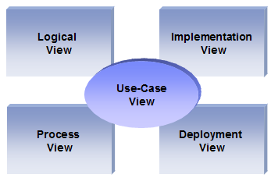
The “4+1” View Model allows various stakeholders to find what they need in the software architecture.

Scope
The scope of this SAD is to depict the architecture of the Distributed Team Collaboration Processes II Tool (DTCPII tool) online application created by the students of OMSE555 – 2010-2012.

This document describes the aspects of Process Specification Tool (PST) design that are considered to be architecturally significant; that is, those elements and behaviors that are most fundamental for guiding the construction Process Specification Tool and for understanding this project as a whole. Stakeholders who require a technical understanding of Process Specification Tool are encouraged to start by reading this document, then reviewing the Process Specification Tool UML model, and then by reviewing the source code.

Definitions, Acronyms, and Abbreviations
- Apache – Web Server
- ASP.NET - Microsoft web platform
- HTTP – Hypertext Transfer Protocol
- PHP - Hypertext Processor scripting language
- Mono – open source implementation of Microsoft’s Common Language Infrastructure
- MySQL – relational database management system (RDBMS)
- WWW – World Wide Web
- SAD - Software Architecture Document
- RUP - Rational Unified Process
- UML – Unified Modeling Language
- User - This is any user who is registered on the website
- Creator (Process Owner) - This is a user who can create/ modify DTCPII output (Process Specification)
- Reader - This user can read/download DTCPII output (Process Specification)
- Administrator – this user can read, modify and delete any of DTCPII tool Process Specification, Process Review, Process Template and administer other user rights / roles. Administrator can delegate or share administrative rights to other users in the system.

References

[PP]: Project Proposal

[SPMP]: Software Project Management Plan

[SRS]: Software Requirements Specification

[MedBiquitous]: Sample SAD, http://medbiq.org/std_specs/techguidelines/softwarearchitecture.pdf

[KRU41]: The “4+1” view model of software architecture, Philippe Kruchten, November 1995, http://www3.software.ibm.com/ibmdl/pub/software/rational/web/whitepapers/2003/Pbk4p1.pdf

[RUPRSA]: Developing a J2EE Architecture with Rational Software Architect using the Rational Unified Process®, IBM DeveloperWorks, Jean-Louis Maréchaux, Mars 2005, http://www-128.ibm.com/developerworks/rational/library/05/0816_Louis/

Overview

In order to fully document all the aspects of the architecture, the Software Architecture Document contains the following subsections.
Section 2: describes the use of each view
Section 3: describes the architectural constraints of the system
Section 4: describes the functional requirements with a significant impact on the architecture
Section 5: describes the most important use-case realization.
Section 6: describes design’s concurrency aspects
Section 7: describes how the system will be deployed.
Section 8: describes any significant persistent element.
Section 9: describes any performance issues and constraints
Section 10: describes any aspects related to the quality of service (QoS) attributes

Architectural Representation
This document details the architecture using the views defined in the “4+1” model [KRU41], but using the RUP naming convention. The views used to document the DTCPII tool application are:

Use Case view
Audience: all the stakeholders of the system, including the end-users.
Area: describes the set of scenarios and/or use cases that represent some significant, central functionality of the system. Describes the actors and use cases for the system, this view presents the needs of the user and is elaborated further at the design level to describe discrete flows and constraints in more detail. This domain vocabulary is independent of any processing model or representational syntax (i.e. XML).
Related Artifacts : Use-Case Model, Use-Case documents

Logical view
Audience: Designers.
Area: Functional Requirements: describes the design's object model. Also describes the most important use-case realizations and business requirements of the system.
Related Artifacts: Design model

Process view
Audience: Integrators.
Area: Non-functional requirements: describes the design's concurrency and synchronization aspects.
Related Artifacts: (no specific artifact).

Module Decomposition view
Audience: Programmers.
Area: Software components: describes the modules and subsystems of the application.
Related Artifacts: Implementation model, components

Data view
Audience: Data specialists, Database administrators
Area: Persistence: describes the architecturally significant persistent elements in the data model
Related Artifacts: Data model.

Deployment view
Audience: Deployment managers.
Area: Topology: describes the mapping of the software onto the hardware and shows the system's distributed aspects. Describes potential deployment structures, by including known and anticipated deployment scenarios in the architecture we allow the implementers to make certain assumptions on network performance, system interaction and so forth.
Related Artifacts: Deployment model.

Architectural Goals and Constraints
Server side
DTCPII tool will be hosted on one of PSU Apache web servers running on a Linux platform, and connecting to one of the PSU’s MySQL Database servers. All communication with client has to comply with public HTTPS, TCP/IP communication protocol standards.

Client Side
Users will be able to access DTCPII tool only online. Clients/users are requiring using a modern web browser such as Mozilla Firefox 10, Internet Explorer 9, latest versions of Google Chrome or Safari.

Security

Reader rights will be grated to any user accessing the application-landing page.
Security for DTCPII tool will be integrated with PSU’s existing security mechanisms (ODIN or CECS).
Administrator and Creator user rights will be assigned through the integrated with PSU security. Only Administrator user can add or remove other Creators and perform other administrative tasks.

Persistence

Data persistence will be addressed using a relational database.

Reliability/Availability

Reliability/Availability will be addressed through the server platform supported PSU’s Computer Action Team (CAT) Tier 1: /faculty-staff/cat-support-tiers-an-overview-3.html.

Performance

There is no particular constrains related to system performance.
It is anticipated that the system should respond to any request well under standard database and web server script timeouts (20 seconds), also system performance can depend on available hardware, PSU network and internet connection capabilities. In addition, upload / download times can depend on data size which in turn depends on user input. Therefore, actual performance can be determined only after system deployment and testing.

Use-Case View
This is a list of use-cases that represent major functionality of the final system [SRS]:
- View process specification
- Begin new process specification
- User Login
- Input Process Components data
- Publish Process Specification
- Delete process data
- Delete all data for specified user
- System delete
- Process Specification download
- Process Families

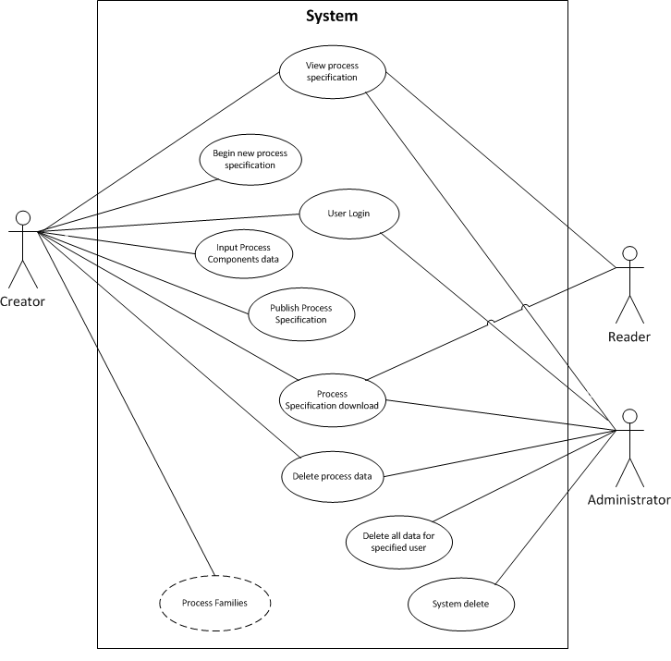

Actors

As described in the actors’ correspondence diagram below, web user could be one of three types:
- Administrator has enhanced privileges to view, delete or download Process Specifications.
- Creator – could create, update, delete and download data for particular Process Specification
- Reader – could view and download data for particular Process Specification
- System – Apache Web Server is the fourth type of actor and is the system itself. It handles all the physical and logical process of the software.

Use-Case Realizations
Use case functionality diagram below describes how design elements provide the functionalities identified in the significant use-cases. Use cases are displayed as functionalities for the system. Functionality may enclose more than one use-case.

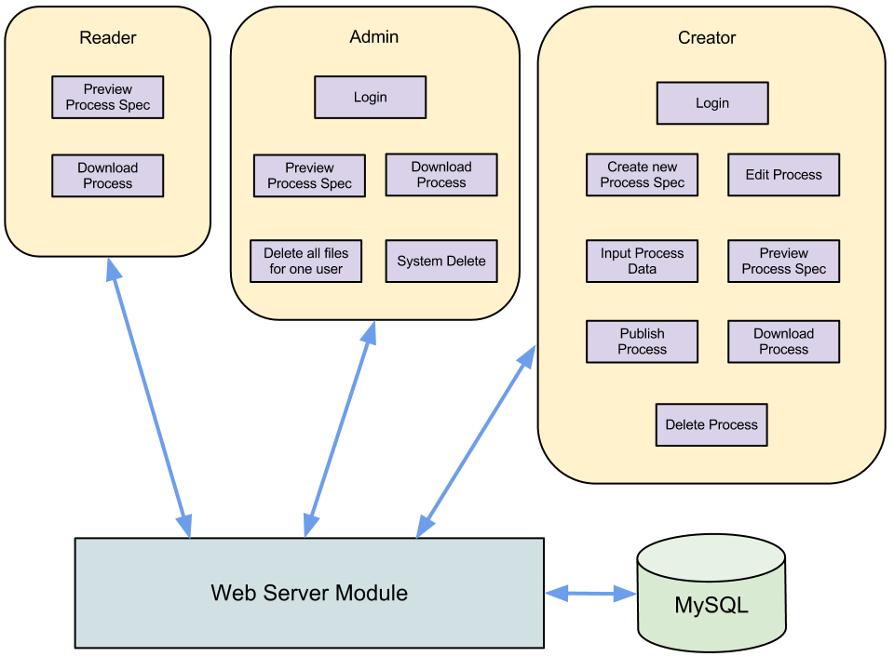
Vad säger detta? Det går att göra bättre.
/Anders S

Logical View

Overview
DTCPII tool is divided into layers based on the N-tier architecture [KRU41].
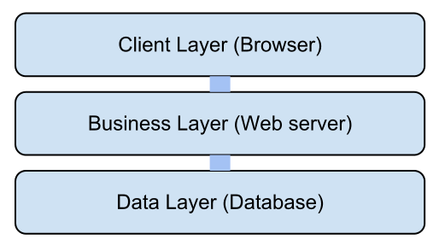
Man kan göra flera logiska vyer. I vårt fall behövs en konceptuell vy!!
/Anders S

The layering model of the DTCPII online application is based on a responsibility layering strategy that associates each layer with a particular responsibility.
This strategy has been chosen because it isolates various system responsibilities from one another, so that it improves both system development and maintenance.

Process View
Due to disconnected nature of HTTP request / response and ability of relational database management system (RDMS), DHCPII tool will handle multiple users simultaneously. Therefore, concurrency issues such as synchronous versus asynchronous mechanisms will be not considered in this document.

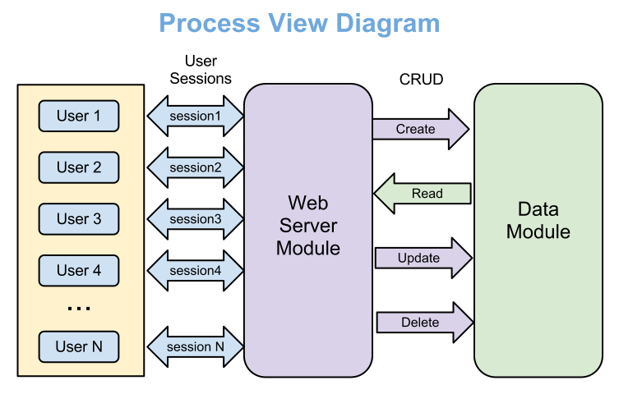
Detta kan också göras bättre! Visa exempel på en process utifrån ett UseCase och använd ett sekvensdiagram.
/Anders S

- User – Creator, Reader or Administrator
- Session – HTTP session assigned by web server automatically
- CRUD – Create-Read-Update-Delete

Module Decomposition View
Module decomposition view based on principles separation of concerns and abstraction and supports goals of modifiability and usability.

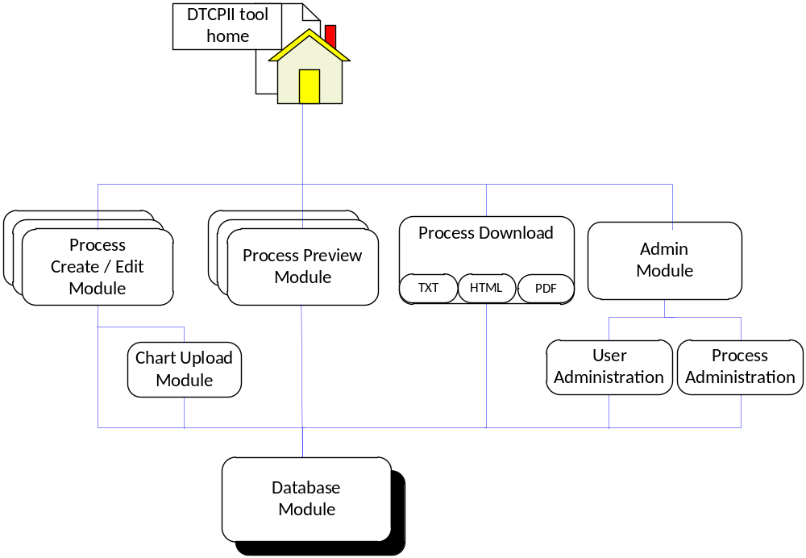
Man kan göra flera logiska vyer. I vårt fall behövs en konceptuell vy!!
/Anders S

Data View
The data view represents significant part of the DHCPII tool. Modularization (normalization) is selected as design approach of physical data model. Data consistency and quality are enforced through the series of Primary and Foreign Key constrains.
Data access will be provided only through the user web interface, however Process Template tables (Templates, Components and Subcomponents) will be filled manually since we are not planning to create special front-end interface for that. Nevertheless, the Data View structure will allow easy maintainable because all process complexity is hidden in the template tables, therefore creating or modifying process template will require minimum efforts.

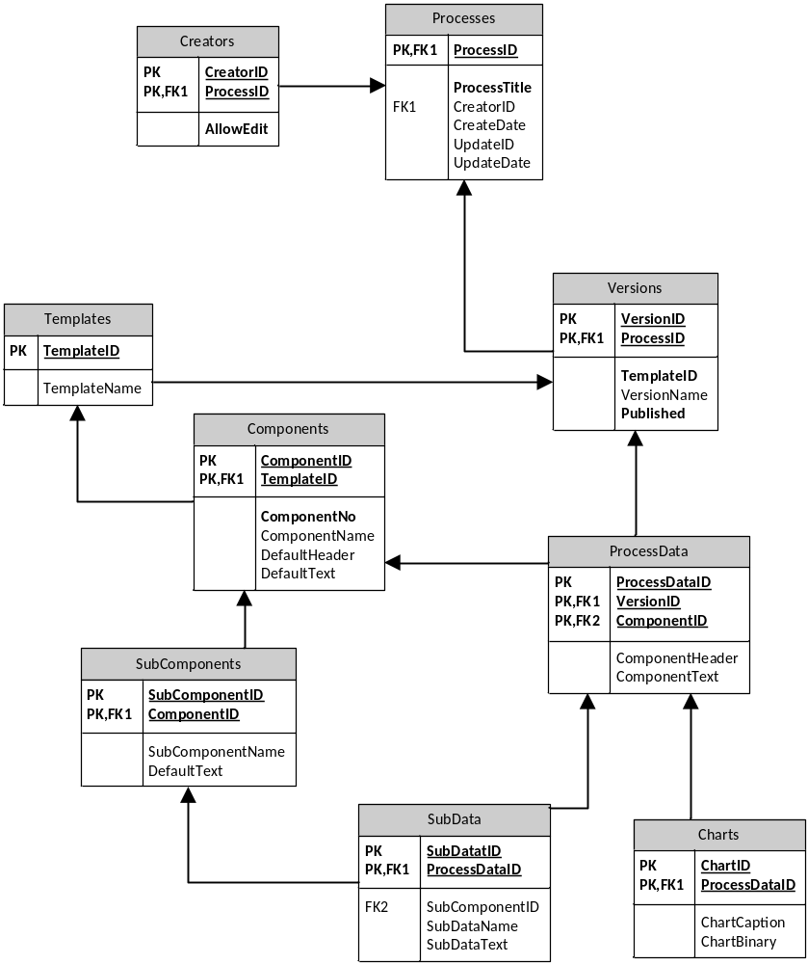

Deployment View
DTCPII tool deployment has not been considered yet. All future implementation details will be included in this section.

Size and Performance
Volumes
- Simultaneous users 30 max (OMSE students)
- Data storage under 10MB per user (including uploaded charts)

Performance
- With maximum load all transactions well under standard server script / database connection timeout – 20 seconds.

Issues and concerns
- User authentication / integration with PSU’s systems
- Charts (image) uploading – is it feasible to save images as binary field into database and what the upload file size limits
- Do we need to create user interface for Process Specification Templates
- The data structure will allow creating only two-level process hierarchy (Process Components and Sub-components). Additional level of hierarchy will require changing data structure.

