C++ Programming

Lab Manual 3

Home Task

Name: Hussain Aun Ali

CMS: 463652

Section A

Q1) Taking province as user input and outputting its population using switch-case.

#include <iostream>

using namespace std;

int main(){

int province;

cout<<"\nSelect a province: \n1.Sindh\n2.Punjab\n3.KPK\n4.Balochistan\n"<<endl;

cin>>province;

switch (province){

case 1 : cout<<"The population of Sindh is 54,858,515"<<endl;

break;

case 2 : cout<<"The population of Punjab is 116,827,125"<<endl;

break;

case 3 : cout<<"The population of KPK is 39,372,462"<<endl;

break;

case 4 : cout<<"The population of Balochistan is 20,094,659"<<endl;

break;

}

Output:

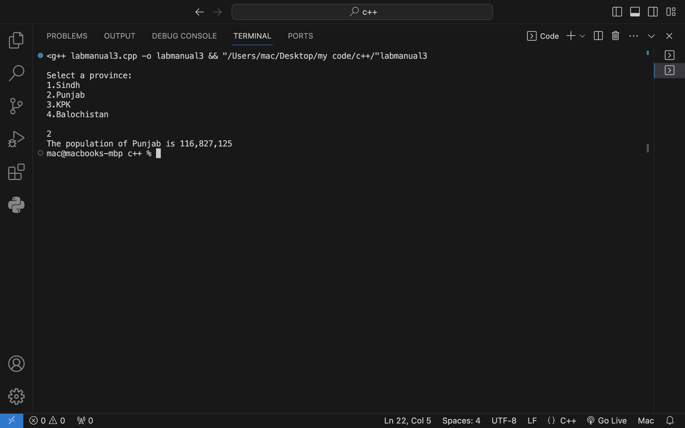

Q2)Determining whether an inputted alphabet is a vowel or a consonant using switch-case statements

char alphabet;

cout<<"Enter an alphabet: "<<endl;

cin>>alphabet;

alphabet = tolower(alphabet);

if (alphabet >= 'a' && alphabet <= 'z'){

switch (alphabet){

case 'a':case 'e' :case 'i' :case 'o' :case 'u':

cout<<"Alphabet is a vowel"<<endl;

break;

default: cout<<"Alphabet is a consonant"<<endl;

break;

}

}

else{

cout<<"Invalid Syntax"<<endl;

}

Output:

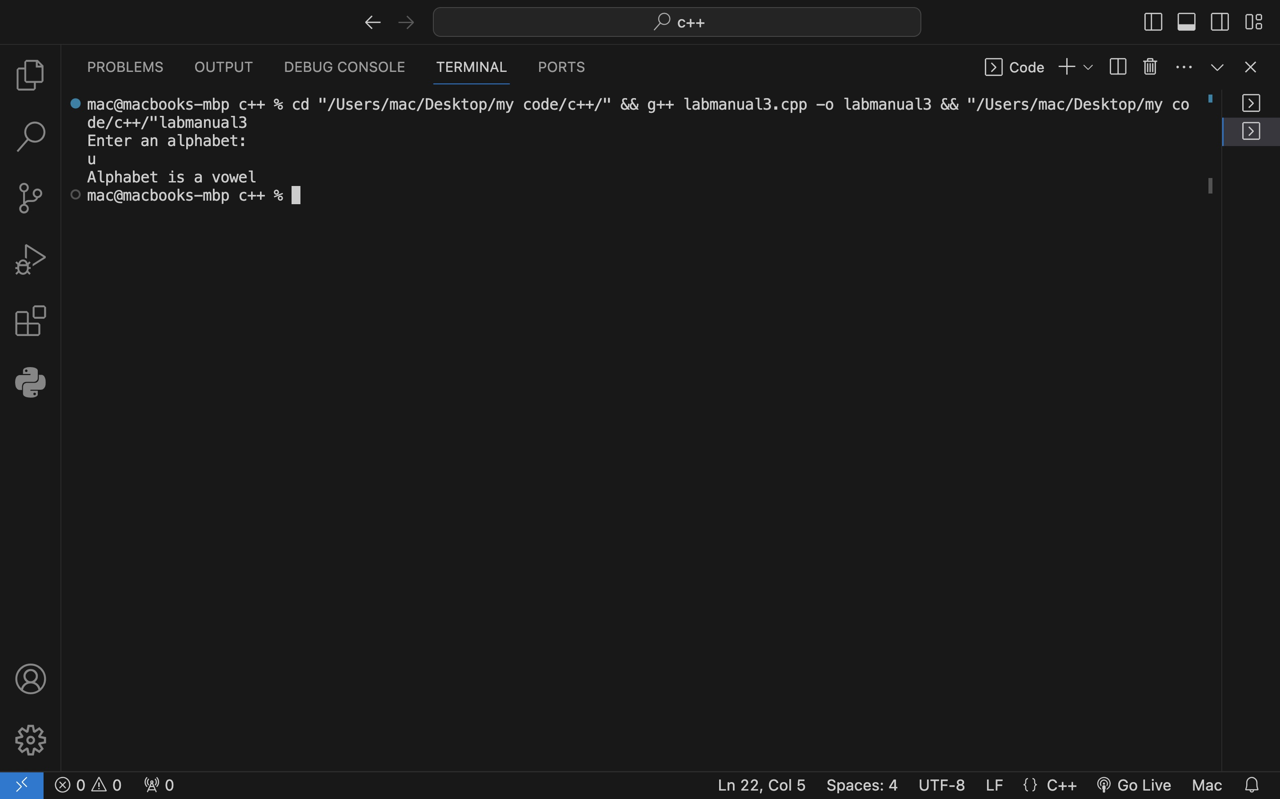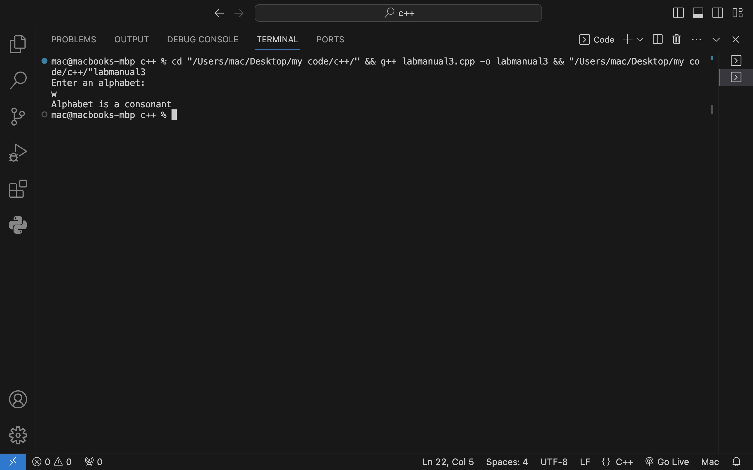

Q3) Taking a number as an input from user and determining if it is equal, greater or less than zero using switch case statements.

int number;

int s;

cout<<"Enter a number: "<<endl;

cin>>number;

if (number > 0){

s = 1;

}

else if (number == 0){

s = 0;

}

else if (number < 0 ){

s = -1;

}

else{

cout<<"Invalid Syntax"<<endl;

}

switch (s){

case 1 : cout<<"Number is greater than zero"<<endl;

break;

case 0 : cout<<"Number is equal to zero"<<endl;

break;

case -1 : cout<<"Number is less than zero"<<endl;

break;

}

Output:

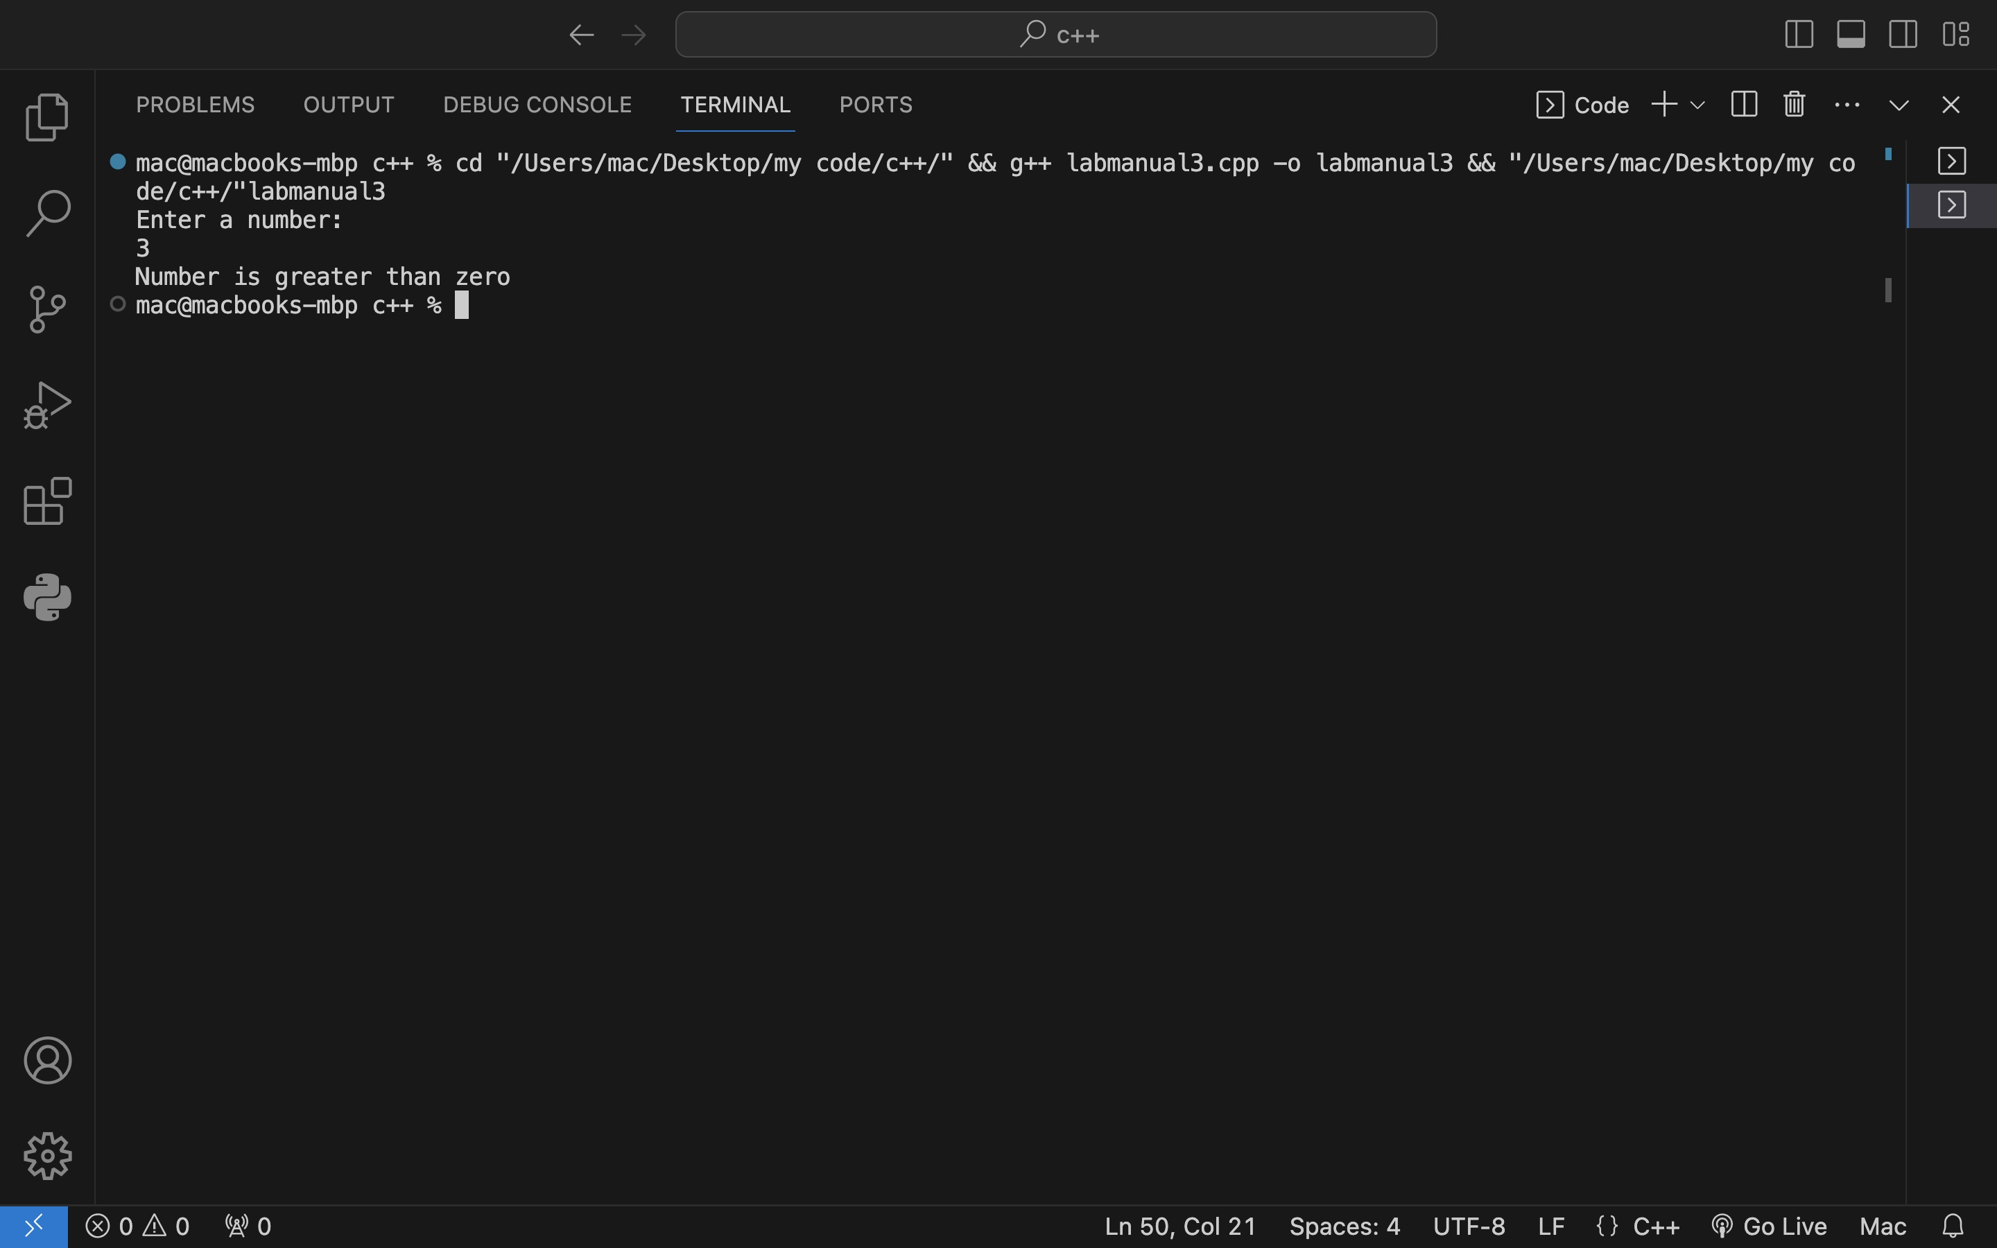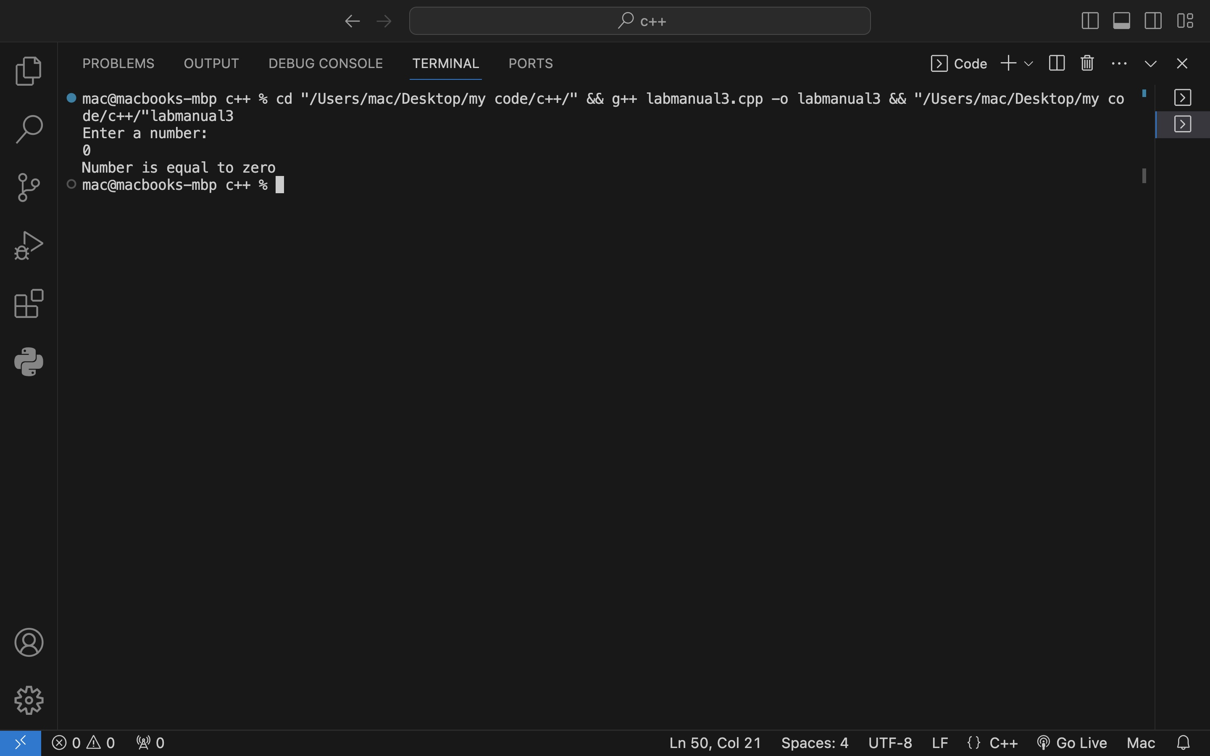

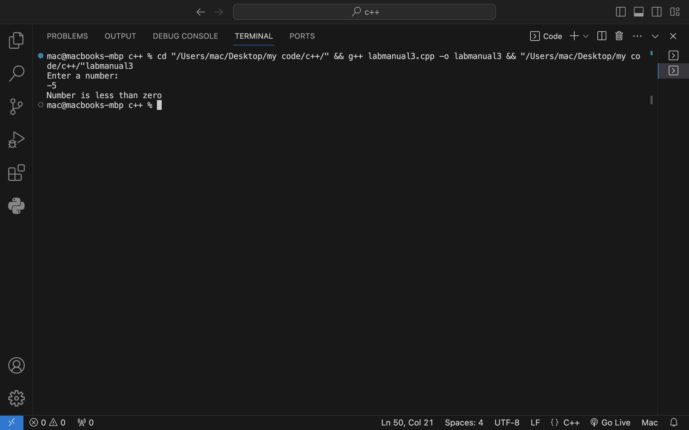

Q4) Determining whether a person is a child, teenager or an adult using nested if-else.

int age;

cout<<"Enter an age: "<<endl;

cin>>age;

if (age > 0){

if (age < 13)

cout<<"Person is a child"<<endl;

else{

if (age < 20)

cout<<"Person is a teenager"<<endl;

else{

if (age<100)

cout<<"Person is an adult"<<endl;

else{

cout<<"Age cannot be greater than 100"<<endl;

}

}

}

}

else{

cout<<"Invalid Syntax"<<endl;

}

Output:

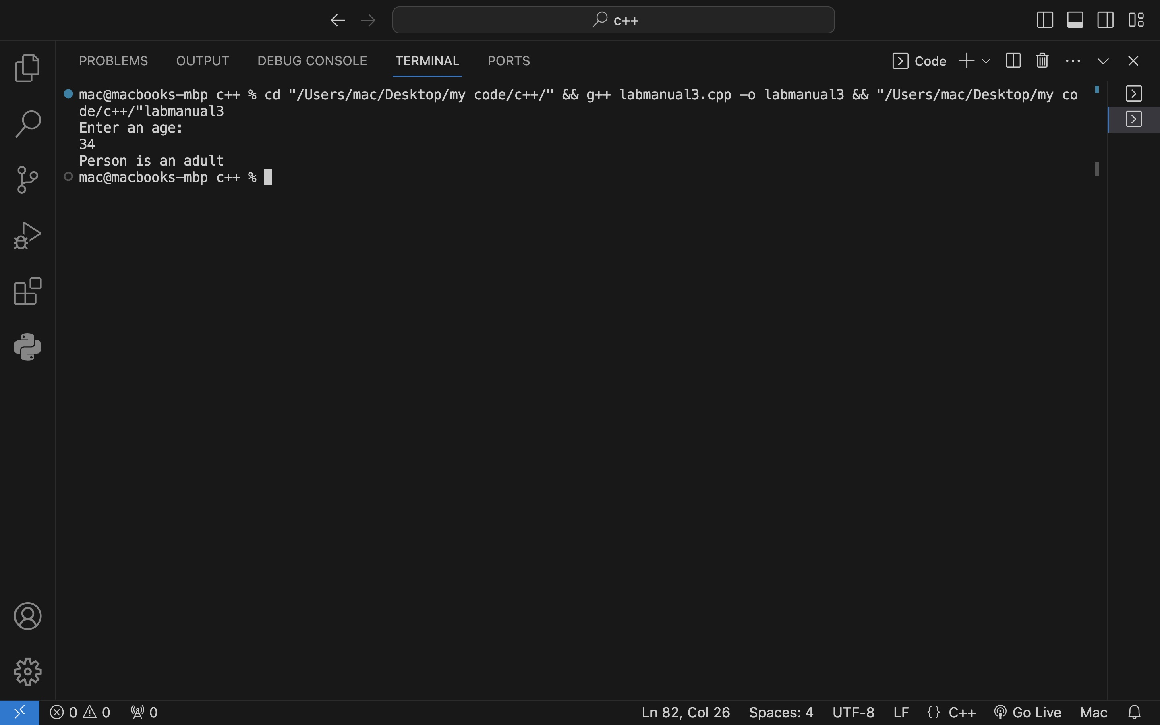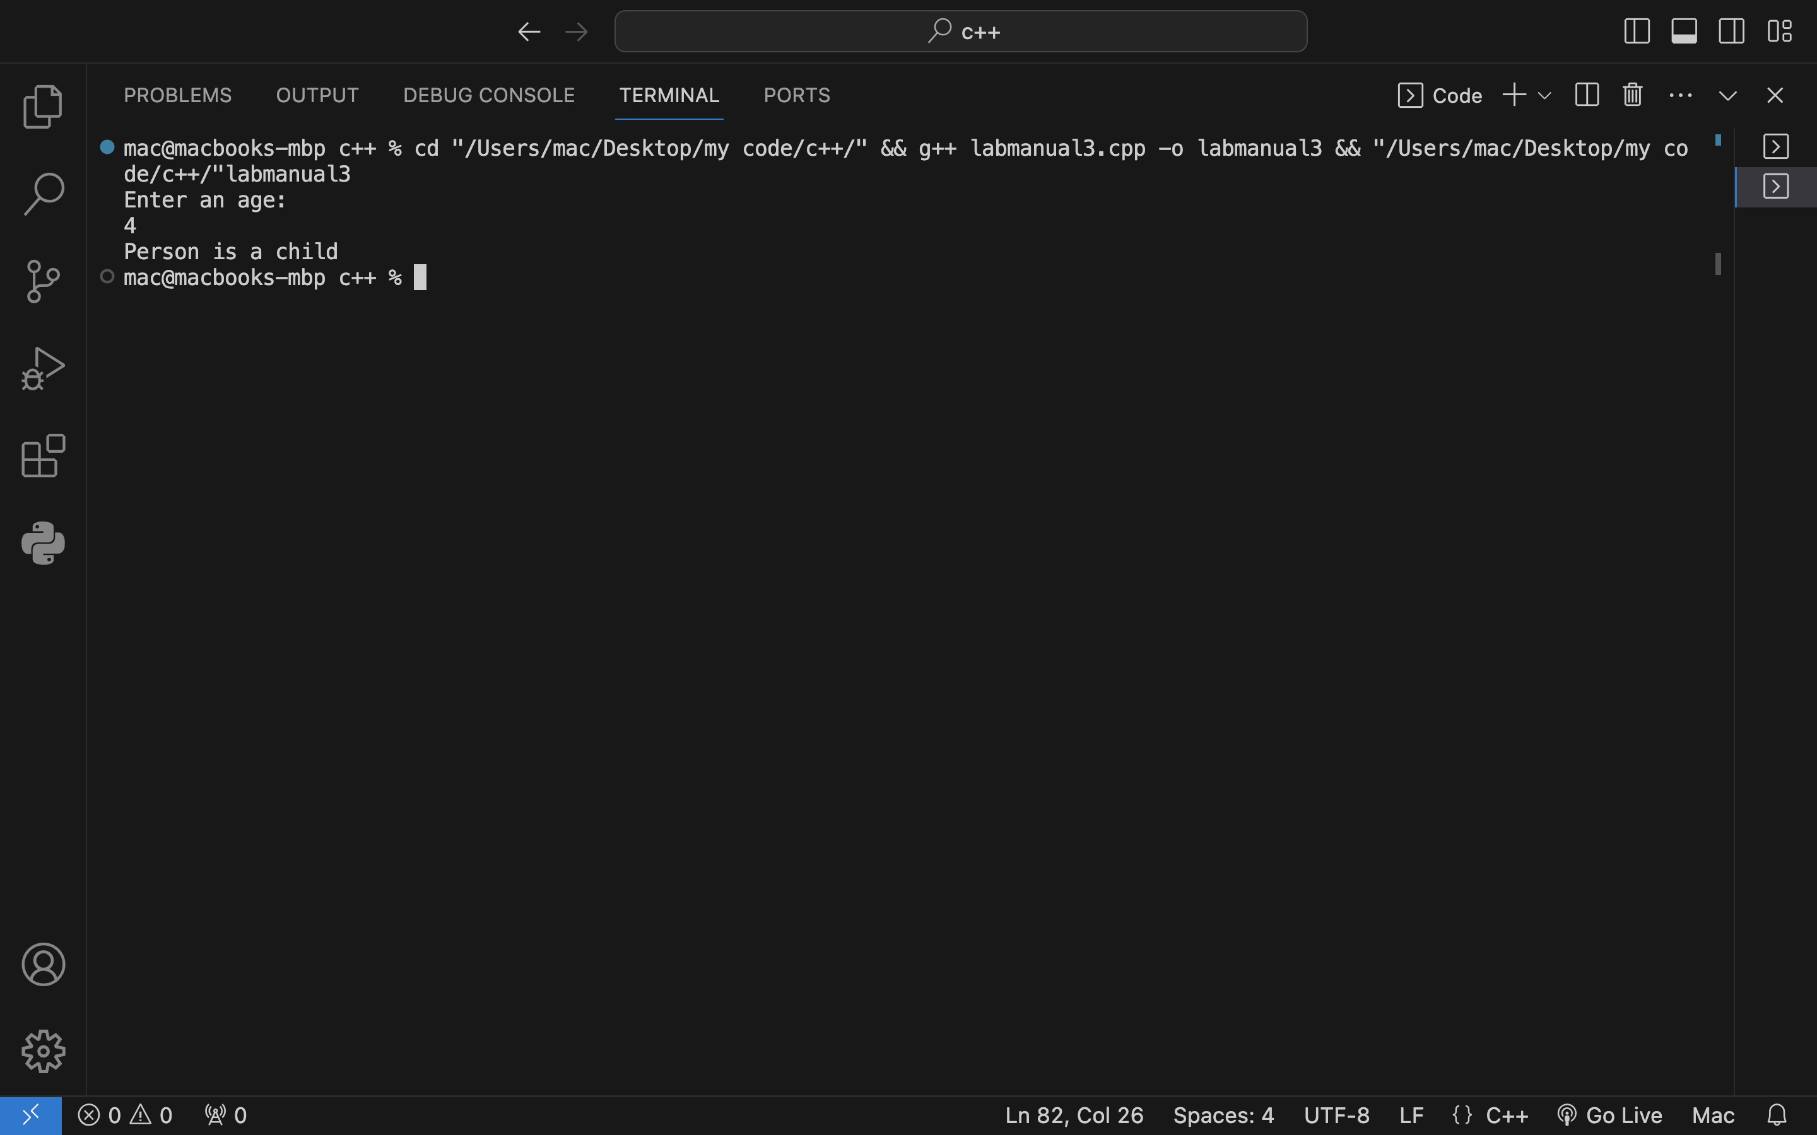

Q5) Taking three inputs from user and outputting greater one using nested if-else.

int a,b,c;

cout<<"Enter three numbers: "<<endl;

cin>>a>>b>>c;

if (a > b){

if (a > c)

cout<<a<<" is greatest"<<endl;

else{

if (b > c)

cout<<b<<" is greatest"<<endl;

else{

cout<<c<<" is greatest"<<endl;

}

}

}

else{

if (b > c)

cout<<b<<" is greatest"<<endl;

else{

cout<<c<<" is greatest"<<endl;

}

}

Output:

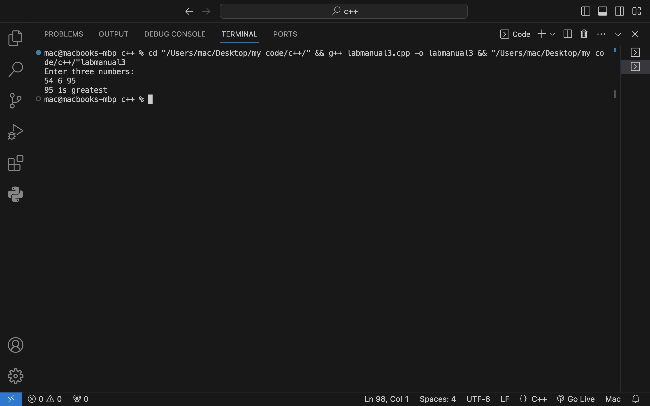

Q6) Determining whether an input alphabet is a vowel or a consonant using nested if-else.

char alpha;

cout<<"Enter an alphabet: "<<endl;

cin>>alpha;

alpha = tolower(alpha);

if (alpha >= 'a' && alpha <= 'z'){

if (alpha == 'a') //checking vowels

cout<<"Alphabet is a vowel"<<endl;

else{

if (alpha == 'e')

cout<<"Alphabet is a vowel"<<endl;

else{

if (alpha == 'i')

cout<<"Alphabet is a vowel"<<endl;

else{

if (alpha == 'o')

cout<<"Alphabet is a vowel"<<endl;

else{

if (alpha == 'u')

cout<<"Alphabet is a vowel"<<endl;

else{

cout<<"Alphabet is a consonant"<<endl; //alphabet consonat

}

}

}

}

}

}

else{

cout<<"Invalid Syntax"<<endl; //this will output if user input is anything other than an alphabet

}

}

Output:

