Index
OilSense: A Dual-Modality Optical and Capacitive Instrument for Assessing Frying-Oil Degradation, with Beer–Lambert Normalisation of the Optical Channel
I. Introduction | 2
II. Background and Related Work | 3
A. Chemistry of Frying-Oil Degradation | 3
B. How Fast Oil Degrades | 3
C. Optical Methods | 3
D. Dielectric Methods | 3
E. Existing Instruments | 3
III. Theory | 4
A. Optical Absorbance and the Beer–Lambert Law | 4
B. Normalisation of the Optical Indicator | 4
C. Capacitive Sensing and the Probe Model | 5
D. Temperature and Immersion Depth | 5
IV. System Design | 5
A. Architecture | 5
B. Optical Subsystem | 6
C. Capacitive Subsystem | 7
D. Probe Mechanical Design | 7
E. Electrical Interconnection | 7
F. Firmware and Data Acquisition | 8
G. Cross-Validation and Fault Attribution | 8
V. Experimental Methods | 9
A. Probe Calibration | 9
B. Sample Preparation | 9
C. Measurement Procedure | 9
D. Data Sources and Analysis | 9
VI. Results | 9
A. Probe Calibration | 9
B. Converter Range | 10
C. Permittivity of Fresh and Degraded Oils | 10
D. Effect of Temperature | 11
E. Capacitive Signal Budget | 11
F. Optical Normalisation | 12
G. Optical Response to Degradation | 12
H. Summary of Results | 13
VII. Discussion | 13
A. Why the Capacitive Channel Was Limited by Geometry | 13
B. How the Capacitive Channel Could Be Improved | 14
C. The Optical Channel | 14
D. Value of Two Channels | 14
E. The Cross-Validation Tolerance in Physical Units | 14
F. Cost | 15
G. Limitations | 15
VIII. Future Work | 15
IX. Conclusion | 15
Appendix A: Error of the Linear Optical Normalisation | 16
Appendix B: FDC1004 Conversion and Ranging | 16
References | 16

OilSense: A Dual-Modality Optical and Capacitive Instrument for Assessing Frying-Oil Degradation, with Beer–Lambert Normalisation of the Optical Channel

Abstract—Edible oil that is reused for deep frying accumulates polar degradation products, and Indian food-safety regulations require oil above 25 % total polar materials (TPM) to be discarded [1]. Small food businesses rarely have a way to measure TPM. This paper describes OilSense, a hand-held instrument that measures frying oil with two physically independent channels: an AS7265x 18-channel spectral sensor (410–940 nm) for optical absorbance, and an FDC1004 capacitance-to-digital converter with two stainless-steel electrodes for the dielectric response. A digital temperature probe allows temperature correction, and an ESP32 microcontroller normalises both indicators, cross-validates them and reports the result. Two-point calibration of the probe in air and fresh oil gave a cell constant of 10.8 pF per unit permittivity and a parasitic offset of 3.6 pF, so the ratio of the oil reading to the air reading is 2.50 instead of the ideal 3.0. Combining this calibration with published dielectric data shows that the capacitive signal is sensitive to temperature, immersion depth and stray capacitance on the same scale as the degradation signal, which explains why the capacitive channel was limited by electrode geometry. For the optical channel, we show analytically that normalising the ratio of a short-wavelength channel to a near-infrared channel logarithmically, as the Beer–Lambert law requires, makes the indicator linear in absorber concentration. A linear normalisation instead carries a systematic mid-range error of 0.14–0.27 of full scale for discard-level absorbances of 0.5–1.0. The prototype costs ₹9,262, about one-sixth of the list price of a commercial dielectric TPM meter.
Index Terms—Frying oil, total polar materials, visible–NIR spectroscopy, Beer–Lambert law, capacitive sensing, dielectric permittivity, sensor fusion, ESP32, AS7265x, FDC1004.
Nomenclature
Symbol | Meaning | Unit
A, A_{d} | Absorbance; absorbance at discard limit | —
T | Transmittance I/I₀ | —
c, x | Absorber concentration; c/c_{d} | —
R, R₀, R_{d} | Short/NIR channel ratio; fresh; discard | —
ε_{r}, ε₀, ε_{d} | Relative permittivity; fresh; discard | —
k | Probe cell constant | pF
C, C_{p} | Measured capacitance; parasitic offset | pF
n_{C}, n_{O} | Normalised capacitive, optical indicators | —
TPM / TPC | Total polar materials / compounds | %

I. Introduction
Deep frying is among the most common cooking methods in India, from roadside stalls to hotel kitchens and snack factories. The same body of oil is normally reused for many batches. At frying temperatures of 160–190 °C, and in contact with the water, starch and protein released by food, the oil undergoes hydrolysis, oxidation and thermal polymerisation [2]. These reactions convert triglycerides into free fatty acids, mono- and diglycerides, oxidised triglycerides, and dimers and polymers. All of these products are more polar than the original oil, and their combined mass fraction, total polar materials (TPM), is the most widely used single measure of frying-oil quality [3].
Degraded oil affects both health and food quality. FSSAI therefore requires that used cooking oil above 25 % TPM is not used for further frying [1]. Meeting this requirement needs a measurement. Laboratory determination by column chromatography is accurate, but it takes hours to days and requires a laboratory. Portable dielectric meters such as the testo 270 give a reading in about 30 s with a specified accuracy of ±2 % TPM [4], but at about ₹55,000 they are beyond the means of the street vendors and single-outlet restaurants who fry most of the food sold in India. In practice, oil is replaced according to elapsed time, the number of batches, or its colour and smell. None of these is reliable, because the rate of degradation depends on the oil, the food, the temperature and how often fresh oil is added.
Low-cost instruments that use one sensing principle have a further weakness: they cannot tell when their own reading is wrong. A capacitive reading rises if water from the food is carried into the oil, and an optical reading rises if crumbs are suspended in the sample or the optical window is fouled. In each case the instrument reports a plausible number with no indication that it is wrong.
OilSense addresses both problems. It measures the oil with two channels that respond to the same degradation process through unrelated physical mechanisms. An optical channel tracks the coloured products that absorb short-wavelength light, and a capacitive channel tracks the polar molecules that raise the oil’s permittivity. Each channel is normalised to a common scale from fresh oil to the discard limit, and the two are compared before a result is reported.
This paper makes four contributions:
- the design of a low-cost, hand-held dual-modality instrument built from an ESP32, an AS7265x spectral sensor and an FDC1004 capacitance converter (Section IV);
- a calibration procedure for the capacitive probe that needs no reference instrument, and a figure of merit that quantifies parasitic capacitance (Sections III-C and VI-A);
- a quantitative explanation, based on the measured calibration and published dielectric data, of why the capacitive channel is limited by electrode geometry (Sections VI-B to VI-E and VII-A);
- an analytical comparison of linear and Beer–Lambert (logarithmic) normalisation of the optical channel, showing why the logarithmic form is required for meaningful cross-validation (Sections III-B and VI-F).
Section II reviews the chemistry of frying oil and existing measurement methods. Section III develops the theory of both channels. Section IV describes the hardware, firmware and software. Section V gives the calibration and test methods, Section VI presents the results, Section VII discusses them, and Sections VIII and IX give future work and conclusions.

II. Background and Related Work

A. Chemistry of Frying-Oil Degradation
Choe and Min describe three main reaction pathways in frying oil [2]. In hydrolysis, water released from food attacks the ester bonds of triglycerides, releasing free fatty acids, monoglycerides and diglycerides. In oxidation, oxygen dissolved in the oil and absorbed at its surface reacts with unsaturated fatty acids to form hydroperoxides. These break down into secondary products including aldehydes, ketones, alcohols and short-chain acids, some of which are volatile and some of which stay in the oil. In thermal polymerisation, fatty-acid radicals combine into dimers and higher polymers, which increase viscosity, promote foaming and darken the oil.
Each pathway produces molecules that are more polar than the original triglycerides. TPM, defined as the fraction that is retained on a silica column under standard conditions, therefore integrates the effect of all three pathways. Gertz compared chemical and physical quality indicators for used frying fats and found that TPM and polymerised triglycerides are the most reliable indicators of degradation [3]. The coloured products formed in oxidation and polymerisation also give used oil its characteristic darkening from pale yellow to amber and brown.

B. How Fast Oil Degrades
Published frying trials show how quickly TPM reaches the regulatory limit. Kung and Hsieh fried French fries in palm oil at 180 °C and measured TPC with a testo 270. TPC rose from 4.67 % in fresh oil to 24.17 % after 20 h and 26.33 % after 24 h [5]. Aşkın and Kaya fried French fries in linoleic and oleic sunflower oils at 180 °C, 7 h per day. TPC rose from 7.50 % and 4.00 % to 24.75 % and 27.75 % respectively after 28 h [6]. These data, plotted in Fig. 18 (Section VI), show a roughly linear rise of about 0.65–0.9 % TPM per hour of frying. They also show that the time to reach the limit varies between oils, which is why a fixed replacement schedule cannot be optimal.

C. Optical Methods
Coloured degradation products absorb mainly in the violet–blue region of the spectrum. Xu measured the absorbance of 220 used-oil samples from 10 different oils, fried for 0–80 h, and found that absorbance at 490 nm correlated with TPC measured by the AOCS method (r = 0.974). The published regression is TPC = −2.7865x² + 23.782x + 1.0309, where x is the absorbance at 490 nm [7]. Yu et al. fried potato chips repeatedly in soybean and coconut oil and found that Hunter b* (yellowness) increased with the number of fryings and with TPC [8]. Xu also developed a reagent-based colour test for TPC that is read with a spectrophotometer [9]. These studies support the use of visible absorbance as a degradation indicator. They also show that fresh oils differ in colour, so a fresh-oil reference is needed for each oil.

D. Dielectric Methods
Fresh vegetable oils are weakly polar. Lizhi et al. measured the relative permittivity of eight fresh oils at 25 °C and found values from 3.057 (safflower) to 3.127 (corn), nearly constant between 100 Hz and 500 kHz [10]. They also found that permittivity falls with temperature, with a slope of −0.006 per °C for soybean oil between 20 and 45 °C. Šegatin et al. heated six oils at 180 °C and measured the static permittivity at 25 °C. For sunflower oil it rose from 3.13 to 4.18 by the end of heating [11]. Wiege et al. measured permittivity at 130 °C during thermal treatment of sunflower oil and palm fat, and report an increase of about 23 % over 76 h [12].
Several groups have built capacitive probes for frying oil [13, 14]. Liu et al. report that the capacitance of their sensor rose from 34.08 to 34.32 pF at 25 °C, and from 30.00 to 30.14 pF at 40–50 °C, as TPM rose from 7 % to 32.5 % [14]. Kung and Hsieh used a simple, low-cost two-electrode cell in palm oil and found a rising trend in capacitance with frying time, with standard deviations of up to 7.8 pF between repeats [5]. These results show that the dielectric approach works but that the signal is small, and that temperature and cell construction strongly affect it. The testo 270 is a commercial instrument built on the same principle [4].

E. Existing Instruments
Table I. Comparison of frying-oil assessment methods.
Method | Principle | Speed | Limitations
Column chromatography | Separation of polar fraction | Hours–days | Laboratory, trained staff
testo 270 [4] | Capacitive | ≈30 s | ≈₹55,465; single modality
Research capacitive probes [13, 14] | Capacitive | Seconds | Small signal; temperature and geometry sensitive
OilSense (this work) | Optical (18 ch) + capacitive + temperature | Seconds | Prototype; capacitive channel geometry-limited

Table I summarises the main methods. All of them except OilSense rely on a single physical principle, and none can detect when its own reading has been corrupted by something other than degradation. We are not aware of a low-cost instrument that combines optical and dielectric sensing and uses their agreement as a check on validity.

III. Theory

A. Optical Absorbance and the Beer–Lambert Law
When light of wavelength λ and intensity I₀ passes through a path length l of a liquid containing an absorbing species at concentration c, the transmitted intensity is [15]
T = I/I₀ = 10^{−ελlc} (1)
where ε_{λ} is the absorptivity at that wavelength. The absorbance is defined as
A = −log₁₀T = ε_{λ}lc (2)
Equation (2) carries the key point of this section. Absorbance, not transmitted intensity, is proportional to concentration. Transmittance falls exponentially with concentration, while absorbance rises linearly (Fig. 1). When several absorbing species are present, their absorbances add.

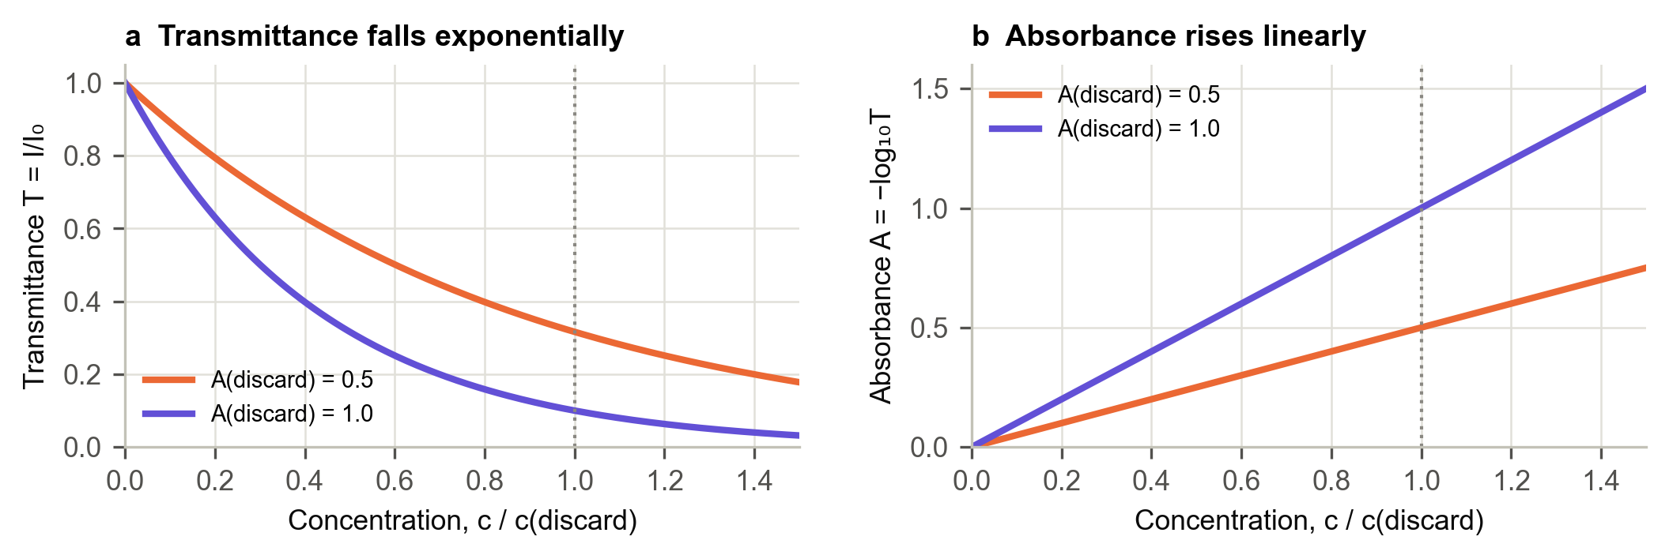
Fig. 1. Beer–Lambert model for an indicator band whose absorbance at the discard limit is 0.5 or 1.0. (a) Transmittance falls exponentially with concentration; (b) absorbance rises linearly. Analytical model of (1)–(2), not measured data.

OilSense does not measure I₀ directly. It uses the ratio of a short-wavelength channel, where degradation products absorb strongly, to a near-infrared (NIR) channel, where they absorb weakly:
R = S_{short} / S_{NIR} (3)
Any factor that scales both channels equally cancels in R, including LED intensity and ageing, small changes in optical path, and uniform fouling of the window. If the NIR channel is not attenuated by the absorbing products, then R = R₀·10^{−A}, where R₀ is the fresh-oil ratio and A is the additional absorbance of the short-wavelength band caused by degradation.

B. Normalisation of the Optical Indicator
To compare the two channels, each is mapped to a common scale n that is 0 for fresh oil and 1 at the discard threshold. For the optical ratio, the obvious choice is a linear normalisation between the fresh value R₀ and the discard value R_{d}:
n_{lin} = (R₀ − R) / (R₀ − R_{d}) (4)
Let x = c/c_{d} be the concentration as a fraction of its discard value, and A_{d} the absorbance at the discard limit. Substituting R = R₀·10^{−Adx} into (4) gives
n_{lin}(x) = (1 − 10^{−Adx}) / (1 − 10^{−Ad}) (5)
This is a concave function of x. It equals the ideal value x only at the end points, and it overstates degradation everywhere in between. The logarithmic normalisation converts the ratio to absorbance before scaling:
n_{O} = ln(R₀/R) / ln(R₀/R_{d}) (6)
Substituting the same expression for R gives n_{O} = A_{d}x/A_{d} = x exactly, for any value of A_{d}. The systematic error of the linear form, e(x) = n_{lin}(x) − x, is largest where its derivative is zero:
x* = log₁₀[A_{d} ln 10 / (1 − 10^{−Ad})] / A_{d} (7)
For A_{d} = 0.5, x* ≈ 0.45 and the maximum error is 0.141. For A_{d} = 1.0, x* ≈ 0.41 and the maximum error is 0.269. These results are evaluated in Section VI-F.

C. Capacitive Sensing and the Probe Model
Two electrodes immersed in oil form a capacitor whose dielectric is the oil. The measured capacitance is the sum of an active part, proportional to the relative permittivity ε_{r} of the oil, and a parasitic part C_{p} that does not depend on the oil:
C = k ε_{r} + C_{p} (8)
The cell constant k depends only on the electrode geometry (area, spacing and wetted length). C_{p} comes from the leads, the converter input, the housing, and any conductor near the electrodes. Measuring C in two media of known permittivity, here air (ε ≈ 1) and fresh oil (ε ≈ 3), gives two equations from which k and C_{p} follow. No reference TPM instrument is needed.
For a probe with no parasitic capacitance, the ratio of the oil reading to the air reading would equal the permittivity of the oil. In general,
C_{oil}/C_{air} = (kε_{oil} + C_{p}) / (k + C_{p}) (9)
This ratio is a simple figure of merit. Values near 3 mean that the reading is dominated by the oil, and lower values mean that it is dominated by parasitic capacitance. Equation (9) depends only on the ratio C_{p}/k, so it can be used to compare successive probe designs.

D. Temperature and Immersion Depth
The permittivity of oil falls with temperature. From the linear fit of Lizhi et al. for soybean oil, dε/dt ≈ −0.006 °C⁻¹ [10]. From (8), a temperature change Δt changes the capacitance by ΔC = k·(dε/dt)·Δt. For elongated parallel electrodes, k is approximately proportional to the wetted length L, so a fractional depth change ΔL/L changes the active capacitance by the same fraction:
ΔC ≈ (C − C_{p}) · ΔL/L (10)
Both effects add to the reading in the same way as a genuine change in permittivity. A single-channel capacitive instrument cannot tell them apart.

IV. System Design

A. Architecture
Fig. 2 shows the system architecture. An ESP32 microcontroller with integrated 2.4 GHz Wi-Fi is the hub. The AS7265x spectral sensor, the FDC1004 capacitance converter and an OLED display share one I²C bus and are distinguished by their bus addresses. A digital temperature probe uses a separate 1-Wire interface, and a rechargeable lithium-ion cell powers the unit. After each measurement, the ESP32 shows the result on the OLED and sends a record over Wi-Fi to a Firebase Realtime Database. A browser-based dashboard reads the records and displays the history.
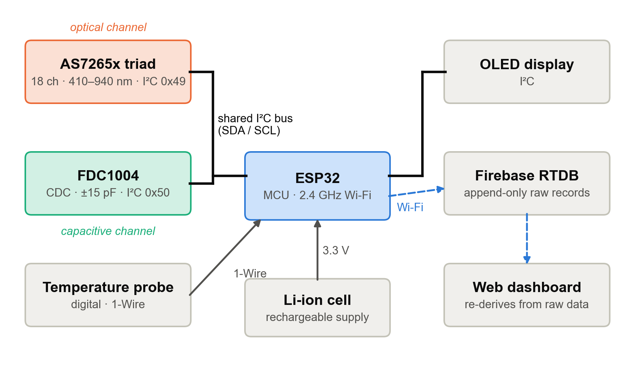
Fig. 2. OilSense system architecture. The optical (orange) and capacitive (green) channels share the ESP32’s I²C bus.
Fig. 3 shows the assembled prototype. The two threaded stainless-steel electrodes and the sheathed temperature probe project from the base of a 3D-printed PETG housing, and the OLED display is set into the lid. Table II lists the main components.

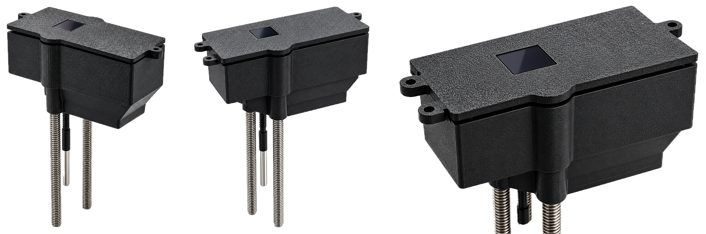
Fig. 3. The OilSense prototype (backgrounds removed): front three-quarter view, opposite three-quarter view, and close-up of the housing and display.

Table II. Main components.
Component | Role | Key specifications
ESP32 | Controller, Wi-Fi | Dual-core MCU, 2.4 GHz Wi-Fi, I²C master
AS7265x (AS72651/2/3) | Optical channel | 18 ch, 410–940 nm, FWHM 20 nm, ±10 nm [16]
Triad LEDs | Illumination | 5700 K white, 405 nm, 875 nm [17]
FDC1004 | Capacitive channel | ±15 pF, CAPDAC to 100 pF, 0.5 fF, 25 kHz [18]
Electrodes ×2 | Sense capacitor | Threaded SS 304, parallel
Temperature probe | Correction | Digital, 1-Wire, −55 to +125 °C
OLED | Readout | I²C, in lid
Housing | Enclosure | 3D-printed PETG

B. Optical Subsystem
The AS7265x is a chipset of three spectral sensors, each with six filtered photodiode channels. According to the ams datasheet, AS72653 covers 410–535 nm (channels A–F), AS72652 covers 560, 585, 645, 705, 900 and 940 nm (G–L), and AS72651, which is the master device that talks to the host, covers 610–860 nm (R–W) [16]. Each channel has a nominal full width at half maximum of 20 nm and a centre-wavelength accuracy of ±10 nm (Fig. 4). The SparkFun Triad board adds a 5700 K white LED, a 405 nm UV LED and an 875 nm IR LED [17].

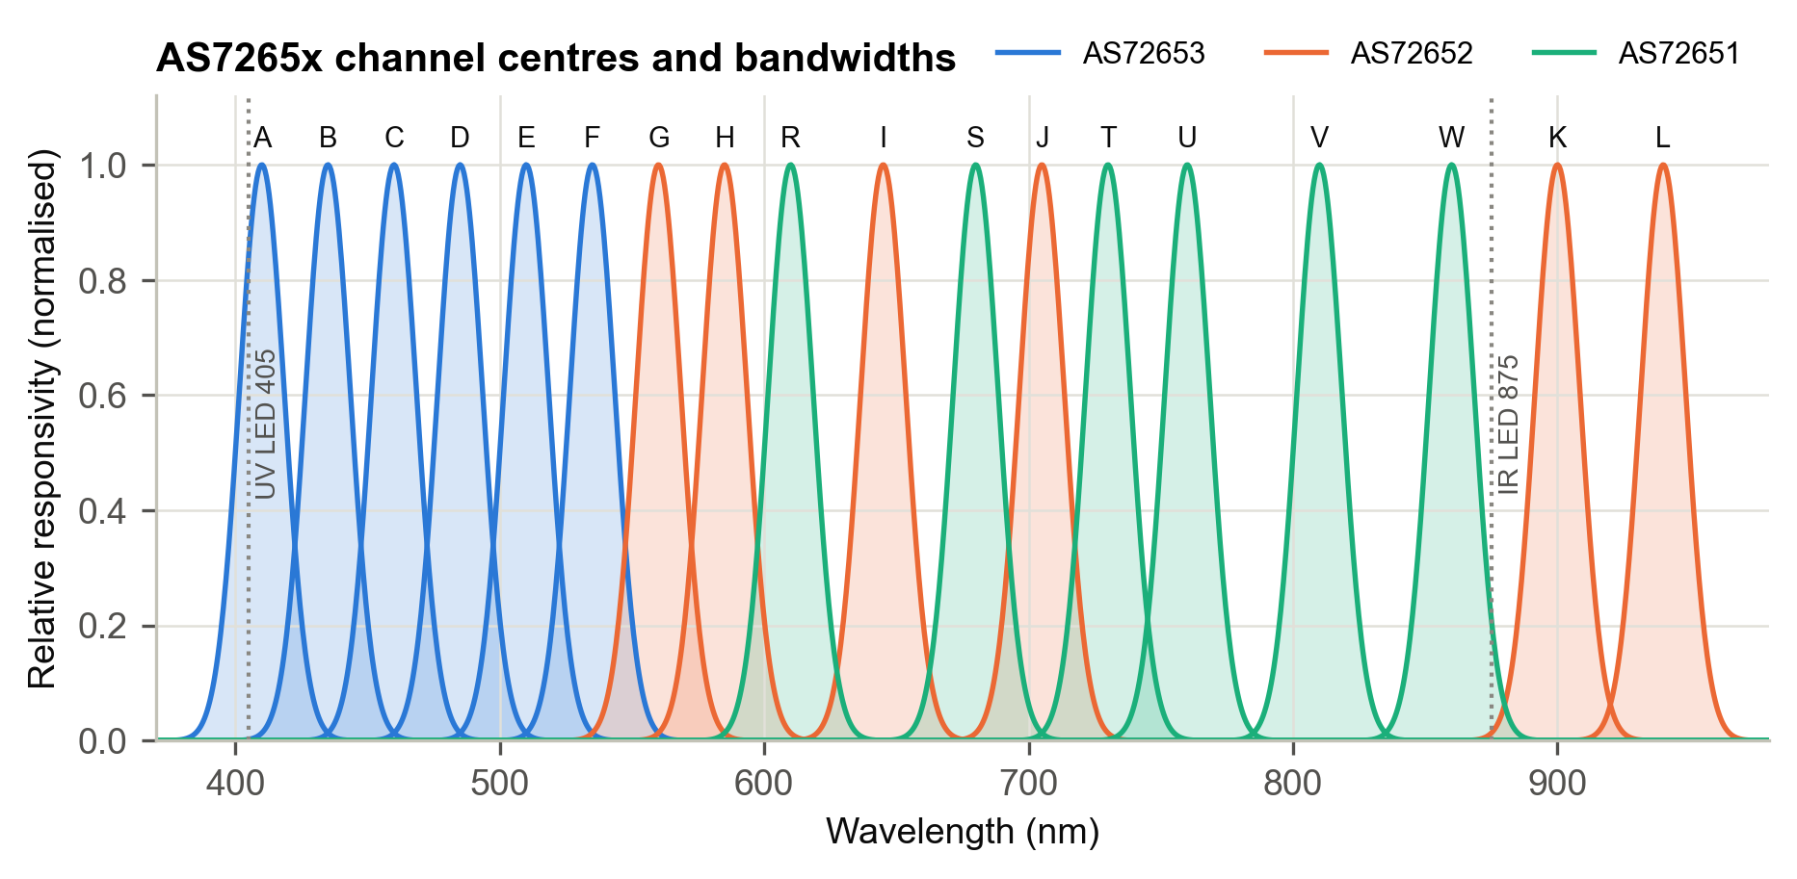
Fig. 4. AS7265x channel centres and nominal 20 nm bandwidths from the ams datasheet [16], drawn as Gaussian approximations, with the board’s UV and IR LED wavelengths. Not measured filter responses.

The LEDs illuminate the oil, and the photodiodes receive the light returned from it, so each channel value depends on how strongly the oil absorbs at that wavelength. Xu’s 490 nm wavelength [7] lies within the 20 nm band of channel D (485 nm), and the channels below 535 nm are the most sensitive to the coloured products of degradation. The NIR channels (V 810, W 860, K 900, L 940 nm) are only weakly affected by oil colour and serve as the reference in (3). The other 14 channels are recorded with every reading for later multivariate analysis. The LEDs are switched on only during the spectral scan, which limits heating of the sensor and the sample.

C. Capacitive Subsystem
The FDC1004 is a four-channel capacitance-to-digital converter. It applies a 25 kHz excitation and measures a ±15 pF range around a programmable offset, the CAPDAC, which can be set from 0 to 96.9 pF in steps of 3.125 pF [18]. The firmware adjusts the CAPDAC so that the reading stays inside the ±15 pF window, which gives a total usable range of about 115 pF (Fig. 10, Section VI-B). The converter has a resolution of 0.5 fF and runs from 3.0–3.6 V, drawing 750 µA when active. Its 25 kHz excitation lies in the range where oil permittivity is independent of frequency [10], so published permittivity values apply directly to the instrument.
Electrode 1 connects to input CIN1 through a shielded lead, and electrode 2 connects to ground. The design calls for the shield to be driven by the FDC1004’s SHLD1 output at the same potential as the sense line. This active guarding reduces the stray capacitance contributed by the cable and by nearby objects, including the user’s hand.

D. Probe Mechanical Design
Fig. 5 shows the probe in cross-section. Both electrodes are threaded rods of grade-304 stainless steel held parallel by the housing. Stainless steel was chosen because the free fatty acids in hot, degraded oil corrode copper and brass. Corrosion would change the electrode surface and cause a capacitance drift that is indistinguishable from degradation. The threads increase the wetted surface area for a given length, which raises k, but they also retain oil residue between readings.
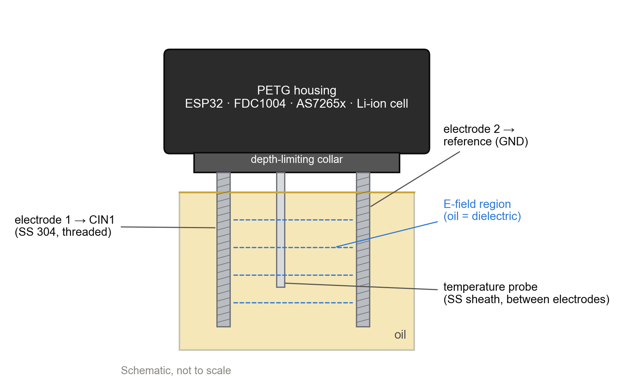
Fig. 5. Probe cross-section (schematic, not to scale). The oil between the electrodes forms the dielectric; the collar fixes the immersion depth.
Two details of the geometry matter for the results in Section VI. First, the temperature probe sits on the centre line between the electrodes, so its stainless sheath lies inside the electric field. Any conductor in the field, whether connected or floating, shortens the effective dielectric gap and adds capacitance. Because the sheath is fixed in place, its contribution is constant and is absorbed into C_{p} by calibration, but it still reduces the figure of merit in (9). Second, by (10), capacitance scales with wetted length, so a depth-limiting collar sets the immersion depth mechanically rather than by eye.

E. Electrical Interconnection
Fig. 6 shows the interconnections. All three I²C devices share SDA, SCL, 3.3 V and ground. The temperature probe uses a dedicated GPIO with a pull-up resistor. Table III summarises the bus addresses.

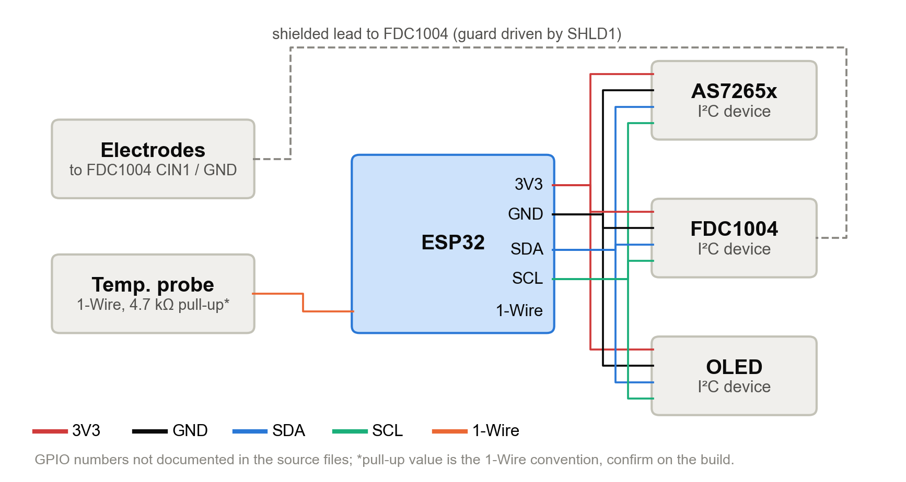
Fig. 6. Interconnect diagram. All I²C devices share SDA/SCL and 3.3 V; the electrodes connect to FDC1004 CIN1 and ground through a shielded lead.

Table III. Bus and interface summary.
Device | Interface | Address
AS7265x (AS72651) | I²C | 0x49
FDC1004 | I²C | 0x50 [18]
OLED display | I²C | Module default
Temperature probe | 1-Wire | Dedicated GPIO
Firebase RTDB | Wi-Fi 2.4 GHz | Authenticated HTTPS

F. Firmware and Data Acquisition
Fig. 7 shows the sequence of one measurement. The firmware reads the temperature, then takes 64 successive FDC1004 conversions on CIN1, adjusting the CAPDAC if necessary, and computes their mean and standard deviation. A sudden rise in the standard deviation indicates a loose connection, vibration of the probe, or gas bubbles between the electrodes. The firmware then switches on the illumination, reads all 18 calibrated channel values and switches the illumination off. It applies the stored temperature correction and calibration constants, normalises both indicators, performs the cross-validation of Section IV-G, displays the result and uploads the record.

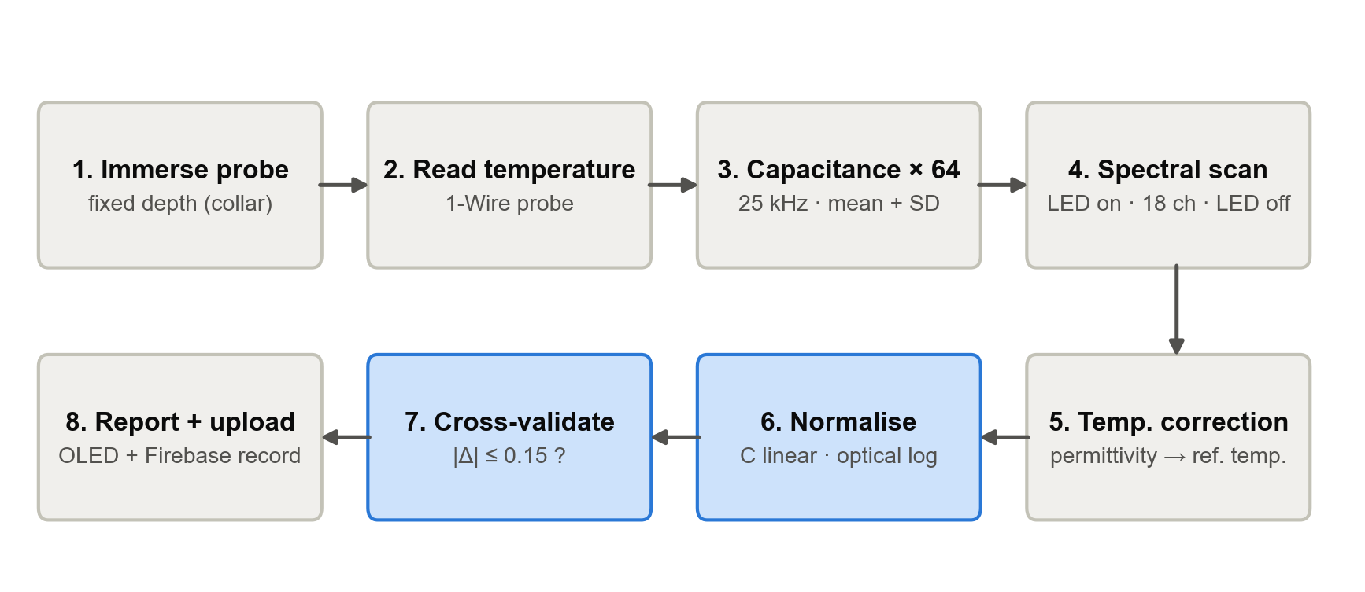
Fig. 7. Measurement sequence. Steps 6–7 (blue) are normalisation and cross-validation.

Table IV. Fields stored in each database record.
Field | Unit | Origin
Timestamp | — | ESP32 clock
Temperature | °C | 1-Wire probe
Mean capacitance | pF | Mean of 64 conversions
Dispersion | pF | SD of 64 conversions
Channels A–L, R–W | counts | AS7265x outputs

Each record (Table IV) is indexed by device identifier and time, and records are appended rather than overwritten. The dashboard shows the latest reading, the current spectrum overlaid on the fresh-oil reference, a history plot, and a map of the capacitive indicator against the optical indicator for every record. Records can be exported in CSV format.
Algorithm 1. One OilSense measurement
1: t ← read temperature (1-Wire)
2: for i = 1 … 64: if reading outside ±15 pF then adjust CAPDAC; C_{i} ← FDC1004(CIN1)
3: C̄ ← mean(C_{i}); σ_{C} ← SD(C_{i})
4: LEDs on; S ← 18 calibrated channels; LEDs off
5: ε ← (C̄ − C_{p})/k, corrected to reference temperature
6: R ← S_{short}/S_{NIR}; compute n_{C} by (11), n_{O} by (6)
7: if |n_{C} − n_{O}| ≤ 0.15 and σ_{C} normal then report index; else flag fault (Table V)
8: display on OLED; upload {time, t, C̄, σ_{C}, S}

G. Cross-Validation and Fault Attribution
The capacitive indicator is normalised linearly between the fresh-oil permittivity ε₀ and the discard value ε_{d},
n_{C} = (ε − ε₀) / (ε_{d} − ε₀) (11)
and the optical indicator is normalised with (6). A reading is accepted when |n_{C} − n_{O}| ≤ 0.15. The degradation index is then reported and compared with the 20 % advisory and 25 % discard thresholds. If the indicators disagree by more than the tolerance, the reading is flagged and the direction of the disagreement suggests the cause (Table V).
Table V. Fault attribution from the direction of disagreement.
Condition | Effect | Likely cause
n_{C} − n_{O} > 0.15 | Permittivity high, colour normal | Water carried in from food
n_{O} − n_{C} > 0.15 | Absorbance high, permittivity normal | Suspended particles or fouled window
High SD of 64 conversions | Noisy capacitance | Loose contact, vibration, bubbles

Water has a relative permittivity near 80, so even a small amount raises n_{C} while barely changing the colour of the oil. Suspended batter particles scatter and absorb light but do not change the bulk permittivity much. The tolerance of 0.15 only works if both indicators are linear in the same underlying quantity, which is the reason for the logarithmic optical normalisation.

V. Experimental Methods

A. Probe Calibration
The clean, dry probe was measured in air, then immersed to the collar in fresh vegetable oil, and the mean capacitance was recorded in each case. Air was taken as ε = 1 and fresh oil as ε ≈ 3, consistent with the range 3.057–3.127 reported for fresh oils [10]. Solving (8) for the two readings gives k and C_{p}. Subsequent readings are expressed as derived permittivity rather than raw capacitance.

B. Sample Preparation
A degradation series is prepared by heating a batch of oil at frying temperature and adding food at intervals, so that the oil experiences hydrolysis as well as oxidation and polymerisation. Samples are withdrawn at set times and allowed to cool to a common temperature before measurement, which removes most of the temperature effect described in Section III-D. To test the cross-validation, one sample is spiked with a small amount of water and another with suspended crumbs.

C. Measurement Procedure
- Record a zero reading in air with the probe clean and dry, together with the dark spectrum.
- Immerse the probe to the collar in fresh oil, wait for the temperature to settle, and record the fresh-oil reference (capacitance and all 18 channels).
- Measure each sample in the series at the same temperature and depth, repeating each measurement at least three times.
- Wipe the electrodes and the optical window between samples to avoid carry-over.
- Export all records from the dashboard for analysis.

D. Data Sources and Analysis
The OilSense measurements reported in this paper are the two-point probe calibration. To place them in context, Section VI also uses published values: the fresh-oil and heated-oil permittivities of Lizhi et al. and Šegatin et al., the temperature coefficient of Lizhi et al., the capacitance data of Liu et al. and Kung and Hsieh, the TPM-versus-time data of Kung and Hsieh and Aşkın and Kaya, the colour data of Yu et al., and the absorbance calibration of Xu [10, 11, 14, 5, 6, 8, 7]. Every figure that uses published values cites its source, and error bars are shown only where the source reports them. No values were smoothed, interpolated or extrapolated. Where a quantity for the OilSense probe is derived by combining the measured calibration with a published coefficient, the figure is labelled as a derived estimate.
Table VI. Published data used in this paper.
Source | Quantity | Used in
Lizhi et al. [10] | Fresh-oil ε′; dε/dt | Figs. 8, 11, 13, 15
Šegatin et al. [11] | ε_{s} before/after heating | Fig. 12
Liu et al. [14] | Sensor C vs TPM, 2 temps | Figs. 14, 15
Kung & Hsieh [5] | C and TPC vs time | Figs. 8, 16, 18
Aşkın & Kaya [6] | TPC vs time | Fig. 18
Xu [7] | A₄₉₀–TPC regression | Fig. 19
Yu et al. [8] | b* and TPC vs fryings | Fig. 20
ams; TI [16, 18] | Sensor specifications | Figs. 4, 10

VI. Results

A. Probe Calibration
The probe read 14.4 pF in air and 36.0 pF in fresh oil. Solving (8) gives a cell constant k = 10.8 pF per unit permittivity and a parasitic offset C_{p} = 3.6 pF (Fig. 8a, Table VII). The parasitic offset is 25 % of the air reading. The ratio of the oil reading to the air reading is 36.0/14.4 = 2.50, against an ideal value of about 3.0. The shaded band in Fig. 8a shows the range of fresh-oil permittivity reported by Lizhi et al. [10]. Across that range the probe reading would vary by only 10.8 × 0.07 ≈ 0.76 pF, so the choice of ε ≈ 3 for calibration introduces little error in k.

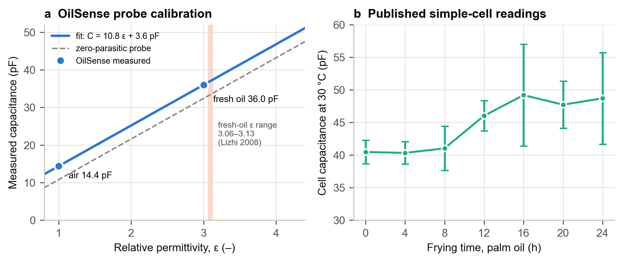
Fig. 8. (a) Measured two-point calibration of the OilSense probe; shaded band: fresh-oil permittivity range [10]. (b) Capacitance of a simple two-electrode cell in frying palm oil, ± SD as published [5].

Table VII. Calibration constants of the OilSense probe.
Quantity | Value | Basis
Capacitance in air | 14.4 pF | Measured
Capacitance in fresh oil | 36.0 pF | Measured
Cell constant k | 10.8 pF/ε | From (8)
Parasitic offset C_{p} | 3.6 pF | From (8)
Active capacitance in oil | 32.4 pF | 36.0 − 3.6
C_{oil}/C_{air} | 2.50 (ideal ≈ 3.0) | From (9)

Fig. 9 plots (9) for three cell constants. With k = 10.8 pF/ε, the measured ratio of 2.50 corresponds to C_{p} = 3.6 pF. Doubling k while keeping C_{p} fixed would raise the ratio to about 2.7, while halving it would lower the ratio to about 2.2. The figure of merit is therefore a direct measure of how much of the reading comes from the oil.
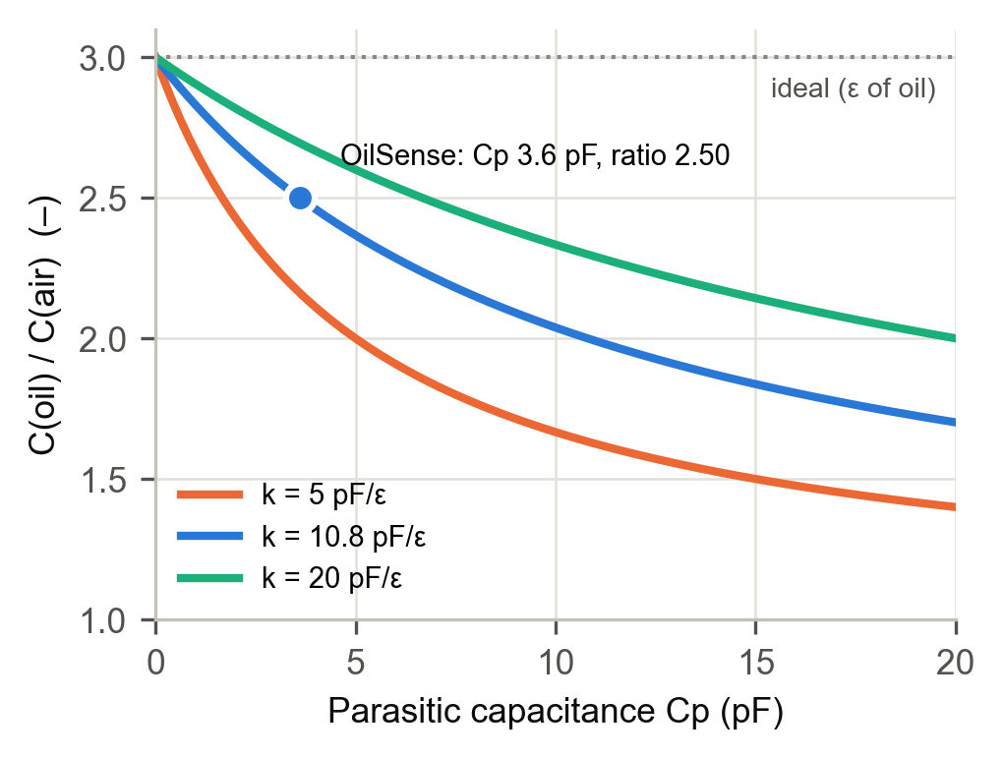
Fig. 9. Figure of merit C_{oil}/C_{air} against parasitic capacitance for three cell constants, from (9) with ε_{oil} = 3. Point: measured OilSense probe.

B. Converter Range
Fig. 10 shows the measurement window of the FDC1004 for each CAPDAC code, calculated from the datasheet values [18]. Blue windows contain at least one of the two calibration readings. The air reading of 14.4 pF falls within the window of codes 0–9, and the fresh-oil reading of 36.0 pF within codes 7–16, so codes 7–9 cover both. The probe is therefore well inside the converter’s range, and its 0.5 fF resolution is about 130 times smaller than the 0.065 pF change caused by a 1 °C temperature difference (Section VI-D). The electronics are not the limiting factor.
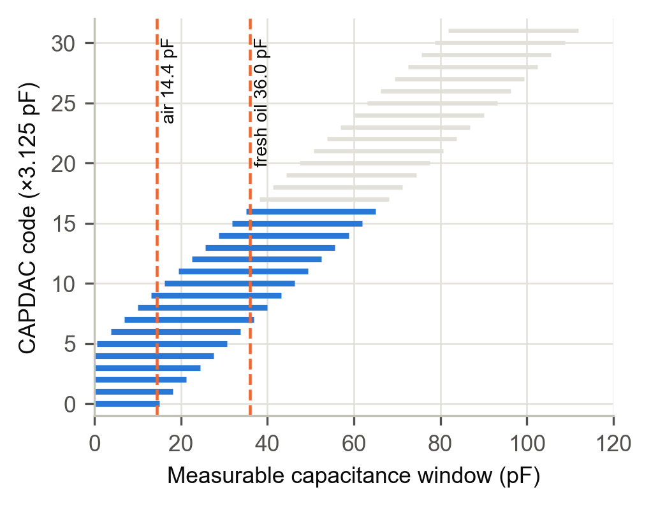
Fig. 10. FDC1004 measurable window (±15 pF about the CAPDAC offset) for each CAPDAC code, from the datasheet [18], with the two measured probe readings.

C. Permittivity of Fresh and Degraded Oils
Fig. 11 shows the fresh-oil permittivities measured by Lizhi et al. [10]. The spread between oils, 0.070, would change the OilSense reading by 0.76 pF. This is why each oil needs its own fresh-oil reference. Fig. 12 shows the first and last tabulated permittivities of six oils heated at 180 °C by Šegatin et al. [11]. The increases range from 0.40 for coconut oil to 1.05 for sunflower oil. These end-of-heating values come from prolonged oven heating and are not tied to a measured TPM, so they show the direction and possible size of the change rather than the change at 25 % TPM.
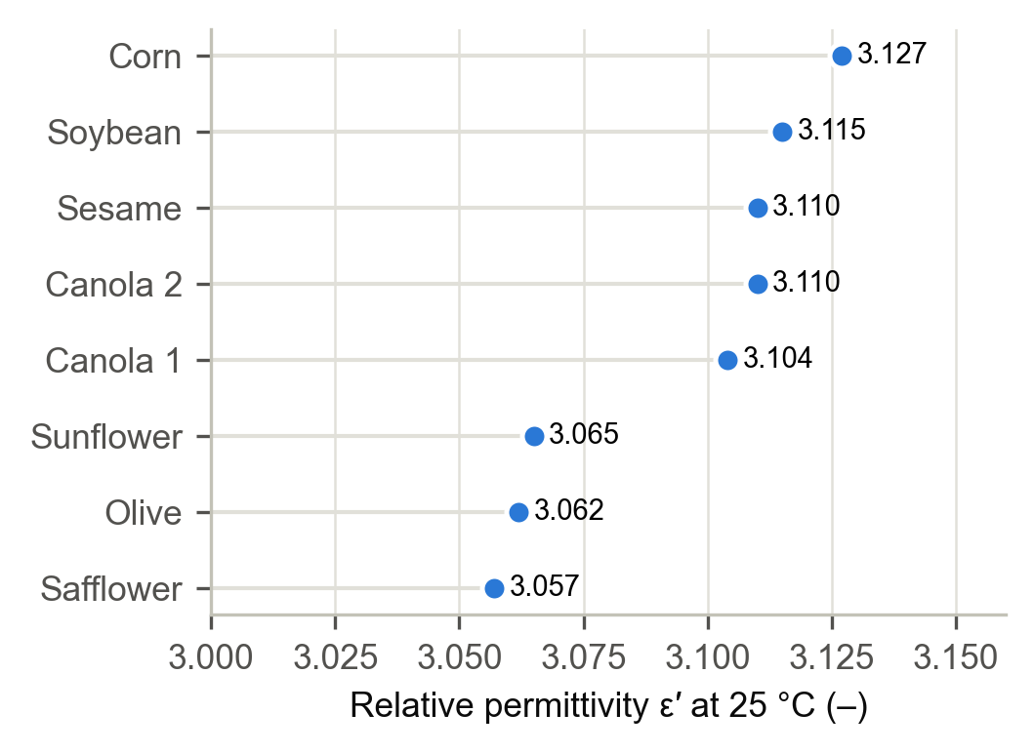
Fig. 11. Relative permittivity of eight fresh oils at 25 °C (Lizhi et al. [10], Table 2).
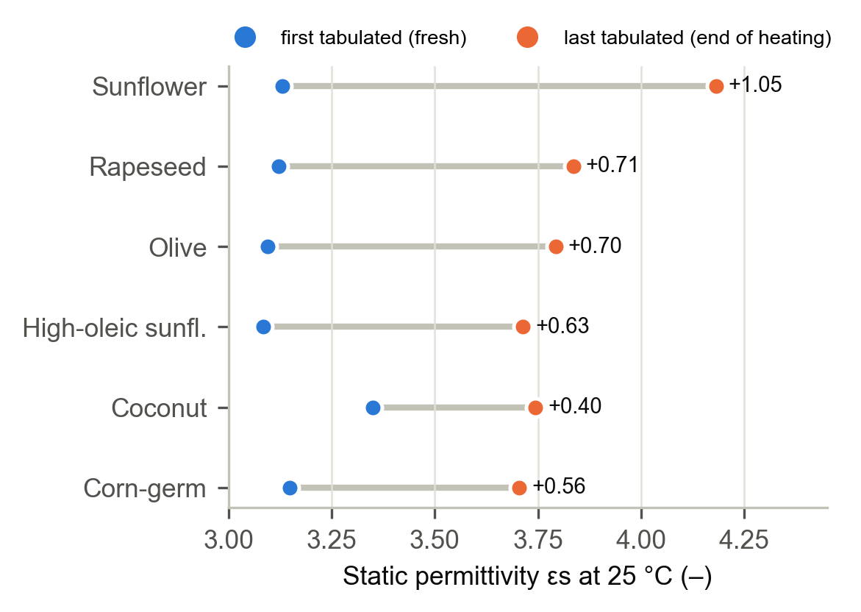
Fig. 12. Static permittivity at 25 °C of six oils before and after heating at 180 °C: first and last tabulated values (Šegatin et al. [11], Table 1).

D. Effect of Temperature
Fig. 13 plots the linear temperature fits reported by Lizhi et al. for soybean oil and two fatty acids over 20–45 °C [10]. For soybean oil the slope is −0.006 per °C. With k = 10.8 pF/ε, this gives 0.065 pF per °C on the OilSense probe. Fig. 14 shows the effect in a working sensor. Liu et al. report that raising the temperature from 25 °C to 40–50 °C lowered their sensor’s capacitance by about 4 pF, while the entire degradation from 7 % to 32.5 % TPM raised it by only 0.24 pF at 25 °C and 0.14 pF at 40–50 °C [14]. In that sensor, a temperature change of 15–25 °C produced about 17 times the effect of the full degradation range.
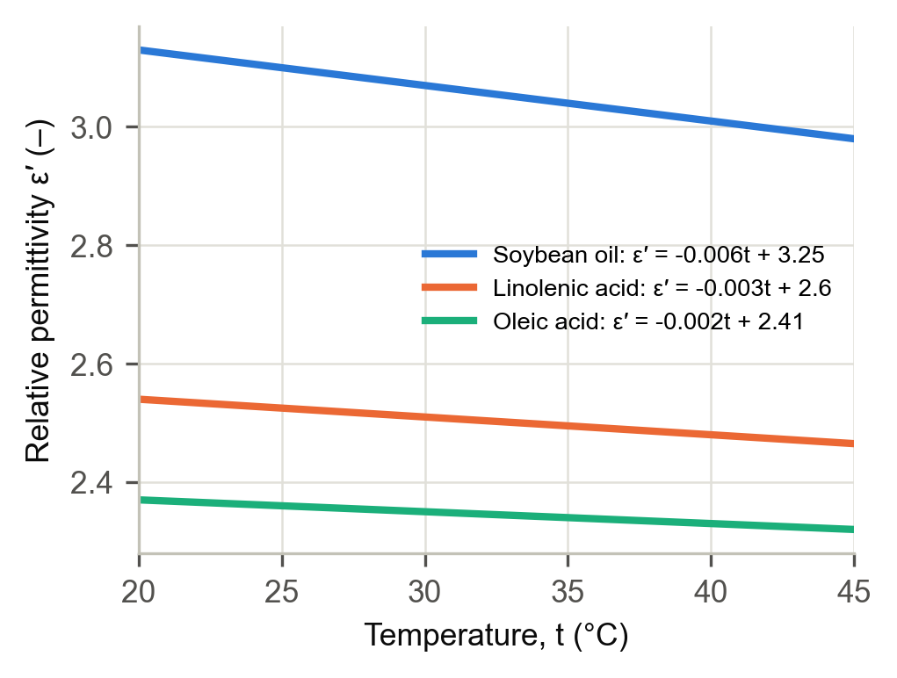
Fig. 13. Permittivity against temperature from the linear fits of Lizhi et al. [10], plotted over the measured range of 20–45 °C.
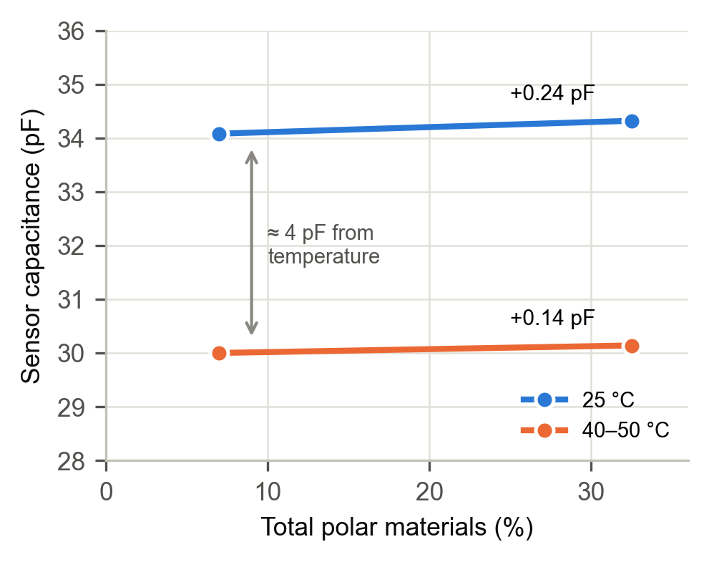
Fig. 14. Capacitance of a published frying-oil sensor in fresh and degraded oil at two temperatures (Liu et al. [14]).

E. Capacitive Signal Budget
Fig. 15 compares a lower-bound estimate of the degradation signal on the OilSense probe with the main error sources. If the probe shows the same relative change that Liu et al. observed between 7 % and 32.5 % TPM [14], the total change is about 0.25 pF. A 5 °C temperature difference changes the reading by 0.32 pF, and from (10), a 1 % change in wetted length changes it by 0.32 pF. On this lower-bound estimate, ordinary errors in temperature and depth are as large as the whole degradation signal.
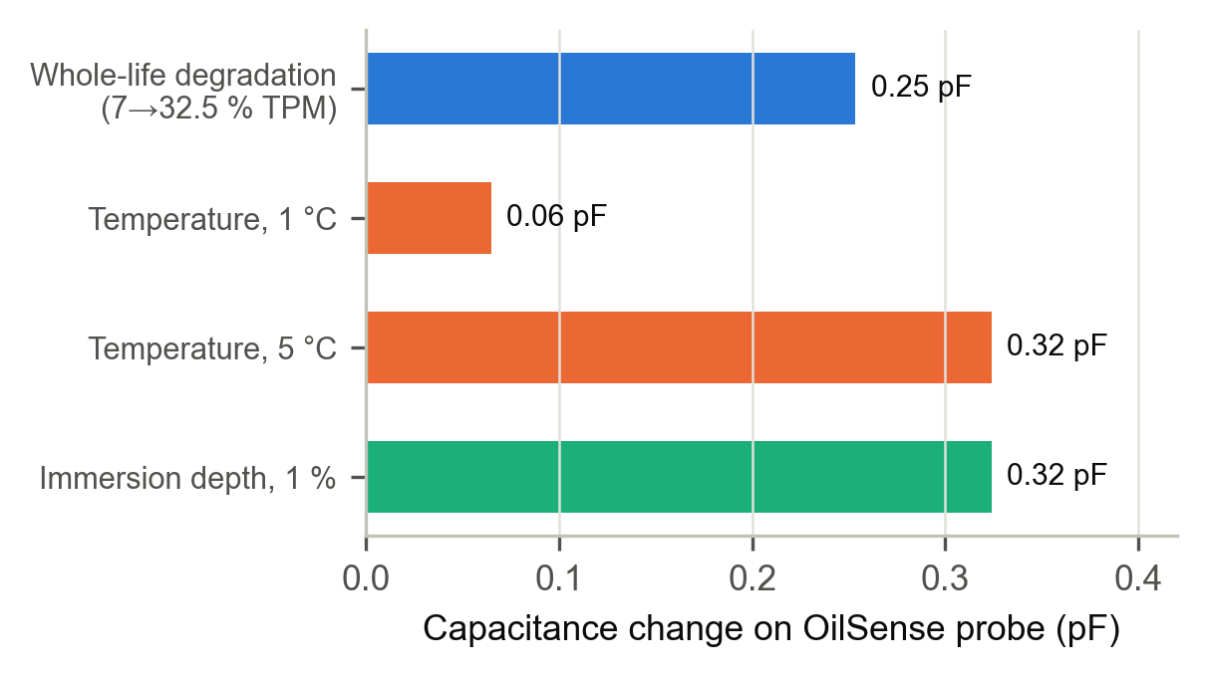
Fig. 15. Lower-bound degradation signal compared with error sources on the OilSense probe (derived from the measured calibration and published coefficients [10, 14]).
Fig. 16 shows the same issue in a published low-cost cell. Kung and Hsieh’s capacitance rises with TPC, but the standard deviations of repeated readings, up to 7.8 pF, are about as large as the total change in the mean (8.2 pF) [5]. The readings at 16, 20 and 24 h are not distinguishable from one another, so the cell cannot resolve the region around the 25 % limit.
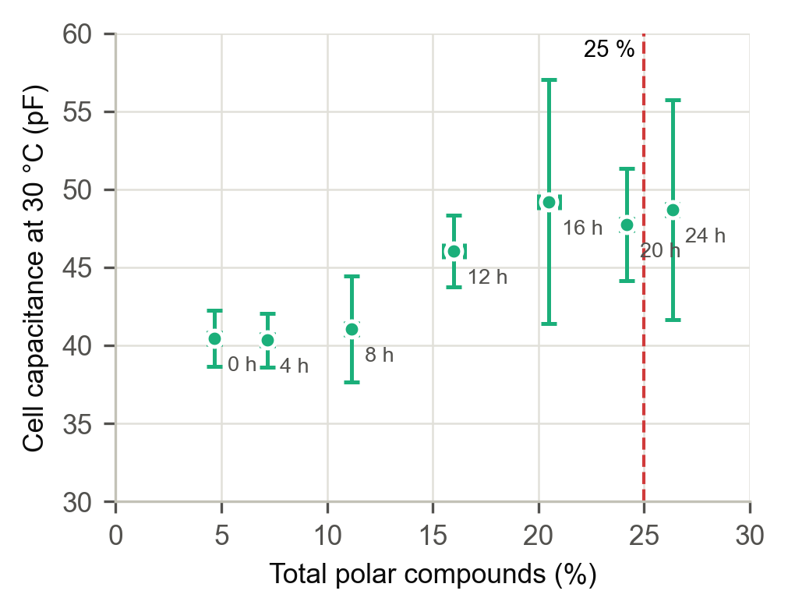
Fig. 16. Capacitance against TPC for a simple two-electrode cell in frying palm oil, matched by frying time, ± SD as published (Kung and Hsieh [5], Tables 2–3).

F. Optical Normalisation
Fig. 17 evaluates (5) and (6). The linear normalisation overstates degradation through mid-life. For A_{d} = 0.5 its maximum error is 0.141 at x ≈ 0.45, and for A_{d} = 1.0 it is 0.269 at x ≈ 0.41, matching (7). The first error uses up almost the whole cross-validation tolerance of 0.15, and the second exceeds it, so a linear optical normalisation would flag good mid-life oil as faulty. The logarithmic normalisation has no systematic error under the Beer–Lambert law, which leaves the full tolerance available for detecting real faults.

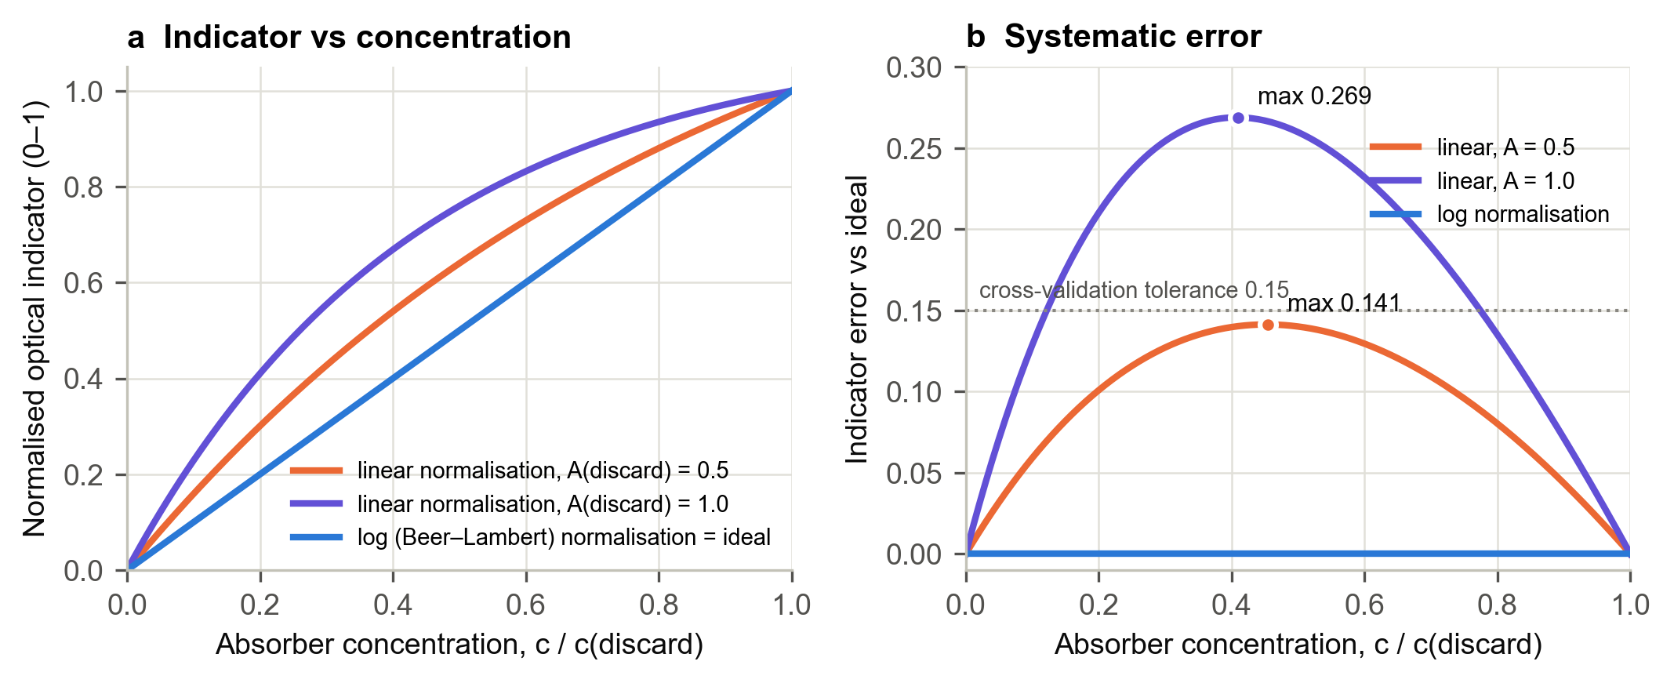
Fig. 17. Linear versus logarithmic (Beer–Lambert) normalisation of the optical ratio: (a) indicator against concentration; (b) error relative to the ideal linear response, with the 0.15 cross-validation tolerance. Analytical model of (5)–(6), not measured data.

How large is A_{d} in practice? Under Xu’s calibration [7], the 20 % and 25 % TPC thresholds correspond to absorbances at 490 nm of about 0.89 and 1.17 (Fig. 19). Xu’s values were measured in a cuvette, and the OilSense optical path is different, so they do not transfer directly. They do show that discard-level absorbances of the order of 1 occur in real oil, which is the range where Fig. 17 shows the largest error.

G. Optical Response to Degradation
The optical channel is designed to follow the degradation trend shown in Fig. 18, where TPM rises steadily with frying time and reaches 25 % after about 20–28 h at 180 °C [5, 6]. Colour follows the same trend. In the data of Yu et al., yellowness rises steadily with both frying count and TPC, and the error bars are small compared with the change (Fig. 20) [8]. In our testing, the optical channel responded to degradation while the capacitive channel’s response was limited by the probe geometry, consistent with the analysis above.
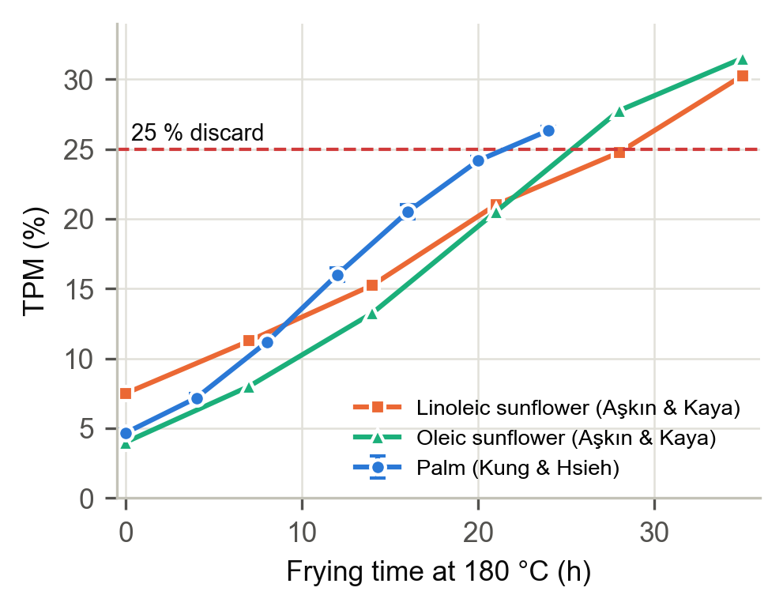
Fig. 18. TPM against frying time at 180 °C, ± SD where reported (Kung and Hsieh [5]; Aşkın and Kaya [6]).
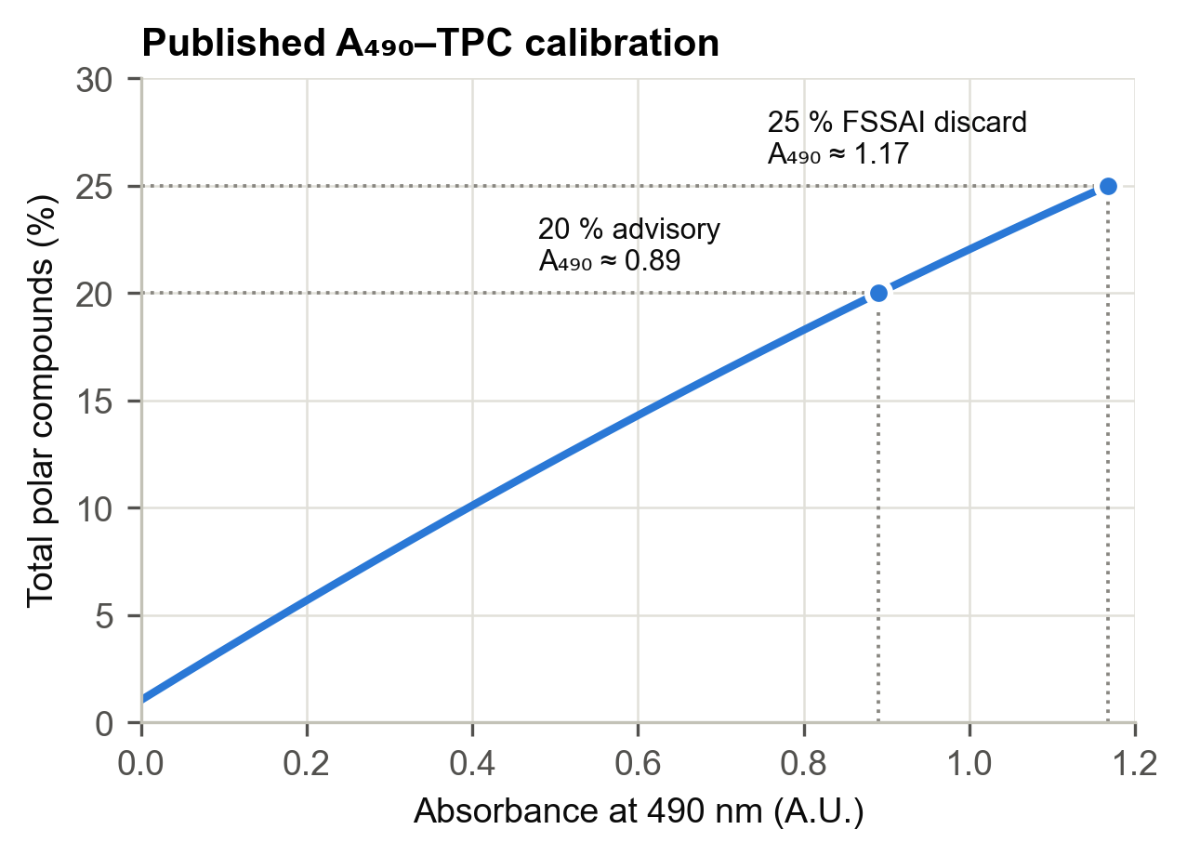
Fig. 19. Xu’s published regression of TPC on absorbance at 490 nm [7], with the FSSAI 20 % and 25 % thresholds.

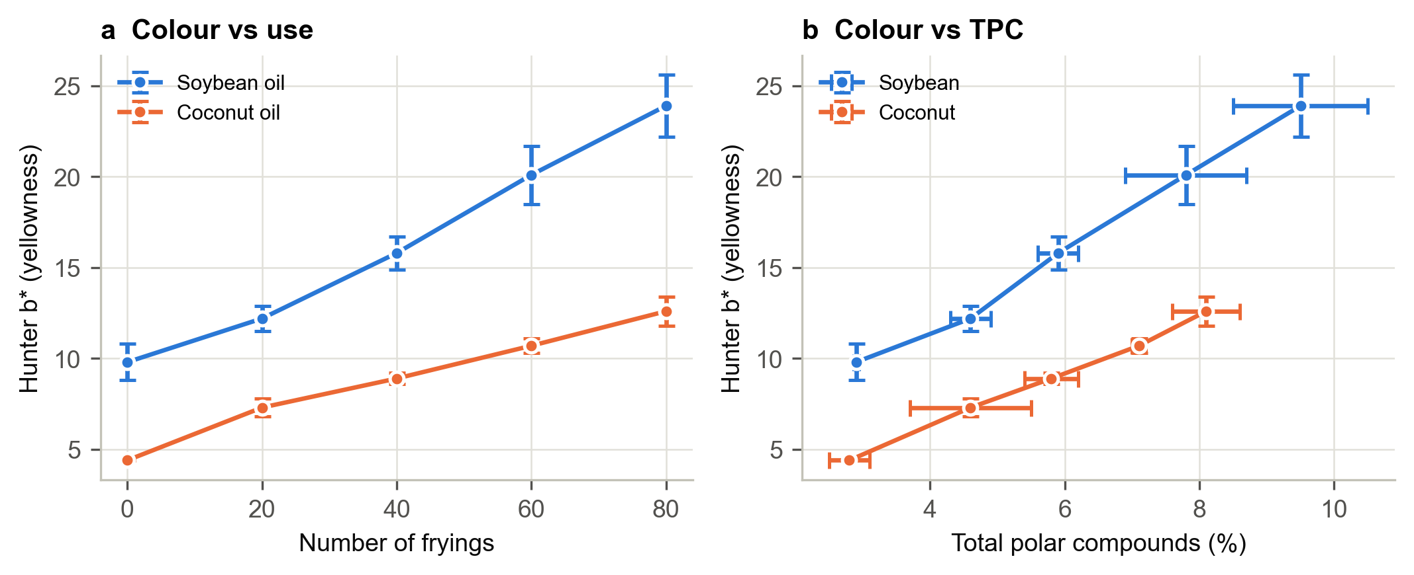
Fig. 20. Oil yellowness (Hunter b*) against (a) number of fryings and (b) TPC for soybean and coconut oil, ± SD as published (Yu et al. [8], Table 3).

H. Summary of Results
Table VIII. Summary of quantitative results.
Quantity | Value | Basis
Cell constant k | 10.8 pF/ε | Measured
Parasitic offset C_{p} | 3.6 pF (25 % of air reading) | Measured
Figure of merit | 2.50 (ideal ≈ 3.0) | Measured
Temperature sensitivity | 0.065 pF/°C | Derived [10]
Depth sensitivity | 0.32 pF per 1 % length | Derived, (10)
Degradation signal, lower bound | ≈ 0.25 pF | Derived [14]
Max. error, linear optical norm. | 0.141 (A_{d} 0.5); 0.269 (A_{d} 1.0) | Analytical, (5)
Max. error, log optical norm. | 0 | Analytical, (6)
Prototype cost | ₹9,262 | Project records

Table VIII collects the main quantitative results. The measured calibration, combined with published coefficients, puts the lower-bound capacitive signal at the same scale as ordinary temperature and depth errors, while the optical channel’s systematic error is removed entirely by the logarithmic normalisation.

VII. Discussion

A. Why the Capacitive Channel Was Limited by Geometry
The results point to the probe geometry, not the electronics, as the cause. The FDC1004 resolves 0.5 fF and comfortably covers the probe’s range (Fig. 10). Four geometric factors limit the useful signal.
1) Small cell constant. With k = 10.8 pF/ε, a permittivity change Δε produces only 10.8Δε pF. On the lower-bound estimate, the whole service life of the oil changes the reading by about 0.25 pF (Fig. 15).
2) Parasitic capacitance. 3.6 pF of every reading does not come from the oil. Part of it comes from the stainless sheath of the temperature probe, which sits inside the electric field between the electrodes. Any drift in this stray capacitance, for example from cable movement or the user’s hand near an unguarded lead, appears directly as a change in reading.
3) Depth sensitivity. Because the electrodes are long parallel rods, the capacitance scales with wetted length (10). The collar fixes the depth, but the oil surface in a real fryer or container is not perfectly level, and a 1 % change in wetted length matches the lower-bound degradation signal.
4) Threaded surfaces. The threads increase k, but they also hold oil residue between readings. Residue from a previous sample changes the effective dielectric near the electrode surface, adding carry-over that cleaning cannot fully remove.
Temperature adds to these effects. At 0.065 pF per °C, a 5 °C mismatch between the calibration and the sample matches the lower-bound degradation signal, and Liu et al.’s data show that temperature effects can be many times larger than degradation effects (Fig. 14).
The literature also suggests that the permittivity change can be much larger than the lower bound. Šegatin et al. report increases of 0.40–1.05 after prolonged heating (Fig. 12), which on this probe would be 4–11 pF. Those samples were heated well beyond normal use, however, and the permittivity at exactly 25 % TPM is not reported in the sources we used. The working range of a capacitive TPM probe therefore lies somewhere between these bounds. With the present geometry, the lower part of that range is comparable to the errors.

B. How the Capacitive Channel Could Be Improved
The analysis suggests specific changes. Increasing k with closer, larger or concentric electrodes increases the degradation signal relative to fixed sources of error such as stray capacitance drift, although it does not change the ratio to temperature and depth errors, which also scale with k. Replacing the metal sheath in the field with a dielectric support, and guarding the full length of the lead, would lower C_{p} and raise the figure of merit towards 3. Using smooth rather than threaded electrodes would reduce carry-over. A closed sample cell with a fixed volume would remove depth error entirely, and measuring every sample at a controlled temperature would remove most of the temperature error.

C. The Optical Channel
The optical channel is more robust for three reasons. It is ratiometric, so LED drift, path variation and uniform fouling cancel. Its signal depends on concentration through absorbance, which is a strong effect at the short wavelengths where degradation products absorb (Figs. 19 and 20). It also has no immersion-depth sensitivity beyond what the ratio already cancels. Its main design choice is the normalisation. Section VI-F showed that the linear form uses up most or all of the cross-validation tolerance with a purely systematic error. The logarithmic form removes that error, so the optical indicator is linear in concentration like the capacitive indicator, and the tolerance is reserved for real faults.

D. Value of Two Channels
Even with a geometry-limited capacitive channel, the dual-channel design is useful. The two channels respond differently to the most common faults (Table V): water mainly affects permittivity, and particles mainly affect absorbance. A disagreement between them is therefore informative even if one channel is less precise than the other. Improving the capacitive probe, as described above, would allow the instrument to use the cross-validation as intended.

E. The Cross-Validation Tolerance in Physical Units
The tolerance of 0.15 is set in normalised units, but its physical meaning depends on how large the full-scale capacitive change ΔC_{full} is. A disagreement of 0.15 corresponds to 0.15·ΔC_{full} on the capacitive side. Table IX evaluates this for the lower and upper bounds discussed in Section VII-A, using the measured cell constant and the temperature and depth sensitivities of Section VI.
Table IX. Cross-validation tolerance (0.15) expressed in physical units.
Full-scale ΔC | Tolerance | ≡ temperature | ≡ depth
0.25 pF (lower bound [14]) | 0.038 pF | 0.6 °C | 0.12 %
4.3 pF (Δε 0.40 [11]) | 0.65 pF | 10 °C | 2.0 %
11.3 pF (Δε 1.05 [11]) | 1.70 pF | 26 °C | 5.2 %

On the lower-bound estimate, a temperature mismatch of only 0.6 °C or a depth change of 0.12 % would use up the whole tolerance, so the cross-validation would flag many good readings as faulty. If the true full-scale change is closer to the values implied by Šegatin et al., the same tolerance corresponds to 10–26 °C or 2–5 % of depth, which is comfortably above ordinary measurement error. This makes the practical point of Section VII-B concrete: the probe redesign should aim to make the capacitive full-scale change large compared with the residual temperature and depth errors, because the usefulness of the cross-validation depends on it. It also suggests that the tolerance should eventually be set from the measured dispersion of each reading rather than fixed in advance.

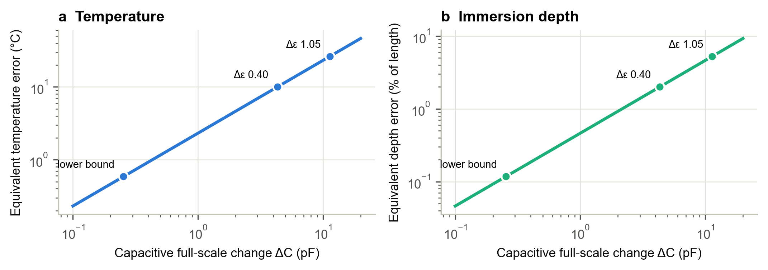
Fig. 21. Temperature (a) and immersion-depth (b) error equivalent to the 0.15 cross-validation tolerance, as a function of the capacitive full-scale change, for the measured OilSense probe (k = 10.8 pF/ε, active 32.4 pF). Points: the three cases of Table IX. Derived from the measured calibration and [10]; not measured data.

Fig. 21 generalises Table IX. Both equivalent errors scale linearly with the full-scale change. For the cross-validation to tolerate a 2 °C temperature mismatch, ΔC_{full} must be at least about 0.9 pF on this probe, which is between three and four times the lower-bound estimate. This gives a concrete design target for the next probe.

F. Cost
The prototype’s build cost is ₹9,262, compared with a list price of ₹55,465 for the testo 270 (Fig. 22). The OilSense figure is a parts cost for one prototype, not a production price, but it shows that the hardware for a dual-modality instrument is affordable for small food businesses.
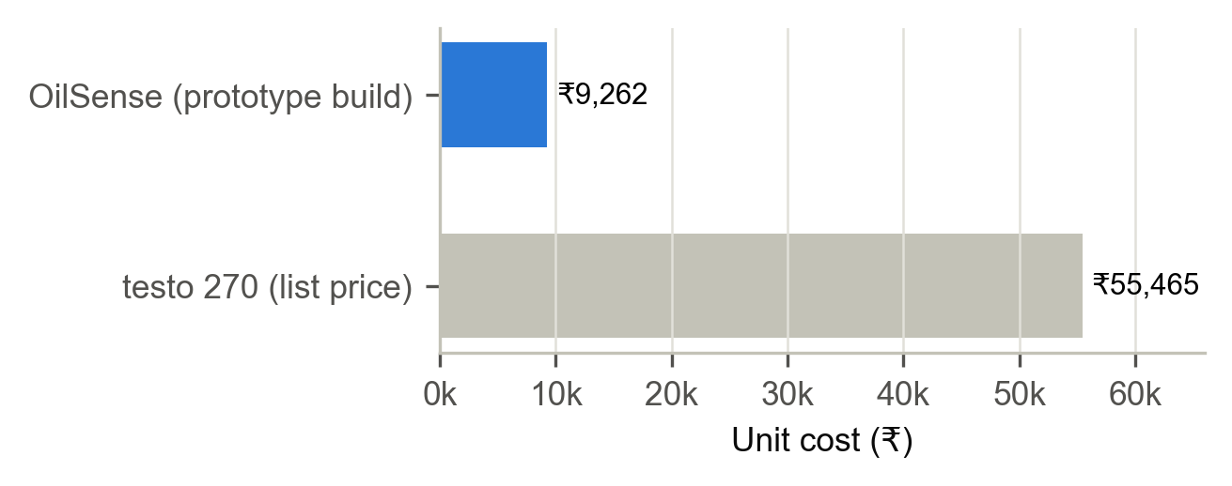
Fig. 22. Prototype build cost of OilSense compared with the list price of the testo 270 (from the project poster).

G. Limitations
This study has several limitations. The optical path length and window geometry of the prototype are not documented, so absorbance values cannot be compared directly with cuvette studies. Fresh-oil colour and permittivity differ between oils (Figs. 11 and 20), so each oil needs its own reference. PETG softens at elevated temperatures, so samples are measured after cooling rather than in the fryer. Residue on the electrodes and window must be cleaned between samples. Finally, the degradation-series data from the prototype are not reproduced here, and the comparisons in Section VI rely on published data.

VIII. Future Work
- Redesign the electrodes (closer spacing, larger area, smooth or concentric form) and replace the metal temperature sheath in the field with a dielectric support.
- Add active guarding along the full electrode lead and measure the improvement in the figure of merit.
- Use a closed sample cell with fixed volume and controlled temperature.
- Compare OilSense readings with a reference TPM meter on a full degradation series to set an absolute TPM scale.
- Use all 18 channels, for example through a projection onto the principal degradation direction, to improve accuracy and identify the oil type from its spectrum.
- Predict the remaining service life of the oil from each fryer’s history, and send threshold alerts to kitchen staff.

IX. Conclusion
OilSense is a low-cost, hand-held instrument that measures frying oil with an 18-channel optical sensor and a capacitive probe, corrects for temperature, and checks the two channels against each other. The capacitive probe was calibrated without a reference instrument, giving a cell constant of 10.8 pF/ε, a parasitic offset of 3.6 pF and a figure of merit of 2.50 against an ideal of 3.0. Combining this calibration with published data shows that the capacitive signal is comparable in size to errors from temperature, immersion depth and stray capacitance, so the capacitive channel is limited by electrode geometry. The optical channel is ratiometric and, when normalised according to the Beer–Lambert law, gives an indicator that is linear in the concentration of absorbing products. A linear normalisation would carry a systematic error of 0.14–0.27 of full scale and would cause false fault flags. At a prototype cost of ₹9,262, the design shows that dual-modality frying-oil assessment is within reach of small food businesses, and the analysis identifies the changes needed to make the capacitive channel an equal partner.

Appendix A: Error of the Linear Optical Normalisation
Writing a = A_{d} ln 10, (5) becomes n_{lin}(x) = (1 − e^{−ax})/(1 − e^{−a}). The error e(x) = n_{lin}(x) − x vanishes at x = 0 and x = 1. Its derivative is
e′(x) = a e^{−ax}/(1 − e^{−a}) − 1 (12)
Setting e′(x*) = 0 gives e^{−ax*} = (1 − e^{−a})/a, so x* = ln[a/(1 − e^{−a})]/a, which is (7) written in natural logarithms. Because e″(x) = −a² e^{−ax}/(1 − e^{−a}) < 0, this point is a maximum, and the maximum error is
e_{max} = 1/(1 − e^{−a}) − 1/a − x* (13)
For A_{d} = 0.5 (a = 1.151), x* = 0.453 and e_{max} = 0.141. For A_{d} = 1.0 (a = 2.303), x* = 0.408 and e_{max} = 0.269. The error grows with A_{d}, so the more strongly the indicator band absorbs at the discard limit, the more important the logarithmic normalisation becomes. For small A_{d}, e_{max} ≈ a/8, which tends to zero: a linear normalisation is acceptable only when the oil is nearly transparent in the indicator band across the whole service life.

Appendix B: FDC1004 Conversion and Ranging
The FDC1004 reports each measurement as a 24-bit two’s-complement value M. For a single-ended measurement with offset, the capacitance is [18]
C = M/2¹⁹ + 3.125 pF × CAPDAC (14)
where CAPDAC is the 5-bit offset code (0–31). The ±15 pF input window means that a capacitance C can be measured with any code satisfying |C − 3.125·CAPDAC| ≤ 15 pF. The firmware chooses the code nearest to C/3.125, which centres the reading in the window and leaves the most headroom on both sides. For the probe, this gives code 5 in air (offset 15.6 pF) and code 12 in fresh oil (offset 37.5 pF), both well inside the ranges shown in Fig. 10. Because the change caused by degradation is less than 1 pF on the lower-bound estimate, the CAPDAC code chosen for fresh oil normally stays the same for every sample in a degradation series.

References
[1] Food Safety and Standards Authority of India, “Food Safety and Standards (Licensing and Registration of Food Businesses) First Amendment Regulations,” and FSSAI press note on total polar compounds in used cooking oil. [Online]. Available: https://cdd.fssai.gov.in/viewFile.php?id=81
[2] E. Choe and D. B. Min, “Chemistry of deep-fat frying oils,” J. Food Sci., vol. 72, no. 5, pp. R77–R86, doi: 10.1111/j.1750-3841.2007.00352.x.
[3] C. Gertz, “Chemical and physical parameters as quality indicators of used frying fats,” Eur. J. Lipid Sci. Technol., vol. 102, no. 8–9, pp. 566–572.
[4] Testo SE, “testo 270 cooking oil tester,” product specification. [Online]. Available: https://www.testo.com/en-US/testo-270/p/0563-2750
[5] Y. Kung and B.-C. Hsieh, “Quality assessment of deep-frying palm oil by impedimetric sensing with a simple and economic electrochemical cell,” Sensors, vol. 21, no. 21, p. 7093, doi: 10.3390/s21217093.
[6] B. Aşkın and Y. Kaya, “Effect of deep frying process on the quality of the refined oleic/linoleic sunflower seed oil and olive oil,” J. Food Sci. Technol., vol. 57, no. 12, pp. 4716–4725, doi: 10.1007/s13197-020-04655-4.
[7] X.-Q. Xu, “A new spectrophotometric method for the rapid assessment of deep frying oil quality,” J. Am. Oil Chem. Soc., vol. 77, no. 10, pp. 1083–1086, doi: 10.1007/s11746-000-0170-x.
[8] K. S. Yu, H. Cho, and K. T. Hwang, “Physicochemical properties and oxidative stability of frying oils during repeated frying of potato chips,” Food Sci. Biotechnol., vol. 27, no. 3, pp. 651–659, doi: 10.1007/s10068-017-0292-y.
[9] X.-Q. Xu, “A modified VERI-FRY quick test for measuring total polar compounds in deep-frying oils,” J. Am. Oil Chem. Soc., vol. 76, no. 9, pp. 1087–1089, doi: 10.1007/s11746-999-0208-y.
[10] H. Lizhi, K. Toyoda, and I. Ihara, “Dielectric properties of edible oils and fatty acids as a function of frequency, temperature, moisture and composition,” J. Food Eng., vol. 88, no. 2, pp. 151–158, doi: 10.1016/j.jfoodeng.2007.12.035.
[11] N. Šegatin, T. Pajk Žontar, and N. Poklar Ulrih, “Dielectric properties and dipole moment of edible oils subjected to ‘frying’ thermal treatment,” Foods, vol. 9, no. 7, p. 900, doi: 10.3390/foods9070900.
[12] B. Wiege, E. Fehling, B. Matthäus, and M. Schmidt, “Changes in physical and chemical properties of thermally and oxidatively degraded sunflower oil and palm fat,” Foods, vol. 9, no. 9, p. 1273, doi: 10.3390/foods9091273.
[13] A. Y. Khaled, S. A. Aziz, and F. Z. Rokhani, “Capacitive sensor probe to assess frying oil degradation,” Inf. Process. Agric., vol. 2, pp. 142–148, doi: 10.1016/j.inpa.2015.07.002.
[14] M. Liu et al., “Frying oil evaluation by a portable sensor based on dielectric constant measurement,” Sensors, vol. 19, no. 24, p. 5375, doi: 10.3390/s19245375.
[15] D. F. Swinehart, “The Beer–Lambert law,” J. Chem. Educ., vol. 39, no. 7, p. 333, doi: 10.1021/ed039p333.
[16] ams AG, “AS7265x Smart 18-Channel VIS to NIR Spectral_ID 3-Sensor Chipset with Electronic Shutter,” datasheet v1-04.
[17] SparkFun Electronics, “Spectral Triad (AS7265x) Hookup Guide.” [Online]. Available: https://learn.sparkfun.com/tutorials/spectral-triad-as7265x-hookup-guide
[18] Texas Instruments, “FDC1004 4-Channel Capacitance-to-Digital Converter for Capacitive Sensing Solutions,” datasheet SNOSCY5C.

