**Undergraduate Final Year Project Proposal**

**Develop a construction forecast system on Web**

**Nguyen Tran Huynh Nhu**

**Bachelor of Science with Honours in Computing**

**[000914797]**

## Overview

Nowadays, in industry, at any field of action, producing a good product always asks the producers who must have a quite good process from beginning stage to finishing one. All of everything which are from human to resource need to be calculated detailed and accurately. Construction also has no exception. Building a house or a building, the contractor always ensure that elements about materials, workforces, tax,… must be purposed and implemented organizationally for a successfully, safe and legal project. All of calculations, enumerations and managements are set up a forecast.

A construction building forecast will be based on technical design to analysis the number of materials, human resources, machines,… From analysed amount and norm which Ministry of Construction has promulgated will calculate all of spending and tax. From that point, forecast will analysis anticipated expense of a construction project.

At present, with the strong development of information technology which has applied on many of fields popularly, meanwhile there are only some forecast construction desktop applications. In addition, understanding about the importance of establishing forecast in construction industry so I want to have develop a construction forecast web application by php web language with purpose that it will optimize features and user-friendly for users as well as companies.

## Aim

A web version of construction forecast application.

## Objectives

3.1 Knowledge of construction forecast

3.1.1 Reference construction forecast desktop application (2.0)

3.1.2 Investigate definitions, elements and their features in construction forecast (2.0)

3.1.3 Investigate principle and mechanism of forecast (4.0)

3.1.4 Write report for describing construction forecast overview (1.0)

3.2 Investigation of PHP and MySQL

3.2.1 Install and learn php web language (7.0)

3.2.2 Install and learn MySQL (3.0)

3.2.3 Write report for introducing a little bit about PHP and MySQL (2.0)

3.3 Evaluation of JavaScript

3.3.1 Look for general knowledge about JavaScript (1.0)

3.3.2 Learn features and how to use JavaScript for building Web application (3.0)

3.3.3 Write report for introducing a little bit about JavaScript (1.0)

3.4 Implement the construction forecast web application

3.4.1 Construct ideas and UML for project (3.0)

3.4.2 Design and construct database system of project (5.0)

3.4.3 Design project interface (3.0)

3.4.4 Implement the project (15.0)

3.4.5 Test and fix bugs the project (4.0)

3.4.6 Write report for describing the construction forecast web application which I have developed (4.0)

3.5 Report

3.5.1 Review and edit report (1.0)

3.5.2 Review and uploap final report (1.0)

## Legal, social, ethical and professional

**Legal**

* PHP is language which has used popularly of World Wide Web

All of construction norms in forecast have been promulgated by Ministry of Construction

My project belongs to me and University of Greenwich

Documents which I have used for reference in my project is legal

**Social**

* Construction forecast web application which I developed will not be relevant to national security and social evil

**Ethical**

* This project is my own project and it don’t have plagiarism

**Professional**

* Not disclose or authorise to be disclosed, or use for personal gain or to benefit a third party, confidential information except with the permission of University of Greenwich, or as required by Legislation.
* Respect and value alternative other perspectives, seek and accept honest criticisms about my work.
* Avoid any situation that may rise to a conflict of interest between me and relevant authority.

(Trustee Board Regulations Schedule 3 v4, 2011)

## Planning

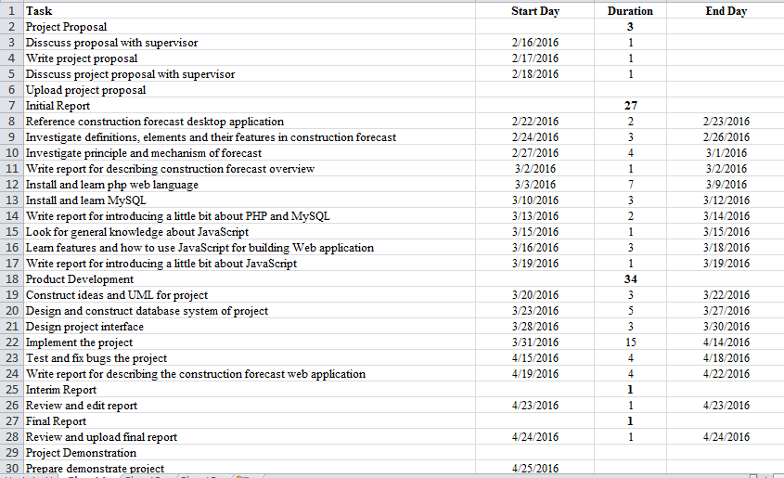

## References

Trustee Board Regulations Schedule 3 v4, 2011. *CODE OF CONDUCT FOR BCS MEMBERS.* Swindon: British Computer Society.