AI-Driven KPI Framework for Objective Evaluation of Political Performance
José Gustavo Roa de la Fuente
DOI: leave as is, will be created by the journal
Abstract
Introduction. Democratic societies often lack objective and accessible mechanisms to evaluate the performance of politicians, legislators, and public officials. Citizens are frequently exposed to campaign rhetoric and media-driven narratives rather than measurable outcomes, undermining accountability and informed decision-making.
Method. This paper proposes an Artificial Intelligence (AI)-driven framework to define, calculate, and present Key Performance Indicators (KPIs) derived from verifiable public data. The architecture integrates four layers, data ingestion, storage, processing, and presentation, while incorporating corrective “flags” (e.g., corruption, misconduct, refusal of audits) to adjust baseline KPIs.
Analysis. A simulated case study with three fictitious politicians was conducted to illustrate the model. Each politician’s performance across multiple positions was evaluated using raw KPIs, then adjusted through optimistic, pessimistic, and hybrid estimates.
Results. The case study demonstrates that integrity-related concerns can outweigh strong performance indicators. Hybrid estimation provided a balanced perspective, avoiding both overconfidence and extreme penalization.
Conclusion(s). The framework highlights both technical feasibility and broader implications: scientific opportunities in explainable AI, challenges in reliable data ingestion, and ethical imperatives for neutrality. It contributes a low-cost, scalable prototype blueprint that leverages technology to promote transparency, strengthen democratic processes, and empower voters and political parties to prioritize capable, accountable leadership.

Introduction
Citizens often lack objective tools to evaluate the performance of their elected officials. Traditional media and political campaigns emphasize rhetoric, while access to structured, verifiable indicators of governance remains limited. This limitation undermines informed voting and weakens democratic accountability. As Norris (2015) emphasizes, “when citizens lack reliable information about the performance of their representatives, the democratic process risks becoming a façade where accountability is severely weakened” [1].
Transparency is a cornerstone of democratic governance, yet even in established democracies, information asymmetries between citizens and public officials persist. The problem is not the absence of data but rather its fragmentation, complexity, and inaccessibility. Most citizens are not trained to interpret government budgets, legislative records, or policy evaluations, and the dissemination of information is often designed in a way that discourages public oversight. According to Transparency International, “corruption thrives where democratic institutions are weak, and accountability mechanisms are under attack” [2].
Recent governmental decisions have further aggravated this problem. For example, in Mexico, the autonomy of the National Institute for Access to Information (INAI) has been significantly reduced, restricting citizens’ ability to demand accountability and monitor the performance of their authorities. As Article 19 reported, “the paralysis of the INAI not only affects transparency but also leaves Mexicans without the means to demand accountability from public officials” [3,23,24,25]. This trend leaves democratic societies increasingly vulnerable, as oversight institutions are weakened and the public is deprived of effective mechanisms for informed participation.
Similarly, in the United States, the infrastructure supporting the Freedom of Information Act (FOIA) has been under systemic strain. Numerous federal agencies have faced mass layoffs in FOIA and communications staffs, creating historic backlogs, delayed responses, and rising instances of information denial. According to American Oversight, “the federal government’s FOIA system is plagued with delays, denials, and resource cuts, which severely undermine the public’s right to know” [4]. These structural issues impede efforts at government oversight and erode confidence in democratic institutions.
Globally, democratic backsliding presents another threat. In Hungary, Viktor Orbán’s government has systematically weakened independent media, civil society, and other democratic institutions. The Guardian has noted that “Orbán has turned Hungary into a model of illiberal democracy by consolidating power, curbing press freedoms, and hollowing out independent institutions” [5]. The Hungarian case illustrates how weakening transparency and accountability can become a deliberate political strategy for consolidating power.
The risks are not confined to individual countries. The Varieties of Democracy (V-Dem) Institute has documented a global decline in democratic quality, noting that “for the first time in two decades, autocratization is affecting more than two-thirds of the world’s population” [6]. Similarly, the International Institute for Democracy and Electoral Assistance (IDEA) warns that “democracy is under assault globally, as more countries are moving towards authoritarianism than at any point in the last 50 years” [7]. This erosion of democratic institutions underscores the urgency of developing innovative mechanisms to safeguard accountability.

Key Performance Indicators (KPIs) as a solution
In the corporate and public administration fields, Key Performance Indicators (KPIs) are widely used to objectively measure success in achieving goals. According to Parmenter (2015), “KPIs represent a set of measures focusing on those aspects of organizational performance that are the most critical for the current and future success of the organization” [8]. Applied to politics, KPIs offer a neutral and evidence-based way to track whether politicians are effectively fulfilling their mandates, managing public resources responsibly, and avoiding misconduct.
The innovation proposed in this paper is to adapt KPI methodologies—traditionally used in business management and governance audits—to the systematic evaluation of political representatives. By establishing KPIs tailored to each political role (legislator, mayor, minister, governor, etc.), it becomes possible to produce an evidence-based profile of performance across a politician’s career. This not only empowers citizens with structured information but also rewards honest, efficient, and responsible officials through informed voting decisions.
Importantly, this framework should not be viewed as a threat by political parties. On the contrary, it represents an opportunity for them to strengthen their legitimacy by ensuring that only their best candidates, those with proven performance and integrity, are endorsed for public office. As Peters and Pierre (2016) argue, “parties that systematically ignore accountability and performance risk losing credibility, while those that embrace transparency can gain long-term legitimacy” [9]. Thus, adopting KPI-based evaluation tools can help political organizations avoid reputational damage caused by corrupt or underperforming members.

Towards an AI-driven evaluation framework
Against this backdrop, the role of technology and Artificial Intelligence (AI) becomes particularly relevant. Traditional accountability tools, such as transparency portals or freedom of information requests, are important but insufficient to deal with the vast scale and complexity of political data. By leveraging AI for systematic ingestion, processing, and presentation of KPIs, it is possible to create mechanisms that are both scalable and citizen-friendly.
This paper proposes the development of an AI-driven framework to systematically define, measure, and present KPIs for politicians, legislators, and public officials. Unlike subjective rankings or opinion-based surveys, this framework relies on publicly available data and measurable outcomes. By automating data collection, cleaning, and analysis, the proposed system minimizes bias and provides citizens with an accessible tool to evaluate political performance transparently.
The relevance of this initiative lies not only in its technical feasibility but also in its social impact. Objective and transparent evaluation tools empower voters to make informed decisions, civil society organizations to strengthen advocacy, and oversight institutions to reinforce accountability. As the United Nations Development Programme (UNDP) has stated, “open and accountable governance is not merely a goal in itself, but a prerequisite for achieving sustainable development and citizen trust” [10].
In sum, while democratic backsliding, institutional weakening, and information asymmetries represent global challenges, the convergence of AI technologies and KPI-based evaluation presents a unique opportunity to innovate accountability mechanisms. This research contributes to that effort by outlining a neutral, adaptable architecture capable of generating reliable KPIs for political actors across different governance contexts.

Background and Related Work
The need for objective evaluation of political performance has been recognized in several academic and institutional efforts. Previous initiatives, however, are fragmented and often limited to specific dimensions of governance such as corruption, campaign financing, or legislative activity.
One notable example is the Worldwide Governance Indicators (WGI) developed by the World Bank, which measures aspects such as government effectiveness, rule of law, and control of corruption across countries. As Kaufmann, Kraay, and Mastruzzi state: “The WGI report six dimensions of governance: Voice and Accountability, Political Stability and Absence of Violence, Government Effectiveness, Regulatory Quality, Rule of Law, and Control of Corruption” [11]. While influential, WGI operates at the national level and does not provide granularity at the individual politician or legislator level.
Similarly, the Index of Public Integrity (IPI) created by the Mo Ibrahim Foundation seeks to capture integrity risks but emphasizes systemic factors rather than personal accountability. According to the Foundation, “The Index of Public Integrity provides a transparent and comprehensive measure of a country’s capacity to control corruption and ensure openness, based on objective data sources” [12].
More targeted initiatives include Transparency International’s Political Integrity Toolkit, which outlines best practices for designing integrity indicators. As Transparency International explains, “Political integrity means exercising political power consistently in the public interest, safeguarding democratic institutions, and resisting the use of public office for private gain” [13]. Similarly, the Global Data Barometer module on political integrity emphasizes that “Political integrity data enables accountability mechanisms to function, but such data is often incomplete, inaccessible, or non-standardized across countries” [14]. These efforts underscore the importance of transparency but remain constrained by heterogeneous data formats, lack of automation, and limited accessibility for citizens.
Recent academic work has also explored computational approaches to political data. Berkovitz, Mazuz, and Fire (2022) proposed an open framework for analysing parliamentary records, arguing that “parliamentary records contain rich and valuable information, but their heterogeneous structure and lack of standardization make it difficult to analyse at scale” [15]. In another domain, Saleiro et al. (2018) developed Aequitas, a fairness audit toolkit, demonstrating how AI can support accountability in sensitive domains. They emphasize that “the deployment of automated decision systems in high-stakes domains requires systematic auditing to ensure fairness, transparency, and accountability” [16].
Despite these advances, no widely adopted framework exists that integrates multiple data sources, harmonizes structured and unstructured evidence, and produces citizen-facing evaluations of individual politicians. The contribution of this paper is therefore to conceptualize a modular, AI-driven architecture that unifies previous lessons learned and provides a foundation for transparent, replicable, and scalable political performance measurement.

System Architecture
The proposed AI-driven framework for evaluating political performance is designed to be modular, extensible, and neutral regarding specific technologies or platforms. Its purpose is to provide a reproducible, auditable pipeline that can be instantiated in small-scale prototypes as well as in fully scalable systems. The architecture comprises four main layers:
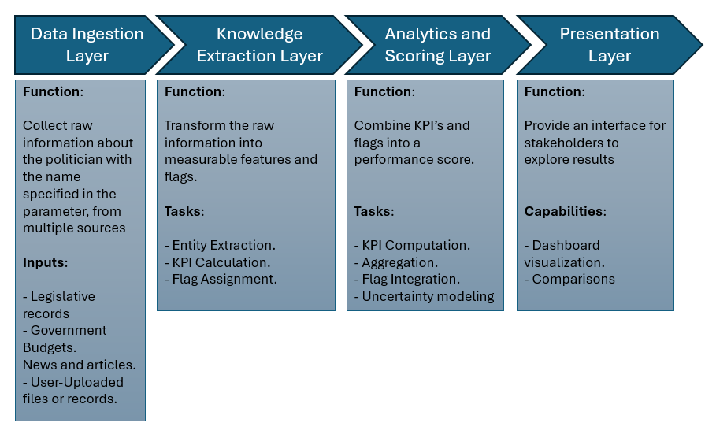
Figure 1. Layers proposed for this architecture.

Data Ingestion Layer
Function: Collect raw information about politicians from multiple sources.
Possible input types:
- Public legislative records (proposals, votes, approvals).
- Government budgets and expenditure reports.
- News articles, press releases, and other publicly available content.
- Files uploaded by users or researchers (PDF, CSV, TXT).
Processing:
- Preprocessing: clean and normalize textual data.
- Metadata tagging: associate data with politician, office held, date, and source.
Output:
- Structured records stored in a raw data repository.

Knowledge Extraction Layer
Function: Transform raw information into measurable features and flags.
Tasks include:
- Entity extraction (names, organizations, offices).
- KPI calculation per office held (legislative activity, budget execution, promises fulfilled, audit results).
- Flag assignment (corruption, personal conduct, addictions, health, fortune, associations).
Output:
- Feature tables representing structured KPIs and flag values.

Analytics and Scoring Layer
Function: Combine KPIs and flags into a coherent performance score.
Tasks include:
- Computation of office-specific KPIs.
- Aggregation across all offices held to compute a total performance score.
- Integration of flags using weighted, product-based, or distributional approaches.
- Optional uncertainty modelling (optimistic/pessimistic, Monte Carlo simulations, credible intervals).
Output:
- Final numerical scores, confidence intervals, and risk indices.

Presentation Layer
Function: Provide an interface for stakeholders to explore results.
Users:
- Citizens, journalists, researchers, academics.
Capabilities:
- Dashboard visualization of KPIs and flags per politician.
- Comparisons across politicians and offices.
- Drill down to raw sources for transparency and audit.

Design Principles
- Neutrality: No assumptions on platform or vendor; layers can be implemented in any stack.
- Extensibility: New KPIs, flags, or sources can be added without modifying core architecture.
- Traceability: Every score can be traced to original sources and intermediate calculations.
- Auditability: Support versioning, logging, and reproducibility of analyses.

KPI and Flag Methodology

KPI Design by Political Role
To ensure fair and context-specific evaluation, Key Performance Indicators (KPIs) are defined according to the institutional role previously or currently occupied by the politician. This modular design allows the system to adapt metrics to legislative, executive, or administrative responsibilities:

Legislators (Congress, Senate, Local Assemblies):
- Ratio of supported legislative proposals to total proposals debated.
- Ratio of approved proposals authored or co-authored.
- Attendance rate to legislative sessions.
- Voting alignment with declared campaign platform.

Executive Roles (Mayor, Governor, President, Municipal President):
- Ratio of campaign promises fulfilled versus declared.
- Percentage of assigned budget executed on public works and social programs.
- Transparency in public procurement (open bidding vs. direct assignments).
- Change in personal declared wealth before and after holding office.

Administrative or Appointed Roles (Secretaries, Ministers, Agency Directors):
- Efficiency of program delivery (e.g., number of beneficiaries reached vs. target).
- Budget execution rates compared to allocations.
- Policy impact indicators specific to the portfolio (e.g., crime reduction for security, health coverage for health ministers).
Each politician’s overall KPI score is derived by aggregating performance across all positions held, normalized by the total number of roles:
KPI_{total} = $\frac{1}{n}\sum_{i=1}^{n}{KPI}$_{i}
where n is the number of roles occupied, and KPI_{i} is the performance score for role i.

Flag Categories and Severity Levels
Beyond quantitative KPIs, qualitative integrity indicators (“flags”) capture ethical, legal, and behavioural dimensions of political performance. These are structured as categorical variables with assigned severity weights:

Corruption Flags
- Red (1.0): Proven guilt, sanctions, or imprisonment.
- Orange (0.7): Under formal investigation.
- Yellow (0.5): Publicly accused but no legal proceedings.
- Green (1.0): No allegations or cases reported.

Personal Conduct Flags
- Incidents of domestic violence, any kind of harassment, sexist behaviour, or unpaid child support.
- Weighting aligned to severity and judicial status.

Addiction Flags
- Refusal or acceptance of random drug/alcohol testing supervised by independent bodies.

Health Flags
- Willingness to undergo and publish independent physical and mental health evaluations. (Boolean: 1 if compliant, 0.3 if non-compliant).

Wealth Audit Flags
- Participation in independent audits of personal and family wealth, covering up to ten years of history. (Boolean: 1 if compliant, 0.3 if non-compliant).

Association Flags (proposed)
- Degree of proximity to individuals or networks involved in corruption or organized crime, weighted by level of evidence.
For each politician, the most severe corruption-related flag overrides less severe ones (e.g., Red takes precedence over Yellow).

Mathematical Aggregation Model
The combined performance score integrates quantitative KPIs with qualitative flag multipliers. Two principal approaches are defined:

Optimistic Estimate (Average)
The mean of flag values is applied as a multiplier:
Score_{opt} = KPI_{total} × $\frac{1}{m}\sum_{j=1}^{m}{f}$_{j}
where f_{j} is the value of flag j, and m the number of active flags.

Pessimistic Estimate (Product)
The product of all flag values is applied as a multiplier:
Score_{pes} = KPI_{total} ×$\prod_{j=1}^{m}{f}$_{j}

Hybrid Estimate (α-weighted)
A convex combination balances both perspectives:
Score_{α} = (1 - α) Score_{pes} + α (Score_{opt})
with α∈[0,1] determined by validation against real-world outcomes.

Uncertainty and Risk Index
To capture the dispersion between optimistic and pessimistic estimates, an uncertainty index is defined:
Δ = Score_{opt} − Score_{pes}
This difference Δ signals the degree of risk in the evaluation:
- Low Uncertainty: Δ < 0.1.
- Moderate Uncertainty: 0.1 ≤ Δ < 0.30.
- High Uncertainty: Δ ≥ 0.3.
Visualization of results presents a band [Score_{pes},Score_{opt}] with a point estimate Score_{α}, offering both transparency and interpretability.

Extension to Judicial Roles
The proposed framework is not limited to legislators or executive officials but can also be extended to judicial authorities in countries where judges and magistrates are elected by popular vote, such as Mexico and Bolivia. In these contexts, accountability is particularly relevant given the sensitive balance between judicial independence and democratic legitimacy.
For judicial roles, specific KPIs can be designed to reflect the performance of magistrates, supreme court judges, or electoral tribunal members:
- Case Resolution Efficiency: Ratio of cases resolved within statutory deadlines versus total cases assigned.
- Consistency of Rulings: Degree of alignment with constitutional principles and precedent, measured by reversals in higher courts.
- Transparency of Judicial Reasoning: Availability of rulings in open databases with clear legal justifications.
- Access to Justice Indicators: Percentage of cases from vulnerable groups admitted and resolved without procedural delays.
Flags acquire even more importance in judicial positions, as impartiality and independence are essential for the rule of law:
- Conflict of Interest Flags: Undisclosed ties to political parties, law firms, or business networks.
- Integrity Flags: Proven cases of bribery, case manipulation, or external pressure in decision-making.
- Transparency Flags: Refusal to disclose professional and financial background as required by electoral or judicial oversight institutions.
As with executive and legislative roles, the most severe flags override lesser ones, ensuring that evidence of judicial corruption or manipulation heavily impacts the aggregated score. The same mathematical aggregation model (optimistic, pessimistic, hybrid) applies, with the uncertainty index Δ signalling the reliability of the judicial evaluation.
By extending the framework to judicial elections, the system provides citizens with structured, evidence-based indicators that promote transparency in one of the most sensitive domains of democratic governance. Political parties and judicial councils may also benefit, as such mechanisms reduce the reputational risks associated with promoting candidates who later become discredited due to corruption or ethical scandals.

Experimental Procedures
The prototype implementation follows the four-layer neutral architecture defined in Section 2. The purpose is not to deliver a fully automated system, but rather to provide a blueprint and proof-of-concept demonstrating the feasibility of applying AI-driven methodologies to political performance evaluation. This section describes the design of each layer in the architecture and the considerations for its minimal implementation.

Data Ingestion
At the current stage, data ingestion is manual and triggered by each user inquiry. A user provides the name of a politician through the web interface. The system checks whether the politician already exists in the database. If records are found, the system displays the date of the last inquiry and prompts the user to confirm whether the data should be renewed. If renewal is requested, the previous record is deleted and new ingestion begins.
Manual ingestion ensures that early prototypes remain feasible under constrained resources while allowing structured capture of information. The ingestion process accepts data entry in multiple formats:
- Direct manual input by the user (structured forms for issues, positions, or KPIs).
- Batch file uploads, including Excel spreadsheets, CSVs, or JSON files containing historical or campaign data.
- Document evidence attachments, such as PDF reports, audit summaries, or official gazettes, which serve as traceable proof for subsequent evaluations.
For future stages, the ingestion process can evolve into semi-automated or fully automated pipelines, where AI models perform information retrieval and entity extraction from the web. As Feldman and Sanger (2007) note, “text mining and natural language processing provide tools to automatically extract structured knowledge from unstructured political data sources” [17]. The proposed architecture allows flexibility to integrate external APIs and Large Language Models (LLMs) such as OpenAI, DeepSeek, Anthropic Claude, or Google Gemini to support automated ingestion.
The ingestion services are envisioned to be agnostic in terms of hosting platforms, meaning they could run on any cloud provider (Microsoft Azure, AWS, Google Cloud) or even on on-premises servers. For a minimal proof-of-concept, a practical path is to deploy ingestion logic as a lightweight service in an Azure App Service Free Layer, which provides sufficient resources for testing without financial investment. Similar approaches are recommended for rapid prototyping in resource-constrained environments (Villamizar et al., 2016) [18].

Data Storage
Data storage is proposed using a relational database model, implemented initially with MySQL hosted on GoDaddy, given its low cost and accessibility.
Following is the proposed ER diagram for the core tables:
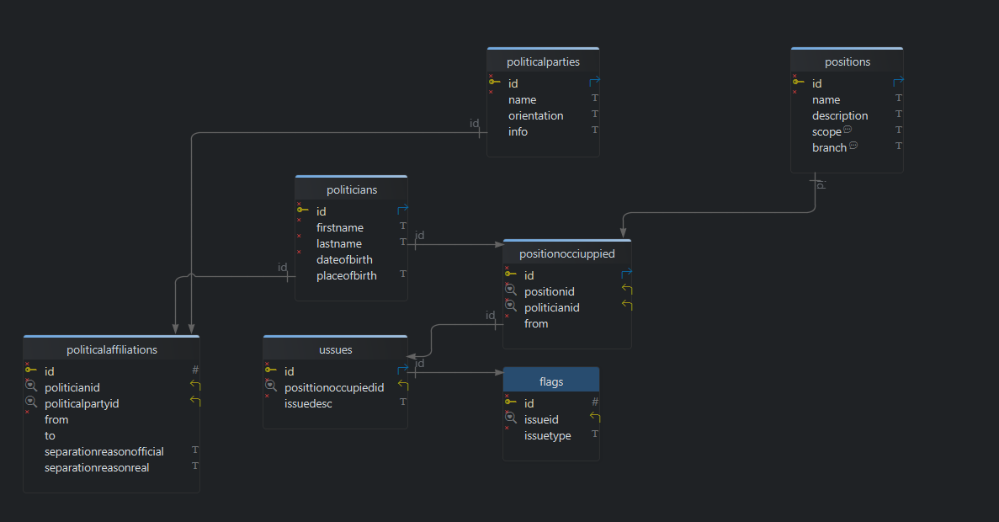
Figure 2. ER Diagram for the core tables.
The schema may include the following core entities

Field name | Data Type | Required | Length | Description
id | BIGINT AUTONUMERIC | True |  | Key ID of the table
firstName | VARCHAR | True | 100 | Politician first name
lastName | VARCHAR | True | 100 | Politician last name
gender | VARCHAR | True |  | Politician gender
isLGBTQ | BIT | True | 1 | Indicates if the politician is LGBTQ+
dateOfBirth | DATETIME | True |  | Politician date of birth
placeOfBirth | VARCHAR | True | 256 | Politician place of birth
Table 1. DB Entities - Politicians.
Field name | Data Type | Required | Length | Description
id | BIGINT AUTONUMERIC | True |  | Key ID of the table
name | VARCHAR | True | 256 | Political Party name
isActive | BIT | True | 1 | Is this political party still active?
Orientation | VARCHAR | True | 128 | Political party orientation (Center. Center – Left, Center – Right, Far – Left, Far Right)
info | TEXT | False |  | Additional info or political party bio.
Table 2. DB Entities – PoliticalParties catalogue.
Field name | Data Type | Required | Length | Description
id | BIGINT AUTONUMERIC | True |  | Key ID of the table
politicianId | BIGINT | True |  | Politician ID
politicalPartyId | BIGINT | False |  | Political party ID. If the politician is independent in this period, leave this field null.
from | DateTime | True |  | Date when the affiliation to this political party starts
to | DateTime | False |  | Date when the affiliation to this political party ended.
separationReasonOficial | VARCHAR | False |  | If the affiliation ended, this field will be MANDATORY and will contain the official reason why the politician ended their affiliation to this political party
separationReasonReal | VARCHAR | False |  | If the affiliation ended, this field will be OPTIONAL and will contain the real reason why the politician ended their affiliation to this political party
Table 3. DB Entities – PoliticalAffiliations.
Field name | Data Type | Required | Length | Description
id | BIGINT AUTONUMERIC | True |  | Key ID of the table
name | VARCHAR | True | 256 | Position name
description | VARCHAR | False | 1024 | Position description
scope | VARCHAR | True | 128 | Position scope. It can be one of the following values: Federal, State, Municipal
branch | VARCHAR | True | 128 | Branch of the government where this position belongs to. (e.g. Executive, Legislative. Judicial).
responsibleForBudget | BIT | True | 1 | Indicates if this position is responsible for handling budget or funds.
Table 4. DB Entities – Positions catalogue.
Field name | Data Type | Required | Length | Description
id | BIGINT AUTONUMERIC | True |  | Key ID of the table
positionId | BIGINT | True |  | Position ID
politicianId | BIGINT | True |  | Politician ID
from | DATETIME | True |  | Date when the politician started in this position
to | DATETIME | False |  | Date when the politician ended with this position. If the politician is still in this position, this value will be null.
separationReasonOfficial | VARCHAR | False | 1024 | Official reason why the politician ended this position. This field will be MANDATORY if the to field is not null.
separationReasonReal | VARCHAR | False | 1024 | Real reason why the politician ended this position. This field will be OPTIONAL if the to field is not null.
Table 5. DB Entities – PositionsOccupied.
Field name | Data Type | Required | Length | Description
Id | BIGINT AUTONUMERIC | True |  | Key ID of the table
positionOccupiedId | BIGINT | True |  | Position occupied ID
issueDesc | VARCHAR | True | 1024 | Description of the issue found
Table 6. DB Entities – Issues.
Field name | Data Type | Required | Length | Description
Id | BIGINT AUTONUMERIC | True |  | Key ID of the table
issueId | BIGINT | True |  | Position occupied ID
issueType | VARCHAR | True | 100 | Issue Type (Flag type)
Table 7. DB Entities – Issues.
Each user inquiry creates or updates entries across these tables, ensuring historical traceability of evaluations. The database design emphasizes extensibility, allowing new KPIs or flag types to be added without structural disruption.
In future developments, the database layer is not limited to MySQL. The architecture allows for deployment on any relational database management system (RDBMS) such as Oracle, SQL Server, or PostgreSQL, depending on institutional preferences or available infrastructure. The principle of database neutrality guarantees long-term portability of the solution, as emphasized by Connolly and Begg (2015), who argue that “conceptual design should remain independent of specific DBMS implementations to maximize scalability and sustainability” [19].

Data Processing
The computation of KPIs is handled by simple API methods, initially implemented in server-side logic. For each political position held, indicators such as legislative productivity, budget execution, or campaign promise fulfilment are calculated. KPI formulas are defined with reference to the specific responsibilities of each role. For example, legislators are evaluated by the ratio of supported bills to approved laws, while municipal executives are assessed based on campaign promises versus executed projects and fiscal responsibility.
Flags, such as corruption scandals, personal conduct, health transparency, or unexplained increases in wealth, are represented numerically. For instance:
- Corruption flag (guilty = 0.1, under investigation = 0.5, free of charges = 1.0).
- Health transparency (boolean: adheres to independent exams = 1, refuses exams = 0.3).
- Wealth audits (boolean: accepts audits = 1, refuses audits = 0.3).
Each flag modifies the KPI score either multiplicatively (pessimistic estimation) or through averaging (optimistic estimation). The system then generates two scenarios:
- Optimistic estimation: where averages reduce the impact of individual negative flags.
- Pessimistic estimation: where multiplicative penalties are applied, amplifying the impact of risks.
A hybrid estimate, based on weighted averaging of the two, provides a balanced final score. This methodology aligns with risk analysis practices, where both optimistic and pessimistic projections are calculated to understand ranges of possible outcomes (Hubbard, 2020) [20].
For future scalability, this layer can evolve into modular services, such as RESTful APIs developed with .NET Web API or Java Spring Boot. The initial monolithic approach simplifies development, but the architecture can support microservices as resources increase. Cloud-native services would enable horizontal scaling and advanced monitoring.

Output
The presentation layer is proposed to be built in Angular and hosted on GoDaddy. This layer provides the user interface through which citizens can:
- Search for a politician.
- Review their KPI performance across multiple positions.
- View associated flags, with clear color-coded visualization (green, yellow, orange, red).
- Compare two or more politicians side by side.
Results are presented using three perspectives:
- Optimistic scenario.
- Pessimistic scenario.
- Hybrid estimate.
Visualization of these scenarios allows citizens to perceive both the best and worst interpretations of available data. In this way, the tool emphasizes transparency of uncertainty, rather than a single deterministic score. As Few (2009) explains, “effective data visualization makes patterns, trends, and exceptions visible at a glance, facilitating informed decision-making” [21].
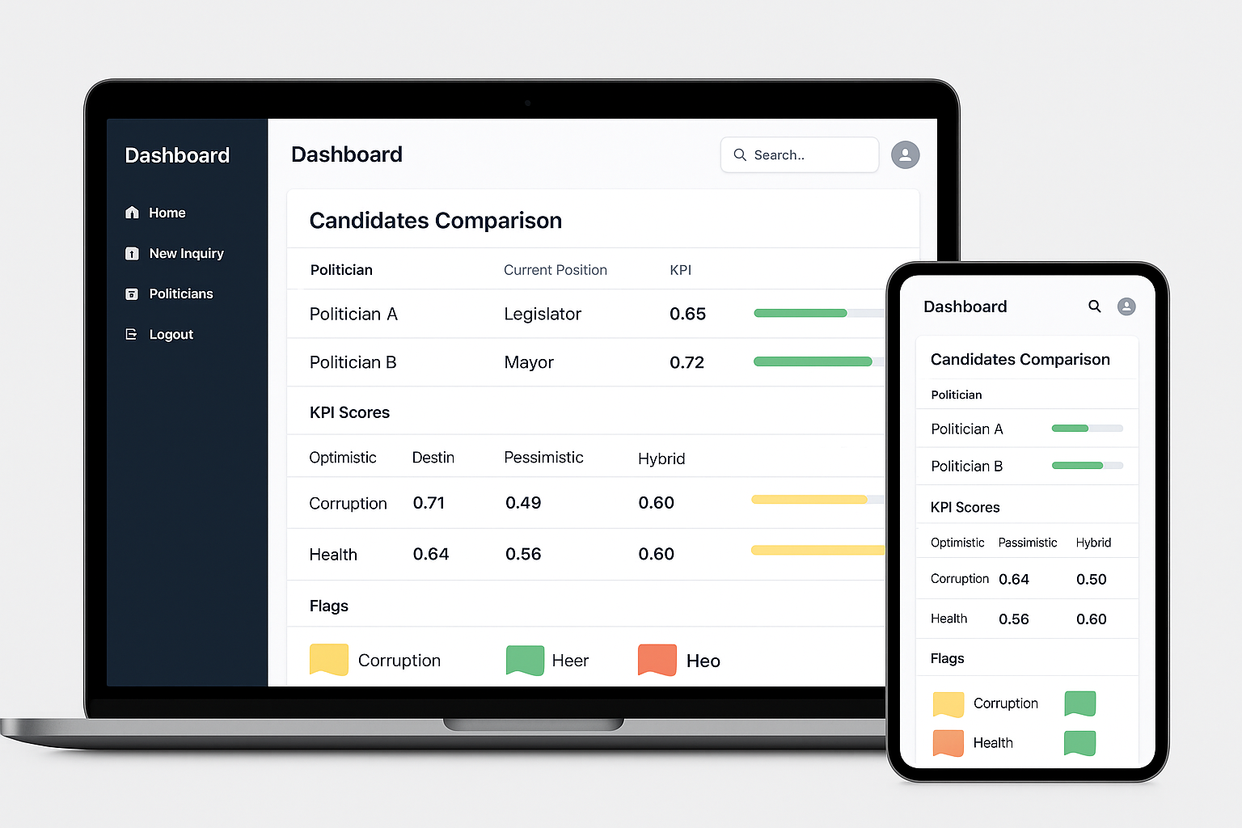
Figure 3. Proposed UI.
The presentation layer also provides traceability by linking KPI values to their supporting evidence (manual entry, file uploads, or documents). This ensures accountability and reduces risks of arbitrary scoring.

Summary
Overall, the prototype described here demonstrates a pathway to implement a minimal but functional architecture under strong resource constraints. By focusing on modularity, neutrality, and transparency, it ensures that future iterations can scale both technologically (via cloud services, microservices, AI automation) and socially (adoption by NGOs, academic institutions, or civil society organizations).
The strength of this approach lies not in immediate sophistication but in providing a clear, reproducible blueprint. As Kitchenham et al. (2002) highlight, “prototyping is not intended to deliver a final system but to explore feasibility, expose potential risks, and validate design concepts at low cost” [22].

Results
The goal of this section is to illustrate the feasibility and potential impact of the proposed framework through simulated examples. Because real-world validated datasets are not yet available, we present fictitious but plausible cases of four politicians with distinct profiles. Each case demonstrates how the baseline KPI score interacts with integrity-related flags, producing optimistic, pessimistic, and hybrid evaluations. This allows us to illustrate the full workflow of the system, from raw data to final comparative insights.

Baseline KPI Calculations
Each political position held by a candidate generates role-specific KPIs (e.g., legislative productivity, municipal budget execution, promise fulfillment). These KPIs are averaged to yield a Raw Performance Score that reflects how effectively the politician carried out their past roles, before any ethical or integrity considerations are applied.
Politician | Positions Held | Raw KPI (avg)
Politician A | Legislator, Mayor | 0.70
Politician B | Legislator | 0.55
Politician C | Mayor, Governor, Minister | 0.68
Politician D | Mayor, Senator | 0.62
Table 8. Baseline KPI calculations example.
The raw KPIs suggest that all four politicians demonstrate moderate to strong performance in their administrative or legislative functions. However, as discussed below, the integration of integrity flags drastically changes these profiles.

Flag Profiles
Flags represent risk-adjusted modifiers that penalize or reward candidates based on transparency, accountability, and ethical conduct. Each flag is encoded numerically (Green = 1.0, Yellow = 0.7, Orange = 0.5, Red = 0.2, or zero if refusal/non-compliance).
Politician | Corruption Flag | Conduct Flag | Health Flag | Wealth Audit Flag
Politician A | Yellow (0.7) | Green (1.0) | Greeb (1.0) | Green (1.0)
Politician B | Orange (0.5) | Yellow (0.7) | Green (1.0) | 0.3 (Refuses audit)
Politician C | Red (0.2) | Orange (0.5) | 0.3 (Partial compliance) | Green (1.0)
Politician D | Green (1.0) | Green (1.0) | Green (1.0) | Yellow (0.7)
Table 9. Flag results example.
This configuration allows us to observe multiple scenarios:
- Politician A: Strong baseline, only a moderate corruption flag.
- Politician B: Mid-range performance, but refusal of wealth audit severely penalizes results.
- Politician C: Good raw performance but crippled by severe corruption and health concerns.
- Politician D: Moderate raw performance with nearly clean flag record.

Adjusted KPI Scores
The adjusted KPI was calculated using three approaches:
- Optimistic (F_avg) – baseline KPI multiplied by the average of flag values.
- Pessimistic (F_prod) – baseline KPI multiplied by the product of flag values.
- Hybrid (F_α) – average of optimistic and pessimistic scores, representing a compromise.

Politician | Raw KPI | Optimistic | Pessimistic | Hybrid
Politician A | 0.7 | 0.67 | 0.49 | 0.58
Politician B | 0.55 | 0.42 | 0.00 | 0.21
Politician C | 0.68 | 0.34 | 0.06 | 0.20
Politician D | 0.62 | 0.59 | 0.43 | 0.51
Table 10. Adjusted KPI Scores example.

Interpretation of Results
- Politician A: Despite a moderate corruption flag, this candidate maintains the highest hybrid score (0.58). This suggests relatively strong viability, with moderate accountability concerns.
- Politician B: A refusal to comply with wealth audits collapses the pessimistic estimate to zero, producing the lowest hybrid score (0.21). Even a decent raw KPI cannot offset transparency failure.
- Politician C: Although raw KPIs are high (0.68), integrity failures in corruption and health drastically reduce scores to near zero, reinforcing the principle that integrity outweighs technical competence.
- Politician D: While raw KPIs are lower than Politician A or C, a nearly clean flag record boosts results. The hybrid score (0.51) demonstrates how integrity can compensate for moderate performance.

Graphical Illustrations
To facilitate interpretation for citizens, results are best represented graphically. For example:
- Bar charts can compare the three scoring methods across candidates, highlighting uncertainty ranges.
- Radar charts can display the individual flag profiles for each politician, making weaknesses visually apparent.
- Heatmaps can compare multiple candidates simultaneously across positions and flags, providing a quick overview of viability.
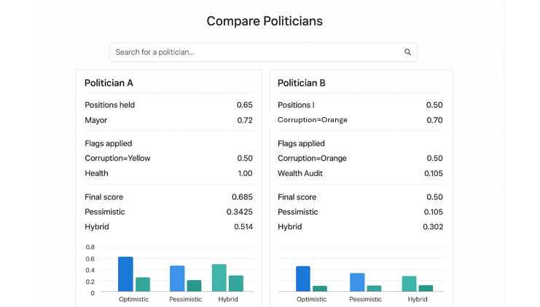
Figure 4. Example of proposed bar chart for result comparisons.
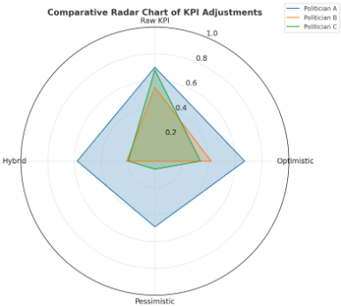
Figure 5. Example of proposed radar chart for result comparisons.

Methodological Insights
Several insights emerge from this exercise:
- Flags carry decisive weight – A single critical refusal (e.g., wealth audits) can collapse the pessimistic estimate, reinforcing the necessity of transparency.
- Integrity matters as much as efficiency – Politicians C and D illustrate opposite dynamics: high performance with low integrity (C) vs. moderate performance with high integrity (D). Citizens can thus evaluate trade-offs explicitly.
- Range estimates improve trust – Showing optimistic, pessimistic, and hybrid scores together provides citizens with a transparent band of uncertainty, rather than a single opaque rating.
- Scalability – This framework can scale to dozens of candidates, with visual dashboards enabling fast comparison.

Summary of Results
This simulation demonstrates that the proposed model effectively combines technical governance indicators (KPIs) with accountability signals (flags). Even without real-world datasets, the proof-of-concept results validate that:
- The methodology is implementable with minimal computational resources.
- Citizens benefit from an intuitive, transparent, and comparative tool.
- Parties and institutions could use this system to pre-select candidates with higher credibility.
Future work will focus on validating the framework against real-world political data and extending the system to include automated ingestion, advanced statistical calibration, and citizen-centered visualization.

Discussion and Implications
The prototype reveals both the promise and the challenges of AI-driven political accountability.
Technical challenges. Reliable data ingestion remains a bottleneck. Government datasets, media reports, and civil society audits are heterogeneous in format and quality. Natural Language Processing (NLP) will be required to extract structured indicators from unstructured sources such as news articles and court rulings. We propose to rely on AI-Driven data ingestion in order to avoid any human bias.
Scientific opportunities. The methodology offers opportunities to explore explainable AI (XAI), fairness-aware modeling, and cross-validation against real-world outcomes (e.g., corruption trials, service delivery metrics, or electoral results).
Ethical considerations. Neutrality is critical: the system must avoid partisan bias and ensure transparency in its algorithms. Over-penalizing individuals through unverified allegations could risk reputational harm. Thus, flags must be clearly sourced and weighted with documented thresholds.

Conclusions
This work proposed a neutral, AI-driven framework for evaluating the performance of politicians through measurable Key Performance Indicators (KPIs) and corrective “flags.” Unlike purely opinion-based assessments, the model is designed to provide citizens, institutions, and researchers with structured and verifiable evidence regarding the effectiveness and integrity of public officials. By combining performance-based indicators (e.g., legislative productivity, budget execution, policy fulfillment) with corrective mechanisms (e.g., corruption, personal conduct, wealth audits), the system offers a balanced evaluation that acknowledges both achievements and risks.
The relevance of this contribution lies in its potential to address a critical gap in democratic societies: the lack of transparent, standardized tools for evaluating political actors. “Without reliable metrics, voters often depend on campaign rhetoric, biased media narratives, or partisan endorsements to form opinions” (Lindberg, 2013, p. 209). This not only weakens accountability but also allows individuals with questionable track records to remain in power. The framework outlined here provides a foundation for overcoming this gap by introducing objectivity, traceability, and replicability into the process of political evaluation.
From a technical perspective, the paper demonstrates the feasibility of building a minimal viable prototype with modest resources—leveraging open-source technologies, cloud-based free-tier services, and lightweight database architectures. This blueprint is deliberately designed to lower barriers to implementation, enabling civil society organizations, academic institutions, and even local governments to adopt or extend the model without prohibitive costs.
From a scientific standpoint, the framework contributes to emerging research on explainable AI (XAI) in governance. It demonstrates how algorithmic decision-making can be combined with human oversight to produce results that are not only accurate but also interpretable. Furthermore, it suggests a pathway for future validation studies where computed KPIs could be cross-referenced against real-world outcomes such as successful prosecutions of corruption, citizen satisfaction surveys, or electoral turnover rates.
Ethically, the paper emphasizes neutrality and transparency. It recognizes the risks of algorithmic bias, reputational harm, and over-penalization from unverified allegations. As such, it proposes safeguards such as documented thresholds, clear data sourcing, and the possibility of independent audits of the system itself. Rather than undermining political parties, this type of framework should be seen as an opportunity: “parties that embrace accountability mechanisms are more likely to strengthen voter trust and long-term legitimacy” (Schedler, 1999, p. 26).
Looking ahead, several avenues of work emerge. First, technical scalability can be achieved by automating ingestion pipelines through Natural Language Processing (NLP) to transform unstructured data (e.g., news articles, judicial reports, or social media content) into structured KPIs. Second, comparative studies across different countries and governance systems would enable benchmarking and highlight cross-national differences in political accountability. Third, partnerships with NGOs, watchdog groups, and academia are necessary to validate, govern, and legitimize the system.
In conclusion, the proposed framework represents a step toward bridging the gap between citizens and their representatives by providing an evidence-based, AI-assisted tool for accountability. It is not a final solution but rather a foundational blueprint—one that can evolve into a practical, globally adaptable platform. By strengthening transparency and empowering citizens with reliable data, such tools can contribute to more resilient democracies, better governance, and ultimately, fairer political systems

About the author
José Gustavo Roa de la Fuente is an independent researcher and IT consultant based in California, USA. He holds a Master’s degree in IT Management and has more than twenty years of professional experience in software development, systems integration, and IT consulting for organizations in the government, education, oil and gas, finance, and healthcare sectors in both Mexico and the United States. His research interests focus on the application of Artificial Intelligence for transparency, governance, and decision-support systems, with particular emphasis on frameworks that promote democratic accountability through technology-driven performance evaluation. He has also contributed to international conferences, such as the SPE Digital Energy Conference and Exhibition (The Woodlands, TX, 2015), where he presented work related to digital solutions for operational risk management in the energy industry.
He can be contacted at gustavoroa@roasystems.com. ORCID: https://orcid.org/0009-0003-0764-6146.

References
- Norris, P. (2015). Why Elections Fail. Cambridge University Press https://www.cambridge.org/core/books/why-elections-fail/628E91199F1216245783D14E322A0FD5
- Transparency International. (2022). Corruption Perceptions Index 2022: Corruption, conflict and security. Berlin: Transparency International. Retrieved from https://www.transparency.org/en/cpi/2022
- Article 19. (2023). The paralysis of the INAI threatens transparency in Mexico. Retrieved from https://articulo19.org/
- American Oversight. (2022). FOIA in Crisis: Systemic Delays and Denials in Access to Public Records. Retrieved from https://www.americanoversight.org/
- The Economist. (2019, Aug 29). How Viktor Orbán hollowed out Hungary’s democracy. The Economist. Retrieved from https://www.economist.com/briefing/2019/08/29/how-viktor-orban-hollowed-out-hungarys-democracy
- V-Dem Institute. (2023). Democracy Report 2023: Defiance in the Face of Autocratization. University of Gothenburg. Retrieved from https://v-dem.net/
- International Institute for Democracy and Electoral Assistance (IDEA). (2021). The Global State of Democracy 2021: Building resilience in a pandemic era. Stockholm: International IDEA. Retrieved from https://www.idea.int/gsod/
- Parmenter, D. (2015). Key performance indicators: Developing, implementing, and using winning KPIs (3rd ed.). Hoboken, NJ: John Wiley & Sons
- Peters, B. G., & Pierre, J. (2016). The handbook of public administration. London: Sage
- United Nations Development Programme (UNDP). (2019). Governance for sustainable development. UNDP Policy Paper. Retrieved from https://www.undp.org/
- Kaufmann, D., Kraay, A., & Mastruzzi, M. (2010). The Worldwide Governance Indicators: Methodology and Analytical Issues. World Bank Policy Research Working Paper No. 5430. The World Bank.
- Mo Ibrahim Foundation. (2021). Index of Public Integrity (IPI). Retrieved from https://mo.ibrahim.foundation/
- Transparency International. (2018). Political Integrity Toolkit. Transparency International Secretariat. Retrieved from https://www.transparency.org/
- Global Data Barometer. (2022). Political Integrity Module. Retrieved from https://globaldatabarometer.org/
- Berkovitz, S., Mazuz, O., & Fire, M. (2022). An open framework for analyzing parliamentary records. Digital Government: Research and Practice, 3(1), 1–14. Retrieved from https://journalofbigdata.springeropen.com/articles/10.1186/s40537-023-00831-3
- Saleiro, P., Kuester, B., Hinkson, L., London, J., Stevens, A., Anisfeld, A., ... & Ghani, R. (2018). Aequitas: A bias and fairness audit toolkit. Proceedings of the Conference on Fairness, Accountability, and Transparency (FAT*), 1–3
- Feldman, R., & Sanger, J. (2007). The text mining handbook: Advanced approaches in analyzing unstructured data. Cambridge University Press
- Villamizar, M., Ochoa, L., Castro, H., Salamanca, L., Verano, M., Casallas, R., & Gil, S. (2016). Infrastructure cost comparison of running web applications in the cloud using AWS, Azure, Google Cloud Platform, and Heroku. 2016 IEEE/ACM 9th International Conference on Utility and Cloud Computing (UCC), 522–527.
- Connolly, T., & Begg, C. (2015). Database systems: A practical approach to design, implementation, and management (6th ed.). Pearson Education.
- Hubbard, D. W. (2020). The failure of risk management: Why it’s broken and how to fix it (2nd ed.). John Wiley & Sons
- Few, S. (2009). Now you see it: Simple visualization techniques for quantitative analysis. Analytics Press
- Kitchenham, B., Linkman, S., & Law, D. (2002). Critical review of quantitative assessment. In Empirical Software Engineering (pp. 13–43). Springer
- Directorio Legislativo. (nd). Following INAI’s closure: Changes in Transparency and Access to Information in Mexico. Directorio Legislativo. Retrieved from Following INAI’s closure: Changes in Transparency and Access to Information in Mexico – Directorio Legislativo
- Mueller, Ritch. (Jan 08th 2025). Newsflash - Constitutional reform dissolving the autonomous constitutional body – INAI. Mueller, Ritch. Retrieved from https://www.ritch.com.mx/en/read/1015/newsflash-constitutional-reform-dissolving-the-autonomous-constitutional-body-inai
- Nieto-Morales, Fernando. (Nov 21st 2024). The Elimination of INAI: A Blow to Transparency and Accountability in Mexico. Wilson Center. Retrieved from https://www.wilsoncenter.org/article/elimination-inai-blow-transparency-and-accountability-mexico
- Lindberg, S. I. (2013). Mapping accountability: Core concept and subtypes. International Review of Administrative Sciences, 79(2), 202–226. https://doi.org/10.1177/0020852313477761
- Schedler, A. (1999). Conceptualizing accountability. In A. Schedler, L. Diamond, & M. F. Plattner (Eds.), The self-restraining state: Power and accountability in new democracies (pp. 13–28). Lynne Rienner Publishers

