**Advanced Lane Lines**

Camera Calibration – calibration.py

I start by preparing "object points", which will be the (x, y, z) coordinates of the chessboard corners in the world. Here I am assuming the chessboard is fixed on the (x, y) plane at z=0, such that the object points are the same for each calibration image. Thus, objp is just a replicated array of coordinates, and objpoints will be appended with a copy of it every time I successfully detect all chessboard corners in a test image. imgpoints will be appended with the (x, y) pixel position of each of the corners in the image plane with each successful chessboard detection.

I then used the output objpoints and imgpoints to compute the camera calibration and distortion coefficients using the cv2.calibrateCamera() function. I applied this distortion correction to the test image using the cv2.undistort() function and obtained this result:

Original: Undistorted:

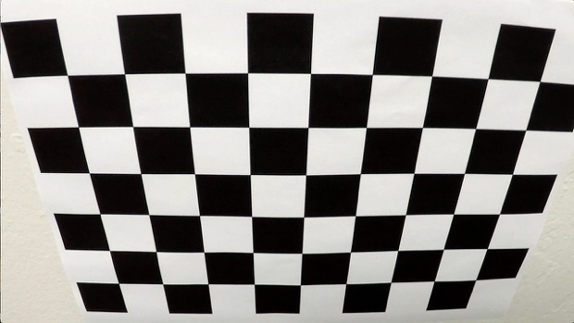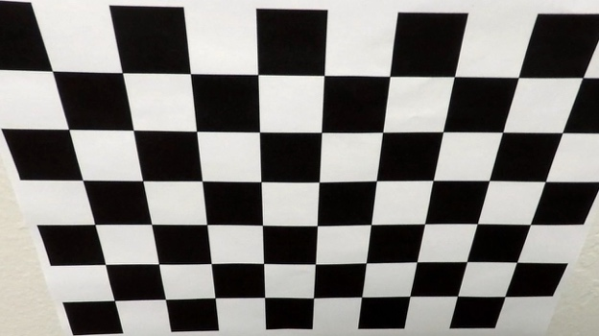

Pipeline:

1. Distortion Correction

Original: Undistorted:

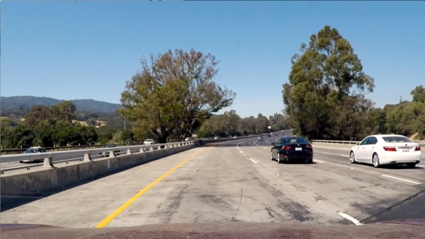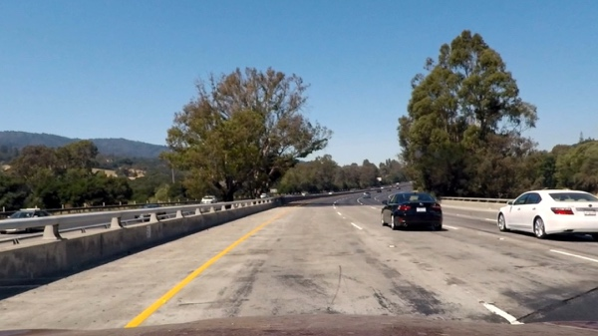

1. X Gradient Threshold

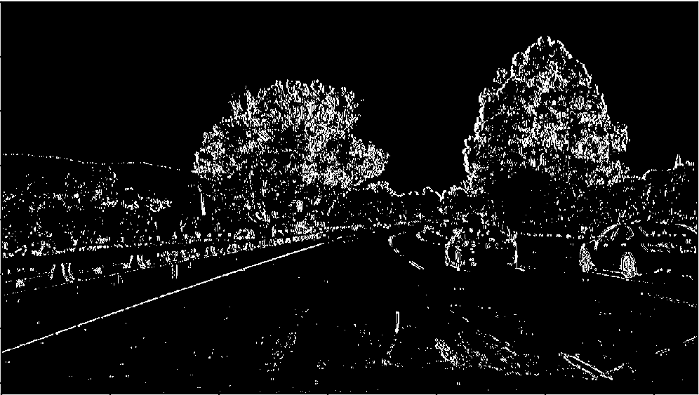

1. Color Threshold

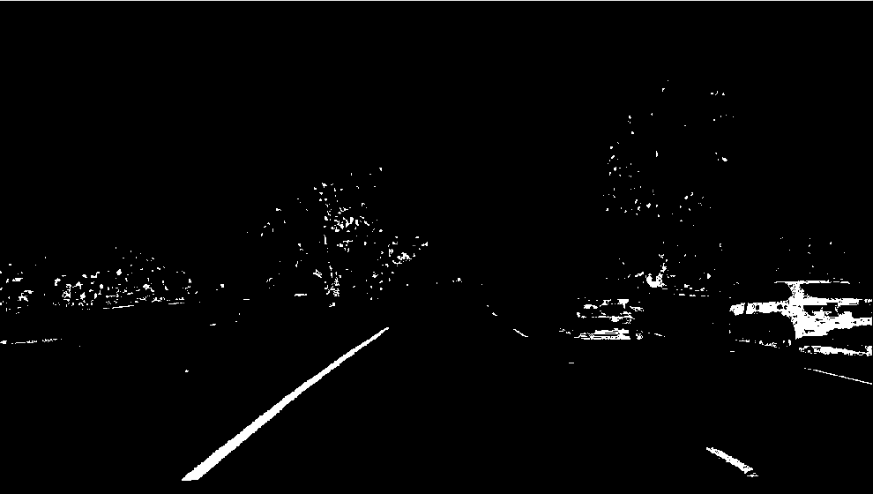

1. Combined Binary

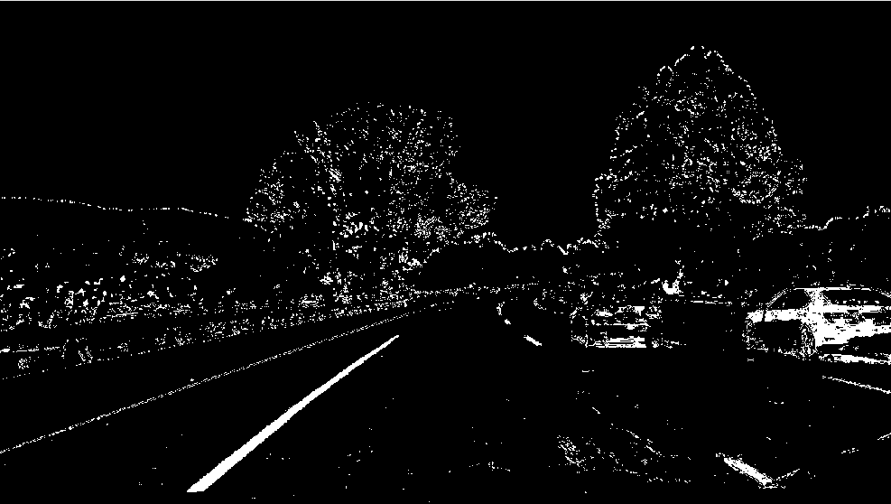

1. Perspective Transform

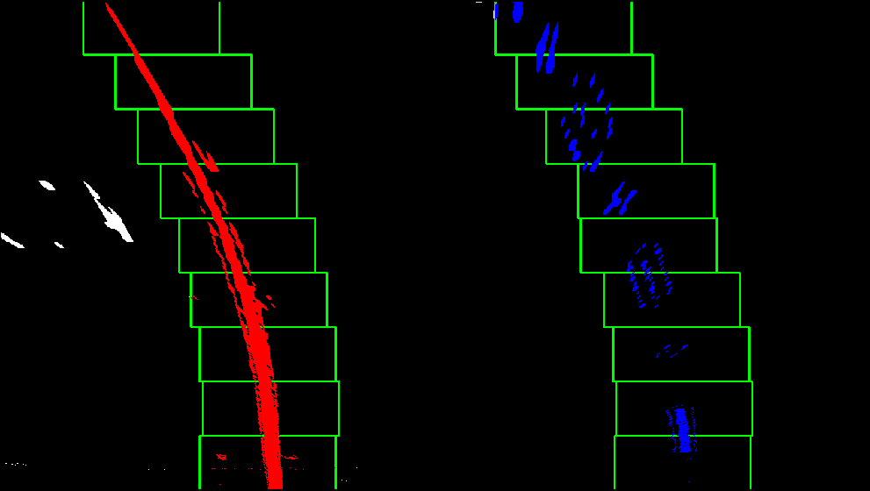

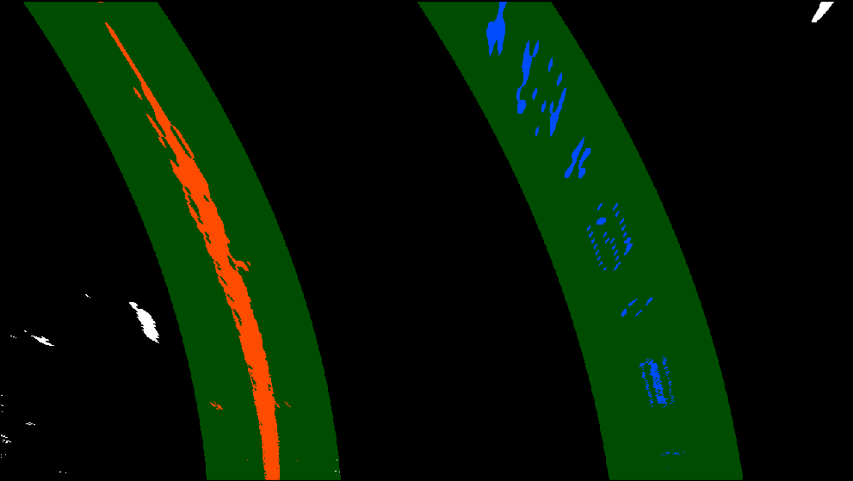

1. Drawing Lines back down on road

