Nanostructures based in ZnO and Biomedical Engineering Applications
G.V. S. Luz1, M.H. Falla¹ and L. M. Brasil¹
¹ University of Brasília-UnB at Gama-FGA, Brasília, Brazil

Abstract— ZnO nanostructures and their potential applications has been the focus of many scientific publications in the last decades. This paper present a succinct analyze on the development of ZnO nanostructures researches, specifically one-dimensional structures (wires, rods, belts and tubes) and 0-dimensional (quantum dots), describing some of the applications improved by the researchers in Biomedical Engineering.

Keywords— ZnO, nanostructures, semiconductors, biomedical engineering, biocompatibility.
- INTRODUCTION
Nanoparticulate semiconductor materials have unique properties and the elucidation of these have led to interesting discoveries in various fields of science and technology [1,2]. The number of scientific publications has increased in the last decade on ZnO nanostructures and their potential applications.
ZnO is used in a number of biomedical applications such as: glucose detection, gas sensors, wound healing and dental filling materials, macrophage adhesion, coating antibodies which identify specific receptors found on cancer cells, improving the dispersion of light in endoscopic techniques, in the formation of electroluminescent and photovoltaic devices, among others [3-7].
The present review analyze this phenomenon of research increasing of ZnO nanostructures, specifically one-dimensional structures (wires, rods, belts and tubes) and 0-dimensional (quantum dots), describing some of the great potential technological applications in Biomedical Engineering.
- Nanostruturas baseadas em ZnO E suas aplicações
Nanostructures are defined as having at least on dimension between 1 to 100 nm, with peculiar properties and applications, different from their bulk counterparts [8-11] which will be described in the following items.

  - 0-dimensional structures (ZnO Quantum dots)
Quantum dots (QDs) are zero-dimensional (0D) structures with great interest of researchers since the 90s [12-13 apud 8]. This structure confine the electrons in nanometer-size of grains, and it is often also called mesoscopic atoms or artificial atoms to express that the scale of electron states in QDs particle is larger than the lattice constant of a crystal (see Fig. 1). Then, there is no precise lower limit to the size, and even macromolecules and single impurity atoms in a crystal can be described as QDs [14]. The quantization of electron energies in crystals with nanometers induce to effective changes in transport and optical properties. Their photoluminescence is hardly size-dependent and associated with the radiative recombination of electron from conduction band (CB) with hole from valence band (VB) [8,14].
ZnO QDs are cheap and biocompatible to the biological systems, thus they have motivated great interest in biological labeling and photocatalytic applications. Zinc oxide QDs shown a broud range of antibacterial activities in relation to various microorganisms [15]. Other research about this substance are promising alternatives for diagnosis and imaging, for example functionalized with siloxane-core polyTEM ESPAÇO EM BRANCO AQUI OU NÃO?(amidoamine) dendrons or (3-Aminopropyl) triethoxysilane as a capping agent that control the ZnO QDs aqueous instability [16-17]. Another example is the chitosan-encapsulated Zn:Mn²⁺ QDs for tumor-targeted drug delivery field enhancing the cellular apoptosis of tumor cells and additionally monitoring the drug dosage rate. This kind of material encourage experiments with clinical diagnostic tools for early detection and classification of cancer, and with more studies they can be applied in other diseases [18].
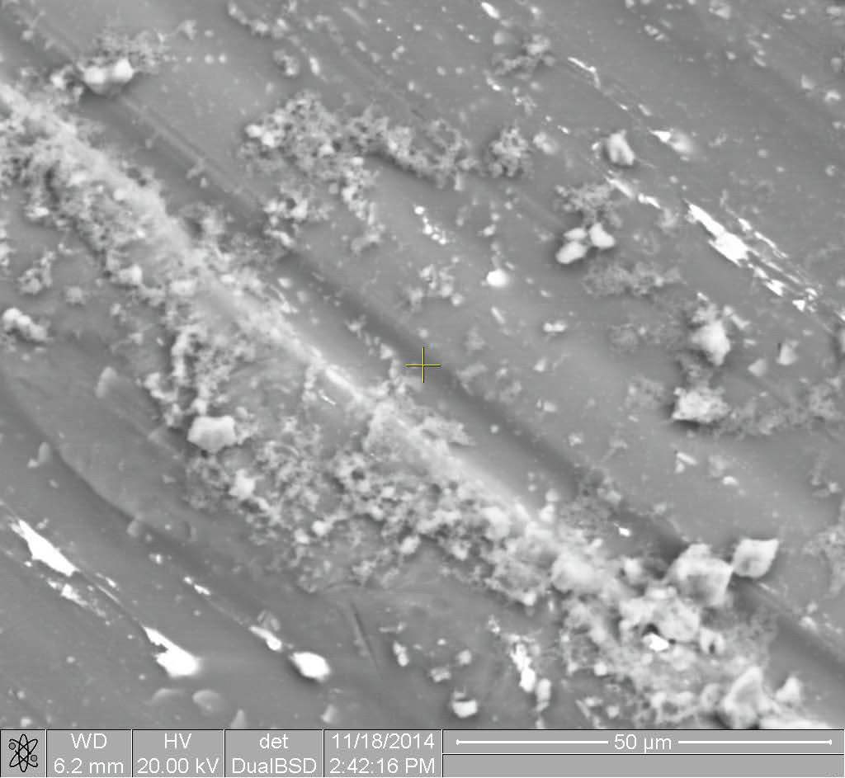
Fig. 1 SEM image of aglomerated ZnO quantum dots
  - One-dimensional structures
Nanorods (NRs), nanowires (NWs), nanobelts (NBs) and nanotubes (NTs) are one-dimensional structures with a important role in fabricating electronic, optoelectronic, electrochemical, and electrochemical devices with nanoscale sizes (see Fig. 2). Unlike the QDs have more difficulties associated with the synthesis and fabrication with well-controled morphology, sizes and purity. And, GLÉCIA, AO MEU VER TEM UM SUJEITO AQUI…they are generally more expensive techniques [8].
The essence of this structures formation is the crystallization, but it is still a process to be extensively explored [8-19]. Using, for example, advanced nanolithographic techiniques [20] or solid state thermal sublimation process, and controlling the growth kinetics, growth temperature and the chemical composition of the reagents, a vast range of nanostructures of ZnO can be synthesized [21].

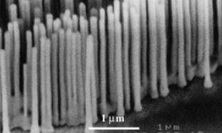
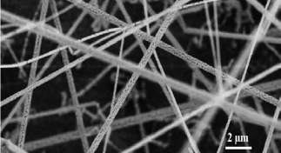
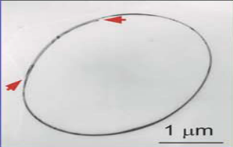
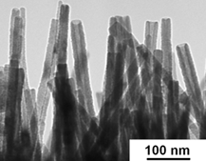
(a)
(b)
(c)
(d)

Fig. 2 SEM images of (a) ZnO nanorods [48], (b) ZnO nanowires [27], (c) ZnO nanobelts [21] and (d) ZnO nanotubes [42].

a) Nanorods (NRs):
Keeping in view of the properties and the extensive use of ZnO NRs in divers lands, have conflicting results about ZnO toxicity from both in-vitro and in-vivo studies. Sotiriou et al. [Error: Reference source not found] relate in their paper that ZnO nanoparticles can induce significant DNA damage and cytotoxicity. The authors coated ZnO NRs with SiO₂, and the result was nanostructured materials maintain their inherent optoelectronic properties while exhibiting minimal toxicity. However, Gopikrishnan et al. [22] report the synthesis and characterization of ZnO NRs on hela cells [22-23] for its biocompatibility/toxicity, and show that the exposure on has no significant induction of oxidative stress or cell death even in higher concentration, i.e. 10 μg/ml. Then, second Gopikrishnan et al. ZnO nanorods might be a safer nanomaterial for biological applications.
Ag/ZnO nanorods were synthesized by wet chemical sol-gel method, and the grain size was controlled using polyvinyl pyridine as capping, in work of Shah et al. [25]. This nanomaterial showed best results about synergistic antibacterial activities, for both Gram positive and Gram negative bacteria in comparison of simple ZnO NRs.
Other kind of application was in work of Wei et al. [4] that present the results about a glucose biosensor based on glucose oxidase (GOx) immobilized on ZnO NRs array grown by hydrothermal decomposition. The authors shows a high affinity between glucose and GOx immobilized on this nanostructures. In addition to the applications described above, other example of studies are being conducted in the luminescence, field emitters cathodes, gas sensing and electron transport properties areas [26].

b) Nanowires (NWs):
Nanowires have been widely studied because of their easy nanomaterials formation comparing with other nanostructures and its applications. ZnO NWs is a single crystal composed of mesoporous walls/volumes and the synthesis is based on a modified solid-vapor process [21]. This feature makes it great potential in applications as filters, catalyst supports, and gas sensorsTEM ESPAÇO?[21, 27- 29].
ZnO NWs compose devices as a ultrasensitive, direct electrical detection of biological and chemical species [30]. There are studies with good frequency stability and reproducibility in the use of the sensing material element for the detection of ammonia [27], humidity TEM ESPAÇO? [28], for example. Devices containing nanostructures provides the detection of a very low concentration of chemical gases, and are small, inexpensive and quickly to identify a chemical vapor in the local. This kind of device can be useful in chemical laboratories and industrial plants for prevent explosions and contamination of the employees, for example.
But, like nanorods, NWs has also good results in antibacterial studies. Na-doped ZnO [31] nanowires have been synthesized by a thermal decomposition route and the authors observed the increasing of intensity visible emission at 420 nm. The antibacterial activity was studied against Escherichia coli 25922 in vitro shown good reaction after UV illumination. Research with Ag/ZnONWs/textile antimicrobial composites [32] via a green chemical approach shown a increasing antimicrobial answer. Furthermore, this material have a stable and recoverable antimicrobial nanostructure NÃO HÁ VÍRGULA AQUI… that can be useful for wound dressings and medical textiles for topical and prophylactic antibacterial treatments. The authors also suggested use on cleanliness of water, air filters and air-conditioning systems.

b) Nanobelts (NBs):
Since 2001 the research about functional oxide-based (1D) nanostructures has quickly developed by reason of their unique and novel applications in optics, optoelectronics, catalysis, and piezoelectricity [21,33-36]. According Wang et al. [21] oxide NBs (1D) have been systematically studied for different compositions and crystallographic structures, for example, with Zn, Sn, In, Cd, and Ga, by evaporating the metal oxide powders at high temperatures. Researches adds that their structural characteristic with cations of different valence states and materials of distinct crystallographic structures, allowing the used for field-effect transistors [34], ultrasensitive gas sensors [34-36], nanoresonators, transducers, actuators, and sensors. For example, the use of transistors applied to tissue may, in the future, help to monitor heart rate and blood pressure of patients, monitor the body temperature by heating or cooling automatically in response to such temperature variations, among others [37].

c) Nanotubes (NTs):
The amount of work concerning zno nanotubes is still scarce, showing up as an area that can still be quite explored. The synthesis of these nanostructures can be, for example, by aqueous solution method [39], via a thermal reduction route using [40], on arbitrary ZnO-film-coated substrates using a low-temperature [41], hydrothermal growth on Si [42- 44], within nanochannels of porous anodic alumina templates by an improved sol–gel process [45], sonochemical method at low temperature [46].
Chen et al. [46] used this nanostructures to fabricate ethanol sensors and shown excellent results for sensing properties at 300 °C. Data obtained demonstrated that this nanomaterial are promising application in gas sensors. In case of Gao et al. [44] work NTs were used for fabrication of a highly aligned silver-decorated array of zinc oxide nanotubes to be used in surface-enhanced Raman spectroscopy (SERS). The ability to investigate the composition of a material on the nano range makes the use of SERS substrates beneficial for environmental analysis, pharmaceuticals, material sciences, forensic science, drug detection, food quality analysis, among others [43][44].
- CONCLUSIONS
In general, this paper demonstrated that the ZnO Quantum Dots are promising alternative for diagnosis and imaging of diseases, like cancer. ZnO nanowires, nanobelts were a potential optoelectronic and gas sensing. ZnO QDs, NBs and NWs are antibacterial material for practical use. And, with respect to the ZnO nanotubes, it can be applied in gas sensors and in SERS substrates which may contribute to future advances in divers??? O QUERES DIZER COM ESTA PALAVRA. ELA NÃO É USUAL… areas like pharmaceuticals and drug detection. Therefore, more research must still be performed regarding potential environmental health risks and it cytotoxicity, but it appears that ZnO nanostructures 0D and 1D have great potential for application in various sectors of Biomedical Engineering.

ACKNOWLEDGMENT
The authors thank the financial support of the Brazilian research financing institutions: CAPES and UnB.

Conflict of Interest
The authors declare that they have no conflict of interest.

REFERENCES
- Khairutdinov R F (1998) Chemistry of semiconductor nanoparticles. Russ Chem Rev 67(2):109-121
- Silva S S, Magalhães F, et al. (2010) Nanocompósitos semicondutores ZnO/TiO₂. Testes Fotocatalíticos. Quím. Nova 33(1):85-89
- Pearton J P S, Northon D P and Ren F (2013) ZnO nanowires for gas and bio-chemical sensing. Metal Oxide Nanomaterials for Chemical Sensors. For Michael A. Carpenter,Sanjay Mathur,Andrei Kolmakov. Springer, New York, Chapter 10 pp 321-343
- Wei A, Sun X W et al. (2006) Enzymatic glucose biosensor based on ZnO nanorod array grown by hydrothermal decomposition. Appl. Phys. Lett. 89, 123902
- Alias S. S. & Mohamad, A. A. Synthesis of Zinc Oxide by Sol–Gel Method for Photoelectrochemical Cells. ISBN 978-981-4560-77-1 (eBook). Ed. Springer, 2014.
- Saito, M., Fujihara, S.: Large photocurrent generation in dye-sensitized ZnO solar cells. Energy Environ. Sci. 1, 280–283, 2008
- 25th Southern Biomedical Engineering Conference 2009, 15 – 17 May 2009, Miami, Florida, USA. IFMBE Proceedings Volume 24, 2009, pp 119-120. Macrophage Response to Zinc Oxide Nanorod Surfaces -Topography and Toxicity. T. Zaveri, N. Dolgova, B. H. Chu, J. Lee, T. Lele, F. Ren, B. G. Keselowsky
- xia et al., One-dimensional nanosctructures: Synthesis, Characterization, and applications. Adv. Mat. 2003, 15. No 5, march 4.
- handbook of nanostructured materials and nanotechnology (Ed. H. S. Nawa) Academic Press, New York 2000.
- Acc. Chem. Res. 1999, 32.
- R. Dagani C&EN News 2000
- Aruchamy A. (1992) Quantum Size Effects in Layered Semiconductor Colloids,” in Optical and Electrical Properties of Layered Semiconductors. Kluwer Acad. Pub.
- A special issue on semiconductor Quantum Dots MRS Bull. 1998, 2, 15.
- Boxberg F and Tulkki J (2004) Quantum Dots: Phenomenology, Photonic and Electronic Properties, Modeling and Technology DOI 10.1117/3.537698.ch4 The Handbook of Nanotechnology. Nanometer Structures: Theory, Modeling, and Simulation.
- Fakhroueian Z, Harsini F M et al. (2013) Influence of Modified ZnO Quantum Dots and Nanostructures as New Antibacterials. Adv in Nanoparticles 2: 247-258
- Moussodia et al.(2010) Biocompatible and stable ZnO quantum dots generated by functionalization with siloxane-core. J Mater Chem 20:1147-1155. DOI 10.1039/B917629B
- Zhang M, Wang Q et al. (2014) Synthesis of biocompatible SiO₂ coated ZnO quantum dots for cell imaging. Proc. SPIE 9230, Twelfth Int Conf on Photonics and Imaging in Biol and Med, 92300B, Sept 17, DOI10.1117/12.2068696
- Jainu M , Nandini T, Muthuvijay M (2014) Quantum Dots Based Bioconjugates In Cancer Treatment. Pharmanest 5(5): 2295-2297
- Givargizov E I (1987) Highly Anisotropic Crystals. Ed: Senechal M, S. Colege. Reidel, Dorcrecht, The Netherlands.
- Cerrina F and Marrian C (1996) MRS Bull, Dec 56.
- Wang Z L (2004) Nanostructure of Zinc Oxide. Materiasldtoday. Georgia Institute of Technology, Atlanta, USA.
- Sotiriou G A, Watson C et al. (2014) Engineering safer-by-design silica-coated ZnO nanorods with reduced DNA damage potential. Environ Sci Nano 1:144-153 DOI 10.1039/C3EN00062A
- Gopikrishnan R, Zhang K, et al. (2010) Synthesis, characterization and biocompatibility studies of zinc oxide (ZnO) nanorods for biomedical application. Nano-Micro Lett. 2(1):31-36 DOI 10.5101/nml.v2i1.p31-36
- Smith, V. (2002) Wonder Woman: The Life, Death, and Life After Death of Henrietta Lacks, Unwitting Heroine of Modern Medical Science, Baltimore City Paper, Apr 17, 2002
- Shah AH et al. (2013) Enhanced Bioactivity of Ag/ZnO Nanorods-A Comparative Antibacterial Study. J Nanomed Nanotechol 4:168. DOI 10.4172/2157-7439.1000168
- Yi G et al. (2005) ZnO nanorods: synthesis, characterization and applications. Semicond. Sci. Technol. 20 S22
DOI 10.1088/0268-1242/20/4/003
- Wang X, Zhang J and Zhu Z (2006) Ammonia sensing characteristics of ZnO nanowires studied by quartz crystal microbalance. Applied Surf Sci 252(6): 2404–2411
DOI 10.1016/j.apsusc.2005.04.047
- Chang S et al. (2010) A ZnO nanowire-based humidity sensor. Superlattices and Microstructures 47(6):772–778 DOI 10.1016/j.spmi.2010.03.006
- Retamal J R D et al. (2013) Handbook of Zinc Oxide and Related Materials. V. 2 Devices and Nano-Engineering. CRC Press Taylor and Francis Group. Edited by Zhe Chuan Feng. pp. 154-159
- Patolsky F, Zheng G and Lieber M C (2006) Nanowire sensors for medicine and the life sciences Fernando, M Nanomedicine 1(1):51-65 DOI 10.2217/17435889.1.1.51
- Wu C et al. (2011) Synthesis of Na-doped ZnO nanowires and their antibacterial properties. Powder Tech 205(1-3):137–142 DOI 10.1016/j.powtec.2010.09.003
- Li Z et al. (2014) Ag nanoparticle–ZnO nanowire hybrid nanostructures as enhanced and robust antimicrobial textiles via a green chemical approach. Nanotech 25 145702
DOI 10.1088/0957-4484/25/14/145702
- Wang X, et al. (2004) Large-scale synthesis of six-nanometer-wide ZnO nanobelts J. Phys. Chem. B 108 8773
- Comini E et al. (2002) Stable and highly sensitive gas sensors based on semiconducting oxide nanobelts. Applied Phys Lett 81(10) DOI 10.1063/1.1504867
- Sadek A Z et al. (2005) ZnO Nanobelt Based Conductometric H₂ and NO₂ Gas Sensors IEEE 1326-1329
- Sadek A Z et al. (2007) Characterization of ZnO Nanobelt-Based Gas Sensor for H₂, NO₂, and Hydrocarbon Sensing. IEEE SENS J 7(6):919-924
- Arnold M S et al. (2003) Field-effect transistors based on single semiconducting oxide nanobelts J. Phys. Chem. B 107:659-663
- Mattanaa G et al. (2011) Organic electronics on natural cotton fibres Organic Electronics 12(12): 2033-2039
DOI 10.1016/j.orgel.2011.09.001
- Li Q et al. (2005) Fabrication of ZnO Nanorods and Nanotubes in Aqueous Solutions. Chem Mater 17(5):1001-1006 DOI 10.1021/cm048144q
- Hu et al. (2003) Thermal Reduction Route to the Fabrication of Coaxial Zn/ZnO Nanocables and ZnO Nanotubes. Chem. Mater 15(1):305–308 DOI 10.1021/cm020649y
- Yu H et al. (2005) A General Low-Temperature Route for Large-Scale Fabrication of Highly Oriented ZnO Nanorod/Nanotube Arrays. J Am Chem Soc 127(8):2378–2379 DOI: 10.1021/ja043121y
- Sun Y et al. (2005) Synthesis of Aligned Arrays of Ultrathin ZnO Nanotubes on a Si Wafer Coated with a Thin ZnO Film. Adv Mat 17(20):2477–2481 DOI 10.1002/adma.200500726
- Sun Y et al. (2006) Synthesis and photoluminescence of ultra-thin ZnO nanowire/nanotube arrays formed by hydrothermal growth Chem Phys Lett 431(4-6):352–357 DOI 10.1016/j.cplett.2006.09.100
- Gao et al. (2012) Zinc oxide nanotubes decorated with silver nanoparticles as an ultrasensitive substrate for surface-enhanced Raman scattering. Microchimica Acta 179(3-4):315-321 DOI 10.1007/s00604-012-0898-y
- Wu et al. (2005) Controlled synthesis of ZnO nanowires or nanotubes via sol–gel template process. Solid State Communic 134(7):485–489 DOI 10.1016/j.ssc.2005.02.015
- Chen et al. (2008) Ethanol sensing characteristics of ambient temperature sonochemically synthesized ZnO nanotubes. Sensors and Actuators B: Chem 129(2):639–642 doi:10.1016/j.snb.2007.09.010
- Hoppmann E et al. (2013) Trace detection overcoming the cost and usability limitations of traditional SERS technology. Tech report. Diagnostic anSERS at https://www.diagnosticansers.com/documentation/P-SERS-Whitepaper-v1.0.pdf
- Huang M H et al. (2001) Room-temperature ultraviolet nanowire nanolasers. Science 292:1897
Use macro [author address] to enter the address of the corresponding author:
Author:
Institute:
Street:
City:
Country:
Email:

