
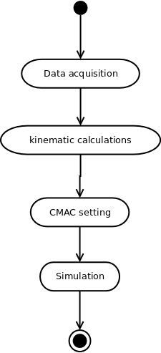
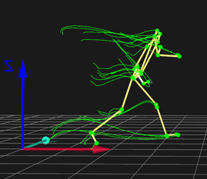


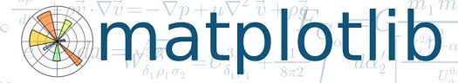
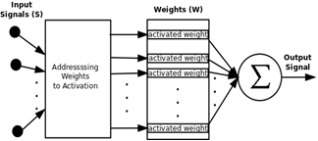
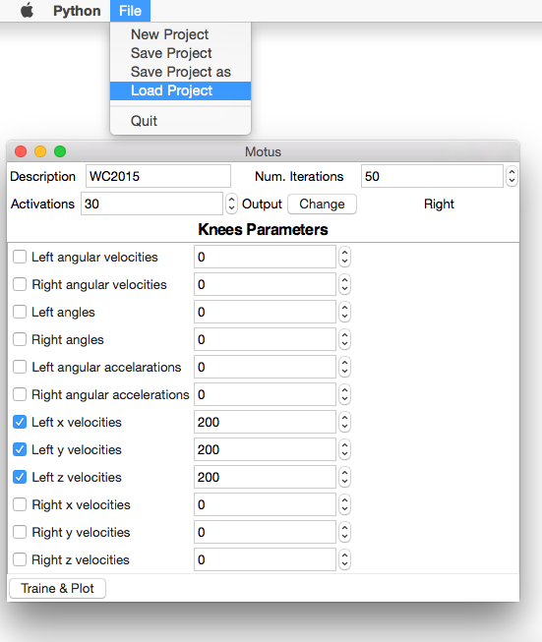


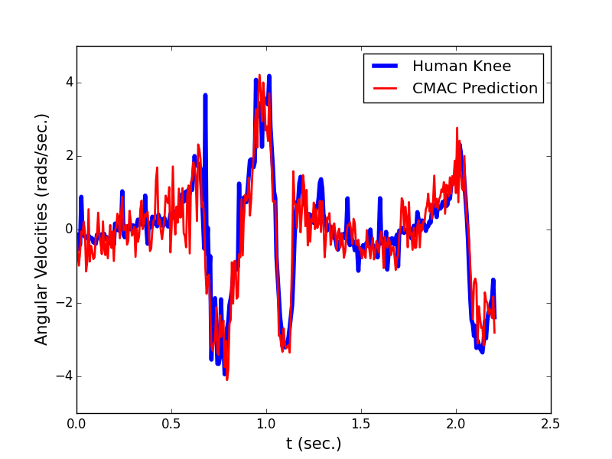

Human Knee Simulation Using CMAC ANN
R. A. Lima, V. R. F. S. Paz, J. P. Martins and L. M. Brasil
Abstract
This paper aims to show the use of a CMAC (Cerebellar Model Articulation Control), a kind of ANN (Artificial Neural Network), to simulate human knee signals. The CMAC is based on cerebellum of mammals, but despite this characteristic, actually what promotes its use, is its very fast operation, which contributes to turn it suitable for adaptive control in real time. This type of control is needed, for example, to control an active transfemoral prosthesis. Simulation of knee angular velocities, based on collected data from the contralateral knee, is presented. The simulation is available as open source software.
Methodology

Data acquisition using motion capture

Software developed using python technology

CMAC schematics
Results

Motus – Software for knee simulation

An example of simulation. The signal represents knee angular velocities. The input signals for this simulation are contralateral knee velocities.

Sponsors


Human Performance Laboratory at Faculty UnB Ceilândia

Project website:
http://github.com/rob-nn/motus

