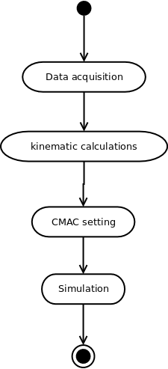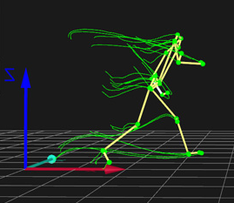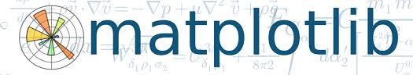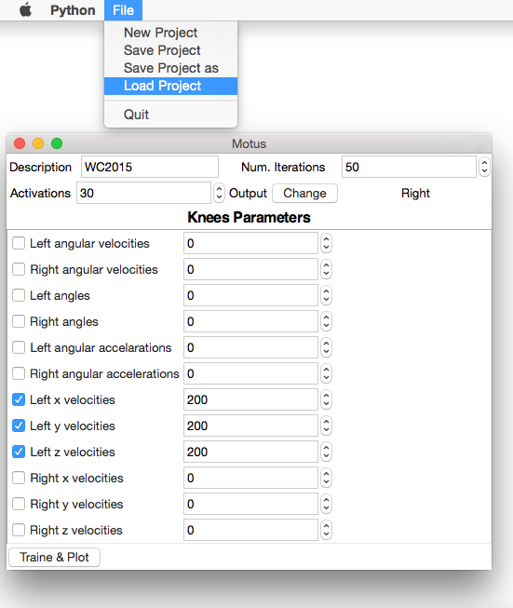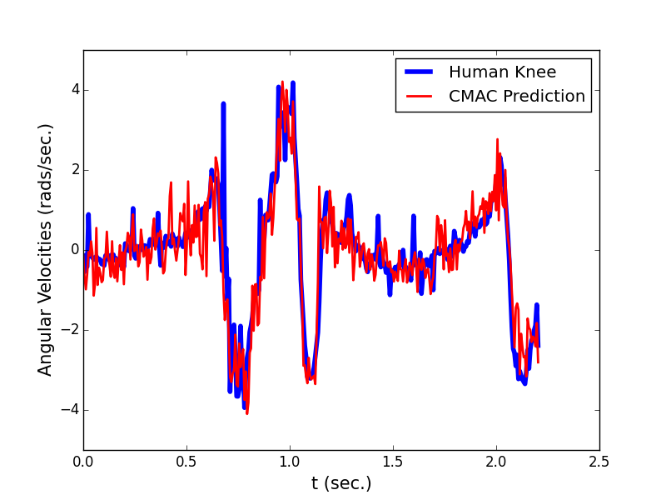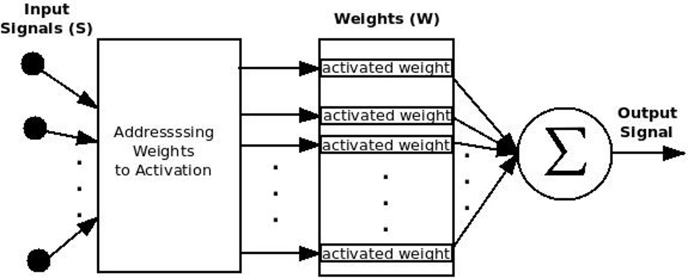

Human Knee Simulation Using CMAC ANN

R. A. Lima1, V. R. F. S. Paz1,2, J. P. Martins1 and L. M. Brasil1

1University of Brasília-UnB at Gama-FGA, Brasília, Brazil, 2University of Brasília-UnB at Ceilândia-FCE, Brasília, Brazil

**Abstract**

This paper aims to show the use of a CMAC (Cerebellar Model Articulation Control), a kind of ANN (Artificial Neural Network), to simulate human knee signals. The CMAC is based on cerebellum of mammals, but despite this characteristic, actually what promotes its use, is its very fast operation, which contributes to turn it suitable for adaptive control in real time. This type of control is needed, for example, to control an active transfemoral prosthesis. Simulation of knee angular velocities, based on collected data from the contralateral knee, is presented. The simulation is available as open source software.

**Methodology**

*Data acquisition using motion capture*

*Software developed using python technology*

Knee simulation process

*CMAC schematics*

**Results**

*Motus – Software for knee simulation*

*An example of simulation. The signal represents knee angular velocities. The input signals for this simulation are contralateral knee velocities.*

**Sponsors**

*****Human performance laboratory - University of Brasilia at Ceilândia*

***Project website:***

***http://github.com/rob-nn/motus***