**Budget Justification**

The budget (Figure 1, below) includes the costs required to complete the proposed work, and consists of salary support for the PI (2 months) and two graduate students (12 months each). It also includes costs for AWS compute, extra hard drive storage for a local server, travel for 2 1-day in person CZI meetings and open-access publication costs.

**Personnel**

Rob Patro (PI) will commit 2 months effort to this project. He will be responsible for helping to design and develop the methods and tools proposed in Aims 1 & 2. He will be responsible for mentoring and guiding the junior personnel, evaluating and reporting progress on the project, interacting with members of the collaborative network, and disseminating research results.

Avi Srivastava (graduate student) will commit 12 months effort to this project. He will be primarily responsible for helping to design, implement and test the methods proposed in Aim 1. He will be responsible for helping to analyze the results on both experimental and synthetic data, and will be responsible for integrating these methods into the Salmon software. He will assist in writing the relevant scientific manuscripts and presenting the relevant results at conferences and meetings.

Hirak Sarkar (graduate student) will commit 12 months effort to this project. He will be primarily responsible for helping to design, implement and test the simulator proposed in Aim 2. He will be responsible for helping to design the generative models, and to implement them efficiently to allow simulations to produce transcriptome-scale data for thousands of cells. He will assist in writing the relevant scientific manuscripts and presenting the relevant results at conferences and meetings.

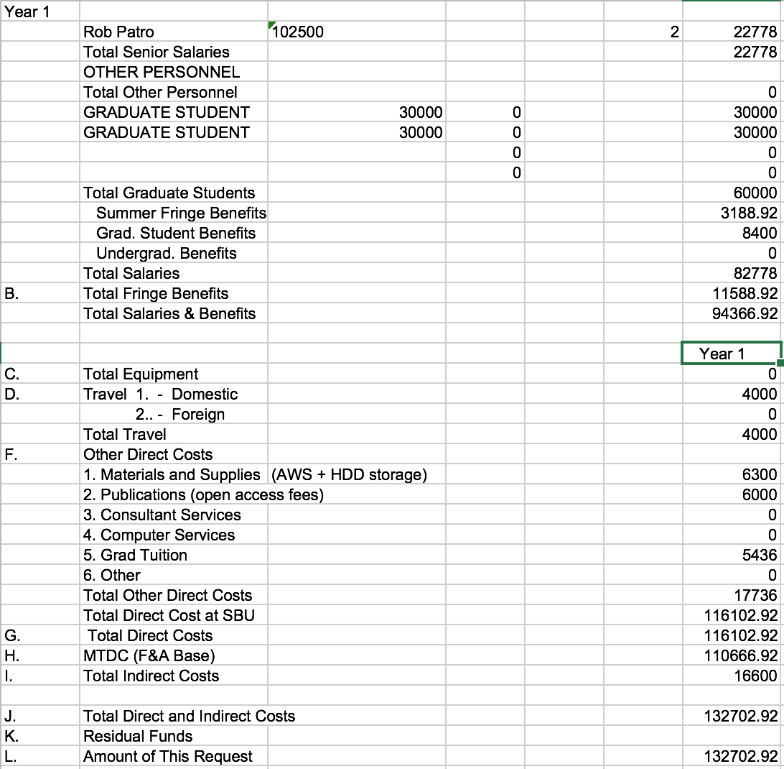

Figure Preliminary budget

**Materials & Supplies:**

We request ~$17,000 in materials, supplies and other costs which consists of:

* $4,000 to cover 2 1-day trips to meet with CZI personnel in person and discuss the project
* $5,000 for AWS compute credits to be used for large-scale processing of scRNA-seq samples with the methods we develop
* $1,300 for new storage capacity in our local servers to be used for this project
* $6,000 to cover open-access publication costs for 2 scholarly manuscripts