Databases Quiz
INSTRUCTIONS: This is just an informal test for me to check how much everyone knows about databases before we start on the module material. When you answer the quiz, please indicate what is the knowledge you already knew, what is the new knowledge learnt from the first week class.

1. What is Data?
2. What is a Database?
3. What is a relational Database?
4. What other Database architectures can you name?

5. What is an attribute?
6. What is a primary key?
7. What is a foreign key?
8. What is cardinality?
9. What is data integrity?
10. Explain Referential Integrity, give an example;

11. Explain the Join operation, give an example;
12. Explain the Division operation, give an example;
13. What is tuple in Relational Calculus?
14. What is domain in Relational Calculus?

15. How do you create a table in SQL, give an example;
16. How do you insert values into a table in SQL, give an example;
17. How do you update values into a table in SQL, give an example;
18. How do you list all the values in a table in SQL, give an example;
19. What is a table join, give an example of how you would do this in SQL
20. What is a table view, give an example of how you would do this in SQL

21. Do an ERD for the following scenario;
A doctor prescribes drugs

22. Do an ERD for the following scenario;

A student is registered for a programme within a faculty. Programmes consist of a number of courses. A course will not normally be available unless at least ten students are registered to present for examination in the current session. Students are required to attend a number of obligatory courses, and may opt for additional courses. All courses have a unique course code and are allocated a weighting in units. It is also necessary to record venue reservations for the purposes of assembling a timetable. This consists of course code, class group, day, time and venue. Two sets of venue reservations exist, one for each semester.

23. Reduce the following ERD from an N-to-N relationship;

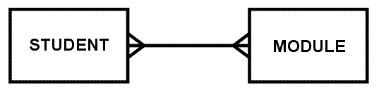
24. Outline your experience of using databases (educational and work)

