Lab 4:

Task1: You are requested to design a database to maintain information about hospital staff, including doctors and nurses, and patients at the hospital. The information we need includes:

* Staff, including their names, addresses and social-security numbers.
* Patients, including their names, addresses, and the name of their insurance company.
* Patients are each assigned to a ward (room).
* Those staffs who are nurses are assigned to zero or more wards. Each ward has at least one nurse assigned.
* Those staffs who are doctors are assigned to zero or more patients. Patients may or may not have a doctor assigned, and they may have more than one doctor. Patients in the same ward may have different doctors but will always have the same nurse(s).

Using ERWin to draw the crows feet ER model.

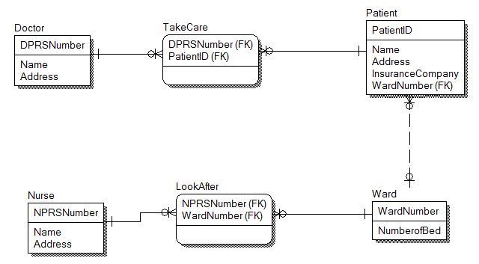

Task 2. Some large cities (e.g. Dublin, Cork) would like to start a car-sharing project to reduce the number of cars in the city and also reduce the cost of having a car available when needed for each individual. One car is partially owned by several people. The number of owners per car may vary. Also, each person can own a different percentage of the car, depending on how often he/she uses the car. Each person might own part of more than one car.

However, only one person can use the car at any particular day. A database model is needed to keep track of reservations made for the car.

Using ERWin design and draw a crows feet ER diagram to keep track of each car and the reservation of the car. Specify key attributes of each entity type and structural constraints on each relationship type. It should show clearly the mandatory and optional participation between the entities. Note any unspecified requirements, and make appropriate assumptions to make the specification complete.

