Lab:

**Part 1 - Erwin**

1. Using ERWIN, open the Film Club ERD.
2. In ERWIN, under physical model, select Action/forward engineer to output your design as a set of commands. Select “Preview “ to look at the SQL comments generated (i.e. the DDL) and see if you can understand it. Save your DDL in a file, E.g. **ClubDDL.SQL**

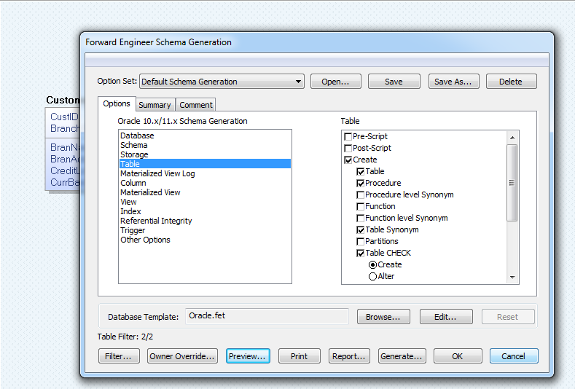

**Part 2 – using the DDL to create the club database**

In phpMyAdmin, create a new database, then run DDL in SQL to create all tables. You can also follow the “How to work with MYSQL” ppt to create tables, and insert some data into tables.