# Probability and Statistical Inference Lab

# Installing and using RCommander

* This lab is **OPTIONAL**. Plain R is sufficient for all the work we are doing in this module, but the RCommander GUI provides a faster way to explore the data.
* Whether you choose to try it out or not, command line R code will have to be used for the CA.
* RCommander can be a useful tool for discovering R, as it prints (to the console) the R commands behind the GUI actions, which means that you can use it as a learning tool.

STEPS:

1. Install and load the RCommander package on the command line in RStudio:
   1. Install the package with command:

install.packages("Rcmdr")

This may take several minutes.

NOTE: If you are working on a Mac you will need to download and install XQuartz before installing RCommander, please read the MacOS Installation notes at <https://socialsciences.mcmaster.ca/jfox/Misc/Rcmdr/installation-notes.html>

This YouTube video is also useful <https://www.youtube.com/watch?v=M1PVmz3_W5E> ****IGNORE installing R – you have already done this.

* 1. Load the package with the following command:

library(Rcmdr)

This should launch another application window as below which you will interact with for the rest of the lab:

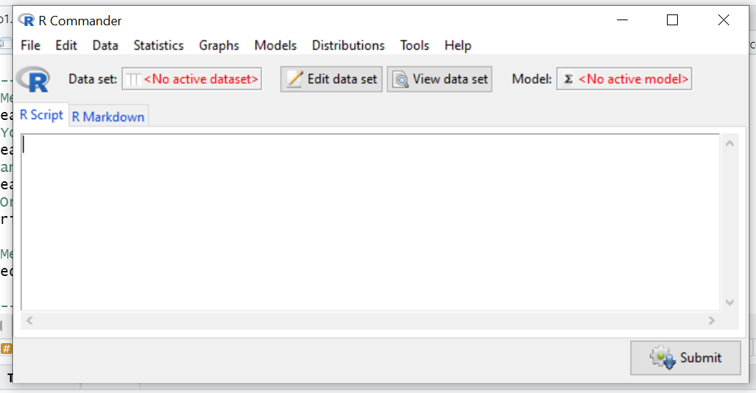

1. Load the Salaries dataset from carData

From the Data Menu Select Data in Packages and then select Read data from an attached package. The screen below should appear:

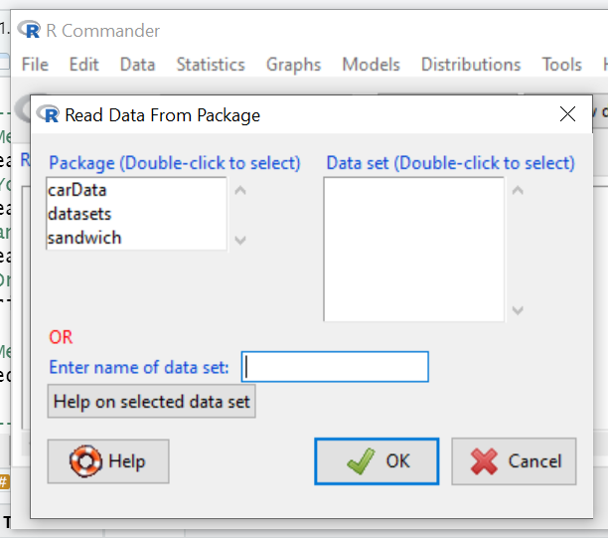

Double-click carData in the Package list and select Salaries from the list of datasets presented then click OK.

You will be presented with the screen below:

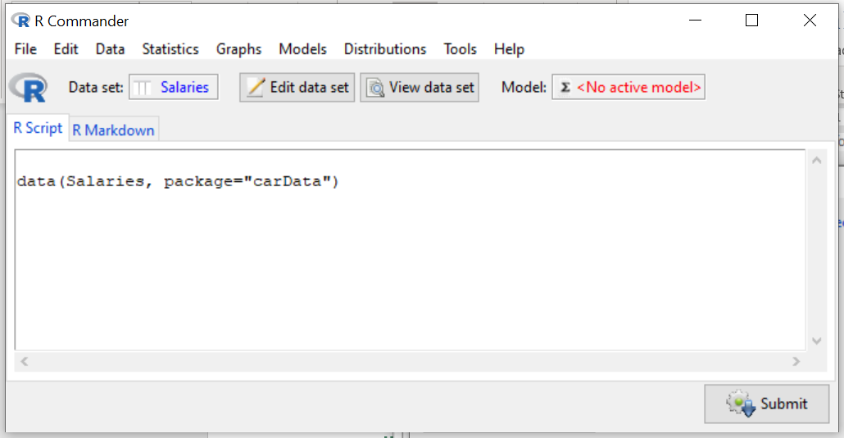

Click View Data set to look at the data.

1. Experiment with the Statistics Menu.
   1. Try creating some numerical summaries using the following menu path:

Summaries -> Numerical Summaries

Look at salary, years of service

* 1. Try creating numerical summaries for particular groups in your sample:

Summaries -> Numerical Summaries and then choose

Summarize by groups e.g. by gender or rank or discipline

* 1. Try creating some frequency distributions using the following menu path: Summaries -> Frequency Distributions
  2. Try creating some frequency distributions summarised by group – these are called contingency tables:

Summaries -> Contingency Tables

1. Experiment with the Graphs Menu
   1. Try creating a histogram of salary using the following menu path: Graphs -> histogram
   2. Try creating a density curve to see how close it is to the normal distribution using the following menu path
   3. Create a Stem and Leaf plot
   4. Create a Boxplot
2. Saving your work

You will notice as you work through the above that R code is being shown in the R Script window.

You can save this as a script and run this as an R script again without having to go through R Commander.

At any point File -> Save Script or File -> Save Script as … and save to a location you are happy with.



1. Entering your own R commands

You can enter your own R commands into the R Script window.

Try entering some of the commands from last week to see how it works.