4. Software
Use of AI tools in software design. We used an AI coding assistant (Claude Code by Anthropic) as a development tool throughout the software work. It helped us with three things. First, it built a software-in-the-loop simulator that runs our unmodified robot firmware on a PC (Section 4.c). Second, it ran large automated parameter studies in that simulator, such as tuning the heading controller and checking how close to the line the out-of-bounds handling lets the robot drive. Third, it reviewed the code and found defects; for each one it explained how it was found, and we could reproduce it in simulation. All design decisions, field tests and final parameter choices were made by the team. The AI tool made each test-and-tune cycle much shorter: we can run hundreds of simulated test runs in minutes, compared with a few physical runs per hour.

a. Overview
The robot runs two programs:
- Vision (OpenMV H7, MicroPython). The camera looks up into a mirror and sees the field all around the robot (omnidirectional vision). It finds the ball, the blue goal and the yellow goal by colour, measures the angle and distance to each one, and sends the results to the main controller over UART about 20–40 times per second.
- Control firmware (Arduino Mega 2560, C++17, PlatformIO). It reads the camera data, the BNO055 inertial sensor (IMU), the ball-capture phototransistor and the buttons. It calculates the robot's position on the field, picks a behaviour using a finite state machine, and drives four omni-wheels and a solenoid kicker.
Everything that can differ between our two robots (pins, motor layout, controller gains, out-of-bounds limits, camera calibration) is kept in one configuration file. The same source code is built for both robots.

b. General Software Architecture
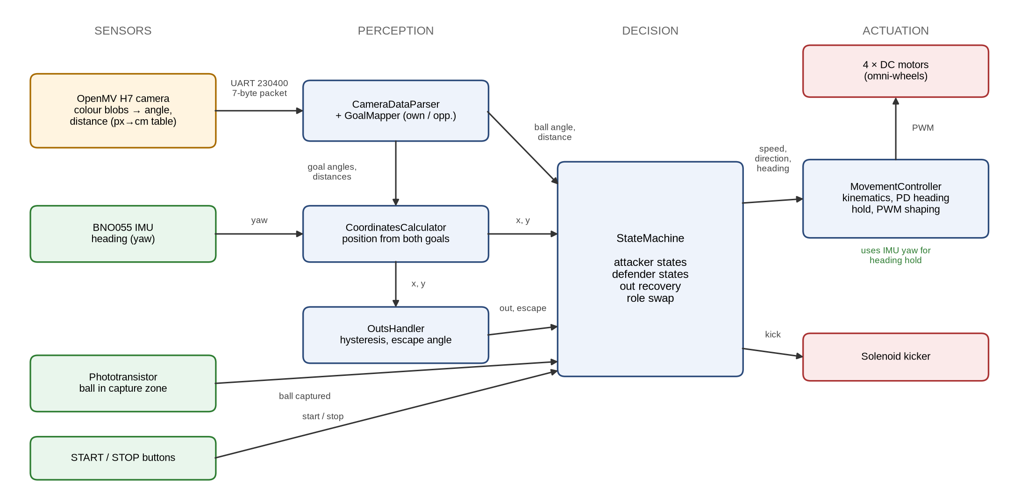
Figure 4.1 – Data flow between the sensors, the software modules and the actuators
The firmware is divided into four layers. Each layer uses only the layers below it (Table 4.1).
Layer | Responsibility | Main modules
Core | Hardware drivers, one class per device | Motor, Kicker, Dribbler, Led, BNO055, Button, Phototransistor, UART
Control | Turning sensor data into estimates and motor commands | CameraDataParser, CoordinatesCalculator, OutsHandler, MovementController, BallDetector, BallMotionWatcher, Timer
Management | Robot configuration and behaviour | RobotConfig / RobotType, GoalMapper, StateMachine, States, Robot
Utils | Shared algorithms | PID and PD + cubic (PDC) controllers, math helpers
Table 4.1 – Firmware layers
Vision pipeline. Each frame, the OpenMV program:
1. Masks everything outside the mirror, and hides the robot's own body.
2. Finds the goals as the largest blobs of the threshold colour (in the LAB colour space).
3. Finds the ball as the most round blob of its colour.
4. Calculates each object's angle from its position in the image relative to the calibrated image centre.
5. Converts its distance from the image centre (in pixels) to centimetres using a calibration table measured separately for each robot.
The six values (angle and distance for three objects) are sent in a 7-byte packet: a start byte, then each value scaled into one byte. This format keeps the link short and easy to check: a frame that does not start with the start byte is simply dropped.
Localization. The robot finds its position from both goals at once. The IMU gives the robot's heading on the field, so the angle to each goal can be turned into a vector in field coordinates. Each goal vector equals the robot position minus that goal's position. The goals sit symmetrically on either side of the field centre, so the average of the two vectors is the robot's position relative to the centre of the field. This needs no field map and no knowledge of the exact goal positions. The IMU zero heading is set once during start-up, with the robot facing the opponent goal.
Behaviour (finite state machine). The robot is always in exactly one state (Figure 4.2). Each state returns a motion command (speed, direction, target heading, kick) and decides which state comes next. Transitions are checked in a fixed order of priority:
1. Global events. The STOP button returns the robot to Idle. Leaving the allowed field area switches to Out Recovery from any state; when the robot is back inside, it returns to the state it left.
2. Role swap. If the ball has stayed still or out of sight for a set time, the attacker and the defender swap roles. A cool-down time prevents the roles from swapping back and forth.
3. The state's own transitions.
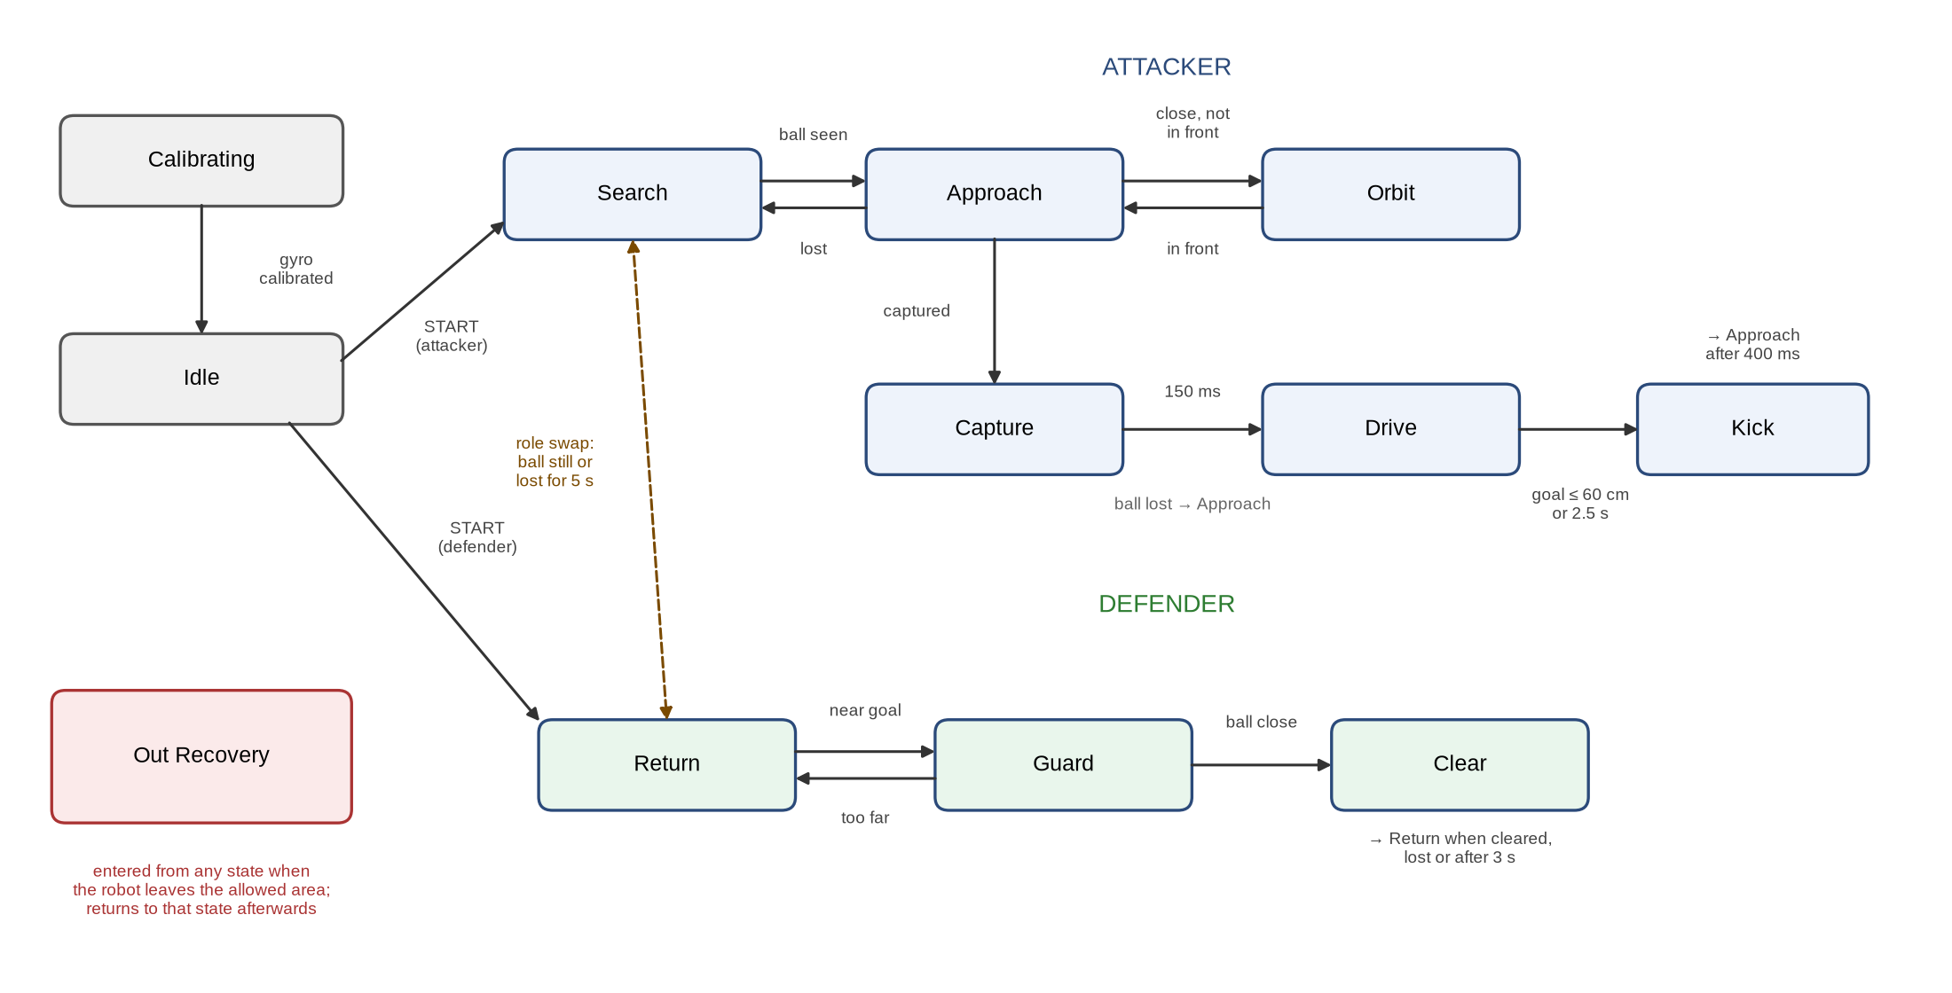
Figure 4.2 – Finite state machine of the robot behaviour
The attacker states are Search, Approach, Orbit (circling round the ball until it is in front), Capture, Drive (carrying the ball towards the goal) and Kick. The defender states are Return (to its own goal), Guard (moving along the goal) and Clear (pushing the ball away). All states are created once at start-up, so no memory is allocated while the robot is running.
Motion control. The robot drives on four omni-wheels mounted at 45°, 135°, 225° and 315°, so it can move in any direction while keeping the same heading. For the requested direction and speed, MovementController calculates each wheel's speed using the inverse kinematics of the wheel layout. It then adds a heading-correction term from a PD controller that uses the IMU yaw. Three further steps make the robot easier to control:
- Turn first. When the heading error is large, the driving speed is reduced in proportion to the error, so the robot turns first and then drives. Otherwise, on two of the wheels the driving and turning commands cancel out.
- Proportional scaling. If any wheel command would exceed the PWM limit, all four wheel commands are scaled down by the same factor, so the direction of travel does not change.
- Dead-zone compensation. Any non-zero wheel command is stretched up to the minimum PWM at which that robot's wheels start to turn. Without this, a wheel given a very small command does not turn and in practice brakes the robot.
Out-of-bounds handling. OutsHandler compares the estimated position with four limits, one per side of the field. The two axes (left/right and towards each goal) are handled separately, and each has its own hysteresis: once an out is detected, it is cleared only when the robot is back inside the limit by a set margin. The escape direction is the sum of the directions away from all the limits that were crossed. In a corner, the robot therefore leaves diagonally instead of alternating between the two sides.

c. Innovative Solutions
1. Software-in-the-loop simulator. We built a 2D simulator that compiles our real firmware for the PC. Only the hardware layer is replaced: pins, PWM, UART, IMU and buttons. Each simulated robot has its own virtual hardware, so up to four copies of the firmware can play in the same match. Debug programs (sketches) also run unchanged. To keep the simulator realistic:
- The camera model reuses the real calibration tables and the same packet encoding as the robot, and adds pixel noise, detection dropouts, frame latency and errors in the image centre calibration.
- The robot model includes motor inertia, the wheel dead zone, differences between motors, how the 8-bit and 16-bit timers on the ATmega2560 behave when the PWM value goes out of range, and IMU latency.
- A visual mode shows the field, the position the robot estimates against its real position, what the camera detects, and the robot's serial output (Figure 4.3). A batch mode runs hundreds of games or test scenarios automatically.
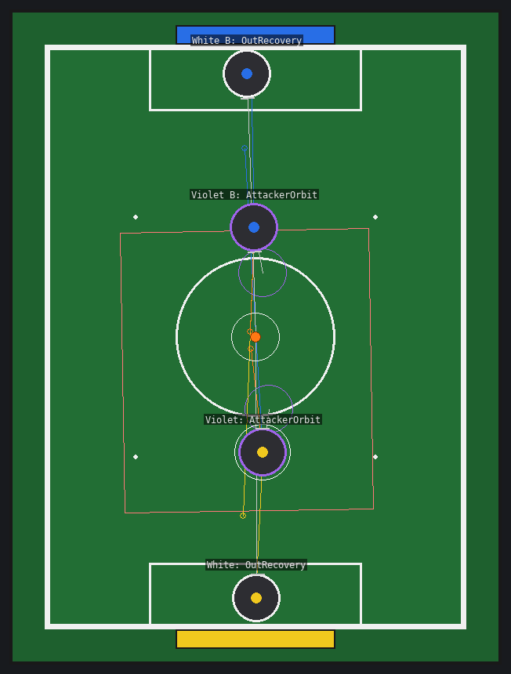
Figure 4.3 – Simulator: a 2 vs 2 match played by four copies of the real firmware (thin circles show where each robot thinks it is, coloured lines show what its camera detects, the rectangle shows its out-of-bounds limits)
2. Simulation-driven tuning and testing. Every change was checked across a range of robot conditions, not just one, because the real loop rate, wheel speed and motor differences are only approximately known. For example, we tested loop rates from 8 to 40 Hz, two wheel speeds and several motor dead zones. Examples are given in Table 4.2.
Problem | Finding in simulation | Result
Robot shaking around its own axis | The cubic term of the heading controller produced more than full motor power at a 15° error, so the robot kept swinging without settling in 13 of 32 simulated robot configurations | Cubic term removed and gains re-tuned: no sustained swinging in any configuration
Robot moving back and forth at the out-of-bounds limits | Sensor noise near a limit switched the out state on and off about 14 times per second | Hysteresis and diagonal escape: about 2.5 direction changes per second, and the robot never crossed the line
Robot turning with only one wheel while driving | Wheel commands below the dead zone braked the robot | Dead-zone compensation: all four wheels take part in turning
Table 4.2 – Examples of simulation-driven fixes
3. Single configuration for two robots. Each robot's hardware and calibration data are kept as named values in one configuration file and passed through the code as typed structures. The same firmware can be built for either robot, and the simulator reads the same values, so a tuning result found in simulation applies to the real robot directly.
Testing procedure. Each module has its own debug program: camera parser, coordinates, heading controller, out-of-bounds handling, motors, kicker and others. Each one prints its data over the serial port. We first test a module in the simulator and then on the field with the same debug program, and compare the printed values. Calibration data from field tests, such as the measured goal distances and the out-of-bounds limits, is entered back into the simulator, so the simulator stays close to the real robot.

d. Source code
The full firmware, the OpenMV program and the simulator are available on request. Short excerpts of the localization, out-of-bounds and motion-control code are given in Appendix A.

Appendix A. Source Code Excerpts
The excerpts below are taken unchanged from the robot firmware (C++17).
A.1 Localization from both goals (CoordinatesCalculator, see Section 4.b).
void CoordinatesCalculator::calculate_coordinates(gyroData gyro_data, cameraData data)
{
float angle_rad_own = radians(gyro_data.yaw + data.own_goal_angle);
float angle_rad_opp = radians(gyro_data.yaw + data.opp_goal_angle);

float x_own = data.own_goal_distance * sin(angle_rad_own);
float y_own = data.own_goal_distance * cos(angle_rad_own);

float x_opp = data.opp_goal_distance * sin(angle_rad_opp);
float y_opp = data.opp_goal_distance * cos(angle_rad_opp);

_coordinates.x = (x_own + x_opp) / 2;
_coordinates.y = (y_own + y_opp) / 2;
}

A.2 Out-of-bounds handling with hysteresis and diagonal escape (OutsHandler).
int8_t OutsHandler::_update_axis(int8_t state, float value, float high, float low)
{
if (value >= high)
return 1;
if (value <= low)
return -1;

// Back inside: clear the out only after the hysteresis
if (state == 1 && value < high - _hysteresis)
return 0;
if (state == -1 && value > low + _hysteresis)
return 0;
return state;
}

void OutsHandler::handle(coordinates coords, outsBounds outs)
{
_out_x = _update_axis(_out_x, coords.x, outs.right, outs.left);
_out_y = _update_axis(_out_y, coords.y, outs.front_goal, outs.rear_goal);

// Opposite to the crossed bounds: RIGHT -> -90, LEFT -> 90, FRONT -> 180, REAR -> 0, RIGHT + FRONT -> -135
if (in_out())
_escape_angle = round(degrees(atan2(static_cast<float>(-_out_x), static_cast<float>(-_out_y))));
}

A.3 Holonomic motion with heading hold (MovementController).
void MovementController::set_velocity(int16_t lin_speed, int16_t move_angle, int16_t align_angle, gyroData gyro_data)
{
int16_t error = align_angle - gyro_data.yaw;
if (error > 180)
error -= 360;
else if (error < -180)
error += 360;

float angular_speed = _align_control->calculate(error);

// Far from align_angle the robot turns first and drives after: otherwise on two of the wheels
// driving and turning cancel each other out and the robot turns with the other two only
float lin = lin_speed * constrain(1.0 - abs(error) / static_cast<float>(TURN_FIRST_ANGLE), 0.0, 1.0);

Motor *m[4] = {&_motors.m1, &_motors.m2, &_motors.m3, &_motors.m4};
int16_t loc[4] = {_loc_angles.m1_angle, _loc_angles.m2_angle, _loc_angles.m3_angle, _loc_angles.m4_angle};
float speeds[4];
float max_speed = 0;
for (int i = 0; i < 4; i++)
{
speeds[i] = m[i]->direction() * (lin * cos(radians(move_angle + loc[i])) + angular_speed);
max_speed = max(max_speed, fabs(speeds[i]));
}

// A wheel can't go faster than 255: slow all of them down equally so the direction stays the same
float scale = max_speed > 255 ? 255 / max_speed : 1;
for (int i = 0; i < 4; i++)
{
float speed = speeds[i] * scale;
// Below _min_pwm a wheel doesn't turn and Motor::run() actually brakes it, the other wheels then
// fight against it. Stretch every non-zero command to [_min_pwm, 255]
if (fabs(speed) >= 3)
speed = (speed > 0 ? 1 : -1) * (_min_pwm + fabs(speed) * (255 - _min_pwm) / 255.0);
else
speed = 0;
m[i]->set_speed(speed);
}
}

