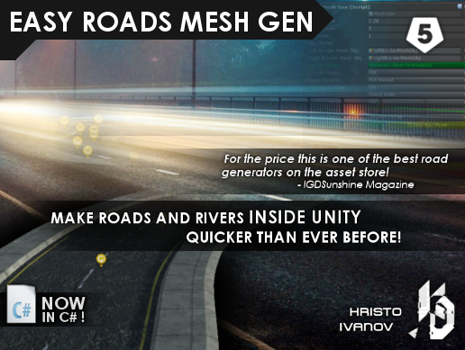

EASY ROADS MESH GEN

v2020

By Hristo Ivanov

ASP: Kris Development

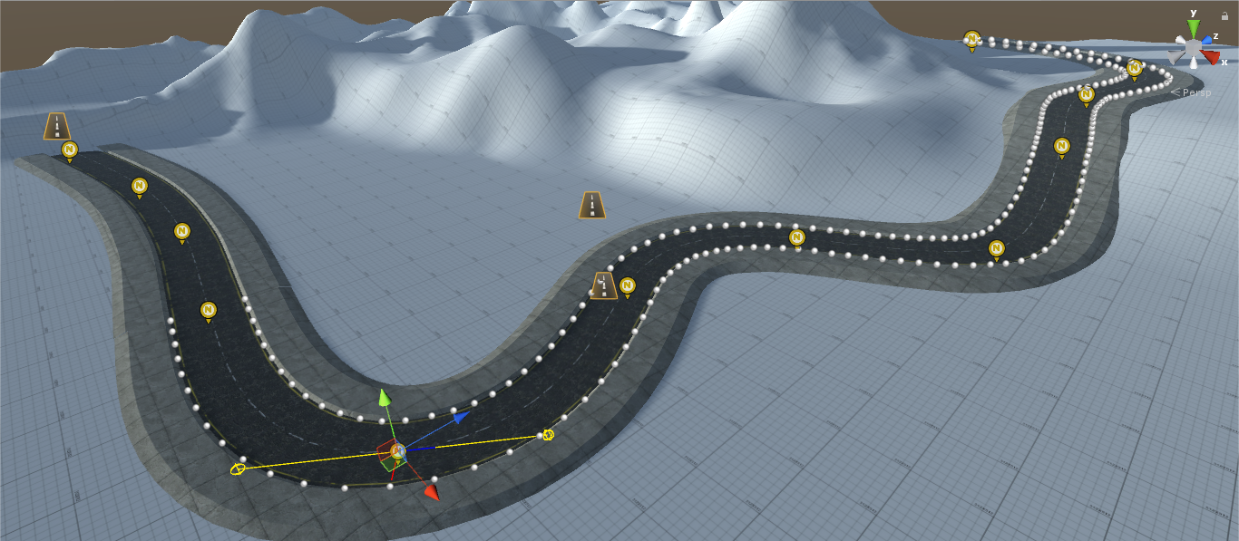

Introduction

Create roads and rivers without the need of 3D modeling software!

Easy Roads Mesh Gen allows for very fast and easy creation of roads and rivers inside Unity. It has easy to use, simple and organized interface which improves the workflow.

Just drag the navigation points where you want them and the tool will do the rest. Pick your own texture and apply it on top.

Instructions:

To use this tool you need to create an empty game object and assign the MeshGen.cs component to the empty object. You can also use the quick creation option by using right click and going to *Create > ER Mesh Gen*.

This will open up the Mesh Gen interface and will create a couple Navigation Points (Nav Point) in the scene.

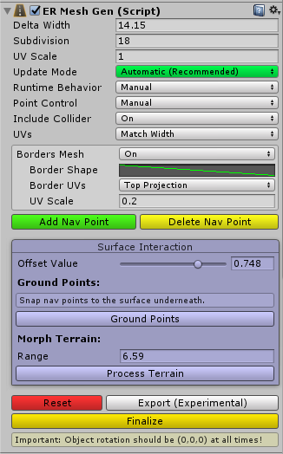

To extend the array of Nav Points click **"Add Nav Point".**

Use **"Delete Nav Point"** to delete the last added point.



The **"Update Mode"** menu changes the way the mesh is being updated (manually, vertices only, real time or automatically).

It is highly recommended to use **“Automatic”** as this option has the benefits of **“Realtime”** and runs only when the object is selected, which increases performance in the Editor.

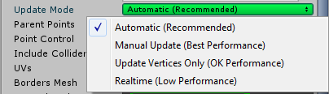

**"Delta Width"** represents the width of the generated mesh. Think of it as the width of the road.

Increasing **“Subdivision”** will make the road generate more vertices per segment, and anything higher than 1 will allow you to take advantage of the Bezier curve logic.

**“UV Scale”** is a modifier for the repetition of the generated UVs.

**"Include Collider"** will create mesh collider and update it every time the mesh is updated.

**"Point Control"** will change the way the points behave in the scene. The Full Manual option will let the user rotate and manually modify each point while Automatic will rotate and scale the points based on their position.

**"UVs"** control the way the texture is being drawn on top of the mesh.

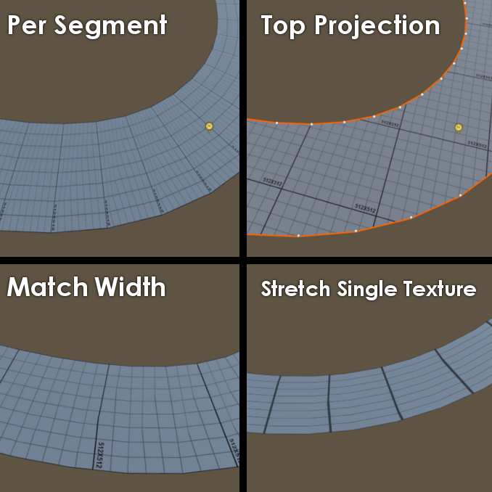

The **"Ground Points"** button will move all nav points to the surface of whatever object lies underneath, while keeping the specified offset. This is useful for roughly shaping roads on large terrain.

**“Morph Terrain”** will go through all underlying terrains (if there is more than one) and will modify them to roughly match the shape of the road. Some additional tweaking might be required afterwards, however this feature greatly reduces the amount of work required for matching the terrain with the road.

Road Borders:

There’s an option to generate road borders to use as sidewalks or to help connect the road better with the environment.

To enable them set “Borders Mesh” to ‘’On”

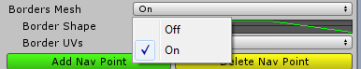

“Border Shape” allows you to practically draw the shape of the sidewalk/border to fit your needs. The curve represents a vertical section of the border mesh.

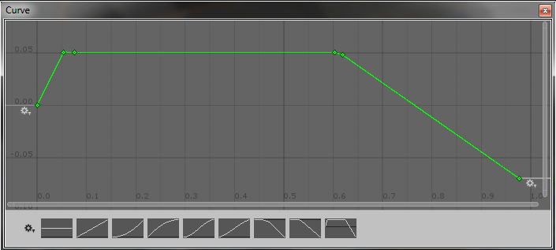

Right click anywhere on the coordinate window and select “Add Key” to create a new point, which you can drag around to modify the shape of the border mesh.

Final Steps:

"Finalize" will remove the script and delete all Nav Points leaving only the generated mesh. Use that if you are sure you no longer need to make changes to the generated mesh. This way you won’t need to worry about future version changes in the tool.

The package also includes "RiverFlow.cs" script which is used to create river-like effect by offsetting the coordinates of the material.

Array Extension:

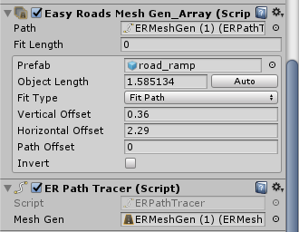

Places prefabs along the path data provided by ER Path Tracer. The Path Tracer component will draw data from the Mesh Gen using the access method:

*meshGen.GetOrientedPathPoints(horizontalOffset, verticalOffset);*

which returns a **List** of **OrientationData**.

(See *ERMG_Lib.OrientationData*)

FAQ: <https://forum.unity.com/threads/easy-roads-mesh-gen-faq-by-kris-development.469553/#post-3245339>

Report any problems with the tool at

[krisdevmail@gmail.com](mailto:krisdevmail@gmail.com)