# Tags and Elements

HTML enables us to "markup" our content to give it a meaningful structure. An HTML element is defined by a opening tag, some content, and an closing tag:

<tagname>Content goes here...</tagname>

Some examples of HTML elements:

<h1>My first heading</h1>

<p>My first paragraph</p>

*Some HTML elements have no content (like the <hr> element).

These elements are called empty elements and don't have an end tag, we'll cover these later.

## Exercise 1

Open the 'my_page.html' found in the 'exercises' folder by double clicking it. By default Windows will suggest the file is opened with a Web Browser as it has an ‘.html’ extension. In order for us to edit the raw HTML markup we have to open the file with a plain text editor such as Notepad.

To open ‘my_page.html’ in Notepad**, right click** the file and select 'Open with'

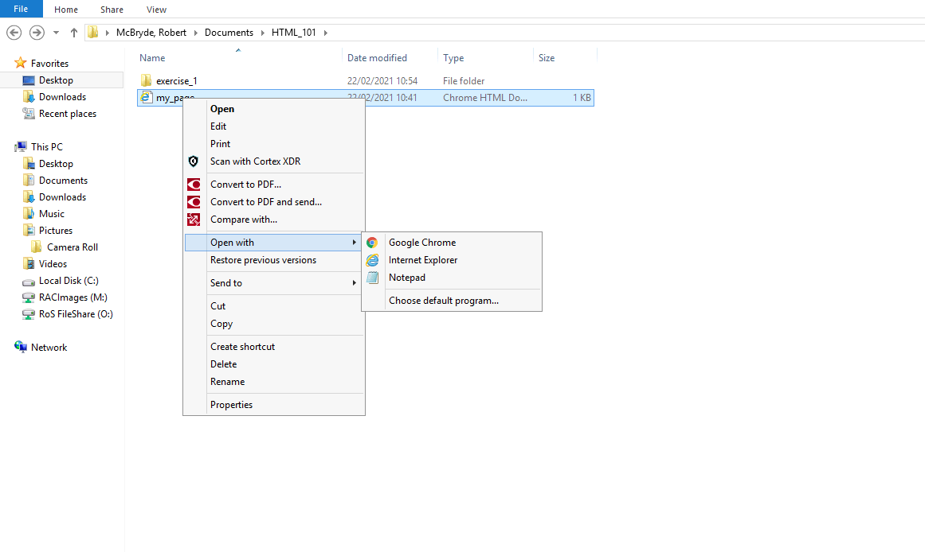

If you don’t see Notepad as an available option then click on the ‘Choose default program’. You will then be able to add it from ‘More options’.

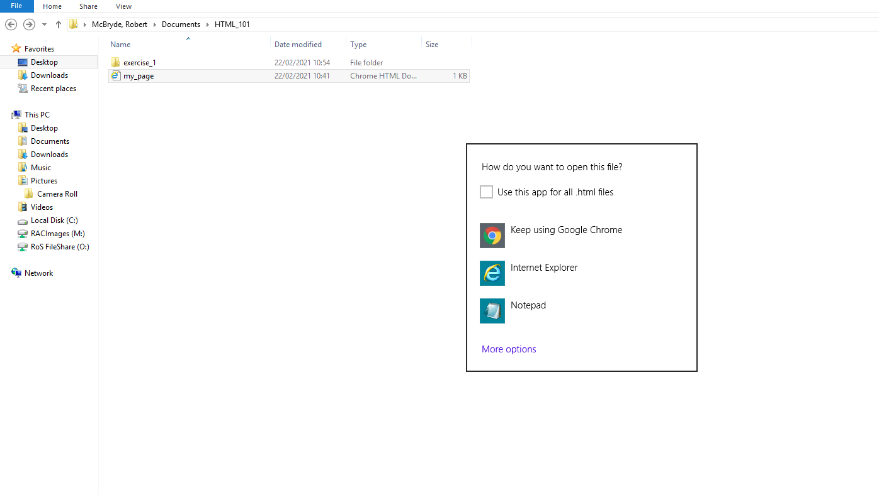

The first line in our HTML files tell the Web Browser this an HTML5 web page via the <!DOCTYPE html> line. This is just a special line that browsers look for when they try to display our web page, and it always needs to look exactly like this.

Then, our entire web page needs to be wrapped in <html> tags. The actual <html> text is called an “opening tag”, while </html> is called a “closing tag”. Everything inside of these tags are considered part of the <html> “element”, which is this ethereal thing that gets created when a web browser parses your HTML tags.

The <body> tags wrap the visible elements in our web page. Anything you put between the opening and closing body tags will be displayed to the end user.

Let’s start by adding a heading containing your name.

HTML provides six levels of heading, and the corresponding elements are <h1>, <h2>, <h3>,…<h6>. The higher the number, the less prominent the heading.

The first heading on a page should typically be a <h1>, so let’s add one containing your name between the <body> opening and closing tags:

<h1>Your Name</h1>

Your HTML should look something like this (the spacing is not mandatory and is ignored by the Web Browser but its good practice to help keep you code clean and easier to read as it grows in size)

<!DOCTYPE html>

<html>

<body>

<h1>Rob McBryde</h1>

</body>

</html>

Save the file and open the 'my_page.html' file in your Web Browser. This can be done via right clicking the file, selecting ‘Open with’ and this time selecting a Web browser rather than Notepad.

You should see your name displayed as a heading:

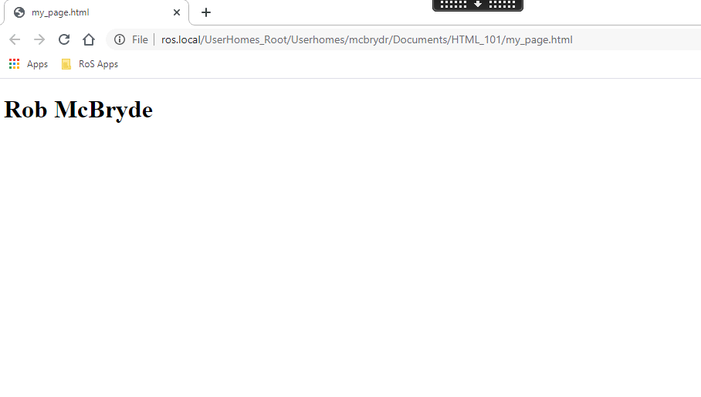

## Troubleshooting

If you aren't seeing your heading, carefully check your HTML tags are nested in the correct order. It's important to ensure there are no overlapping elements.

For instance, the <h1> element is supposed to be inside of the <body>, so you never want to add the closing </body> tag before closing the </h1> tag.

e.g. (DON'T EVER DO THIS)

<body>

<h1>Rob McBryde</body>

</h1>