PeetBros Signals measured at Pin 2 and Pin 3 at the Mega (to ground).

Pin 2. Yellow Trace
Pin 3 Green Trace

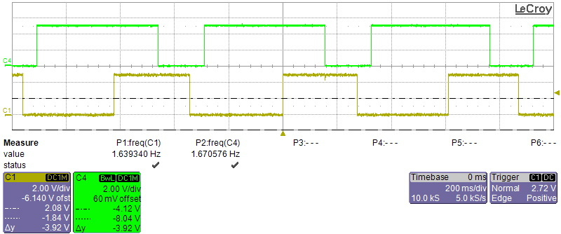
0 Degrees
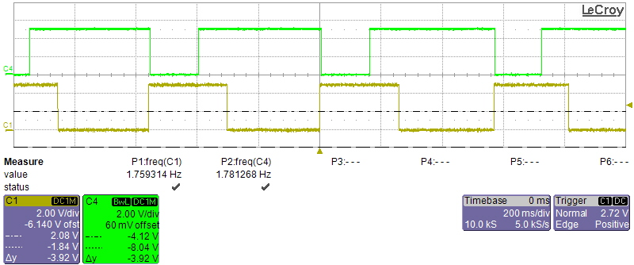
90 Degrees CW
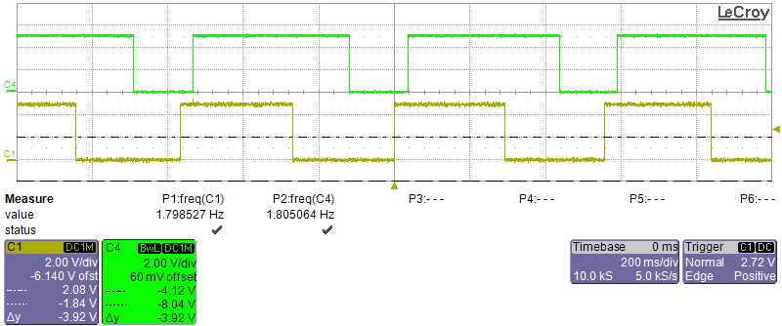
180 Degrees CW
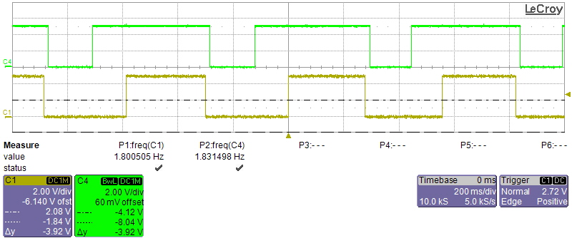
270 Degrees CW

