Freeboard Installation Notes

Install Raspberian from NOOBS as per instructions.

Configure Locale, Timezone, Keyboard, Overclock (medium) and SSH (enabled)

Use Linix to compile freeboard-server code. Could not get code compiled on Windows to work. It is probably something to do with line endings but I could not find it. Compiled the system using Oracle VM Virtual Box with Ubuntu and NetBeans.

Set FileZilla to use a Bridged Network Adapter.

Use FileZilla to transfer the “largest” file from the target directory to /home/Pi using sftp.

Use FileZilla to transfer install_rpi.sh to /home/pi.

Use putty to connect to the RPi.

Do a chmod 777 install_rpi.sh to enable all permissions.

Follow Robert's instructions for installation.

***** The very end of the installation process.
.
.
.

inflating: freeboard-server-0.5.19-SNAPSHOT/freeboard/install_rpi.sh
inflating: freeboard-server-0.5.19-SNAPSHOT/freeboard/DNS_NOTES.txt
inflating: freeboard-server-0.5.19-SNAPSHOT/freeboard/startpc.sh
update-rc.d: using dependency based boot sequencing
update-rc.d: using dependency based boot sequencing
update-rc.d: using dependency based boot sequencing
sudo: unable to resolve host freeboard
sudo: unable to resolve host freeboard
sudo: unable to resolve host freeboard
sudo: unable to resolve host freeboard
sudo: unable to resolve host freeboard
mkdir: cannot create directory `/etc/hostapd': File exists
mv: cannot stat `/etc/hostapd/hostapd.conf': No such file or directory
pi@raspberrypi ~ $

*******************************

Edit /etc/network/interfaces as per Rob's instructions
File after editing

********************************
auto lo

iface lo inet loopback

iface eth0 inet dhcp

#allow-hotplug wlan0
#iface wlan0 inet manual
#wpa-roam /etc/wpa_supplicant/wpa_supplicant.conf
#iface default inet dhcp

#Run as wireless access point
auto wlan0
iface wlan0 inet static
address 192.168.0.1
netmask 255.255.255.0
gateway 192.168.0.1

**********************************
Freeboard ConfigPanel must have:

/dev/ttyUSB0,/dev/ttyUSB1,/dev/ttyUSB2,/dev/ttyACM0,/dev/ttyACM1,/dev/ttyACM2

as the devices and 38400 as the Baud.

Tried to hook up BU353 and set BaudRate to 4800. That got the GPS but not the MEGA.

Used SirfDemo software to set the BU-353 Baud. The change is supposed to be temporary.

Update freeboard-server without reinstall

Running headless, connect to the RPi using putty or similar at address 192.168.0.1

Then find the PID of the running java process and then kill it. See the screednshot below.

FuleZilla or similar can be used to put the new freeboard-server files in the appropriate places in /home/pi.

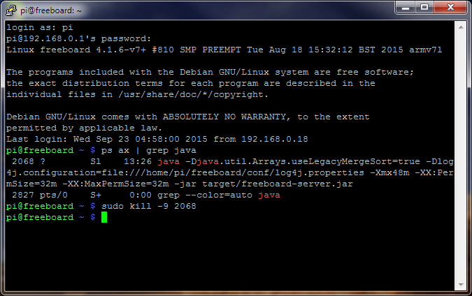

Configure Touchscreen Display

/boot/config.txt
*********************

# For more options and information see
# http://www.raspberrypi.org/documentation/configuration/config-txt.md
# Some settings may impact device functionality. See link above for details

# uncomment if you get no picture on HDMI for a default "safe" mode
#hdmi_safe=1

# uncomment this if your display has a black border of unused pixels visible
# and your display can output without overscan
#disable_overscan=1

# uncomment the following to adjust overscan. Use positive numbers if console
# goes off screen, and negative if there is too much border
#overscan_left=16
#overscan_right=16
#overscan_top=16
#overscan_bottom=16

# uncomment to force a console size. By default it will be display's size minus
# overscan.
#framebuffer_width=1280
#framebuffer_height=720

# uncomment if hdmi display is not detected and composite is being output
hdmi_force_hotplug=1

# uncomment to force a specific HDMI mode (this will force VGA)
hdmi_group=2
hdmi_mode=87
hdmi_cvt 800 480 60 6 0 0 0

max_usb_current=1

# uncomment to force a HDMI mode rather than DVI. This can make audio work in
# DMT (computer monitor) modes
#hdmi_drive=2

# uncomment to increase signal to HDMI, if you have interference, blanking, or
# no display
#config_hdmi_boost=4

# uncomment for composite PAL
#sdtv_mode=2

#uncomment to overclock the arm. 700 MHz is the default.
arm_freq=900

# NOOBS Auto-generated Settings:
hdmi_force_hotplug=1
config_hdmi_boost=4
overscan_left=24
overscan_right=24
overscan_top=16
overscan_bottom=16
disable_overscan=0
core_freq=250

****************************

Attempt to copy of config.txt using FioleZilla failed. Had to enter the changes with nano.

Install UPS PICO.

See UPS PICO BL_FSSD_1.0.pdf , “RaspberryPi Fail Safe Shutdown and RaspberryPi RUN”.

Transfer picofssd.pi to /home/pi using FileZill or some other method.

Use nano to edit /etc/rc.local as per instructions.

Add the picofssd.py to /home/pi

****************************

# Import the libraries to use time delays, send os commands and access GPIO pins
import RPi.GPIO as GPIO
import time
import os

GPIO.setmode(GPIO.BCM) # Set pin numbering to board numbering
GPIO.setup(27, GPIO.IN, pull_up_down=GPIO.PUD_UP) # Setup pin 27 as an input
GPIO.setup(22, GPIO.OUT, pull_up_down=GPIO.PUD_UP) # Setup pin 22 as an output

while True: # Setup a while loop to wait for a button press
GPIO.output(22,True)
time.sleep(0.4) # Allow a sleep time of 1 second to reduce CPU usage
GPIO.output(22,False)
if(GPIO.input(27)==0): # Setup an if loop to run a shutdown command when button press sensed
os.system("sudo shutdown -h now") # Send shutdown command to os
break

time.sleep(0.4) # Allow a sleep time of 1 second to reduce CPU usage

********************************

Have tested shudtown and startup and it seems to be working.

Install a new version of freeboard-server w/o reinstall.

Running headless, connect to freeboard using putty at address 192.168.0.1

Halt freeboard-server by stopping java. Then kill the process.

Use FileZilla or WinSCP to transfer new distribution to the appropriate places in /home/pi.

GPS Notes

Be careful with using Sirfdemo. You must switch the protocol back to NMEA in order to use GPS in freeboard.

