Installed Arduino IDE 1.5.7

Installed Eclipse

Added AVR plugin from http://www.baeyens.it/eclipse/ using Help>Install new software

Added eGit plugin but found it was already installed.

Installed Git

Installed GitHub

Executed command in Windows Powershell

Windows PowerShell
Copyright (C) 2009 Microsoft Corporation. All rights reserved.

C:\Users\RBerliner\Documents\GitHub> dir

Directory: C:\Users\RBerliner\Documents\GitHub

Mode LastWriteTime Length Name
---- ------------- ------ ----
d---- 5/9/2015 8:32 PM Arduino_Atmega

C:\Users\RBerliner\Documents\GitHub> git clone https://github.com/rob42/Freeboar
dPLC_v1_2.git
Cloning into 'FreeboardPLC_v1_2'...
remote: Counting objects: 125, done.
remote: Compressing objects: 100% (99/99), done.
remote: Total 125 (delta 22), reused 125 (delta 22), pack-reused 0
Receiving objects: 100% (125/125), 914.66 KiB | 763.00 KiB/s, done.
Resolving deltas: 100% (22/22), done.
Checking connectivity... done.
C:\Users\RBerliner\Documents\GitHub>

Started Eclipse. Did File>Import select Git/Projects from Git. Next.
Select ExistingLocalRepository, Next.

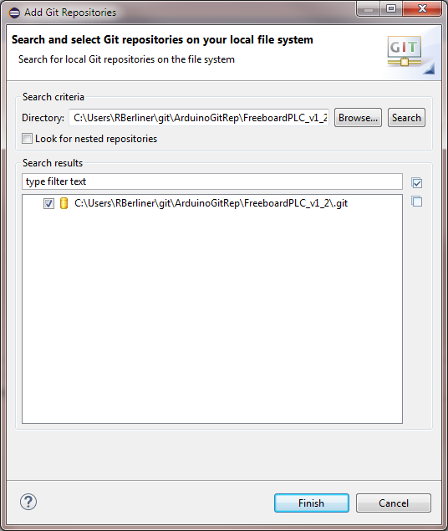
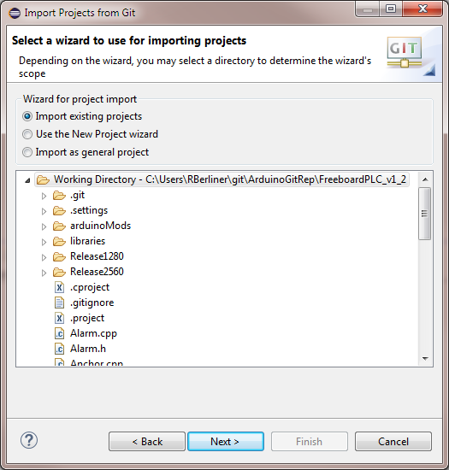
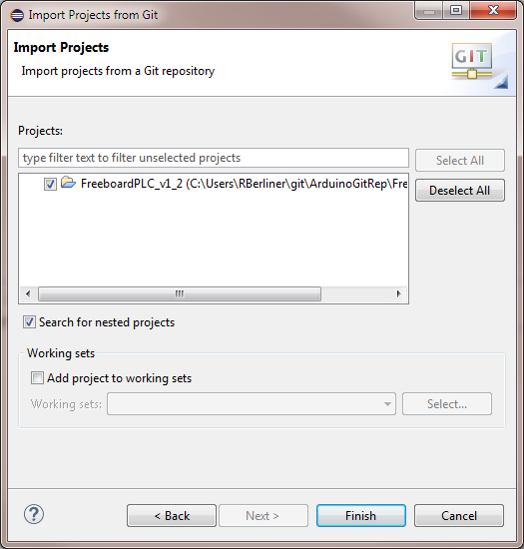
Finish

Right-click on Package select Properties, then Arduino and configure for MEGA. Make sure to ManageConfigurations and set the active configuration.

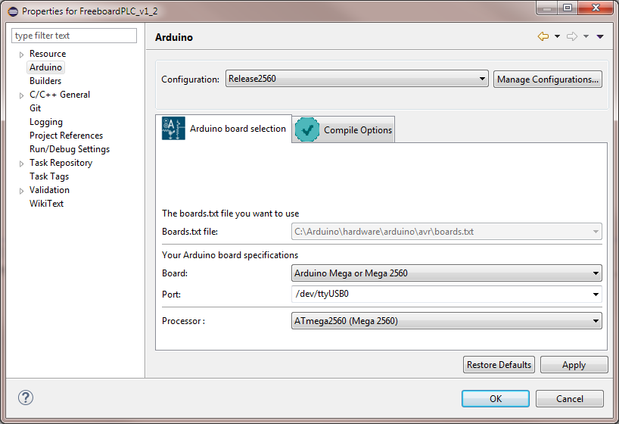
In C/C++ General, Enable projects specific settings.

See the README.txt in the arduinoMods in the Package and follow instructions.

Copy the mingw32-make.exe from C:\MinGW\bin into C:\Arduino\hardware\tools\avr\bin and rename make.exe.

To upload the new binary to the MEGA, use the following command. Check location of hex file and the COM port before proceeding.

C:\Users\RBerliner>C:\Arduino/hardware/tools/avr/bin/avrdude -CC:\Arduino/hardware/tools/avr/etc/avrdude.conf -v -v -v -v -patmega2560 -cwiring -PCOM26 -b115200 -D -Uflash:w:C:\Users\RBerliner\git\ArduinoGitRep\FreeboardPLC_v1_2\Release2560/FreeboardPLC_v1_2.hex:i

Test wind NMEA sentences from MEGA and it is working

Using putty Baud 38400 8, none, XON/XOFF sample output below

Initializing..
default to 38400..
Setting GPS config...
Setting GPS to EM_406A
$PSRF100,1,38400,8,1,0*3D
Start GPS Rx - serial1 at 38400
Start nmea Rx - serial2 at 9600
Start nmea Rx - serial3 at 9600
Start SPI uarts..
CS_PIN set to OUTPUT
CS_PIN OUTPUT = HIGH
Start nmea Rx - serial4 at 9600
MultiSerial::begin
SPI started
SPI UART reset
SPI init complete
Start nmea Tx..
Start nmea Tx - on pins 46 Tx, 48 Rx at 0
Init autopilot..
MultiSerial::begin
SPI started
SPI init complete
Init autopilot..start PID..
Init autopilot..set limits..
Init autopilot complete
Start wind..
Start timer..
Setup complete..
DEBUG:wsMicrosLast >= wsMicros || wsMicros - wsMicrosLast < MICROS_DEBOUNCE
!!VER:1.9,UID:MEGA,APX:0,APS:C,AAX:0,AAR:40.00,WSX:0,WSK:99,
DEBUG:wsMicrosLast >= wsMicros || wsMicros - wsMicrosLast < MICROS_DEBOUNCE
!!VER:1.9,UID:MEGA,APX:0,APS:C,AAX:0,AAR:40.00,WSX:0,WSK:99,
$WIMWV,270.0,R,0.00,N,A*16
DEBUG:wsMicrosLast >= wsMicros || wsMicros - wsMicrosLast < MICROS_DEBOUNCE
!!VER:1.9,UID:MEGA,APX:0,APS:C,AAX:0,AAR:40.00,WSX:0,WSK:99,
DEBUG:wsMicrosLast >= wsMicros || wsMicros - wsMicrosLast < MICROS_DEBOUNCE
!!VER:1.9,UID:MEGA,APX:0,APS:C,AAX:0,AAR:40.00,WSX:0,WSK:99,
$WIMWV,270.0,R,0.00,N,A*16
DEBUG:wsMicrosLast >= wsMicros || wsMicros - wsMicrosLast < MICROS_DEBOUNCE
!!VER:1.9,UID:MEGA,APX:0,APS:C,AAX:0,AAR:40.00,WSX:0,WSK:99,
DEBUG:wsMicrosLast >= wsMicros || wsMicros - wsMicrosLast < MICROS_DEBOUNCE
!!VER:1.9,UID:MEGA,APX:0,APS:C,AAX:0,AAR:40.00,WSX:0,WSK:99,
$WIMWV,270.0,R,0.00,N,A*16
DEBUG:wsMicrosLast >= wsMicros || wsMicros - wsMicrosLast < MICROS_DEBOUNCE
!!VER:1.9,UID:MEGA,APX:0,APS:C,AAX:0,AAR:40.00,WSX:0,WSK:99,
DEBUG:wsMicrosLast >= wsMicros || wsMicros - wsMicrosLast < MICROS_DEBOUNCE
!!VER:1.9,UID:MEGA,APX:0,APS:C,AAX:0,AAR:40.00,WSX:0,WSK:99,
$WIMWV,270.0,R,0.00,N,A*16
DEBUG:wsMicrosLast >= wsMicros || wsMicros - wsMicrosLast < MICROS_DEBOUNCE

Used git gui to revert changes on gps.cpp and rebuilt system with Autobaud back in.

Checked timeout for Autobaud and it is nearly 4 minutes!

