Issue 1 : 400 Bad request error for valid request
Paylaod
{
"dataset_id": "0085581",
"resource_id": "DR0104300",
"version_id": "1",
"dry_run": false
}

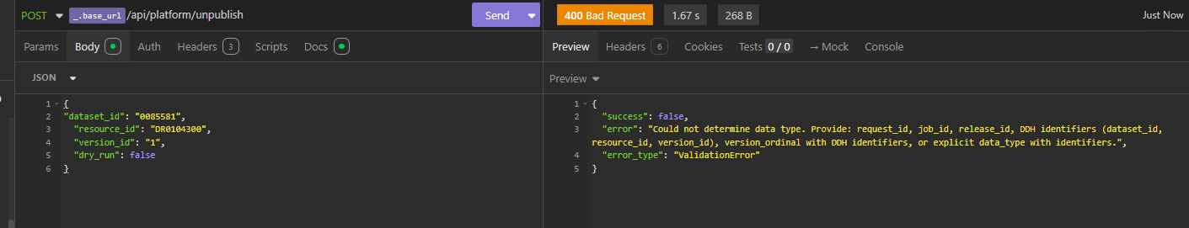

Issue 2 : Job is failing and resubmit required every time
Submit payload
{
"dataset_id": "0085581",
"resource_id": "DR0104298",
"version_id": "1",
"dry_run": false
}

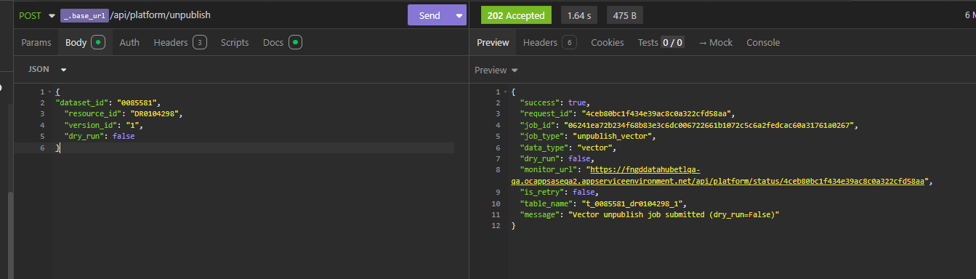
Job Failed
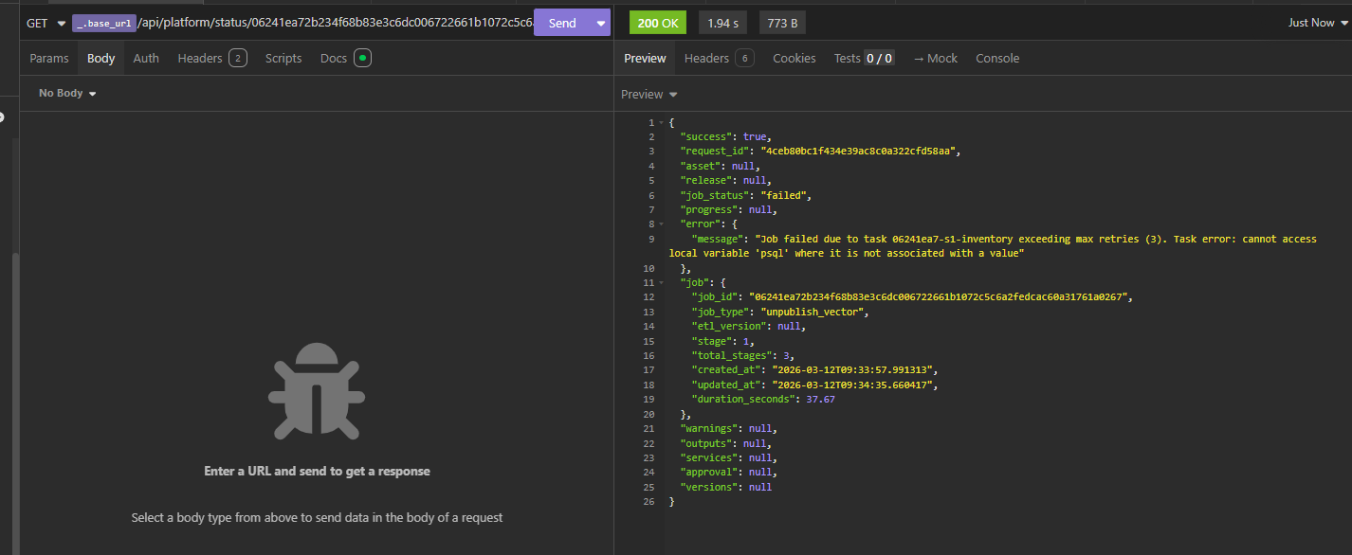
Resubmitted request in “resubmit” end point
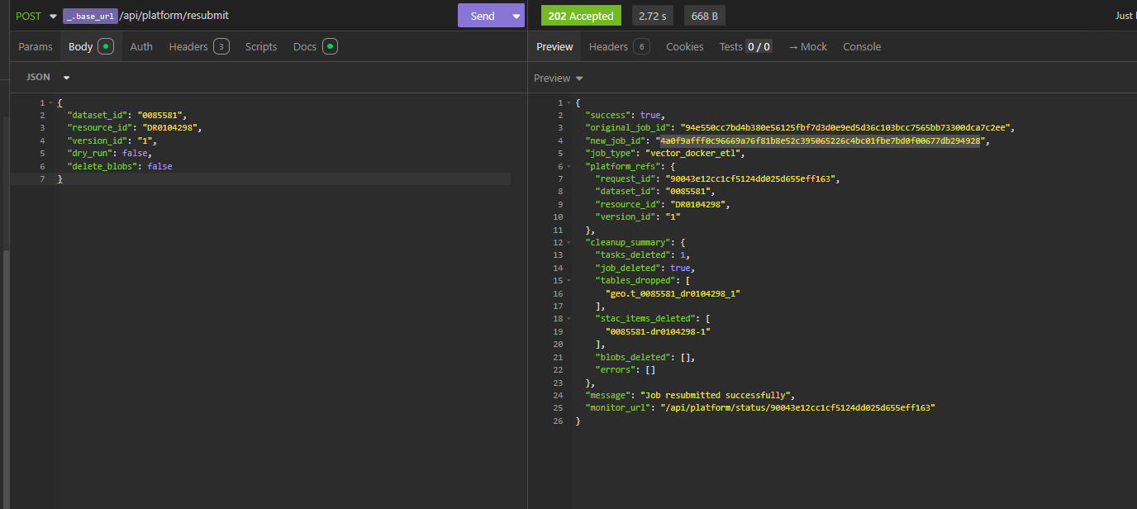
Now job status is completed.

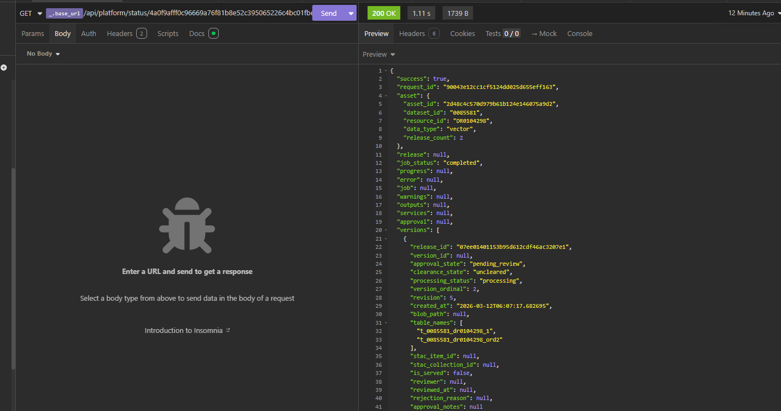

Issue 3 : Noticed file is deleted during unpublish even if we have
"delete_blobs": false
Param during resubmit also

