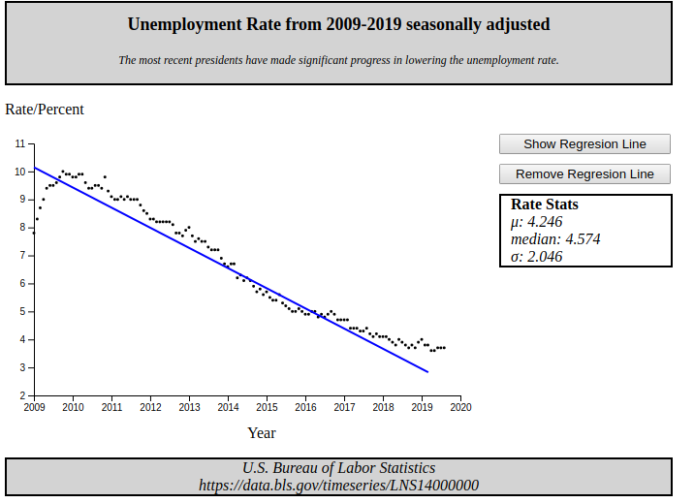
Several data points
Accurate Scaling
Medium sized data set is coherent
Title and source(s)
Data is relevant to Hypothesis
Interactive scatter plot. View at:
https://robdevs.github.io/dataVis/scatterPlot/

