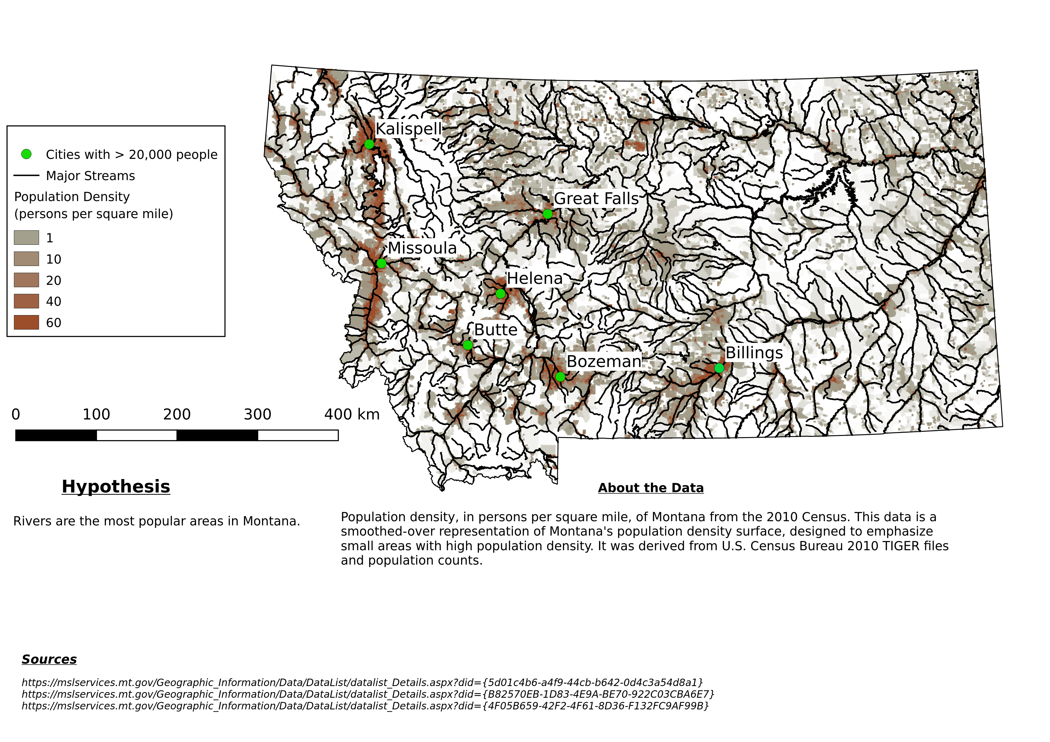
Labled Points of interest
Multiple levels of data
Does not lie about data
Large data set made coherent
Data is not cluttered (Did not graph every town)
Scaled evenly
(2010)

