Part 1 – Scripting Requirments

Contents

1. Scripting Requirments 3

2. Psuedocode (subject to change) 4

3. Security Recommendation 8

1. Scripting Requirments
   1. Automation

The part where automation will be required in Customer Quiz wil be the checking of the user input againts the correct answer of each question.

1. One array that holds the types of pizzas, used for check boxes
   1. By deffault, array listed should be sorted from popular to most popular
   2. From user input view, sorted alphabetically
2. One array for the user input
3. One array for the correct answers

The other automation is the assigning of values to the answers.

* If questions 1-3 are correct – 10 points
* If question 4 selects either the three most popular pizzas – 10 points
  1. Control Structure

1. Answers will be sent on a onClick event
2. For loop for checking the correct answers, and distributing points.
3. Calculation and diplay of score done in the end.
4. Psuedocode (subject to change)
   1. Methods to try

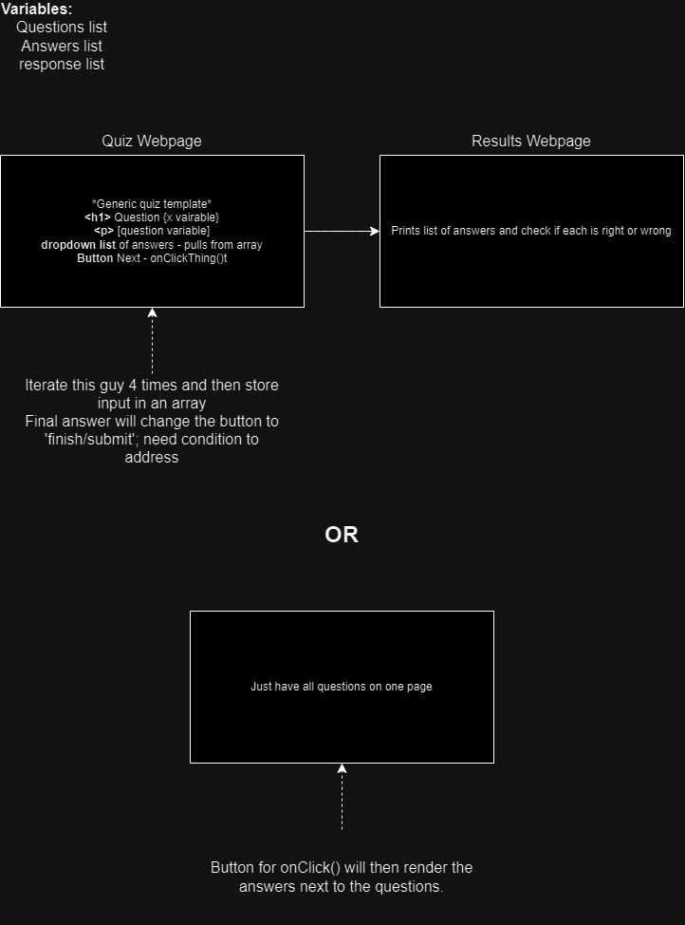

*\*Use the latter/or something along those lines*

* 1. HTML

<div>

<div class=”tab”> <!—id=”questions 1 through 5”-->

<button value=”question x”/>

<div/>

<div>

<label question 1/>

<select/>

<label question 2/>

<select/>

<label question 3/>

<select/>

<label question 4/>

<select/>

<button value=”submit” onClick=’doSomething’/>

</div>

<div>

<button value=”back”/>

<button value=”next”/>

</div>

<p id=”score”></p>

</div>

* 1. JavaScript OLD

topPizzas [15] // descending order

correctAnswer[4]

userInput[4]

let score = 0

select values = topPizzas.sort(sort alphabetically) // hide truth from user

onClick ’doSomething’()

userInput[x] == document.getElementbyId(question x select value) × 4

for the length of correctAnswer array

If user input[] == correctAnswer[]

Score += 10

If iteration is == 4

If user input[] is found in the substring topPizzas array (extract first 3)

Document.getElementById(….).innerHTML = score

* 1. JavaScript NEW

Use this. Syntax is innacurate to final code, however, it should be along these lines.

topPizzas [15] // descending order

correctAnswer[4]

userInput[4]

let score = 0

select values = topPizzas.sort(sort alphabetically) // hide truth from user

onClick ’doSomething’()

userInput [0] = select box value for question 1

userInput [1] = select box value for question 2

userInput [2] = select box value for question 3

userInput [3] = select box value for question 4

for i the length of correctAnswer.length - 1 () // For first 3 questions

if (userInput[i] == correctAnswer[i])

score += 10

if ( userInput[4].includes() in the topPizzas[1-3]) // Use slice to get a subset of the top 3

score += 10

Document.getElementById(….).innerHTML = score

1. Security Recommendation

Assuming a database will be holding the data, Enclose the HTML answers in a <form> tag, and use HTML POST to send the user input to be proccessed by the .js file, then use HTML GET to retrieve the results of the quiz.

Additionally, keep all variables as consts where possible to ensure there will be no unnecessary changes.