### Background

Goal: Application that takes images of ingredients that are to be used in a meal,

and calculates the calories for each item, with the goal of providing a guide for

cooking healthier.

We set out to make an application that made it easier for healthy eating for home cooking and people with unique diets. We started out with a team of 5 to do this project that we planned out together with the goal in mind that we would all contribute to the final product so set out the scale accordingly. This however, did not come to fruition in reality as all of our members would not respond to work on the project. This meant I was the only one that was able to make progress on this project with everything that had been planned out now in the hands of one person.

I adapted the scope of the project a little by removing the machine learning aspect as I saw this as the biggest area that would be not have been able to be completed in the time scale set out. I focused on the areas that will make the biggest impact that will be able to be completed in the time scale allowed.

### Planning and Research

#### Gantt Chart

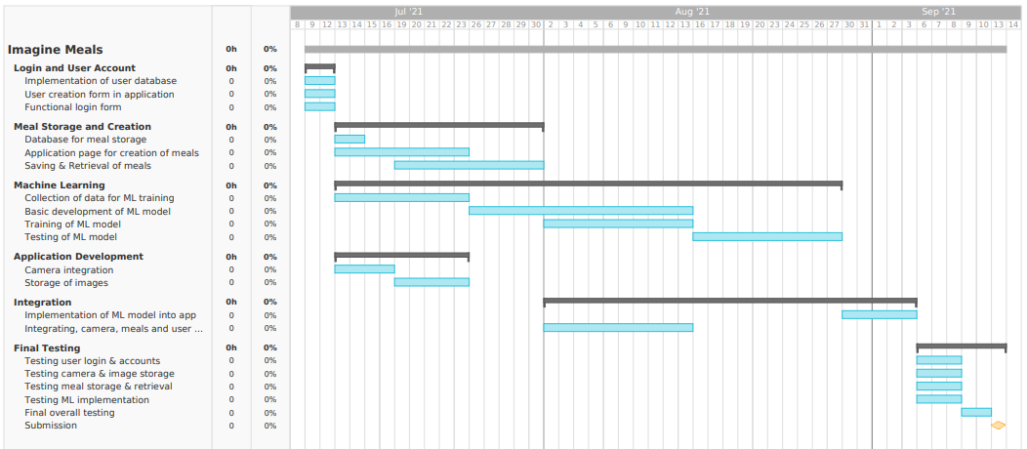

This Gantt Chart gives an overall project timeline broken down into main areas. While

this is our default structure for ordering tasks, some of the tasks can be more flexible

than others. The functional login form task is important, but it is only a dependency for

overall testing. The database for meal storage in contrast needs to be functional in order

to to work on the saving & retrieval of meals. The biggest contingency for the project

involves the machine learning section. While machine learning can be an incredibly

powerful tool it also can be difficult to predict in terms of resource requirements. As we

are developing the machine learning we will be keeping in mind at all times it may not

be feasible for this project. If it turns out the project does not have enough resources to

generate useful machine learning, we will pivot the entire project to a non-ML paradigm.

Design and Prototype Analysis

This app is designed to be one of the best for tracking nutrients. It tracks the amount of food you eat and it consists of information that tracks nutrient content and food intake. This is a kind of good nutrition app for weight loss that helps you track food.

Nutrition apps can help you count calories and gain other useful information about the food you eat. They can also help people find restaurants that are suitable for their dietary needs. Dietary Apps for Eating Disorders Some people recovering from eating disorders have found that using an app can be beneficial to stay healthy.

MyFitnessPal is a well-known powerhouse app that includes more than just food database, barcode scanner, recipe importer, restaurant logger, food intelligence, calorie counter and other features.

Technology apps on mobile devices can help children learn about food groups, nutritional facts, cooking methods, healthy food choices and fun games and tools. In a recent review conducted by the Academy of Nutrition and Dietetics, the following five apps were deemed fun, useful and child-friendly tools to learn the value of food and energize the body.

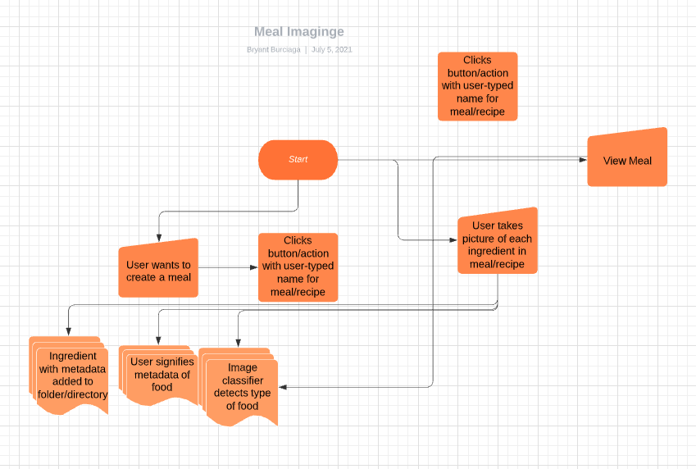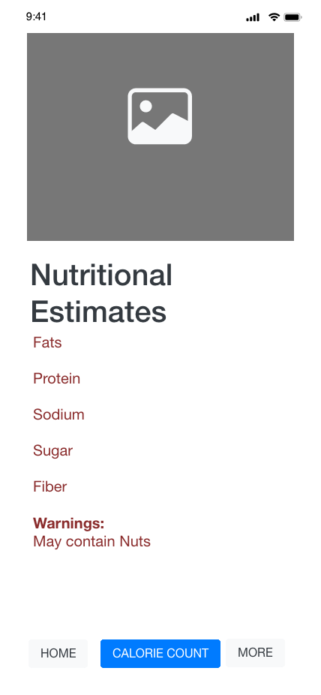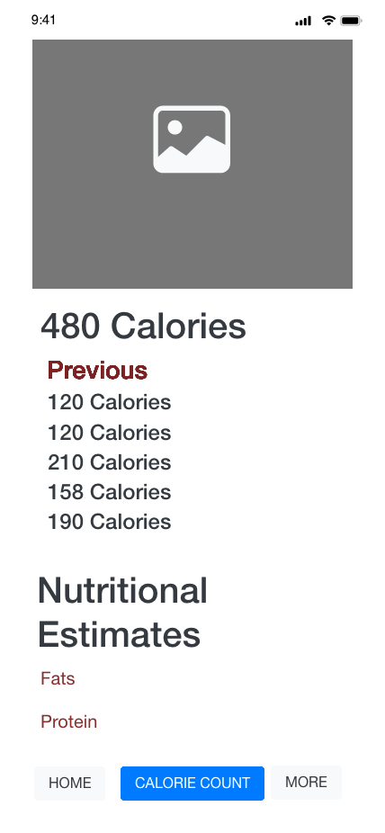

### Prototyping and Iteration

The way we used iteration throughout this project meant that we could focus on specific parts of the project, building up the project in layers. After each iteration we made the project to a more polished complete state.

We first focused on the hardest thing that will give us the biggest bang out the gate to focus on getting us to a minimum viable product, this was the signing in pages and database. We first built up the database design for what user data we needed to store to make the experience pleasant for the user. Then building up the back end code to process a new user signing in to the website to only see information they have access to.

The second iteration of this feature was to add the ability for the user to edit and amend their information associated with the account. We chose to iterate on the user sign in before making the core functionality of the app because a lot of the features we are building will be modified to use for other features, as well as it is easy to see if we have done this correctly as the longing in and account modification is something that is at the heart of every application. If we make the code work well with account management it will work well for other areas.

After iterating the project in reasonably small increments built a great foundation for further development, this meant some of the later features went through smoothly as they had a solid foundation with a lot of the code built up to solve our problems.

### Design

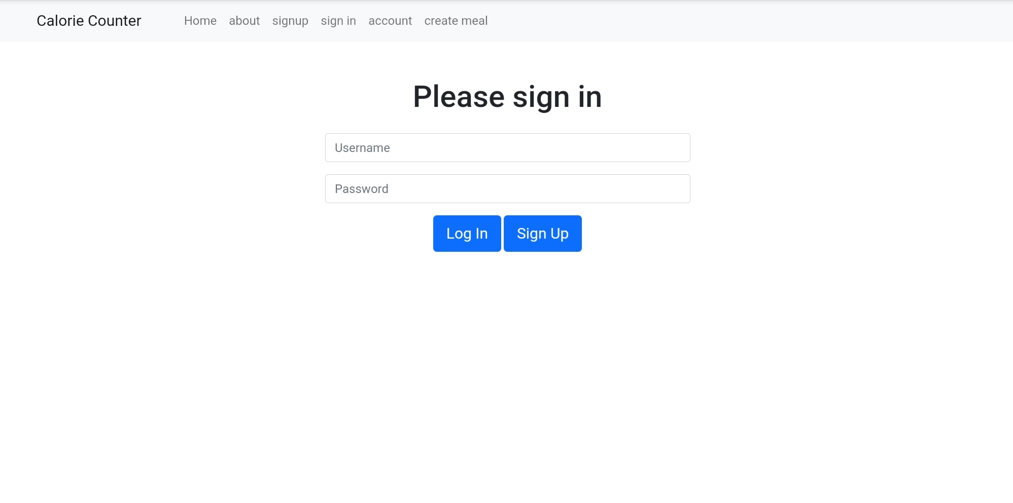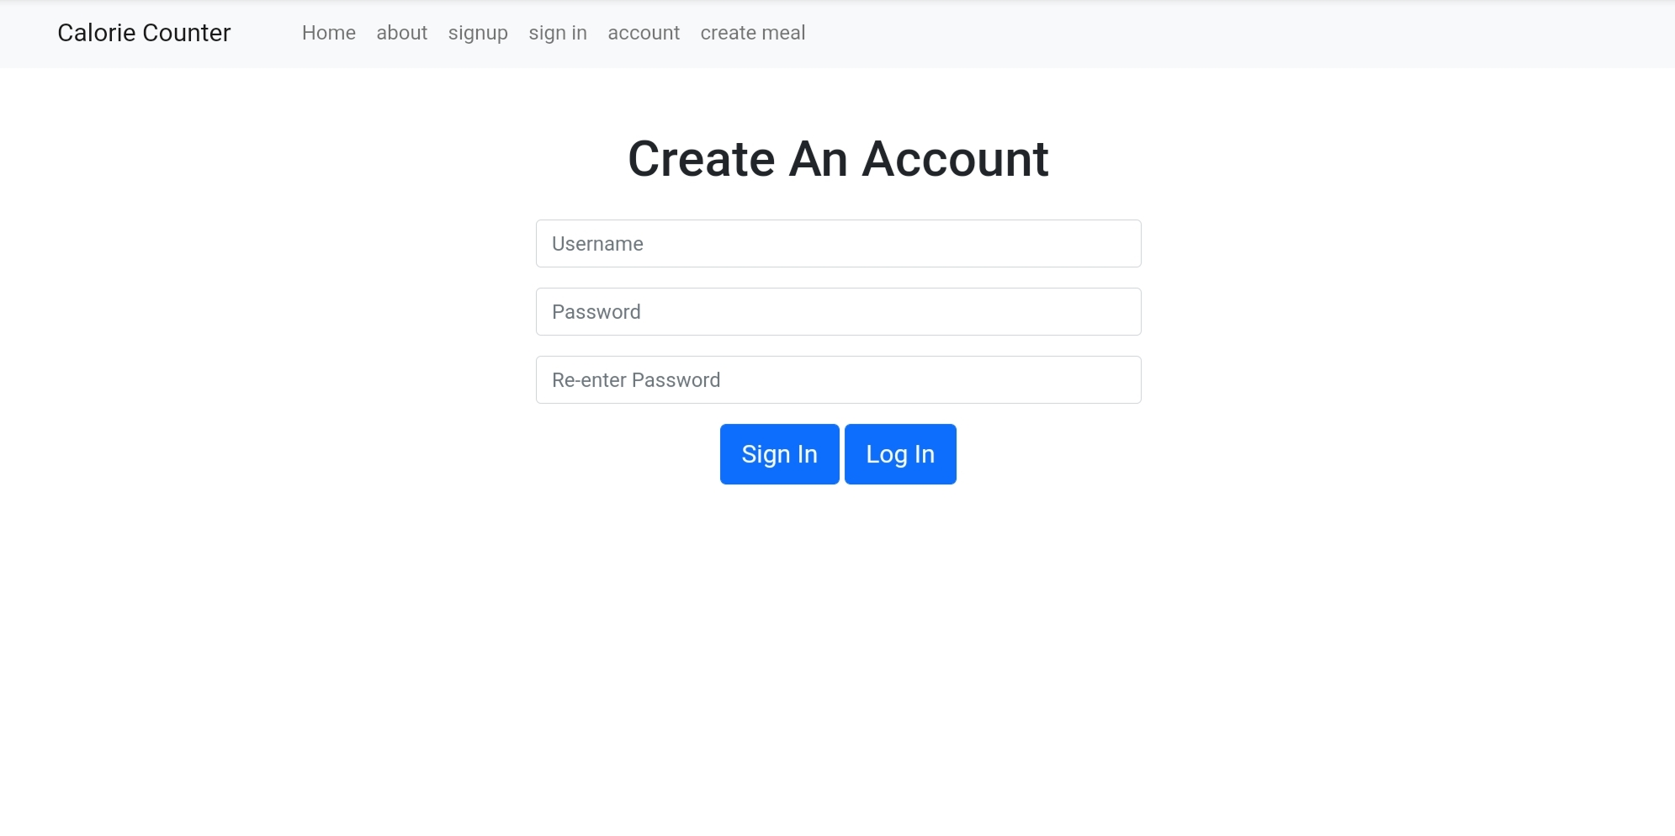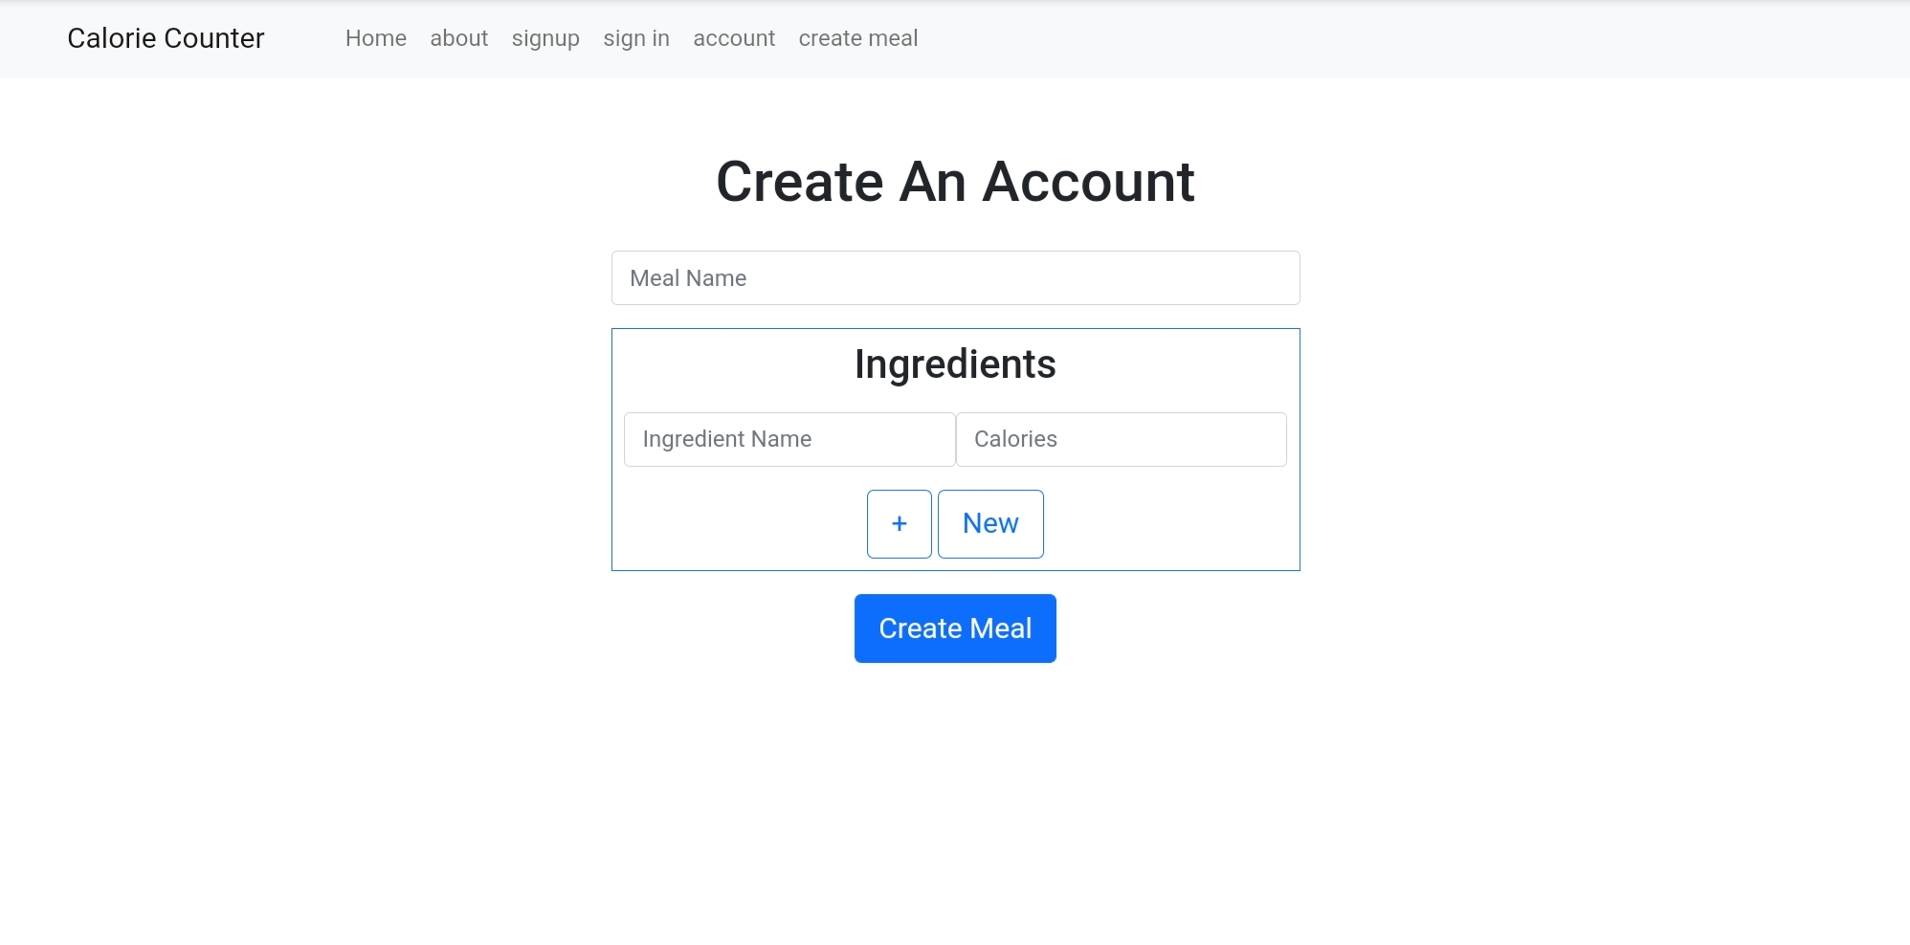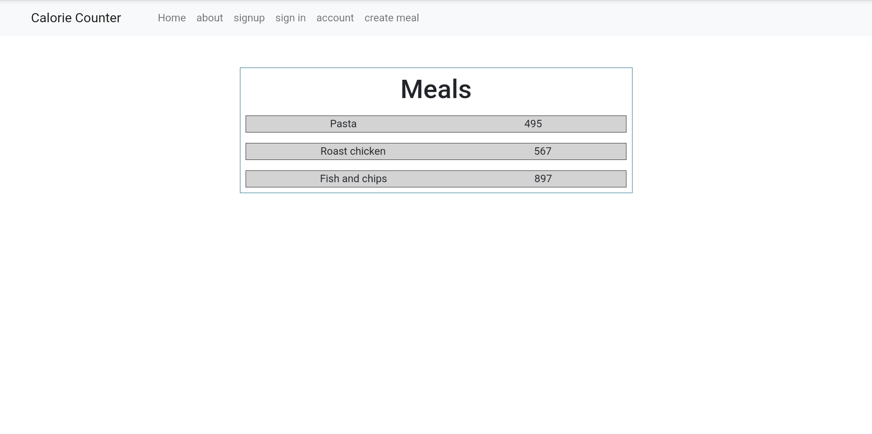

We strayed a little from the pre-vis design to make it easier for us to get to a minimum viable product as quickly as possible. We used a pre-built utility ‘bootsrap’ to get a unified visual style for the website that was purely functional in a visually appealing way. This made it really quick for us to try out new designs for pages while still keeping a unified feel to connect it to the entire website experience.

If we had more time to develop this project we would go back to the visuals, making them more unique and fit with the style of what the website is for. The current state works for getting the project to a usable state as fast as possible, however, it has no identity within a field of other websites. that make it less likely to be used when deployed to users. As our focus was on getting the functionality of the application to the best state and not having the team members around to get this done it fell to the back of the tasks that needed to be done.

### System Development

There are 2 main components to our project, those are account management and meal management. These two components may seem very similar however, the later required a lot more time in development to get right as it required more individual processes to make it work correctly. We was unable to get it to the state we originally wanted, having to settle for something simpler that will be able to be delivered on time while still delivering on our goals.

### Conclusion/Summary

The development and management of the project went smoothly, using the KANBAN method to keep on top of tasks that needed doing and keeping us accountable for testing our code to make sure it worked. The big thing that made this project not up to original standard was having a team that could not ’t hold up their post of the project. I was the only one to contribute to the code of the project. I had to dynamically adapt to these circumstances by cutting back the end goal of the project, removing some of the features that will not give the biggest benefit to the end project. One of these is the machine learning aspect of the calorie ingredient selection. Even with this cut back on expectation it was still very difficult to stay on top of everything without a team supporting me in the project. If we had a better team that I was able to depend on, that will put in that same amount to balance out the work load I believe that we would have been able to complete the project in a timely manor.