

**[****Home****]|[****About Us****]|[****Location & Timeline****]|[****Travel & Accomodation****]**

**[****Things** **to do]|[****FAQ****]|[****RSVP****]**

# **Travel**

Here are some information on how to reach Rome and Villa Livia.

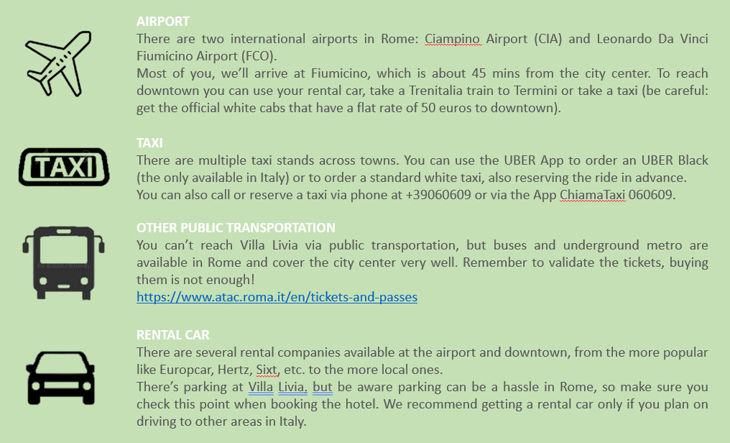

# **Accomodation**

As you can imagine, Rome has plenty of hotels and AirBnB anywhere in the city and at every budget. If you don’t plan to stay in Rome longer, we recommend to stay near Villa Livia in the Appia Antica/Capannelle area. If you plan to enjoy Rome for longer, we recommend to stay closer to downtown, either in the Trevi/Tritone area or in the Trastevere area. Both are close to the main tourist attraction (some times even walking distance), with Trastevere being the more local, characteristic area.

Here are some hotels with our discount code; feel free to take advantage or not.