

**[****Home****]|[****About Us****]|[****Location & Timeline****]|[****Travel & Accommodation****]**

**|[**[**Things to do**](Thingstodo.htm)**]|[****FAQ****]|[****RSVP****]**

# **Travel**

Here is some information on how to reach Rome and Villa Livia.

For transportation to the wedding venue, there are two options. You can rent a car, or you can take a taxi (easily available from any central location) from your hotel/AirBnB to Villa Livia. For those who need help with the return, we will plan to have mini vans running every 30 minutes after 10pm to a central location. The drop off point is tentatively Hotel Villa San Pio. We will provide updates here when we get closer to the date.

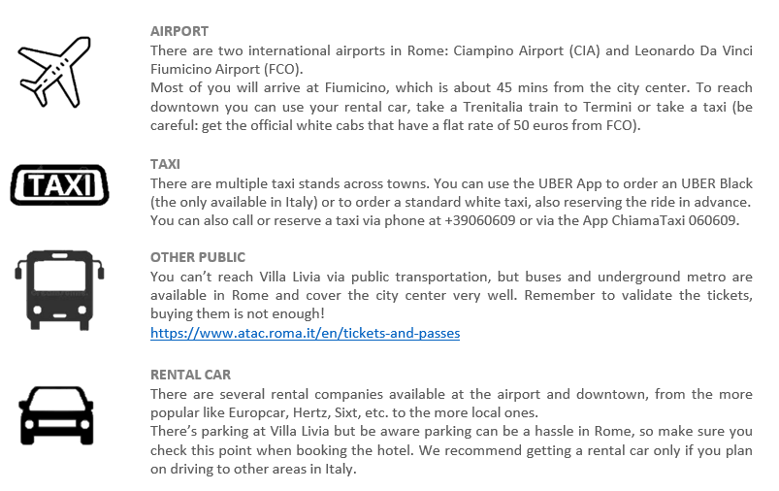

# **Accommodation**

With code **R&M WEDDING June 9th 2023**, you can get extra 5% discount on the best available rate online at the time of booking for Hotel Villa San Pio (<http://www.aventinohotels.com/villasanpio/en/>). You can send them an email to [info@aventinohotels.com](mailto:info@aventinohotels.com) with your arrival and departure dates and type of room.

The discount code is valid until January 31st 2023.

This hotel is situated on the Aventino hill, a more relaxed and elegant residential area, with easier parking and other hotel options.

Otherwise, feel free to book any accommodation of your choice and budget amongst the thousands available in Rome. A good area for tourist attractions is around the Trevi Fountain, but parking there is usually not an option.