

**Project Report**

**CSE411**

**Section-2**

**Course Title: Software Engineering & information System Design**

**Project Title: Student Judge**

**Submitted By:**

Sara Anisa Rahman 2018-1-60-069

Robayed Ashraf 2018-1-60-238

Kamruzzaman Leeon2018-1-60-252

**Submitted To:**

Md. Mohsin Uddin

Senior lecturer

Department of Computer Science & Engineering

East West University

**Submitted Date: January 3, 2021**

**TABLE OF CONTENTS**

**Topic Page**

**Introduction** 3

**Motivations** 3

**Challenges**  3

**Component Diagram** 4

**Requirements** 4 - 6

Non-functional Requirements 4

Functional Requirements 5 - 6

**Technologies** 6

**UML Use Case Diagrams** 6-9

**UML Class Diagrams** 10

**UML Activity and Sequence Diagrams** 11- 13

For All Users 11

For Student Users 11

For Teacher Users 13

**UML Sequence Diagrams** 14- 15

For Student Users 14

For Teacher Users 15

**Entity Relationship Diagram** 16

**User Interface Screenshot**………………………………………………………………… 17-19

**Conclusion** …………………………………………………………………………………...... 19

**Introduction**

Student Judge System is a web application that can used for schools, colleges, coaching centers or any kind of educational institutions. It is such a platform where students can continue their studies and skill developments from anyplace to examine themselves at their own will. It is a platform for a certain group of students can brush up their knowledge by watching subject wise video lecture, blogs and attending the online based exams. They can also track their progress with others.

**Motivations**

* Student Judge System is an exceptional platform that works on student’s academic studies as well as skill development.
* Students can continue their academic studies and skill development from home by using this platform that creates competition among the students, further enhances their intelligence.
* Students do not have to go to coaching or home tutor for academic education and not to join a training center for an extra curriculum.
* As well as this software provides e-books, video material, reading material, and links so that they can find their all study needs in one place.
* Students can make their schedule of study that helps a student more to learn attentively.
* During any kind of natural disaster or pandemic situation, our daily life becomes more complicated and boring. That is why, this platform is ready for the students or even normal people to proper use of their time and money and reduce their boringness.

**Challenges**

* Implementing all the essential features to make the application user friendly.
* As we will work team wise in this project and the deadline is not so far so that our work will becomes little bit harder to maintain all the requirements.
* We will have to work with such technologies that we have not worked with these before.
* We will have to work hard to ensure the privacy of user’s information.
* Make the application security strong to make it safe from any kind of hacking.

**Component Diagram**

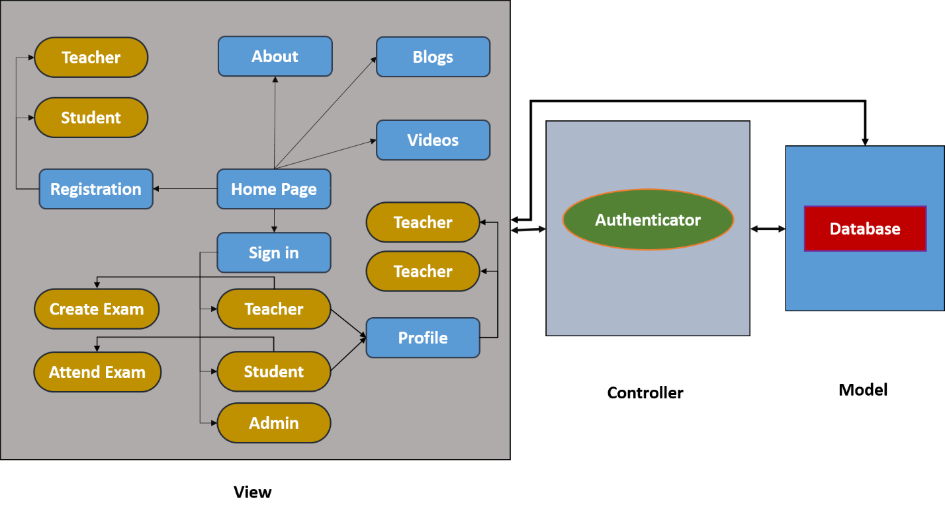

Figure 1: Component Diagram.

**Requirements**

**Non-Functional Requirements**

* Ensuring excellent user experience (UX) by implementing a clean, intuitive, responsive user interface (UI).
* Maintain user’s data and privacy like password, contact information, answer sheet and so on. For teachers and admin, there should be a clean interface for uploading videos, blogs, preparing question paper, returning answer scripts etc.
* Design the application as well structured so that the users can find all of their necessary videos, blogs etc. more quickly and efficiently.
* Design the application with sufficient set of question papers so that the students can prepare themselves properly before attending their school exams.
* Make the application Cloud-hosted and scalable using these services like AWS, Azure, ASP.NET, heroku, python anywhere, etc. to make high throughput.

**Functional Requirement:**

1. User Authentication: Our app deal with students, teachers and a few teachers are admins. We tried to create a clean and user friendly interface so that younger students don’t face any difficulties while signing up their accounts.

**Scenario**: When a user tries to access his account or home/profile page while they are not logged in, they would be redirected to the login page. Once the user enters their username and password and authentication is complete, they will be redirected to their desired page. Pages with personal information can only be accessed through logging in to the system.

There will be three types of users. They are:

1.1. Admin: Admin will control all the managements of the software. Like checking username, password, uploading videos, blogs, preparing questions and checking answer scripts, update result etc.

1.2. Teachers: Teachers can upload videos, write blogs, make questions, and check scripts.

1.3. Students: Students can get all the required services like videos, blogs, e-Books, and so on along with participating in the exams. They can also review themselves with their corrected answer scripts by the teachers.

N.B: Those who will not login with their account, they could also see the videos, blogs, e-Books but could not participate in the exams.

1. User Profile: Everyone has the same things in profile.

2.1. Edit information: User can edit their profile information anytime they wants.

2.2. Delete account: User can delete their account whenever they wants.

2.3. Logout: Users can log out of their account after completing their work.

1. Course level: Course level is related to its category. The category divided the course level.

* Category:
  + - Academic (subcategory class: 1-12).
    - Special Skill development.

1. Examination:

4.1. MCQ: There will be quizzes to brush up their selves in a very short time. MCQ checked automatically (write and upload answer into the server). If anyone answers wrong then the system will suggest which topics needs to be improved.

1. Progress report:

5.1. Self-report: The students can see their progress report (Exam results).

5.2. Ranking: Students can compare their marks and standing of exams with others. So that they can observe their position and realized how much effort needed to update their own ranking.

1. Mail service: This service provides a student course-related information and progress report and new blog arrival news via email.

**Technologies:**

**Frontend:** HTML, CSS, BOOTSTRAP, JAVASCRIPT, AJAX

**Backend:** Django

**Database:** MySQL

**UML Use-case Diagrams:**

**The following diagrams are included:**

1. User authentication module
2. User profile module
3. Blogs, Videos and Exams module

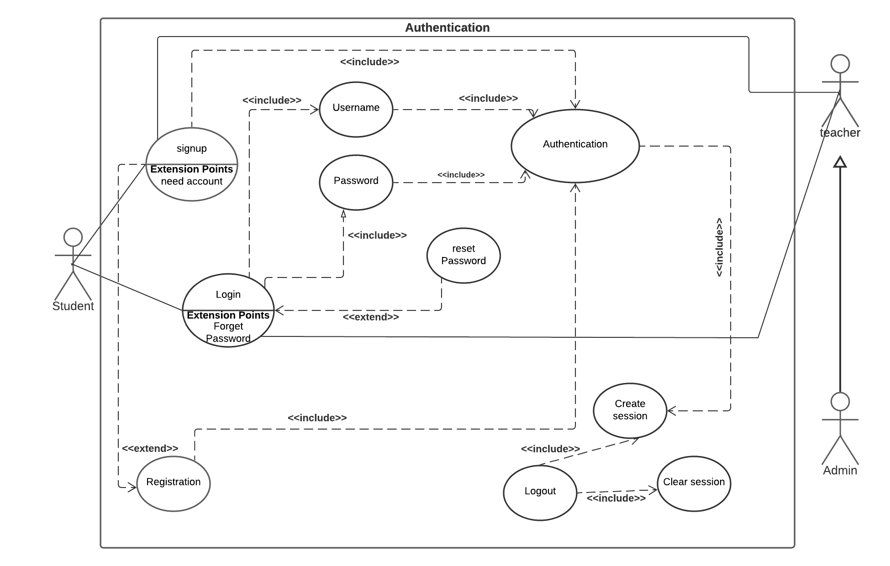

Figure 2: User authentication module.

.

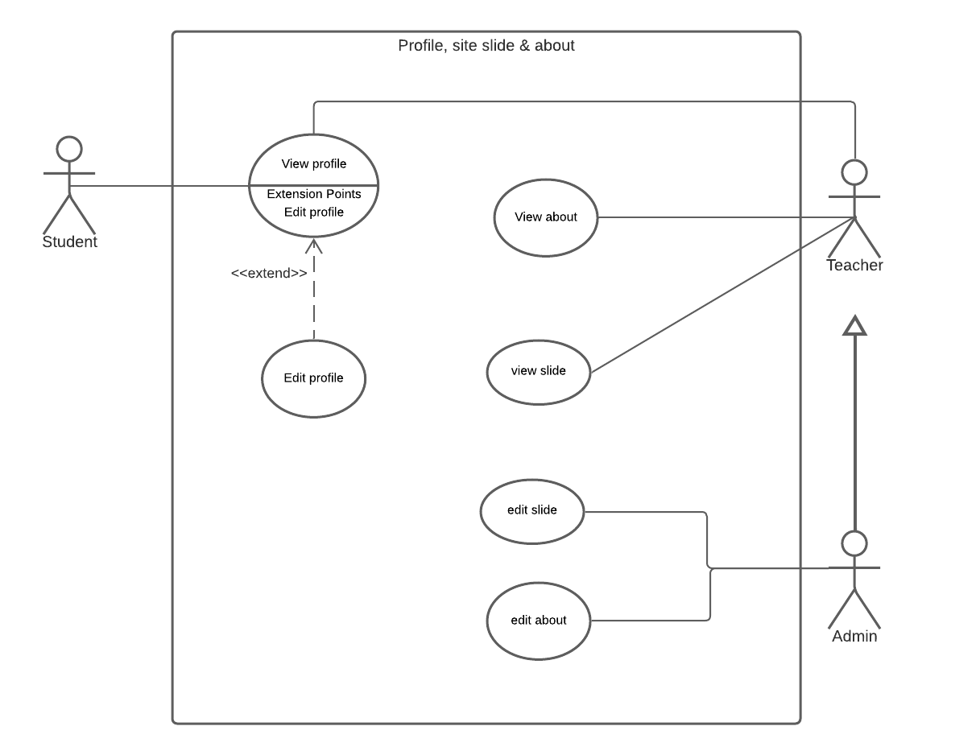

Figure 3: User profile module.

.

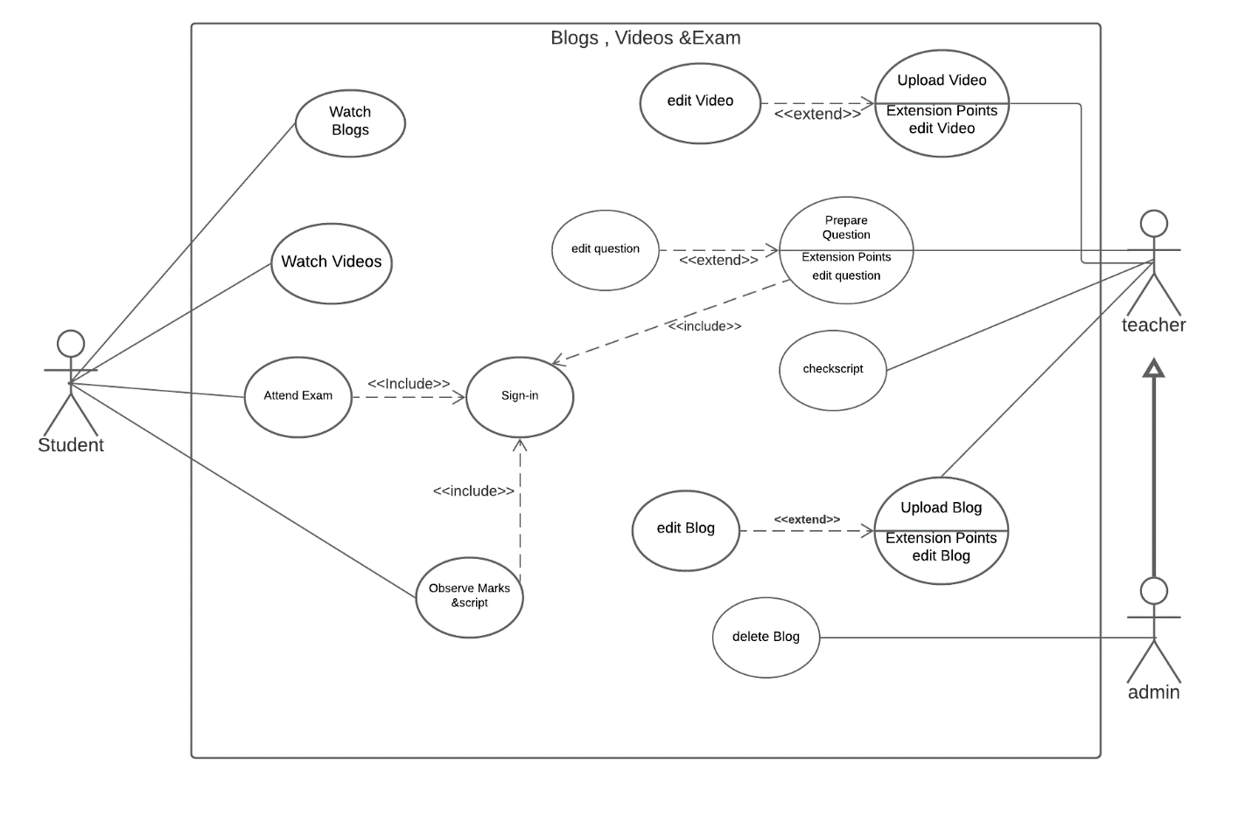

Figure 4: Blogs, Videos and Exams module.

**UML Class Diagram:**

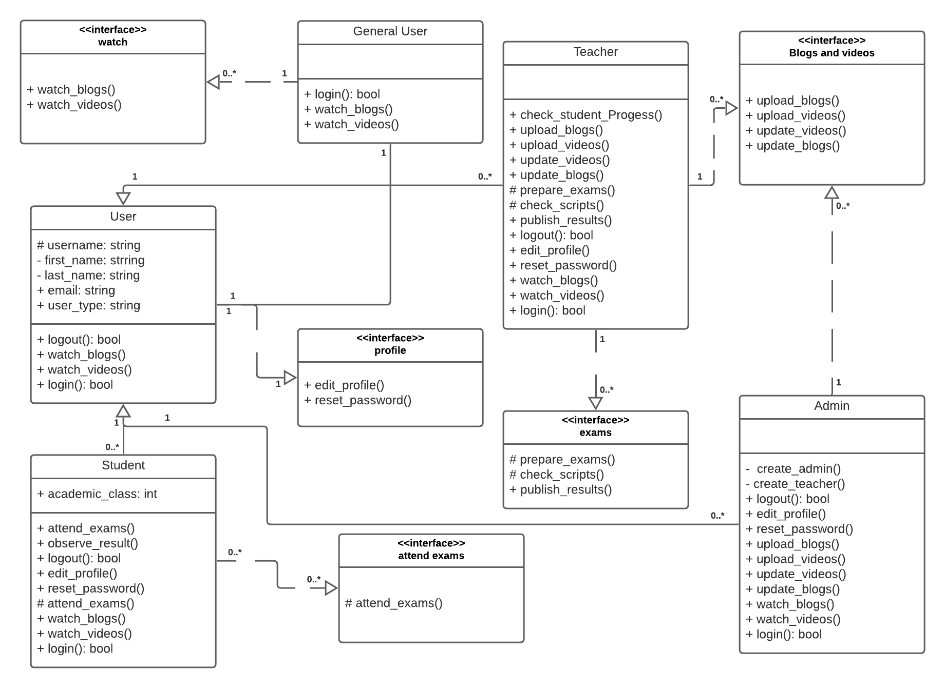

Figure 5: Class Diagram.

**UML Activity Diagram**

**For All Users:**

**Scenario:** All user (Student/Teacher) can see their profile. Also they can edit and add more information including profile picture to their profile. They also watch the blogs and videos by sorting with class, subject, chapter, title.

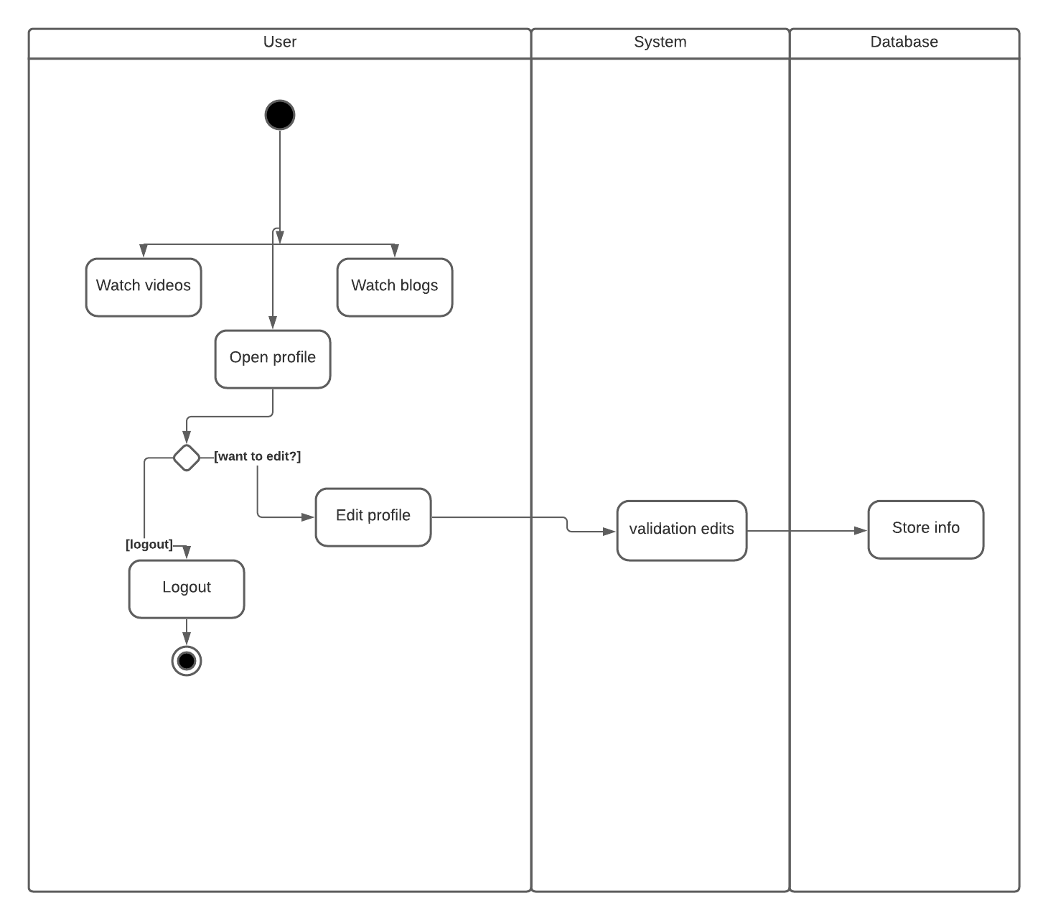

Figure 6: Activity Diagram for All Users.

**For Student Users:**

**Scenario:** A student can attend exam and submit their answer scripts from the examination section. They also see the marks they have obtain in the participated exams. They can see their marks only after the examiner (teacher) check the answer scripts and assign the marks.

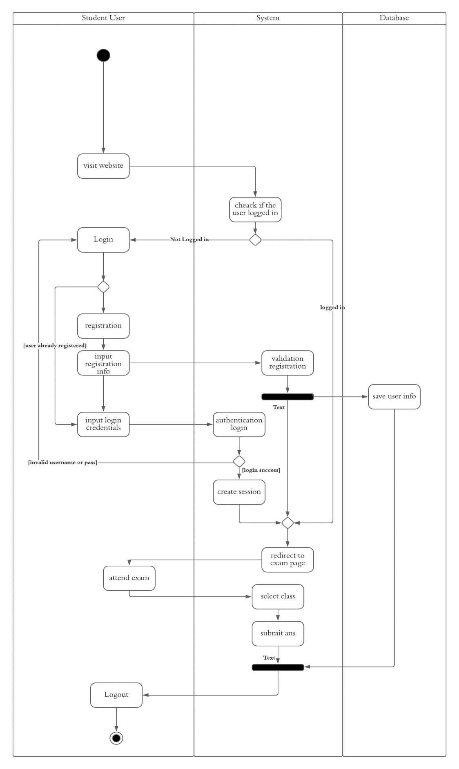

Figure 7: Activity Diagram for Student Users.

**For Teacher User:**

**Scenario:** A Teacher user can upload and edit blogs and videos whose were added by that teacher. A teacher also can taking exams by creating exam form examination section. The teacher can add question by uploading the question file. After the end of the exam the teacher can check the answer scripts.

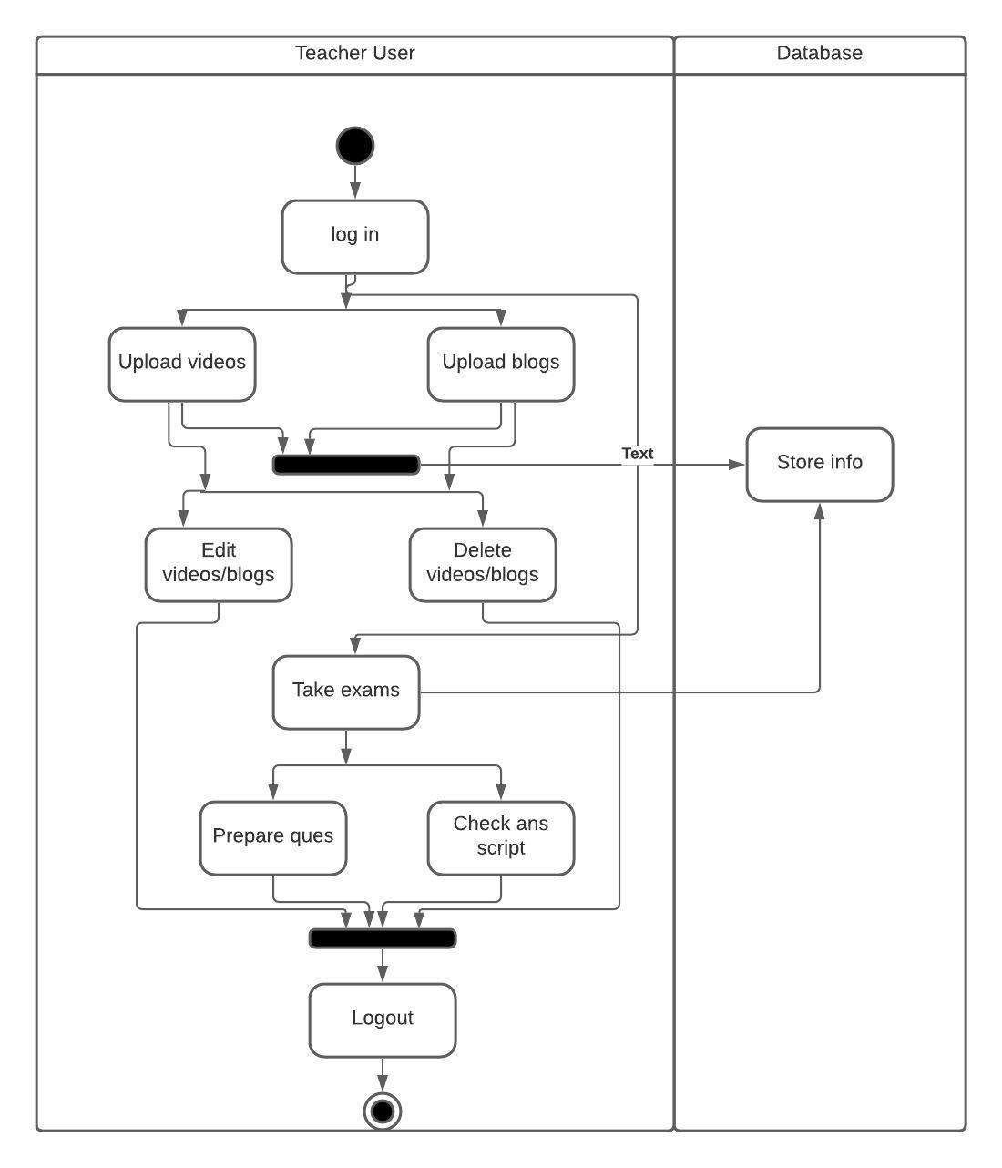

Figure 8: Activity Diagram for Teacher Users.

**UML Sequence Diagram**

**For Student Users:**

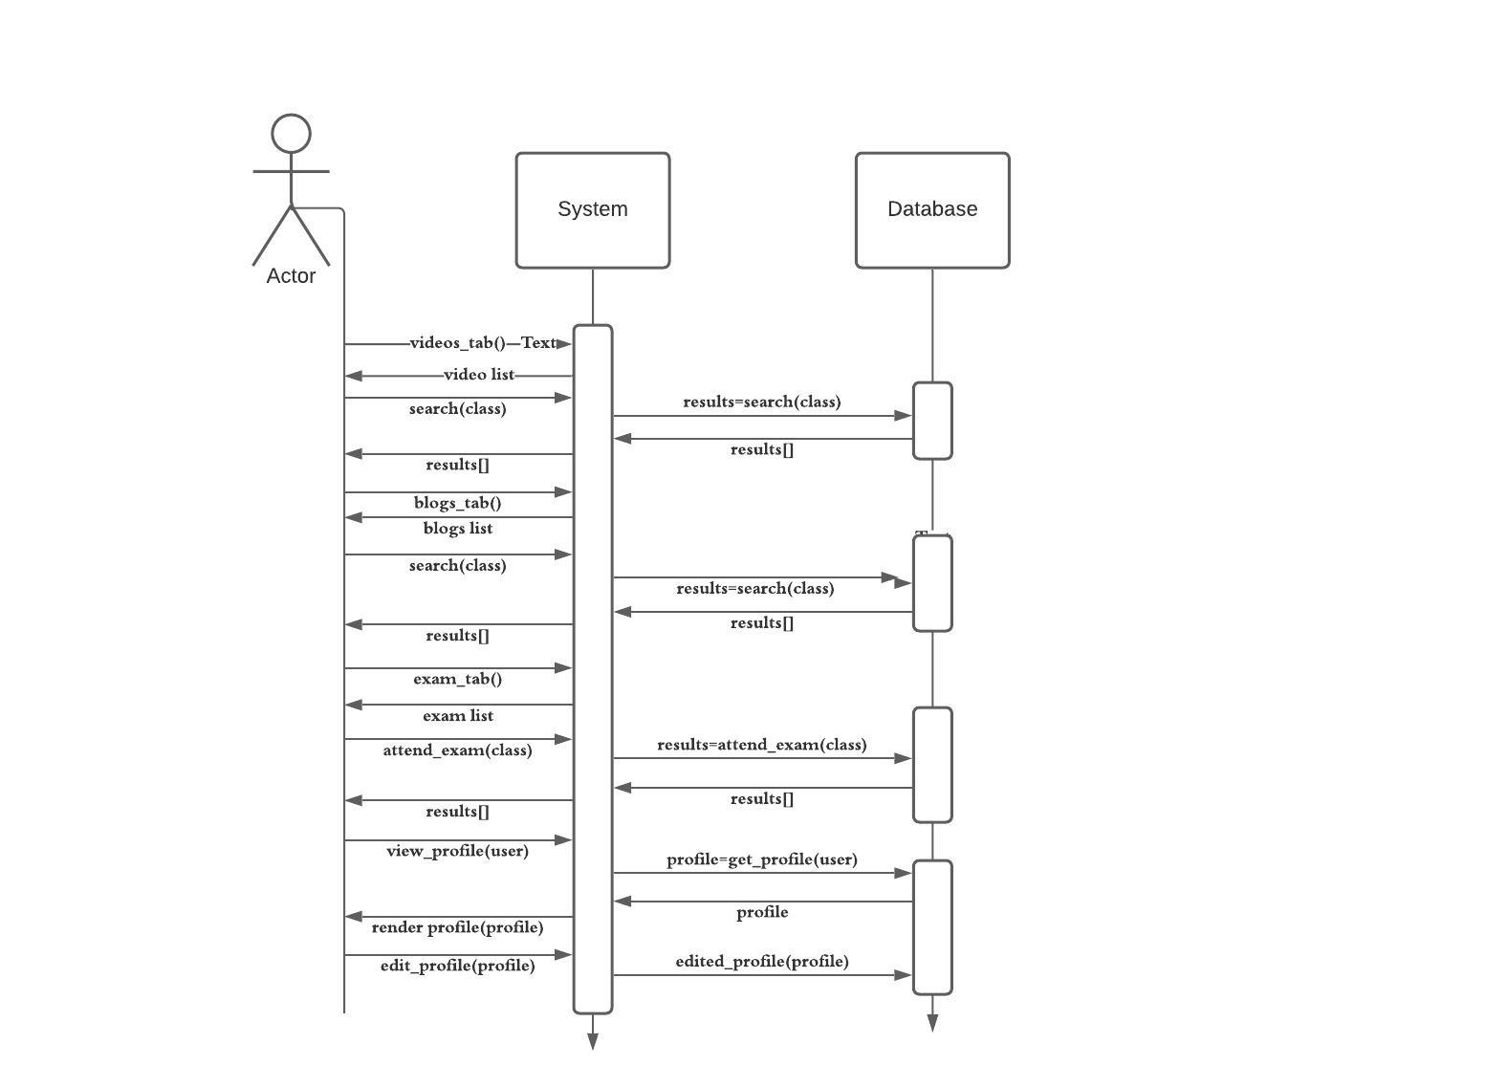

Figure 9: Sequence Diagram for Student Users.

**For Teacher Users:**

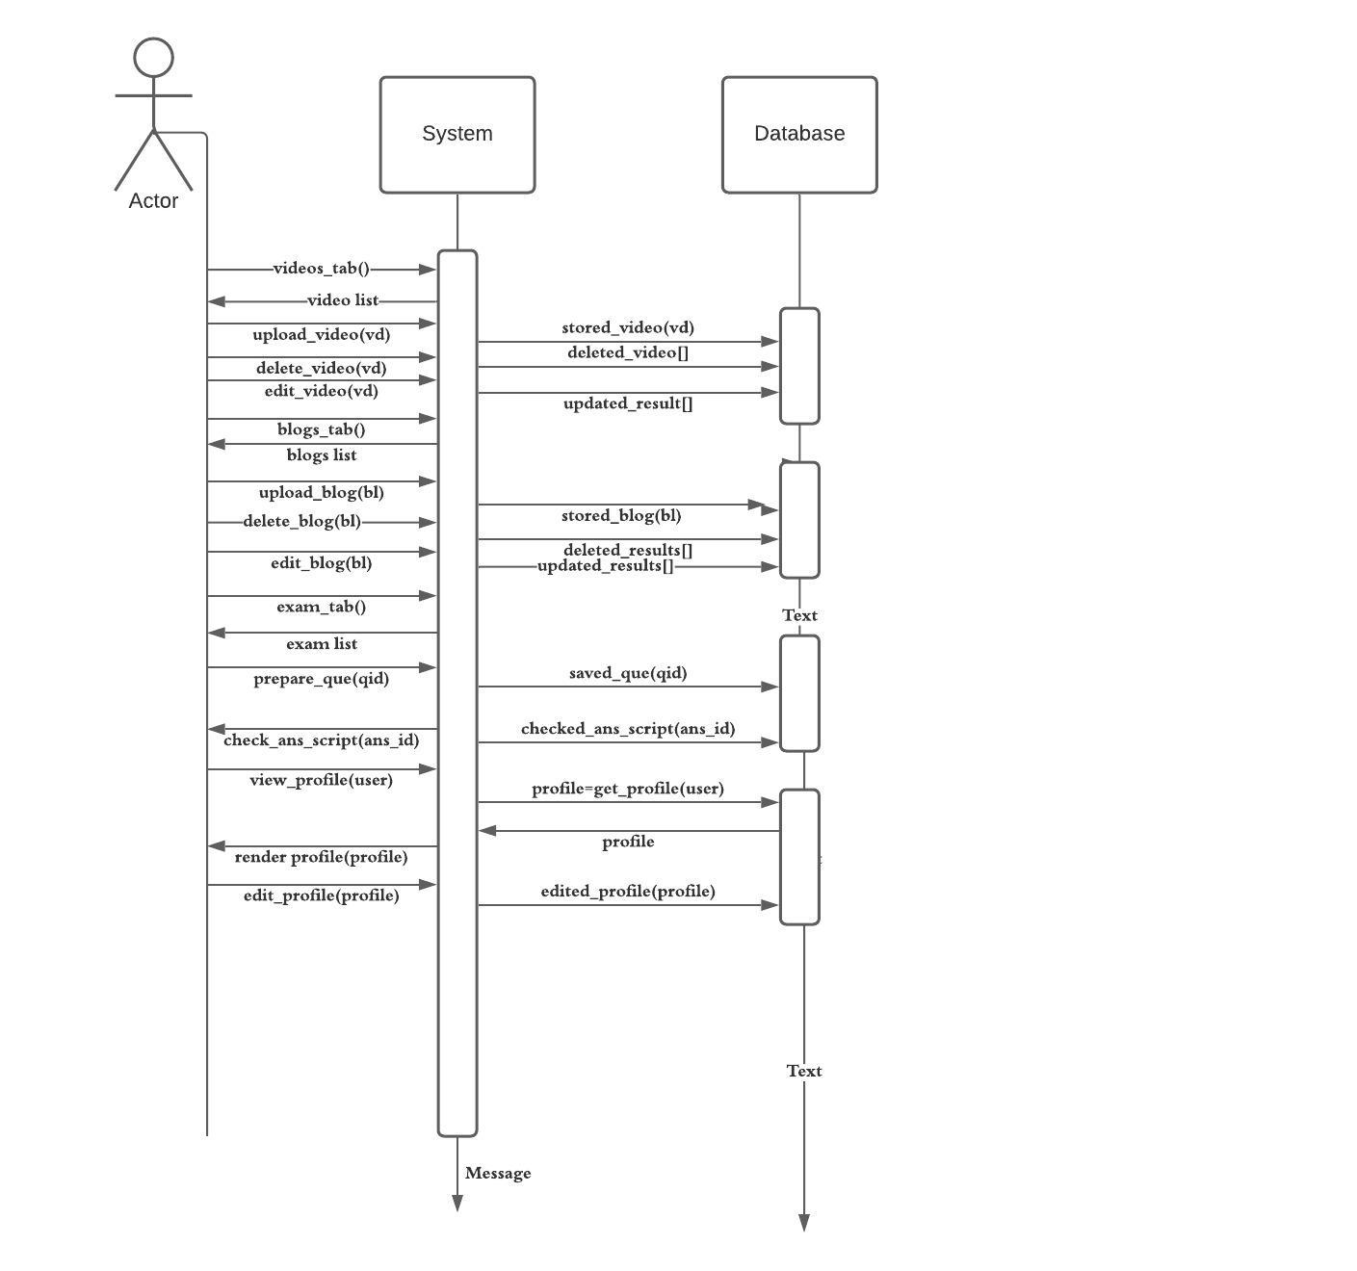

Figure 10: Sequence Diagram for Teacher Users.

**Entity Relationship Diagram**

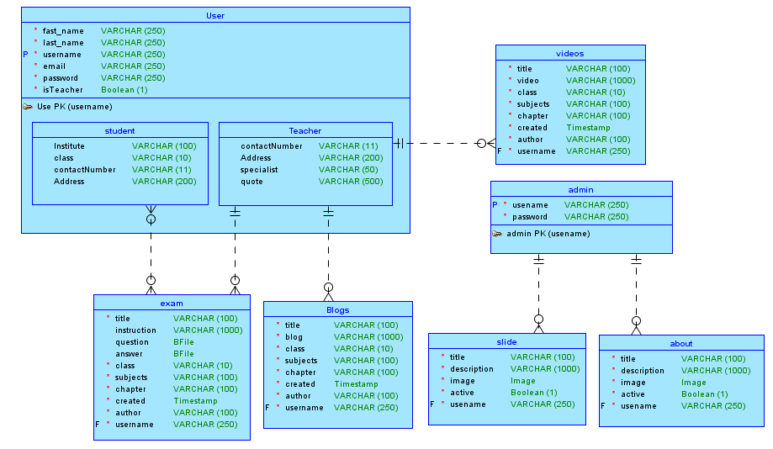

Figure 11: Entity Relationship Diagram.

**User Interface Screenshot**

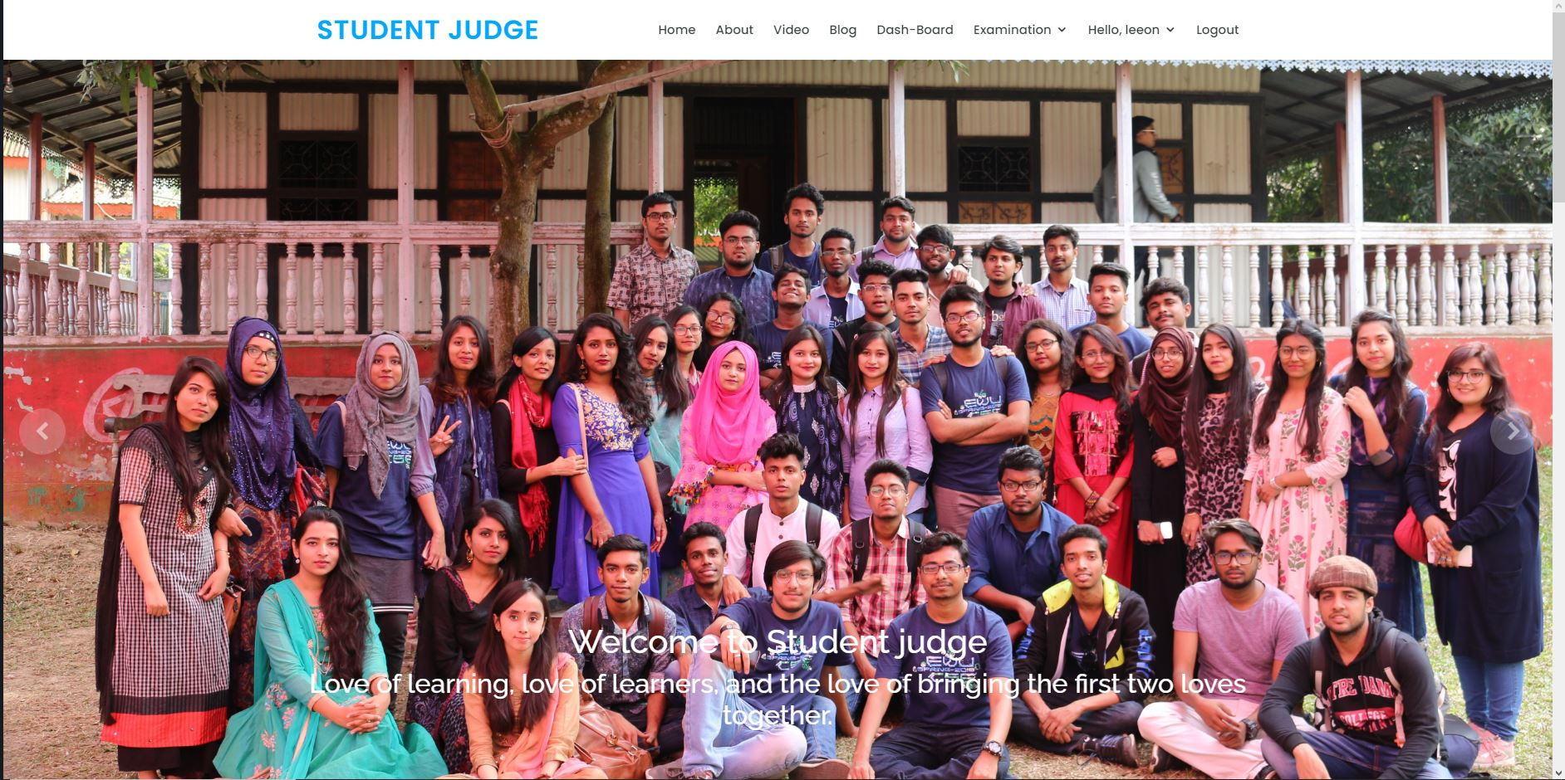

Figure12: Homepage (dynamic)

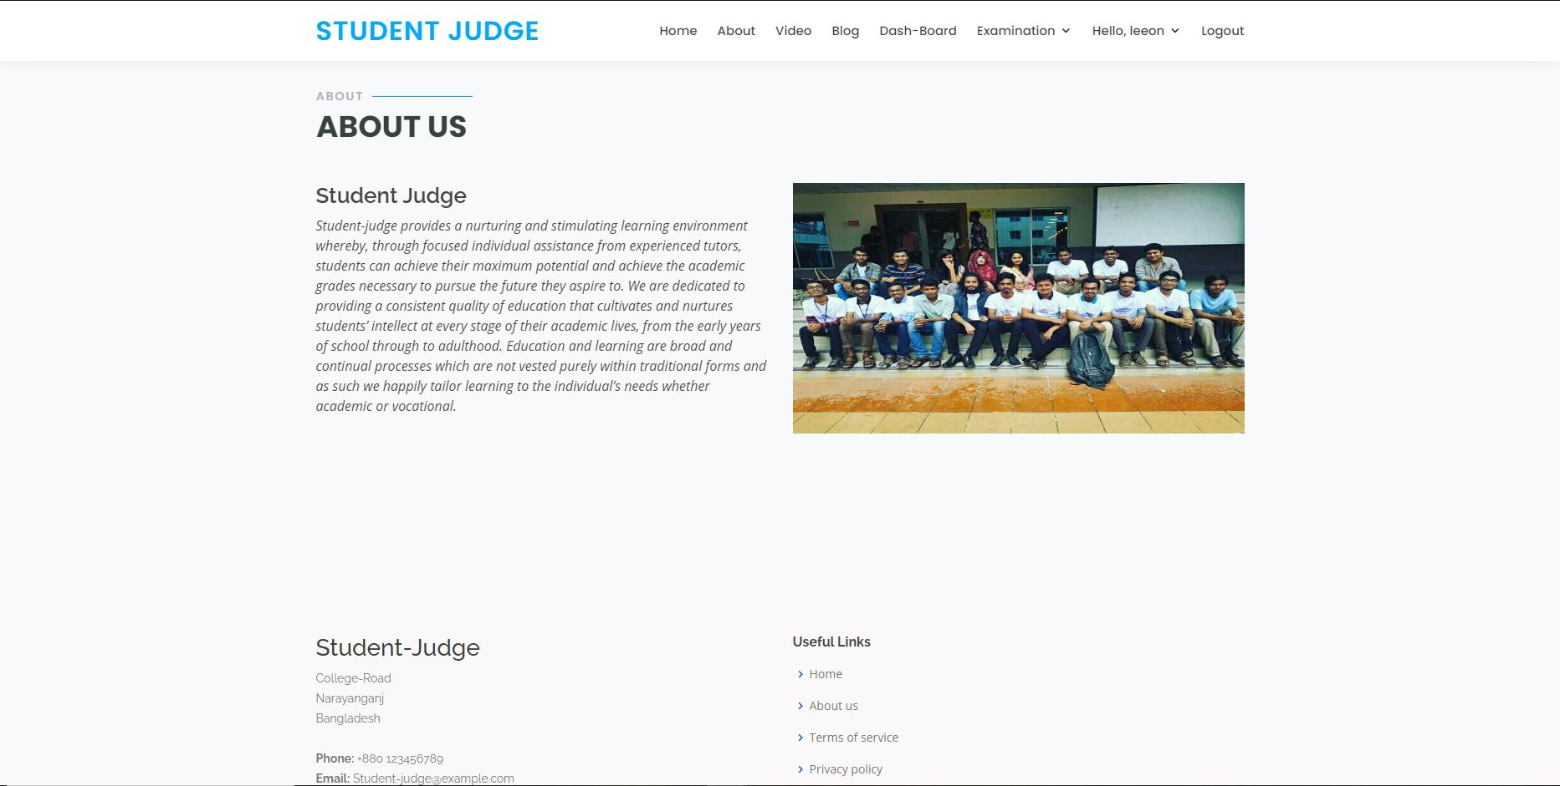

Figure 13: About (dynamic)

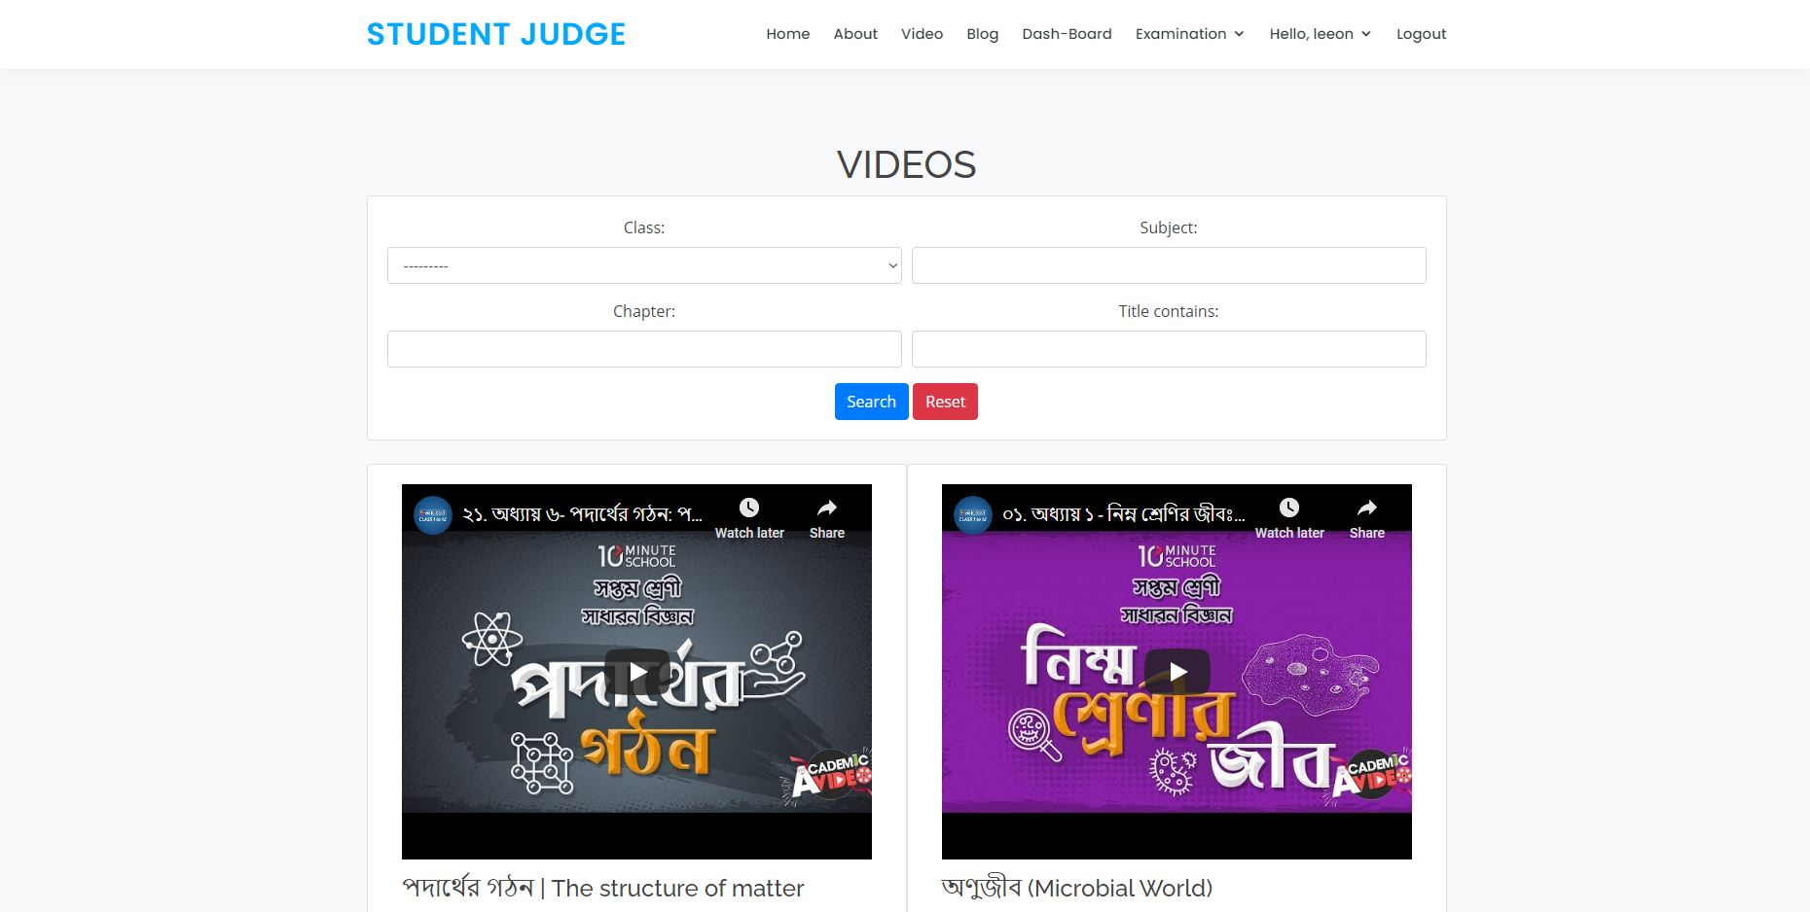

Figure 14: Videos

Figure: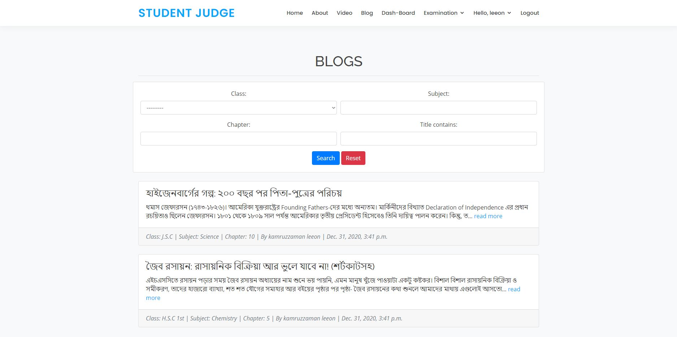 Figure 15: Blogs (4 filter option)

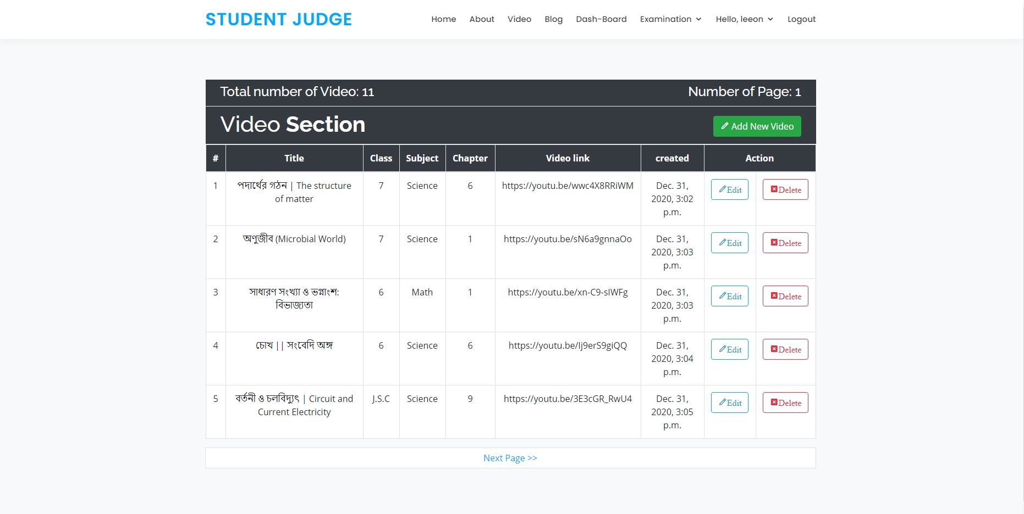 Figure 16: Video upload section (CRUD)

**Conclusion:**

During this pandemic situation, the education system is getting hampered. Student-judge is an online education platform for level 1 to HSC level students. Here students can watch videos, blogs which contain their respective bookish chapters. They can also judge themselves by attending exams. A teacher or admin can add, edit and delete videos and blogs. They can prepare question paper and check answer scripts submitted by the students. Every users can edit their profiles. We tried to make a user friendly online education website for both urban and rural area users. So that every type of students can have the service and no one will be deprived from acquiring knowledge.