EXCELSOFT
AI Sales Intelligence System
Signals. Before the RFP Exists.
Project & Technical Documentation
Advanced / Enterprise-Level Technical Reference
Prepared for project submission, technical review, client presentation, and internal knowledge transfer

Document version 1.0
Generated: 29 September 2026
Classification: Internal / Submission Copy

Table of Contents
This table of contents is generated from the document's headings. In Microsoft Word, right-click it and choose "Update Field" (or press F9) if the entries below do not yet appear.

1. Executive Summary and Project Overview

1.1 Business Context
Excelsoft's Americas sales team is four people, competing in the US education technology and assessment market against vendors with larger sales organizations, greater brand presence, and incumbent relationships already in place. The one structural advantage a small team can build without adding headcount is intelligence: knowing about a change in an institution's technology posture, funding, leadership, or procurement activity sooner than competitors do, and knowing what to do with that information.
Historically, this intelligence advantage did not exist. Sales opportunities were discovered when a Request for Proposal (RFP) was already published — at which point the evaluation criteria were fixed, an incumbent vendor was frequently already entrenched, and every competing vendor was responding to the same document under the same deadline. The window in which a sales team can build a relationship, understand real requirements, and position its solution ahead of a competitor had already closed.
Meanwhile, competitor organizations — Honorlock, Proctorio, Meazure Learning, Caveon, and Questionmark — continuously publish product updates, speak at industry events, update their public web presence, and signal their roadmap through ordinary public activity. That information is available to anyone who looks for it systematically. The problem the Sales team faced was not a lack of information; it was a lack of a system to watch for it.

1.2 What the System Does
The AI Sales Intelligence System is a continuously operable intelligence engine that monitors public information about tracked United States education organizations — universities, colleges, K-12 districts, and public-sector education bodies — together with named EdTech/assessment competitors, and turns what it finds into a structured, evidence-backed record a sales representative can act on.
The system does not predict that an RFP will occur, and it does not claim certainty about a future procurement decision. It surfaces publicly observable evidence, correlates related pieces of evidence into a “potential opportunity,” scores that opportunity with a fixed, auditable rules formula, and lets a sales representative or manager question the underlying data through two AI-assisted conversational interfaces: a scoped AI Sales Advisor and a broader Sales Persona daily copilot.
Every fact the system presents can be traced to a real, stored source: a page it fetched, a federal procurement notice, or a federal spending record. The system is built around one governing rule that shapes every layer of its design: it must never present an AI interpretation as an observed fact, never claim an opportunity is certain, and never invent a source, a date, a person, or a number.

1.3 The Four-Way Distinction
Every insight the system presents is explicitly separated into four layers, and collapsing them — presenting an interpretation as a fact, or a correlated opportunity as a certainty — is treated in this project as a product defect rather than a matter of style.
Layer | Meaning
Observed fact | What a public source actually stated, always attached to a citation
AI interpretation | What the system infers from those facts, clearly labelled as interpretation
Potential opportunity | A correlated set of signals that may be worth a sales representative's attention
Recommended research / action | What a human should reasonably do next, grounded in the same evidence

1.4 Document Purpose and Audience
This document is written for four overlapping audiences: reviewers assessing the project for submission, engineers who need to extend or maintain the system, a client or stakeholder evaluating the product, and a new team member onboarding onto the codebase. It documents the system as it exists in the current codebase — not an aspirational design — and calls out explicitly where a described capability is fully working, partially working, or planned but not yet built.

2. Objectives and Goals

2.1 Primary Objectives

2.2 Non-Goals (Explicitly Out of Scope)
The following were deliberately excluded from this project's scope, and their absence is a design decision, not an oversight:

2.3 Success Criteria

3. System Architecture Overview

3.1 Architectural Style
The system is built as a classic three-tier web application with a strict internal layering discipline on the backend, rather than a microservice mesh. This choice is deliberate: at the data volume and team size this project operates at, a single-process, single-worker backend with clean internal boundaries is easier to reason about, easier to keep evidence-honest, and easier to deploy than a distributed system would be, while the internal layering still gives each concern (routing, business rules, data access) its own place.

3.2 The Four Major Components
Component | Technology | Responsibility
Client | React 19 + Vite + TypeScript | Renders the Dashboard, Organizations, Signals, Opportunities, Competitors, Trends, and AI Advisor pages, plus a persistent Sales Persona chat widget
Backend API | FastAPI (Python), single process | Authenticates and authorizes every request, runs the collection and scoring pipeline, serves all data to the client
Database | PostgreSQL (Supabase) with the pgvector extension | Stores every organization, signal, evidence row, opportunity, score, and the embedded text chunks used for retrieval
AI Layer | Azure OpenAI (chat + embeddings) and Google Gemini (Sales Persona, with Azure fallback) | Proposes candidate signals, explains scores, answers scoped questions, and powers the Sales Persona copilot — always downstream of code-level validation

3.3 Backend Layering Discipline
The backend enforces one rule throughout: routes validate and authorize only; services contain business rules and no direct SQL; repositories are the only layer permitted to touch the database. Ingestion and AI code call services, which call repositories, exactly like the HTTP routes do — there is no second, parallel path into the database.
Client (React)
| HTTPS + Clerk bearer token
v
FastAPI Routes -- validate input, enforce role --
|
v
Services -- business rules, scoring, correlation, AI orchestration --
|
v
Repositories -- the only layer that runs SQL --
|
v
PostgreSQL + pgvector (Supabase)

3.4 External Systems

3.5 Deployment Topology (Target)
The system is designed to run as one backend worker process (see Section 13 for the specific reason multiple workers are not used), a statically hosted frontend, and a managed Postgres instance. This keeps the in-process background scheduler singular and avoids duplicated scheduled scans.

3a. Architecture Diagram
This page is intentionally reserved for the full-page system architecture diagram (client, API, services, AI layer, external sources, and database, with the signal pipeline shown as a distinct flow). Insert the rendered diagram image below, sized to fill the page.
[ SCREENSHOT PLACEHOLDER ]
System Architecture Diagram
Insert the rendered architecture diagram here (client → backend layers → AI layer → external sources → database, with the 11-step signal pipeline shown as a horizontal strip).

4. Complete Application Workflow and Processing Pipeline
Every piece of intelligence the system presents passes through the same eleven-step pipeline, whether it originated from a manually triggered “Scan Now,” a portfolio-wide “Scan All,” or a manager-scheduled one-time trigger. No signal, opportunity, or score reaches the user interface by any other path.
1. Public source (organization website, SAM.gov, USAspending)
2. New information collected (fetch, robots.txt check, politeness delay)
3. Signal extraction (AI proposes a candidate + exact source sentence)
4. Code-level validation (rejects anything not verbatim, wrong org, or invalid type)
5. Duplicate detection (hash -> external id -> snippet/title matching)
6. Signal validation (stored as validated or rejected, with a reason either way)
7. Related signal detection (same organization, overlapping time window)
8. Signal correlation (2+ related signal types -> one potential opportunity)
9. Hybrid opportunity score (deterministic rules formula, not AI)
10. AI score explanation + evidence-backed recommended action (both cited, both validated)
11. Surfaced to the user via the AI Sales Advisor, the Sales Persona, and every screen
A single weak signal is never treated as a guaranteed opportunity: correlation (step 8) requires at least two distinct, related signal types before a potential opportunity is created, and a recency gate additionally blocks a group of purely historical, old signals from creating a brand-new opportunity.

4.1 Trigger Points
Trigger | Scope | Who can start it
Scan Now | One organization | Both roles, if the organization is tracked as active
Scan All | Every active tracked organization | Both roles, via the dashboard
Per-organization schedule | One organization, one future date/time, fires once | Sales Manager only
Portfolio Scan All schedule | Every active organization, one future date/time, fires once | Sales Manager only
Daily scheduler (optional) | Every active organization, every day at a configured time | Configuration only (off by default)

5. Detailed Explanation of Each Pipeline Stage
This section documents every stage of the pipeline in Section 4 individually: what goes in, exactly what logic runs, which external APIs are touched, whether and how AI is involved, what changes in the database, and what comes out. This is the level of detail a new backend engineer would need to modify or debug any single stage without reading the whole codebase.

5.1 Stage 1: Collection Trigger and Source Selection
Input: An organization id (for Scan Now) or the full set of active organizations (for Scan All / a schedule), plus the manager-approved page sources already on file for that organization from a previous discovery pass.
Processing logic: The backend creates a scan_run row per organization (status queued, then running), resolves which official pages are approved for collection, and decides which sources apply: website pages for every organization, SAM.gov and USAspending only for ‘target’ organizations (never for tracked competitors, so the SAM.gov quota is reserved for customer-facing signals).
APIs / external calls involved: None yet at this stage — this is orchestration inside the backend.
AI / ML component: None.
Database interaction: Inserts into scan_runs (and scan_batches for a Scan All); reads organizations and organization_sources.
Output: A running scan_run per organization, with its stage field set and visible to the UI for live progress.

5.2 Stage 2: New Information Collection
Input: The approved page URLs for that organization, plus, for target organizations, a shared SAM.gov search and a per-organization USAspending lookup.
Processing logic: Website pages are fetched through a single shared Fetcher that checks robots.txt, uses an honest identifying User-Agent, enforces at least a five-second delay between requests to the same host, follows only same-domain redirects, and refuses pages that look paywalled or gated. SAM.gov is queried once per scan batch (shared across organizations) and matched locally by organization name, under a strict application-level daily request cap. USAspending resolves the organization to exactly one federal recipient before pulling award data, and is limited to once per organization per 24 hours.
APIs / external calls involved: SAM.gov Get Opportunities API; USAspending.gov Award Search API; the organization's own website (and, for competitor organizations, the five named competitor domains).
AI / ML component: None at this stage — this is raw HTML/JSON collection, not interpretation.
Database interaction: Writes to documents (raw page/notice/award text, a content hash, and the retrieval timestamp) and to source_request_log (for the application-level SAM.gov and USAspending rate limits).
Output: New or updated rows in documents. A document whose content hash has not changed since the last scan is treated as unchanged and skipped from re-extraction.

5.3 Stage 3: Signal Extraction (AI-Assisted)
Input: The body text of one changed or new document, plus the tracked organization's name and the document's source metadata.
Processing logic: The document is sent to the configured Azure OpenAI chat model with a strict system prompt: propose zero or more candidate signals, each with a signal_type (one of the seven closed categories), a title, a plain-language summary, and — critically — a snippet claimed to be an exact, contiguous quotation from the document.
APIs / external calls involved: Azure OpenAI Chat Completions API (JSON-mode response).
AI / ML component: Yes — this is the one stage where the AI genuinely infers structure from unstructured text; every output of this stage is still provisional until Stage 4.
Database interaction: No write yet; candidates are held in memory for validation.
Output: Zero or more candidate signals per document, each carrying its proposed snippet.

5.4 Stage 4: Code-Level Validation
Input: Each candidate signal from Stage 3.
Processing logic: Deterministic code — not the AI — checks four things before a candidate is allowed to exist as a signal: the signal_type must be one of the seven approved categories; the claimed snippet must appear verbatim inside the source document's stored text; the claimed source URL, if present, must match the document it was drawn from; and the document must genuinely be about the tracked organization (via its own organization_id, or a name match). Any failure produces a rejection with a specific machine-readable reason.
APIs / external calls involved: None — pure Python validation logic.
AI / ML component: None (Advisor/Persona models are not invoked here).
Database interaction: None yet.
Output: Each candidate is classified as passing or rejected, with the exact rejection reason attached for the next stage.

5.5 Stage 5: Duplicate Detection
Input: A validated candidate signal, plus the organization's existing signals.
Processing logic: Three tiers, checked in order and stopping at the first match: (1) an existing signal from a document with the identical content hash; (2) an existing signal tied to the same external id (used for SAM.gov notices and USAspending awards, which carry a stable government identifier); (3) an existing signal with an exact matching snippet or title for the same organization within a 30-day window. A match causes the new evidence to be merged into the existing signal rather than creating a new one.
APIs / external calls involved: None.
AI / ML component: None.
Database interaction: Reads signals and evidence for the organization; on a match, writes a new evidence row against the existing signal instead of a new signal row.
Output: Either a merge into an existing signal (with its evidence list extended) or a decision to proceed to create a new signal.

5.6 Stage 6: Signal Validation and Storage
Input: A candidate that passed Stage 4 and was not merged in Stage 5, or a rejected candidate from Stage 4.
Processing logic: The signal is persisted with a state of either validated or rejected. A rejected signal is kept, not discarded — with its rejection_reason stored — so the extraction and validation behavior remains auditable rather than silently lossy.
APIs / external calls involved: None.
AI / ML component: None.
Database interaction: Inserts into signals (and evidence, carrying the source name, source URL, published date if known, and the verbatim snippet).
Output: A new signals row in state validated or rejected, with at least one evidence row when validated.

5.7 Stage 7: Related Signal Detection
Input: The full set of validated signals for one organization from the current and recent scans.
Processing logic: Signals for the same organization are grouped and checked for overlap within a 180-day pairwise window, considering their signal_type and subject matter, to identify which validated signals plausibly describe related developments rather than unrelated, isolated facts.
APIs / external calls involved: None.
AI / ML component: None (this is a deterministic grouping step, upstream of the AI-written correlation narrative in Stage 8).
Database interaction: Reads signals for the organization.
Output: A candidate group of related signal ids for the organization, ready for correlation.

5.8 Stage 8: Signal Correlation
Input: A candidate group of related signals for one organization.
Processing logic: Correlation requires at least two distinct signal types in the group before a potential opportunity is created at all, and a recency gate: a group whose signals are all old (historical-only, outside the recency window) does not create a brand new opportunity, though the old signals can still appear as history on an opportunity created from newer evidence. If an opportunity already exists for the organization, its signal set is updated rather than a second opportunity being created — there is at most one active potential opportunity per organization.
APIs / external calls involved: None at the grouping-decision level.
AI / ML component: The Azure OpenAI chat model writes a short correlation narrative explaining, in plain language and citing the specific signals involved, why these signals may indicate a related development — explicitly avoiding language that claims an RFP or award is certain.
Database interaction: Inserts or updates opportunities and opportunity_signals (the join table recording which signals belong to the opportunity).
Output: One potential opportunity per organization (label = ‘potential_opportunity’), with its correlation_text and the linked signal ids.

5.9 Stage 9: Hybrid Opportunity Score
Input: The opportunity's linked signals and their metadata (type, recency, source reliability).
Processing logic: A fixed, deterministic formula — not the AI — computes a 0–100 score from five weighted factors: procurement relevance (30 points), related signal strength (25), assessment/EdTech relevance (20), recency (15), and source reliability (10). The same inputs always produce the same score, and the calculation is versioned (weight_version ‘v1’) so a future change to the formula does not silently reinterpret old scores.
APIs / external calls involved: None — pure rules code.
AI / ML component: None. This is the one stage in the entire pipeline the AI is structurally barred from influencing.
Database interaction: Inserts a row into opportunity_scores with the total, the band, and every individual factor's points.
Output: A stored score (0–100), a band (High 75–100 / Medium 50–74 / Low 25–49 / Monitor 0–24), and the five-factor breakdown, all reproducible from the stored inputs.

5.10 Stage 10: AI Score Explanation and Recommended Action
Input: The stored score, its factor breakdown, and the opportunity's linked evidence.
Processing logic: The AI explanation is generated after the score already exists and is validated to (a) never assert a different total than what is stored, and (b) avoid forbidden certainty phrases such as ‘will issue an RFP’ or ‘guaranteed.’ A separate evidence-backed recommended action is generated the same way: the model may only cite evidence ids that genuinely exist for this opportunity, and if there is no evidence at all, the model is not called and the field is left null rather than guessed.
APIs / external calls involved: None.
AI / ML component: Azure OpenAI Chat Completions API, twice: once for the score explanation, once for the recommended action, each independently validated before being stored.
Database interaction: Updates opportunity_scores.explanation_text/explanation_status and opportunities.recommended_action_text.
Output: A plain-language, cited explanation of the score, and (when evidence supports it) a concrete next research or outreach action for the sales representative.

5.11 Stage 11: Surfacing to the User
Input: Everything produced above: signals, evidence, the opportunity, its score, its explanation, and its recommended action.
Processing logic: The Dashboard, Organizations, Signals, Opportunities, Competitors, and Trends screens all read this stored data directly — none of them call a model at render time. The AI Sales Advisor and Sales Persona are the two places a model is called live, and both are restricted to answering from this same stored evidence (plus, for the Sales Persona, a small set of allow-listed live web pages), returning ‘insufficient evidence’ rather than a guess when nothing is stored.
APIs / external calls involved: The frontend calls the backend's REST API (Section 8); the Advisor and Persona additionally call Azure OpenAI / Gemini at question time.
AI / ML component: Retrieval-augmented generation over pgvector-embedded document chunks, for both conversational interfaces.
Database interaction: Reads across nearly every table in the schema (Section 9); the Advisor and Persona also write advisor_sessions and ai_interactions to keep a record of what was asked and answered.
Output: The interfaces a sales representative or manager actually uses, documented in full in Sections 15 and 16.

6. Frontend Architecture

6.1 Technology Stack
Concern | Choice
Framework | React 19 with TypeScript, built by Vite
Styling | Tailwind CSS 4, with design tokens defined once in index.css (no raw hex colors in components)
Server state | TanStack Query — every API call is a typed query or mutation, with cache invalidation on writes
Routing | React Router, with a single guarded layout wrapping every authenticated page
Charts | Recharts, used on the Dashboard and Trends pages
Auth UI | Clerk's React components for sign-in; the application itself never handles a password

6.2 Application Shell and Routing
Every authenticated route is wrapped by a RequireAuth component that verifies a Clerk session exists, then calls the backend's /api/v1/me endpoint to resolve the signed-in user's application role. A signed-in user with no application role sees a dedicated “no access” screen rather than being silently let in; a session that expires mid-use is detected and the user is signed out with a clear message, not left looking at a broken page.
The shell itself (AppShell) renders a persistent left sidebar (Dashboard, Organizations, Signals, Opportunities, Competitors, Trends, AI Advisor) and mounts the Sales Persona chat widget once, so it is available as a floating control on every authenticated page without being re-created per route.

6.3 Data Fetching Pattern
Every screen follows the same pattern: a TanStack Query hook defines the query key and the fetch function (a thin typed wrapper in src/api/*.ts around the backend's REST endpoints); the component renders a loading skeleton while the query is pending, an ErrorState with a retry action if it fails, an EmptyState with a clear explanation if the result is genuinely empty, and the real content otherwise. Screens that reflect an in-progress background process — an active scan, a pending scheduled trigger — poll on an interval only while that condition holds, and stop polling once it resolves, so idle screens do not generate unnecessary traffic.

6.4 Component Organization

6.5 Visual Design System
The interface follows a ‘Premium Hybrid’ direction: ordinary product surfaces are clean enterprise — light background, white cards, navy structural color, generous spacing — while AI and intelligence surfaces (the Advisor, the Sales Persona, AI-authored explanation text) use a distinctly darker, indigo-accented panel treatment, so a user always knows at a glance whether they are looking at stored data or an AI-authored interpretation of it. Status colors are consistent throughout: amber/orange for opportunity or attention, green for healthy/positive, red for risk or a destructive action, indigo for AI content.

7. Backend Architecture

7.1 Technology Stack
Concern | Choice
Language / framework | Python, FastAPI, running as a single process / single worker
Database access | SQLAlchemy 2.0 (async), asyncpg driver, Alembic migrations
Database | PostgreSQL via Supabase, with the pgvector extension enabled
Scheduling | APScheduler, running in-process inside the FastAPI lifespan
Web collection | A custom async fetcher over httpx (robots.txt, rate limiting, redirect and content-type checks) plus BeautifulSoup for HTML normalization
AI provider access | Direct HTTPS calls to Azure OpenAI; the Google GenAI SDK for the Sales Persona's Gemini path

7.2 Layering (Strict)
The backend enforces one non-negotiable rule, checked in code review and stated explicitly in the project's own contributor guide: routes validate and authorize only and contain no SQL and no business rules; services contain business logic and never write raw SQL; repositories are the only code permitted to run a database query. Ingestion and AI code (the scan pipeline, the extraction and correlation logic) call services, exactly like an HTTP route does — there is no shortcut path directly from a background job into the database.

7.3 Module Map
Directory | Contents
app/api/v1 | One router module per resource: organizations, signals, opportunities, scans, advisor, persona, dashboard, competitors, peer_competitors, trends, scan_all_trigger, me, health
app/services | Business logic: scans (the pipeline orchestrator), organizations, signal_extraction, signal_dedup, opportunity_correlation, advisor, persona, persona_lookup, dashboard, competitors, peer_competitors, trends, scheduled_scan_trigger
app/repositories | One module per table family, owning that table's SQLAlchemy model and its queries
app/ingestion | The web fetcher, HTML normalizer, robots-respecting host rate limiter, and the SAM.gov / USAspending / Google Search API collectors
app/ai/adapters | The Azure OpenAI adapter (chat + embeddings) and the Gemini Persona adapter, both behind small, swappable interfaces
app/schemas | Pydantic request/response models — the single source of truth for what the API accepts and returns
app/core | Configuration (typed settings from environment variables), the Clerk-based security dependency, structured logging with secret redaction, and the shared error-envelope machinery
alembic/versions | 24 sequential, hand-reviewed database migrations, the schema's full history

7.4 Background Scheduling
Three independent APScheduler jobs can run inside the single backend process: an optional daily Scan All (off unless SCHEDULER_ENABLED is set), and two always-on 60-second checks — one for any organization with a manager-set one-time scheduled trigger, one for a manager-set one-time portfolio-wide Scan All trigger. Both manager-set schedules are stored as a plain database value (a timestamp column, or a singleton table row), not an in-memory job, so a trigger set before a restart is not lost.

8. API Flow and Data Flow Documentation

8.1 Request Lifecycle
Every request to a protected endpoint follows the same sequence: the frontend attaches a Clerk-issued bearer token; FastAPI's dependency layer verifies that token against Clerk's public keys, fetches the user's application role from Clerk's public metadata, and upserts a corresponding row in app_users keyed by the Clerk user id; the route handler then calls exactly one service function; the service calls one or more repository functions; the response is serialized through a Pydantic schema, guaranteeing the client never sees an internal field it was not meant to see.
Browser -> Authorization: Bearer <clerk token> -> FastAPI route
|
verify token (Clerk JWKS) + resolve role
|
Service layer
|
Repository layer
|
PostgreSQL
|
Pydantic response model -> JSON -> Browser

8.2 Full Endpoint Reference
Method | Path | Purpose
GET | /api/v1/health | Public liveness check (the only unauthenticated route)
GET | /api/v1/me | Resolve the signed-in user's application role
GET | /api/v1/organizations | List / search / filter tracked organizations
POST | /api/v1/organizations | Create a new tracked organization (manager only)
GET | /api/v1/organizations/{id} | Organization detail, including its latest scan and score summary
PATCH | /api/v1/organizations/{id} | Update an organization, including tracking status and its scheduled scan trigger (manager only)
DELETE | /api/v1/organizations/{id} | Permanently remove an organization and its owned rows (manager only)
GET / POST | /api/v1/organizations/{id}/sources | List / propose an official page source for an organization
PATCH | /api/v1/organizations/{id}/sources/{source_id} | Approve or reject a proposed page source (manager only)
POST | /api/v1/organizations/{id}/scans | Trigger Scan Now for one organization
GET / POST | /api/v1/scans | List recent scans / trigger Scan All
GET | /api/v1/scans/{id} | Poll one scan's live status and stage
GET | /api/v1/scan-batches/{id} | Poll a Scan All batch's aggregate status
GET / PATCH | /api/v1/scan-all-schedule | Read / set the portfolio-wide one-time Scan All trigger (set is manager only)
GET | /api/v1/signals | List validated signals, filterable by organization, type, and state
GET | /api/v1/signals/{id} | Signal detail with its full evidence list
GET | /api/v1/opportunities | List potential opportunities, filterable and sortable by score
GET | /api/v1/opportunities/{id} | Opportunity detail: score, factor breakdown, correlation text, recommended action, evidence
GET | /api/v1/competitors | The tracked competitor digest, with each competitor's validated signals and evidence
GET / POST | /api/v1/organizations/{id}/peer-competitors | Read / refresh (via a search) an organization's saved peer institutions
GET | /api/v1/dashboard | Aggregate command-center metrics for the landing page
GET | /api/v1/trends | Grounded monthly / state / organization-type signal trend data
POST | /api/v1/advisor/questions | Ask the scoped AI Sales Advisor a question
GET | /api/v1/advisor/sessions/{id} | Retrieve a prior Advisor conversation
POST | /api/v1/persona/messages | Send a message to the Sales Persona copilot

8.3 Error Envelope
Every error response, from every endpoint, uses the same shape, so the frontend has exactly one error-handling code path:
{
"error": {
"code": "VALIDATION_ERROR",
"message": "The request is not valid.",
"details": { "field_name": "reason" }
}
}

8.4 Read vs. Write Data Flow
Read endpoints (the overwhelming majority) never call an AI model — they serve data already computed and stored by the pipeline in Section 5. The two exceptions that call a model synchronously, at request time, are the AI Sales Advisor and the Sales Persona; both are documented in full in Section 10. Every write endpoint that mutates tracked-organization state (create, update, delete, add/reject a source, set a schedule) is restricted server-side to the Sales Manager role, re-checked on every request — not assumed from a client-side UI state.

9. Database Design and Data-Processing Flow

9.1 Technology
PostgreSQL, hosted on Supabase, with the pgvector extension enabled for similarity search over embedded text chunks. The schema currently spans 24 sequential Alembic migrations, each hand-authored and reviewed — there is no auto-generated or unreviewed schema change in the project's history.

9.2 Table Reference
Table | Purpose
app_users | Clerk user id mapped to an application role (Sales Representative or Sales Manager)
organizations | Every tracked institution and competitor: identity, type, market role, tracking status, official website, IPEDS reference fields, and the manager-set one-time scan schedule
sources | The approved registry of collection sources (SAM.gov, USAspending, IPEDS)
organization_sources | Validated, manager-approved official page URLs for one organization
documents | Raw fetched page or notice text, its content hash, and retrieval metadata
document_chunks | Chunked page text plus its embedding vector, used for retrieval-augmented answers
signals | One row per validated or rejected signal, including its type, state, and rejection reason when applicable
evidence | The source name, URL, date, and verbatim snippet backing one signal or one AI answer
opportunities | At most one potential opportunity per organization, with its correlation text and recommended action
opportunity_signals | The join table linking an opportunity to the signals that were correlated into it
opportunity_scores | The stored, versioned rules score and its five-factor breakdown, plus the AI explanation
scan_batches / scan_runs | One row per Scan All batch, and one row per organization's individual scan run, with live stage and status
source_request_log | Application-level rate-limit accounting for SAM.gov, USAspending, and Google Search
organization_peer_competitors | The saved top-5 peer institutions for one organization from its last search
scan_all_trigger | A singleton row holding the manager-set portfolio-wide Scan All schedule
advisor_sessions / ai_interactions | Advisor and Sales Persona conversation history, for follow-up context

9.3 Data Processing Flow Summary
Data flows in one direction through the schema during a scan: documents are written first, then signals and evidence derived from them, then opportunities and opportunity_scores derived from the signals. Nothing is ever back-written from a later stage into an earlier one — a signal never edits the document it came from, and a score never edits the signals behind it. This one-way flow is what makes the evidence chain auditable: a user can always trace a displayed score back through its factors, to the signals, to the evidence, to the original document.

9.4 Referential Integrity
Every table that belongs to one organization carries a foreign key to organizations with ON DELETE CASCADE, so permanently deleting an organization (Section 8.2, Section 15) removes exactly its own owned rows — sources pages, documents and chunks, signals and evidence, its opportunity and score, its scan history, and its Advisor/Persona sessions — without touching any other organization or the shared sources registry.

10. AI / GenAI Components and Integration

10.1 Governing Principle
The AI layer is provider-configurable by design — business logic is never written against one vendor's SDK directly, only against a small internal adapter interface — and, more importantly, it is structurally prevented from fabricating information. The system's one hard rule, enforced in code rather than only in a prompt, is: the AI never sets the opportunity score, never invents a source, a date, a person, or a quotation, and answers ‘insufficient evidence’ rather than guessing whenever the stored data does not support an answer.

10.2 Where AI Is, and Is Not, Used
Stage | AI involved? | What it does
Signal extraction | Yes | Proposes a candidate signal and its supporting snippet from raw page text
Signal validation | No | Deterministic code checks the AI's own claimed snippet against the source
Deduplication | No | Hash / external-id / snippet matching
Correlation | Yes | Writes the plain-language narrative explaining why signals may be related
Opportunity scoring | No | A fixed, versioned rules formula — the AI cannot influence the number
Score explanation | Yes | Explains the already-computed score in plain language, citing evidence
Recommended action | Yes | Generated only when evidence exists; validated against invented citations
AI Sales Advisor | Yes | Answers a question scoped to one organization or opportunity, from stored evidence only
Sales Persona | Yes | Answers a question scoped to one organization or the whole portfolio, from stored evidence plus a small set of allow-listed live pages

10.3 Providers
Provider | Used for | Model | Notes
Azure OpenAI | Signal extraction, correlation, score explanation, recommended action, and as the AI Sales Advisor's model; also the Sales Persona's fallback | A GPT-4.1-class chat deployment | The stable, primary provider for everything except the Sales Persona's first attempt
Azure OpenAI (embeddings) | Document chunk embeddings for retrieval | text-embedding-ada-002 (1536 dimensions) | Stored on document_chunks with the embedding model name, so a future model change does not silently mix incompatible vectors
Google Gemini | The Sales Persona's primary model | gemini-2.5-flash | Falls back automatically to Azure OpenAI on any failure or timeout, so a Persona reply never fully depends on one vendor being available

10.4 Retrieval-Augmented Generation (RAG)
Collected page text is split into overlapping chunks, embedded, and stored in document_chunks with a pgvector column. When the AI Sales Advisor or the Sales Persona is asked a question scoped to one organization, the question itself is embedded and the most similar stored chunks for that organization are retrieved by cosine similarity; only chunks above a configured similarity threshold are used. If nothing clears that threshold, the system responds ‘insufficient evidence’ and does not call the chat model at all — avoiding the cost, and the fabrication risk, of asking a model to answer from nothing.

10.5 The AI Sales Advisor
Strictly scoped to one organization or one opportunity at a time. It never mixes in data from another organization and never fetches a live web page. Its answer is composed of segments, each tagged fact, interpretation, potential_opportunity, or recommended_action; a fact segment must carry at least one citation to a real, retrieved evidence chunk, or it is dropped before the answer is returned to the user.

10.6 The Sales Persona
A broader daily copilot. A conversation begins with an explicit scope choice — one tracked organization (in which case it behaves like the Advisor, closed to that organization's stored data only) or “general / outside data” (portfolio-wide: dashboard metrics, the competitor digest, and live lookups to an organization's own official site or one of the five named competitor domains, fetched through the same robots-respecting fetcher as a scan, never an open web search). It supports task-oriented modes — daily briefing, call preparation, draft email, competitor update, research — and its answers use the same fact/interpretation/recommended-action tagging and citation discipline as the Advisor. A draft email is explicitly labelled as a draft the representative must review; the system never sends anything.

10.7 Hallucination Controls (Concrete, Not Aspirational)

11. Authentication, Authorization, Validation, Error Handling and Security

11.1 Authentication
Clerk is the sole identity provider. The backend never stores a password and never issues its own session token; it verifies the bearer token the frontend receives from Clerk against Clerk's published JSON Web Key Set on every request. A missing or invalid token is rejected with 401 before any route logic runs.

11.2 Authorization
Authorization is a separate concern from authentication, resolved after the token is verified: the backend calls Clerk to read the signed-in user's public role metadata, then upserts a corresponding row in app_users keyed by the Clerk user id. There are exactly two application roles.
Role | Can view | Can write
Sales Representative | Every tracked organization, signal, opportunity, competitor, trend, and the AI interfaces | Nothing that mutates tracked-organization state
Sales Manager | Everything a representative can see | Create/update/delete an organization, approve or reject a page source, set or clear any scheduled scan trigger
A signed-in Clerk user with no role assigned in public metadata is shown a dedicated “no access” screen and is given a 403 by the backend on any API call — the role check happens server-side, on every protected route, not only in the client's UI.

11.3 Input Validation
Every request body and query parameter is defined as a Pydantic model, which rejects an unexpected shape, an out-of-range value, or a wrong type before a route handler's own code runs. Domain-specific rules are layered on top in code — for example, a scheduled scan trigger must be strictly in the future, a two-letter state code must be a real USPS code, and a signal type must be one of the seven approved categories — producing a structured 400 response naming exactly which field failed and why.

11.4 Error Handling
Every error, from a validation failure to an unhandled internal exception, is normalized to the same envelope shape (Section 8.3) with a stable machine-readable code, a human-readable message, and a details object. An unhandled exception is logged with a request id and returned to the client as a generic 500 — internal detail is never leaked into an API response.

11.5 Security Considerations

12. Configuration and Environment Setup

12.1 Configuration Model
All configuration is read from environment variables into a single typed Settings object at process startup (Python, pydantic-settings), so a missing or malformed value fails fast and loudly at boot rather than as a mysterious runtime error later. A local .env file (excluded from version control) supplies these values in development; a hosted deployment supplies them through its platform's secret/environment configuration.

12.2 Environment Variable Reference
Variable | Purpose
DATABASE_URL | PostgreSQL connection string (Supabase)
CLERK_SECRET_KEY | Server-side Clerk verification
CORS_ALLOWED_ORIGINS | Comma-separated list of origins allowed to call the API
APP_ENV / LOG_LEVEL | Environment name and logging verbosity
LLM_PROVIDER / LLM_MODEL / LLM_API_KEY / LLM_TIMEOUT_SECONDS | Azure OpenAI chat configuration (scan pipeline and Advisor)
AZURE_OPENAI_ENDPOINT / AZURE_OPENAI_API_VERSION | Azure OpenAI resource endpoint and API version
EMBEDDING_MODEL / EMBEDDING_DIMENSIONS / EMBEDDING_SIMILARITY_GATE | Embedding deployment and the RAG similarity threshold
CHUNK_SIZE_CHARS / CHUNK_OVERLAP_CHARS | Document chunking parameters for embeddings
PERSONA_GEMINI_API_KEY / PERSONA_GEMINI_MODEL | The Sales Persona's Gemini configuration
PERSONA_LIVE_LOOKUP_ENABLED / PERSONA_ALLOWED_DOMAINS / PERSONA_MAX_LIVE_PAGES_PER_DOMAIN | The Persona's live-lookup allow-list and depth
SAM_GOV_API_KEY / SAM_GOV_SEARCH_URL / SAM_GOV_DAILY_REQUEST_CAP / SAM_GOV_SEARCH_LIMIT | SAM.gov collection and its self-imposed daily quota
HTTP_USER_AGENT / HTTP_TIMEOUT_SECONDS | The honest, identifying User-Agent and request timeout used by the collection fetcher
SCAN_ORG_CONCURRENCY / SCAN_MAX_CONCURRENT_SOURCES / SCAN_MAX_PAGES_PER_ORGANIZATION / SCAN_NEWS_ARTICLES_PER_HUB / SCAN_REFRESH_HOURS | Scan pipeline concurrency and depth limits
INDEX_CONCURRENCY | Document-chunk embedding concurrency
SCHEDULER_ENABLED / SCHEDULER_SCAN_ALL_HOUR_UTC / SCHEDULER_SCAN_ALL_MINUTE | The optional daily Scan All job (off by default)

12.3 Local Development Setup

13. Deployment Architecture and Deployment Flow

13.1 Target Topology
The system is designed to deploy as three independently hosted pieces: a statically built and hosted frontend (any static host or CDN capable of serving a Vite build), a single FastAPI backend process, and a managed Supabase PostgreSQL instance. No component requires a container orchestrator, a message queue, or more than one backend process.

13.2 The Single-Worker Constraint
This is a deliberate, load-bearing architectural decision, not an oversight: the scan scheduler (Section 7.4) runs in-process, inside the same Python process as the API. Running two backend worker processes would mean two independent schedulers, which would duplicate every scheduled scan and could double-count SAM.gov's application-level daily request quota. The backend must be deployed as exactly one worker process. This is an accepted, documented constraint at the project's current data volume, not a scalability gap that was missed.

13.3 Deployment Flow

13.4 Startup Sequence
On process start, the backend, in order: marks any scan that was left ‘queued’ or ‘running’ from a previous, interrupted process as interrupted (so a crash mid-scan does not leave a stuck row forever); sweeps for any collected document that was never embedded, up to a bounded batch, and embeds it; starts the optional daily Scan All job if enabled; and starts the two always-on scheduled-trigger checks described in Section 7.4.

14. Logging, Monitoring, Testing and Troubleshooting

14.1 Logging
The backend emits structured JSON log lines — timestamp, level, logger name, message, and a request id that is generated per HTTP request and returned to the client in an X-Request-ID response header, so a specific user-reported problem can be traced to its exact log lines. A dedicated filter actively redacts values that look like API keys, bearer tokens, or other secret patterns before a line is ever written, so a log cannot leak a credential even if one is accidentally included in an exception message.

14.2 Monitoring Signals Already in Place

14.3 Testing Posture
Per the project's own working agreement, test files are not created unless explicitly requested for a given change; correctness has instead been driven by direct verification against a live Supabase database and real provider APIs throughout development — every feature described in this document was exercised end to end (a real HTTP round trip, a real database check, or both) before being considered complete, rather than left as an assumption. Formal automated test coverage is an explicit item in Section 19's future enhancements.

14.4 Troubleshooting Guide
Symptom | Likely cause | Where to look
A page shows no data at all | The organization has never been scanned | Trigger Scan Now, or check scan_runs for that organization
The Advisor / Persona always says ‘insufficient evidence’ | No embedded document chunks exist yet for that organization | Confirm EMBEDDING_MODEL is configured and a scan has run since
A scan reports ‘partial’ | One collection source failed (commonly SAM.gov's daily quota) | That scan's per-source detail, and source_request_log
A scheduled trigger never fires | The backend was restarted with only one worker expected, or the schedule was set in the past | Confirm the schedule's stored time is genuinely in the future, in UTC
A change to an environment variable has no effect | The running process was not restarted; some settings are only read once at startup | Restart the backend process after any .env change

15. Application Pages and Screens
This section documents every screen in the application: who can see it, what it is for, how it is laid out, and what a user can do on it. Section 16 pairs each of these with a real, current screenshot and a deeper functional / API-level explanation.

15.1 Sign In
Roles: Public (unauthenticated)
Purpose: Establish the user's identity through Clerk before any application data is shown.
Layout: A Clerk-hosted sign-in form embedded in the application's own branded shell.
Key interactions: Sign in with an existing account; on success, the app resolves the user's role and routes to the Dashboard, or to a ‘no access’ screen if the account has no assigned role.

15.2 Dashboard (Intelligence Command Center)
Roles: Both roles
Purpose: The landing page after sign-in: a single-glance summary of the whole tracked portfolio.
Layout: A top row of metric cards (potential opportunities by band, validated signals, competitor/vendor activity, scan status), followed by a prioritized opportunities list, a 30-day signal-volume chart, and grounded AI insights; a lower ‘Scanning’ section holds Scan Now / Scan All controls and per-organization scan progress.
Key interactions: Trigger Scan All; drill into any listed opportunity or signal; watch a running scan's live stage.

15.3 Organizations
Roles: Both roles view; Sales Manager writes
Purpose: Search, filter, and manage the list of tracked target organizations.
Layout: A search box and type/tracking filters above a card list, each card showing tracking status, last-scan summary, and quick actions; a manager-only ‘Add organization’ button and a manager-only ‘Scheduler’ control for the portfolio-wide Scan All trigger.
Key interactions: Search and filter; toggle an organization's tracking status; open the Add-organization dialog; set or clear the portfolio Scan All schedule.

15.4 Organization Detail
Roles: Both roles view; Sales Manager writes
Purpose: The full record for one organization: its approved sources, its signals, its opportunity, and (for a target organization) its saved peer competitors.
Layout: A header with name, tracking status, website, and (when armed) the next scheduled scan time; manager-only Edit / Activate-Inactivate / Delete / Scan Now actions; three tabs — Sources, Signals, Opportunities; a right-hand Peer Competitors card for target organizations.
Key interactions: Edit the organization through a two-tab dialog (Details, and a manager-only Schedule tab); approve or reject a proposed page source; trigger a one-off scan; refresh peer competitors; permanently delete the organization with a type-to-confirm safeguard.

15.5 Signals
Roles: Both roles
Purpose: Browse every validated signal across the whole tracked portfolio.
Layout: A filterable, searchable list (by organization, signal type, and state) of signal cards, each showing its type, a one-line summary, its date, and its source count.
Key interactions: Filter by signal type or organization; open a signal to see its full evidence.

15.6 Signal Detail
Roles: Both roles
Purpose: The complete record for one signal, including every piece of evidence behind it.
Layout: The signal's title, type, summary, and (if applicable) its rejection reason, followed by its full evidence list and a link to the opportunity it contributed to, if any.
Key interactions: Follow a citation to the opportunity it belongs to; open the underlying source URL.

15.7 Opportunities
Roles: Both roles
Purpose: Browse every potential opportunity across the portfolio, ranked by score.
Layout: A filterable list of opportunity cards (organization, score, band, signal count), sortable by score or recency.
Key interactions: Filter by band or organization type; open an opportunity for its full detail.

15.8 Opportunity Detail
Roles: Both roles
Purpose: The complete record for one potential opportunity: its score, its evidence, and what to do next.
Layout: A header with the score and band; a five-factor score breakdown with the AI explanation; the correlated signals with their evidence; the evidence-backed recommended action when available; an inline AI Sales Advisor panel scoped to this opportunity.
Key interactions: Ask the scoped Advisor a follow-up question; open any cited signal or evidence source; open the Sales Persona for broader help.

15.9 Competitors
Roles: Both roles
Purpose: A dedicated digest of what the five tracked EdTech/assessment competitors have publicly done.
Layout: Summary cards (competitors tracked, validated signals, new in the last 30 days) followed by one card per competitor with its validated signals and evidence; a shortcut into the Sales Persona in competitor mode.
Key interactions: Review a competitor's recent activity with evidence; jump into the Sales Persona for a live competitor update.

15.10 Trends
Roles: Both roles
Purpose: Geographic and vertical signal trends, without a manual spreadsheet exercise.
Layout: A summary strip (validated signals, tracked organizations, dated vs. undated counts), a stacked signal-volume-by-month-and-type chart, and horizontal breakdowns by state and by organization type, each clickable through to the filtered Signals list.
Key interactions: Change the trailing time window (3 / 6 / 12 months); click any bar to drill into the underlying signals.

15.11 AI Sales Advisor (scoped)
Roles: Both roles
Purpose: A focused, closed-book conversational interface for one organization or one opportunity.
Layout: A chat panel with the AI's dark, indigo-accented treatment, a scope badge naming exactly what it can see, and a cited-answer renderer with an evidence list beneath each reply.
Key interactions: Ask a question; follow a citation to its evidence; see an honest ‘insufficient evidence’ reply when nothing is stored for that scope.

15.12 Sales Persona (global widget)
Roles: Both roles
Purpose: A floating daily copilot available from every authenticated page.
Layout: A launcher button that opens a scope chooser (one organization, or general/outside data), quick-action chips (briefing, draft email, call prep, competitor update, research), a structured, cited answer renderer, and draft-email cards with a copy-to-clipboard action.
Key interactions: Choose a scope; pick a quick action or type a free-form request; copy a drafted email; change scope to start a fresh conversation.

16. Screenshots and Per-Page Functional Detail
Every screenshot below is a real, current capture taken directly from the running application (signed in as a Sales Manager), not a mockup or an earlier build. Each subsection pairs the capture with a detailed functional breakdown: what the screen does, how a user moves through it, which components render it, and which backend endpoints it calls.

16.1 Dashboard — Intelligence Command Center
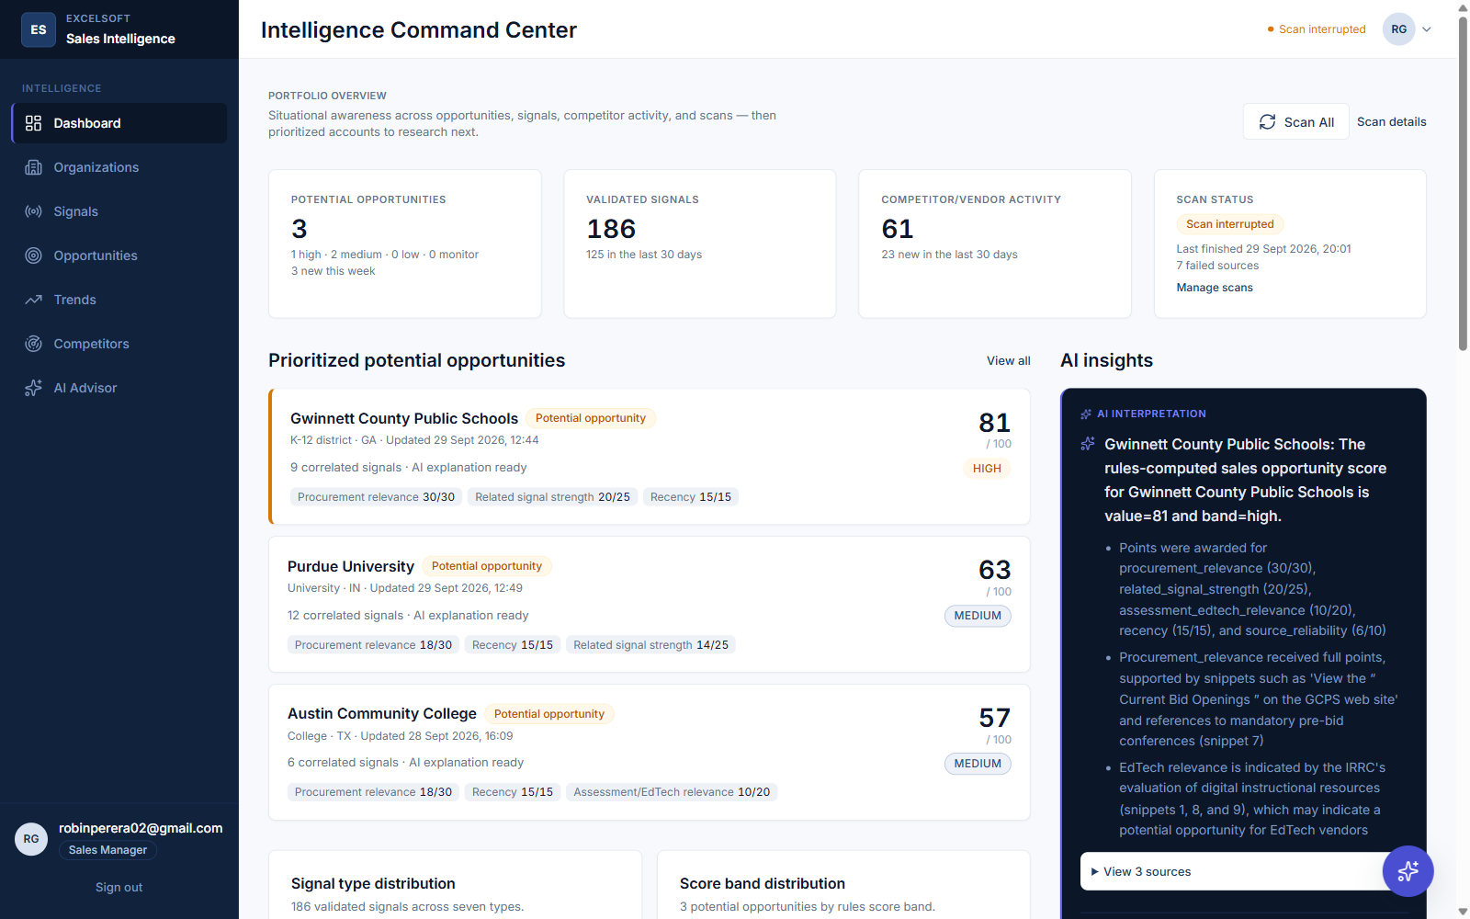
Figure 16.1 — The Dashboard, showing live metric cards, the prioritized-opportunities list, and a grounded AI interpretation panel.
Functionality: Gives a sales manager or representative a single-glance summary of the whole tracked portfolio: how many potential opportunities exist and in which band, how many signals were validated recently, competitor activity, and current scan health.
User flow: The user lands here immediately after sign-in. They can trigger Scan All from the Scanning section, watch a running scan's stage update live, or click through to any listed opportunity or signal for detail.
UI components used: Metric cards, a prioritized-opportunity list (reusing the Opportunity card component), a Recharts signal-volume chart, an AiPanel-styled insights block, and the Scan Now / Scan All controls with live-polling status.
API integration: GET /api/v1/dashboard for the metric payload; POST /api/v1/scans to trigger Scan All; GET /api/v1/scan-batches/{id} polled while a batch is running.

16.2 Organizations — List
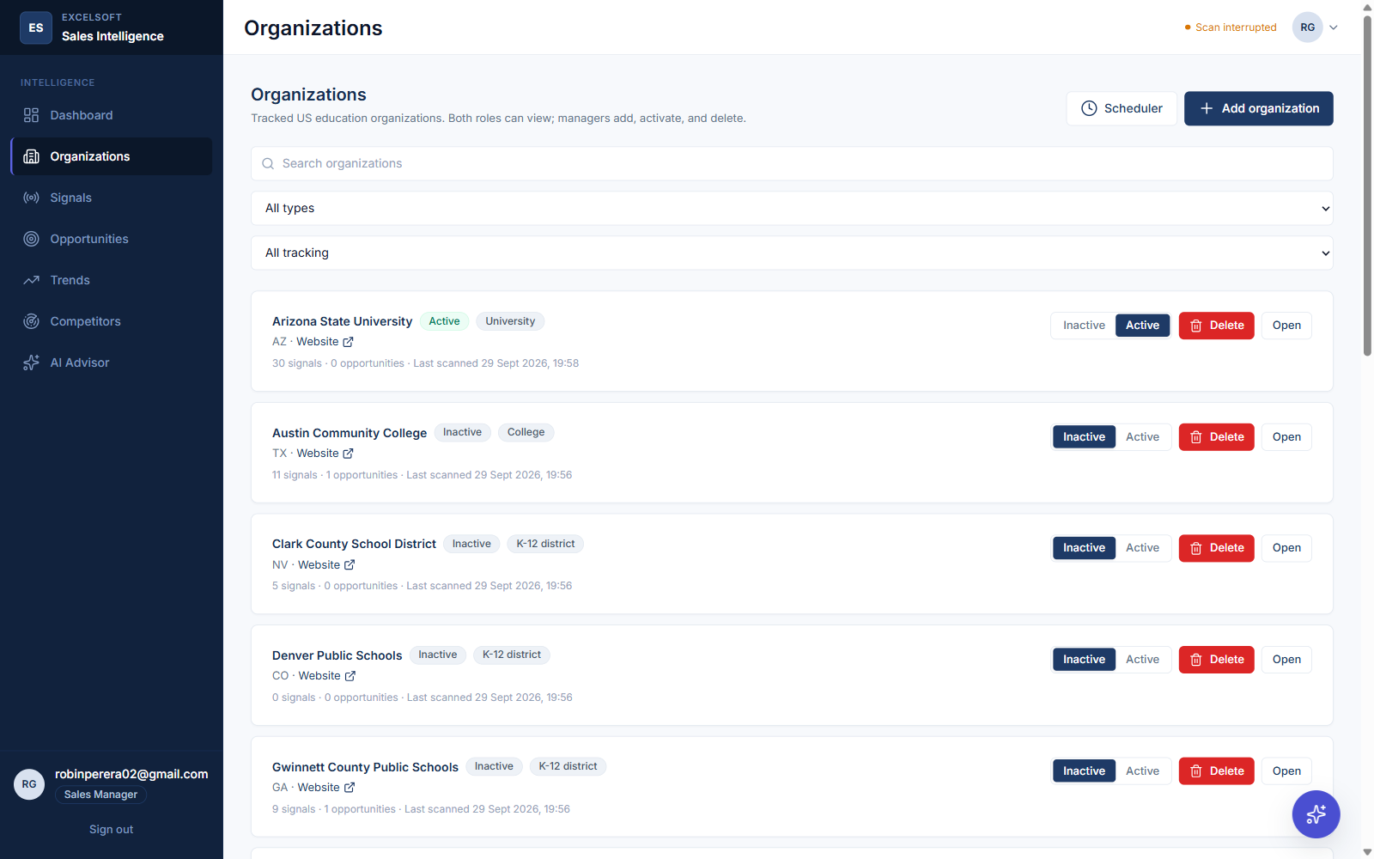
Figure 16.2 — The Organizations list, with search, filters, and the manager-only Scheduler and Add organization controls.
Functionality: Lets a user find a tracked organization quickly and, for a manager, add a new one or arm the portfolio-wide Scan All schedule.
User flow: The user searches or filters, then either opens an organization's detail page or, as a manager, opens the Add-organization dialog or the Scheduler dialog.
UI components used: A search input, type/tracking Select filters, TrackingToggle controls per card, and the two manager-only dialogs (OrganizationFormModal, ScanAllSchedulerModal).
API integration: GET /api/v1/organizations with query filters; PATCH /api/v1/organizations/{id} for the tracking toggle; GET and PATCH /api/v1/scan-all-schedule for the scheduler dialog.

16.3 Organization Detail — with Edit Dialog (Details and Schedule tabs)
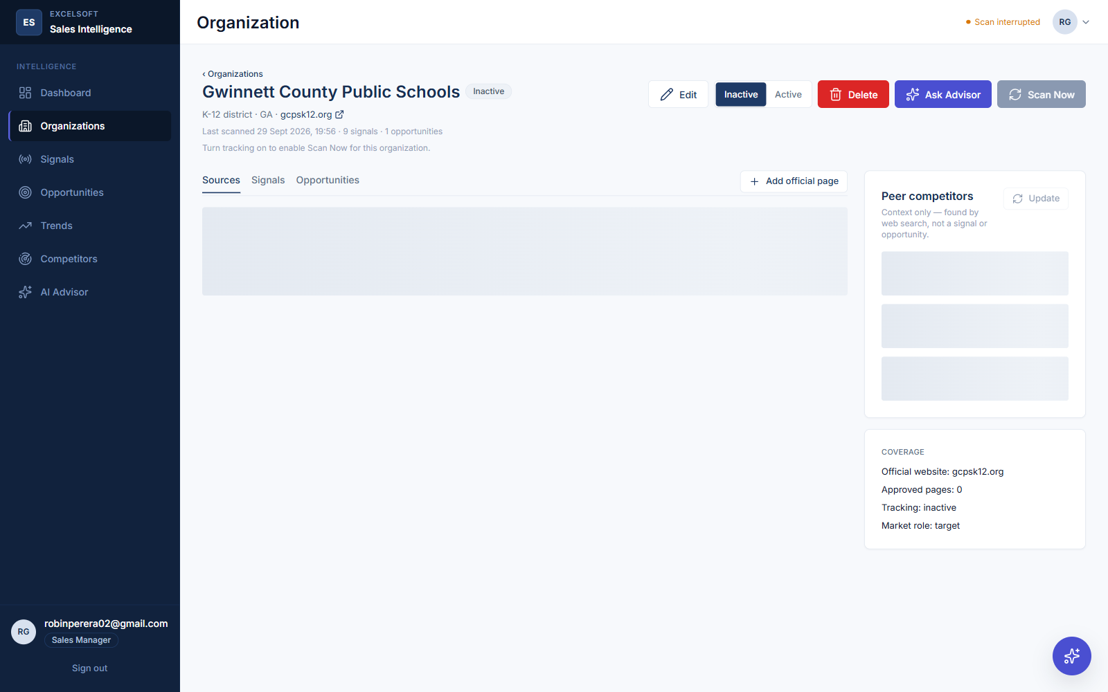
Figure 16.3a — One organization's detail page: sources, signals, opportunities, and the Peer Competitors card.
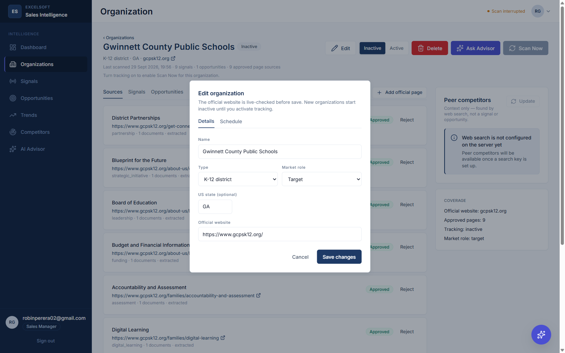
Figure 16.3b — The Edit organization dialog, Details tab.
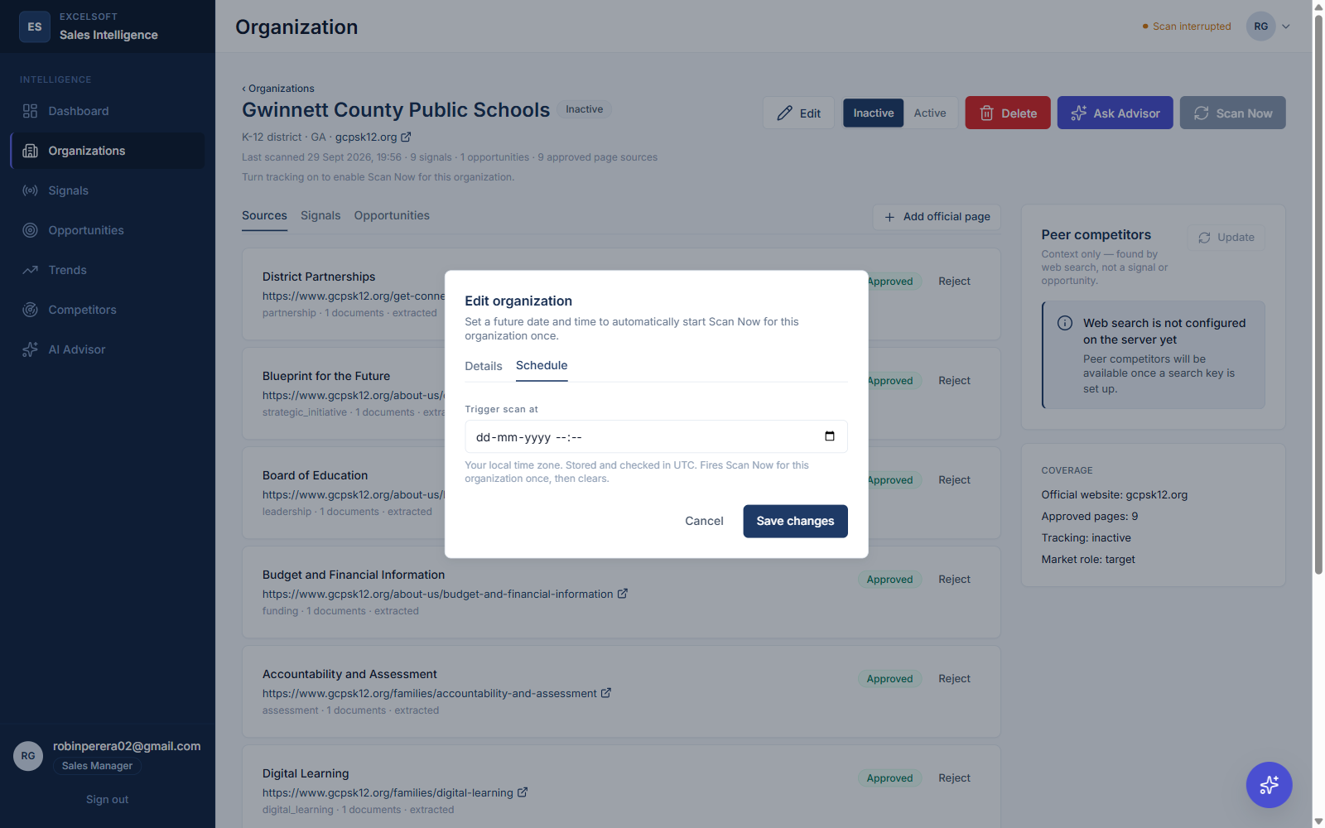
Figure 16.3c — The Edit organization dialog, manager-only Schedule tab, used to arm a one-time future scan trigger.
Functionality: The full working view for one organization: its approved page sources, its signals, its potential opportunity, its peer competitors, and every write action a manager can take on it.
User flow: A manager opens Edit to change identity fields or arm a one-time scheduled scan for this organization specifically; either role can trigger Scan Now, switch between the Sources / Signals / Opportunities tabs, or open the AI Advisor scoped to this organization.
UI components used: A tabbed dialog (OrganizationFormModal) with a datetime-local scheduler input, a DeleteOrganizationModal with a type-to-confirm safeguard, the PeerCompetitorsCard, and the Sources/Signals/Opportunities tab strip.
API integration: GET /api/v1/organizations/{id}; PATCH for edits including scheduled_scan_at; DELETE for removal; POST /api/v1/organizations/{id}/scans; GET/POST peer-competitors endpoints.

16.4 Signals — List and Detail
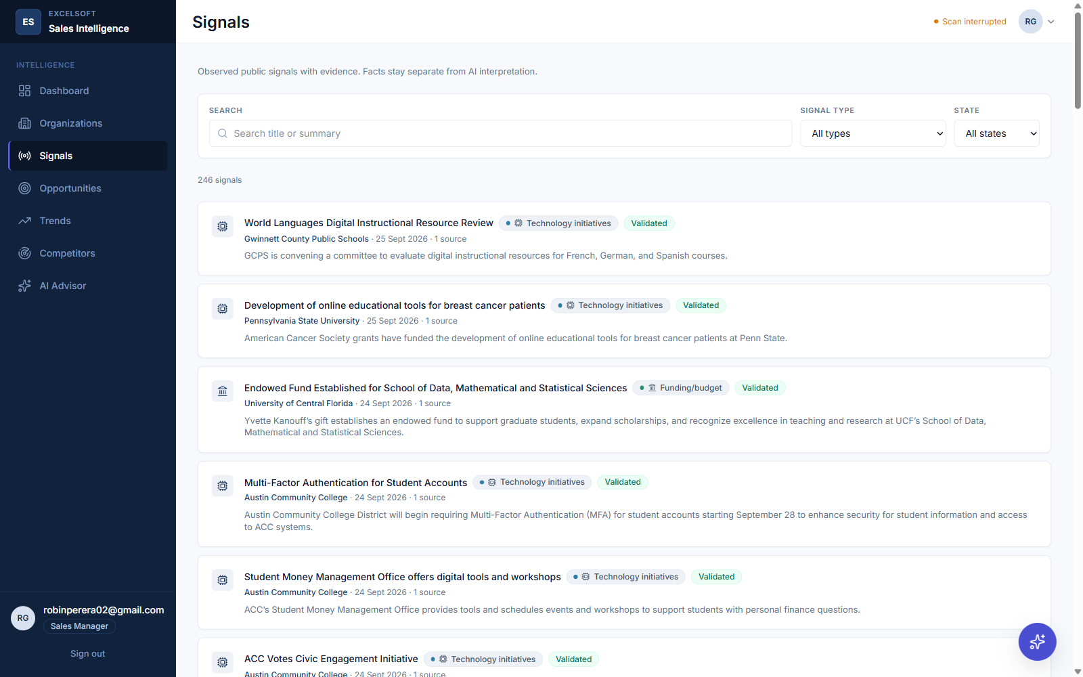
Figure 16.4a — The Signals list, filterable by organization, type, and state.
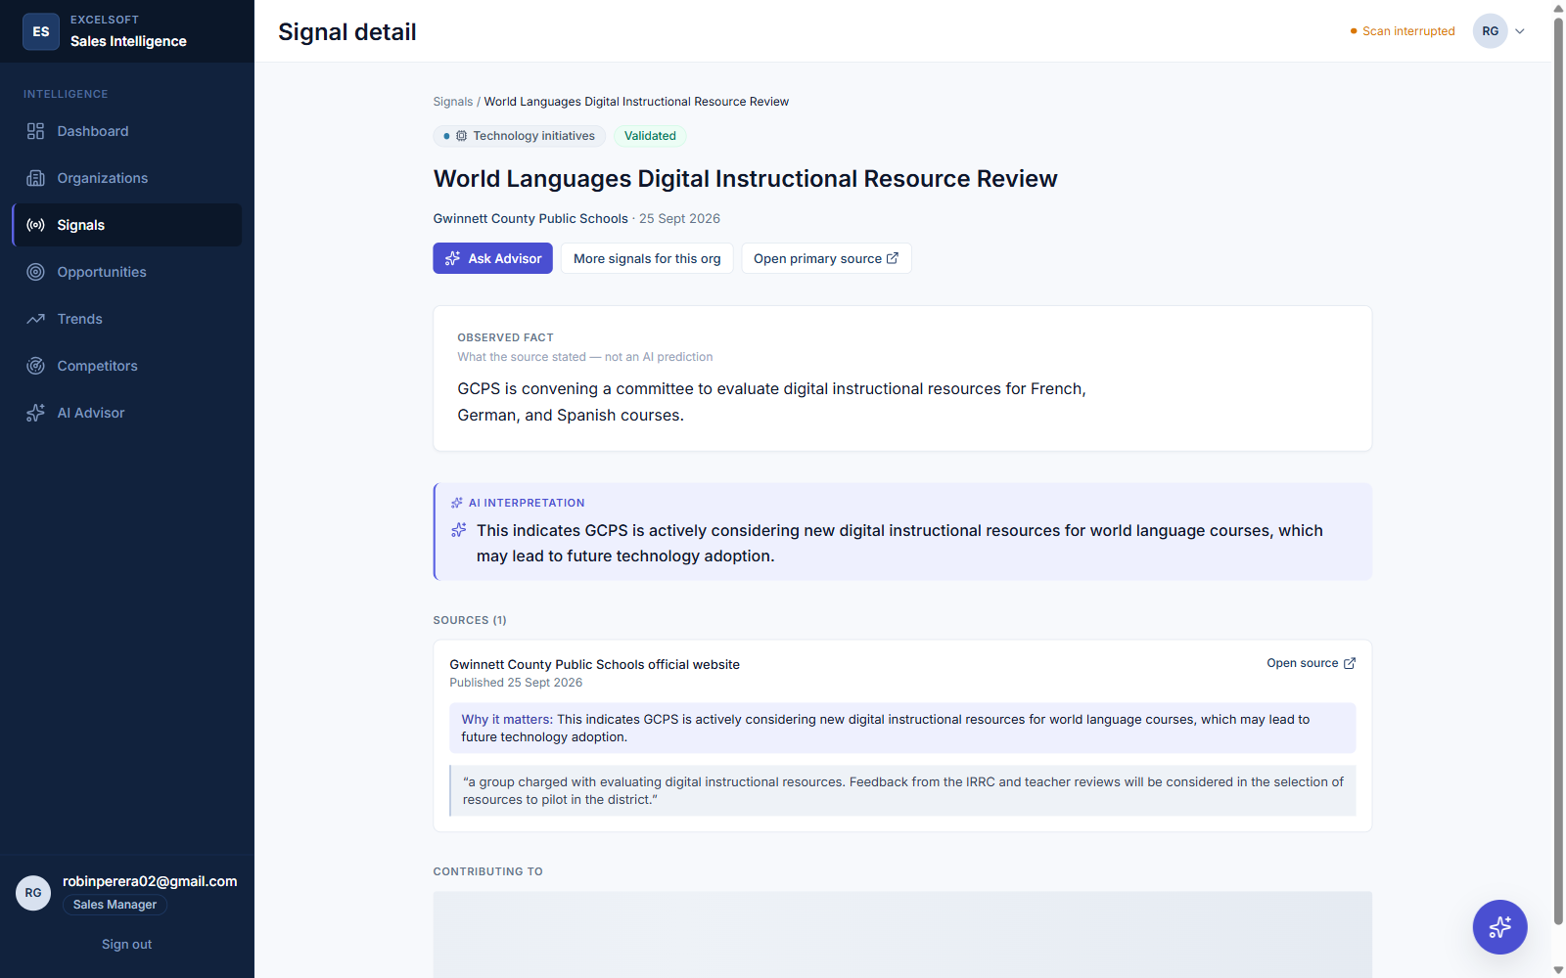
Figure 16.4b — One signal's detail view, showing the observed fact, the AI interpretation, and its cited evidence.
Functionality: Lets a user browse every validated signal across the portfolio, or drill into one signal's full evidence trail.
User flow: The user filters by organization or signal type from the list, then opens one signal to see its verbatim source snippet and citation.
UI components used: SignalCard components in the list; an EvidenceList component and the fact/interpretation layer split on the detail view.
API integration: GET /api/v1/signals with filters; GET /api/v1/signals/{id} for detail.

16.5 Opportunities — List and Detail
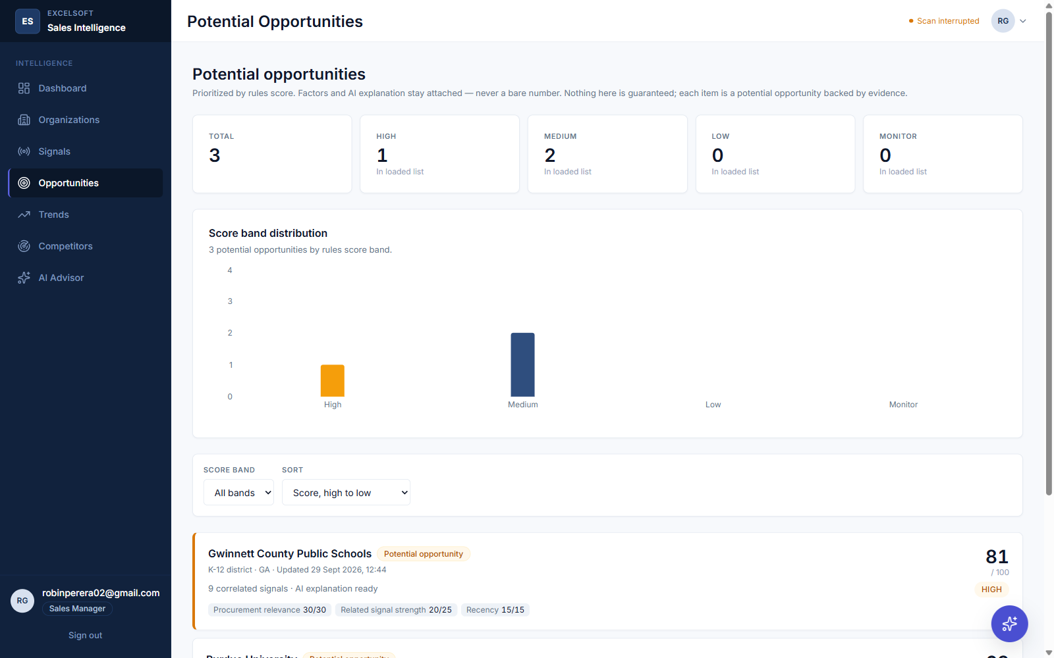
Figure 16.5a — The Opportunities list, with the score-band distribution chart and sortable cards.
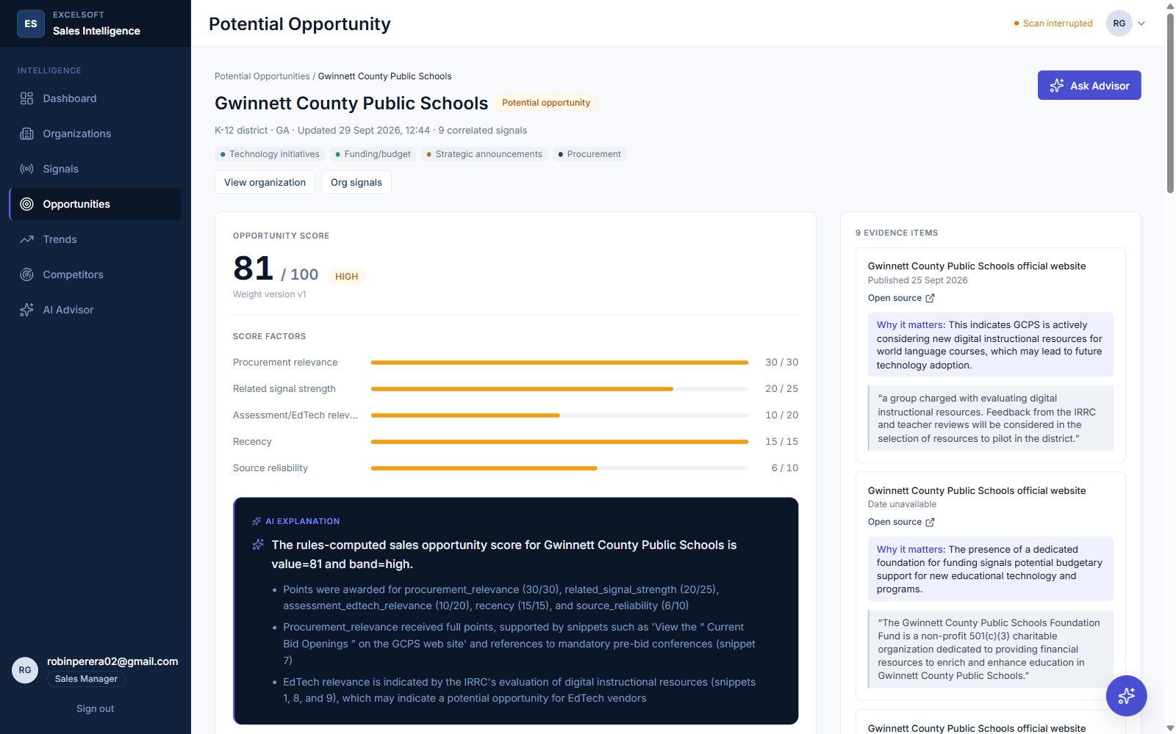
Figure 16.5b — One opportunity's full detail: the five-factor score breakdown, the AI explanation, and its evidence.
Functionality: Shows every potential opportunity, ranked by score, and gives full transparency into how one opportunity's score was calculated and what evidence supports it.
User flow: The user filters or sorts the list, opens an opportunity, reviews its five-factor score breakdown and recommended action, and can ask the scoped Advisor a follow-up question inline.
UI components used: OpportunityCard, ScoreDisplay (with the factor bars), EvidenceList, and an embedded AdvisorPanel.
API integration: GET /api/v1/opportunities with filters/sort; GET /api/v1/opportunities/{id}; POST /api/v1/advisor/questions for the inline Advisor.

16.6 Competitors
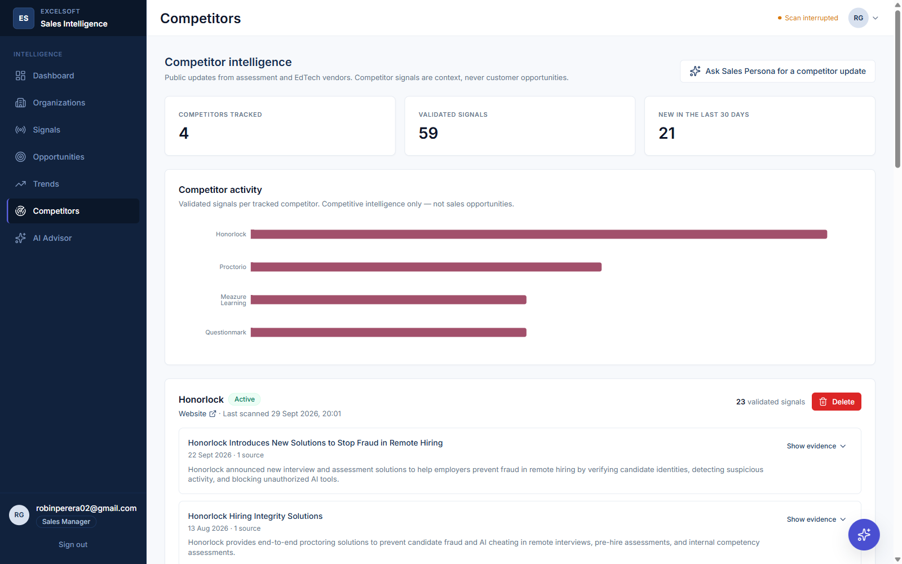
Figure 16.6 — The Competitors page: summary metrics, the per-competitor activity chart, and Honorlock's validated signals.
Functionality: A dedicated view of what the five tracked EdTech/assessment competitors have publicly done, kept structurally separate from customer opportunities.
User flow: The user reviews a competitor's recent validated signals and evidence, or jumps into the Sales Persona for a live, up-to-the-minute update.
UI components used: Summary metric cards, a per-competitor activity bar chart, and one CompetitorCard per tracked competitor with an expandable signal/evidence list.
API integration: GET /api/v1/competitors.

16.7 Trends
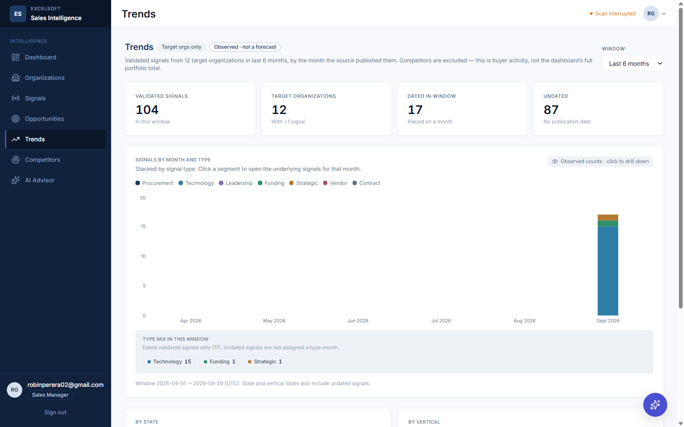
Figure 16.7 — The Trends page: the summary strip and the signals-by-month-and-type chart.
Functionality: Surfaces geographic and vertical signal trends across the tracked portfolio without a manual spreadsheet exercise.
User flow: The user changes the trailing time window and clicks into any bar to see the underlying signals on the Signals page, pre-filtered.
UI components used: A SummaryStrip, a stacked Recharts bar chart, and (below the fold in this capture) two HorizontalBucketChart components for state and organization-type breakdowns.
API integration: GET /api/v1/trends?months=.

16.8 AI Sales Advisor
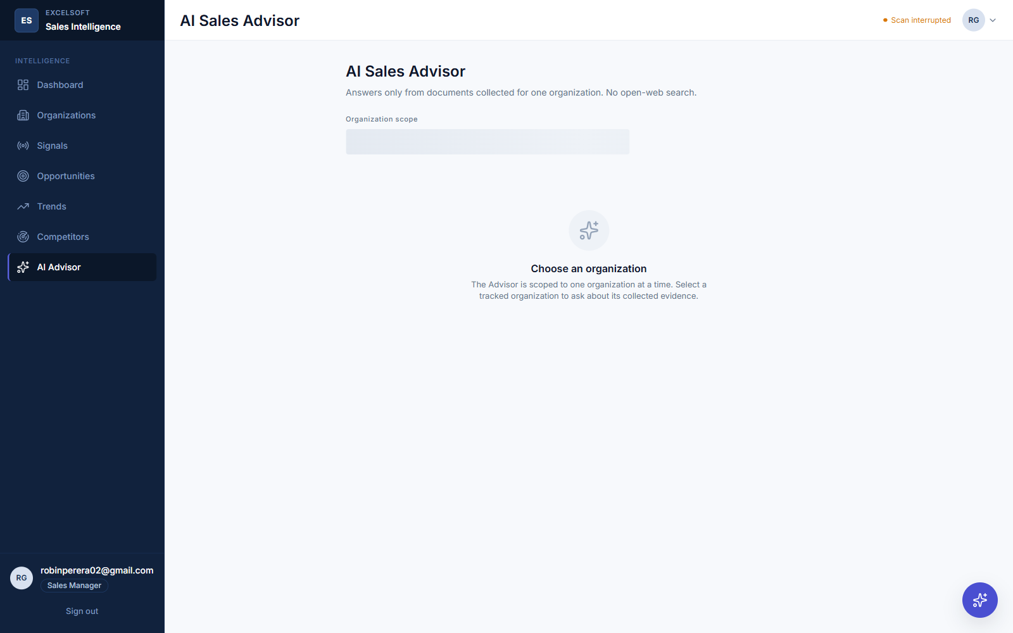
Figure 16.8 — The AI Sales Advisor's scope screen, prompting the user to choose one organization before asking a question.
Functionality: A focused Q&A surface for one organization or opportunity, answering only from that scope's stored evidence.
User flow: The user selects an organization; the Advisor then either returns a cited, fact/interpretation-tagged answer or an honest insufficient-evidence response.
UI components used: The AdvisorPanel component, reusing EvidenceList for citations; the Sales Persona widget is also visible here, open in the background.
API integration: POST /api/v1/advisor/questions; GET /api/v1/advisor/sessions/{id} for history.

16.9 Sales Persona — Scope Chooser and Ready-to-Chat State
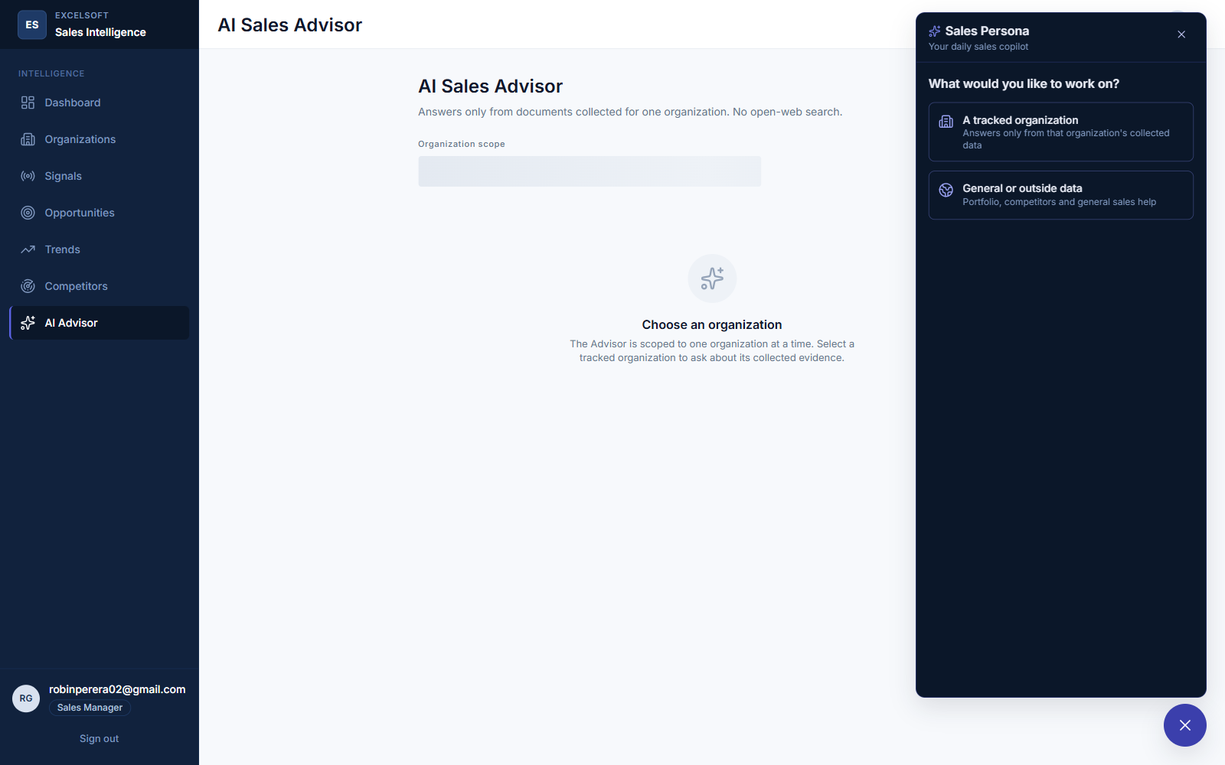
Figure 16.9a — The Sales Persona's opening scope choice: one tracked organization, or general/outside data.
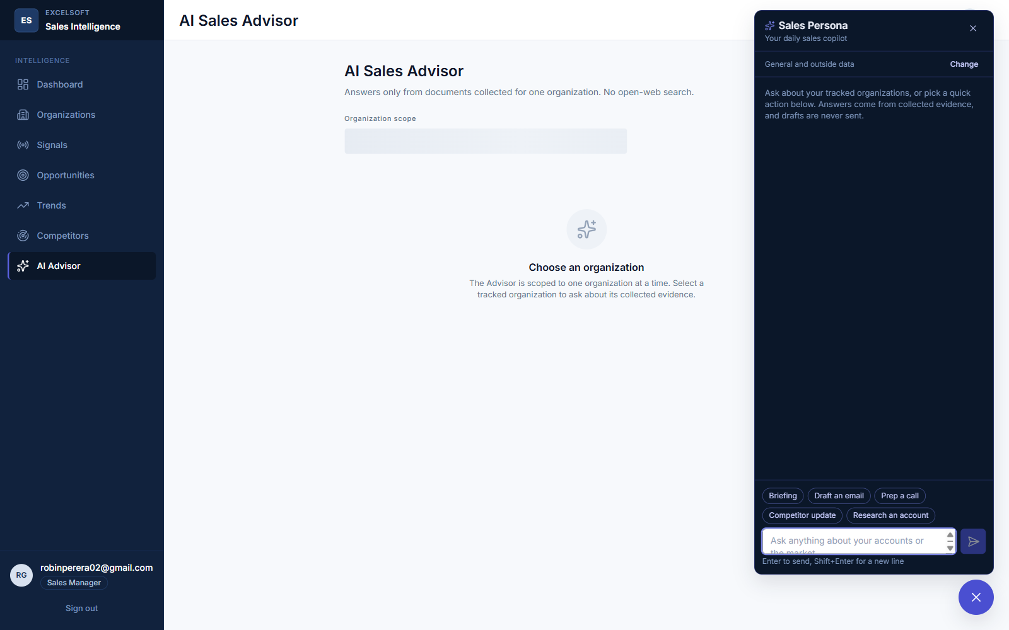
Figure 16.9b — The Persona in general scope, with its quick-action chips and message input ready.
Functionality: A portfolio-wide (or single-organization) daily copilot for briefings, call preparation, competitor updates, research, and draft outreach emails.
User flow: The user opens the widget, chooses a scope, picks a quick action or types a request, and reviews a structured, cited answer; a drafted email can be copied with one click.
UI components used: SalesPersonaWidget, PersonaScopeChooser, and PersonaAnswer (structured block renderer: headings, paragraphs, bulleted facts with citation chips, and email cards).
API integration: POST /api/v1/persona/messages.

17. End-to-End Use Cases and Business Workflows

17.1 Morning Portfolio Review
Actor: Sales Representative
Goal: Start the day knowing what changed across the tracked portfolio without visiting ten organizations' websites individually.
Steps:
- Sign in; the Dashboard loads with current metrics.
- Review the prioritized-opportunities list and the 30-day signal-volume chart for anything new.
- Open the Sales Persona, choose general scope, and select the ‘Daily briefing’ quick action.
- Receive a cited summary of the top opportunities, recent signals, and scan health; act on the recommended next steps.

17.2 Investigating One Opportunity Before a Call
Actor: Sales Representative
Goal: Understand exactly why an organization scored the way it did, and prepare talking points grounded in real evidence.
Steps:
- Open the Opportunities list, filter to Medium+ band, and select one opportunity.
- Review the five-factor score breakdown and its AI explanation.
- Read the correlated signals and their evidence; open a source URL directly if needed.
- Ask the inline AI Sales Advisor a specific follow-up question about this opportunity.
- Open the Sales Persona scoped to this organization and select ‘Prep a call’ for discovery questions and known risks.

17.3 Adding and Activating a New Target Organization
Actor: Sales Manager
Goal: Bring a new institution under systematic monitoring.
Steps:
- Open Organizations and select ‘Add organization.’
- Enter its name, type, and official website; the backend live-validates the website before saving.
- The organization is created as inactive by default; the manager toggles it to Active.
- Trigger Scan Now to run the first collection and extraction pass.
- Review the discovered page sources and approve or reject each one.

17.4 Scheduling an Unattended Scan
Actor: Sales Manager
Goal: Arrange for a scan to run automatically outside working hours, without leaving a browser tab open.
Steps:
- Open one organization's Edit dialog, switch to the Schedule tab, and pick a future date and time.
- Save; the organization detail page now shows the next scheduled scan time.
- At the scheduled time, the backend's always-on trigger check starts the scan automatically and clears the schedule.
- The manager returns later to review the scan's results — no manual trigger was required.

17.5 Reviewing Competitor Activity Ahead of a Renewal Conversation
Actor: Sales Manager
Goal: Understand what a named competitor has publicly announced before a competitive renewal discussion.
Steps:
- Open the Competitors page and review the named competitor's recent validated signals.
- Open the Sales Persona in general scope and select ‘Competitor update’ for a synthesized, cited summary, including a live-fetched excerpt from the competitor's own site.
- Use the synthesized positioning points in the renewal conversation.

17.6 Deactivating and, if Necessary, Removing an Organization
Actor: Sales Manager
Goal: Stop monitoring an organization that is no longer a sales priority, or permanently remove one entirely.
Steps:
- Open the organization's detail page and toggle tracking to Inactive — its history is kept, and it is excluded from future Scan All runs.
- If the organization must be permanently removed (for example, a duplicate created in error), open Delete, type the organization's exact name to confirm, and submit.
- The system blocks the delete if a scan is currently queued or running for that organization, and otherwise permanently removes it and every row it owns.

18. Exception and Failure Scenarios and Their Handling
The system is designed to fail soft: a single failing source, a single failing AI call, or a single failing page fetch degrades that one piece of the result, and is recorded, rather than aborting the whole operation or presenting a misleading success.
Scenario | Handling
A tracked page returns a network error or a non-200 status during a scan | That page's fetch is recorded as failed on the scan_run's per-source detail; the scan continues with every other source and finishes as ‘partial’ rather than ‘failed’ outright
A page is blocked by robots.txt, or looks gated/paywalled | The fetch is refused before any content is read, and recorded with the specific reason; no attempt is made to bypass the restriction
The AI extraction model proposes a snippet that is not actually in the source document | The candidate is rejected in code before it becomes a signal, and the rejection reason (‘snippet not verbatim’) is stored on a rejected signal row
SAM.gov's daily application-level request quota is exhausted | SAM.gov collection is skipped for the remainder of that day; the scan proceeds with website and USAspending collection and reports the quota exhaustion explicitly
The Azure OpenAI or Gemini API call fails or times out | The score explanation, correlation text, or recommended action is left null/unavailable for that item rather than guessed; the Sales Persona automatically falls back from Gemini to Azure OpenAI on any Gemini failure
A user asks the AI Sales Advisor or Sales Persona a question with no supporting stored evidence | The system returns an explicit ‘insufficient evidence’ response and does not call the chat model at all
A manager tries to delete an organization with a scan currently queued or running | The delete is rejected with a 409 Conflict naming the reason; the manager waits for the scan to finish and retries
A scheduled scan trigger is set for a time that has already passed, or the backend process restarts before it fires | A past-or-present time is rejected at submission time (400); a stored, un-fired schedule survives a process restart, because it lives in the database, not in memory
The backend process crashes or is forcibly restarted while a scan is running | On the next startup, any scan left in ‘queued’ or ‘running’ state is marked ‘interrupted,’ so it does not appear as silently stuck forever
A duplicate signal would be created from a second source reporting the same event | Three-tier deduplication (content hash, external id, then snippet/title within a time window) merges the new evidence into the existing signal instead of creating a second one

19. Future Enhancements and Scalability Considerations

19.1 Near-Term Enhancements

19.2 Scalability Path
The current single-process, single-worker design is an explicit, accepted trade-off at the project's present scale (tens of tracked organizations, a handful of concurrent users), not an oversight. If the tracked portfolio or user base grows meaningfully, the following changes would need to happen together, not piecemeal, because of the single-worker scheduling constraint described in Section 13.2:

19.3 Product Scope Enhancements (Explicitly Deferred, Not Rejected)

20. Appendix

20.1 Full Technology Stack Summary
Layer | Technology
Frontend | React 19, TypeScript, Vite, Tailwind CSS 4, TanStack Query, React Router, Recharts
Backend | Python, FastAPI, SQLAlchemy 2.0 (async), Alembic, Pydantic
Database | PostgreSQL (Supabase) with the pgvector extension
AI / RAG | Azure OpenAI (chat + embeddings), Google Gemini (Sales Persona), pgvector similarity retrieval
Web collection | httpx, BeautifulSoup, a custom robots.txt-respecting rate-limited fetcher
Scheduling | APScheduler, in-process
Authentication | Clerk (identity only; authorization is enforced by the backend)

20.2 Glossary
Term | Meaning in this system
Signal | One validated, evidence-backed observation about a tracked organization, in one of seven closed categories
Evidence | The stored source name, URL, date, and verbatim snippet supporting one signal or one AI-authored claim
Potential opportunity | A correlated group of related signals for one organization, scored and never presented as a certainty
Band | The score range an opportunity falls into: High (75–100), Medium (50–74), Low (25–49), Monitor (0–24)
Weight version | A version tag on the scoring formula, so a future change to the formula never silently reinterprets an old, already-stored score
Data origin | Whether a displayed figure is ‘live’ (from a current scan) or ‘cached’ (a labelled fallback, never presented as current without saying so)

20.3 Document Control
This document reflects the codebase as it existed at the time of writing. Where a described capability is fully implemented and verified, it is stated as such; where a gap is known (Section 19), it is stated explicitly rather than implied to be complete. Screenshot placeholders throughout Section 16 must be replaced with current captures before this document is circulated externally.

