**Thunder Production App**

**Rev. 1.2**

**4/24/12**

1. Introduction

This document outlines in wireframe detail what the Thunder Production App could look like. The final app that ships is dependent on the needs of our go-to-market partner and other variables. Hence, professionally created icons and graphics have been left out of this document on purpose. It is expected that either our partner or a UX design company would provide such collateral and would be integrated into that app.

This is a simple tabbed application for the iPad. iTunes on the iPad is another example of a tabbed application. There are three tabs: Home, Promo and About. Home will be the default and will immediately present the user with what he is most interested in: Battery Status, Charging Mode and Audio Processing Mode (which is selectable). The basic flow of operation is outlined in Figure 1 (Top Level Scene Flow).



Fig. 1 – Top Level Scene Flow

Upon start-up of the app, the app will check:

1. Thunder connectivity (actions described in section II).
2. Internet connectivity (actions described in section II).
3. If any forced firmware updates required (actions described in section VI).
4. If any normal firmware updates available (actions described in section VI).
5. If the Thunder has enrolled in the Thunder Loyalty Program (actions described in sections II & III).
6. Thunder Connectivity
7. Thunder Not Connected

The first thing the app does when it is started is look for connectivity with the Thunder. Figure 2 (Thunder Not Connected Flow) shows the basic scene flow when Thunder is not connected.



Fig. 2 – Thunder Not Connected Flow

If not connected, the user will be present with the scene in Figure 3 (No Thunder Detected).

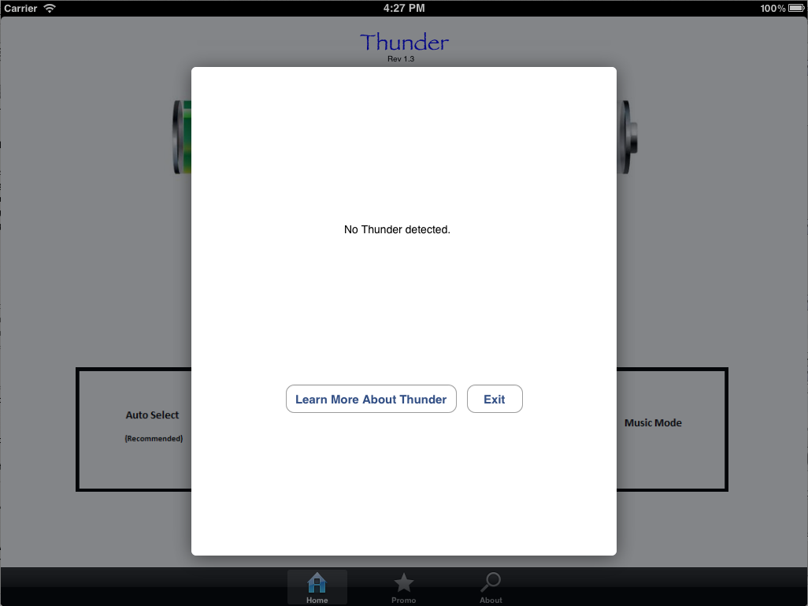

Fig. 3 – No Thunder Detected

Pressing the “Learn More About Thunder” button would take the user to the scene in Figure 4 (Learn More About Thunder).

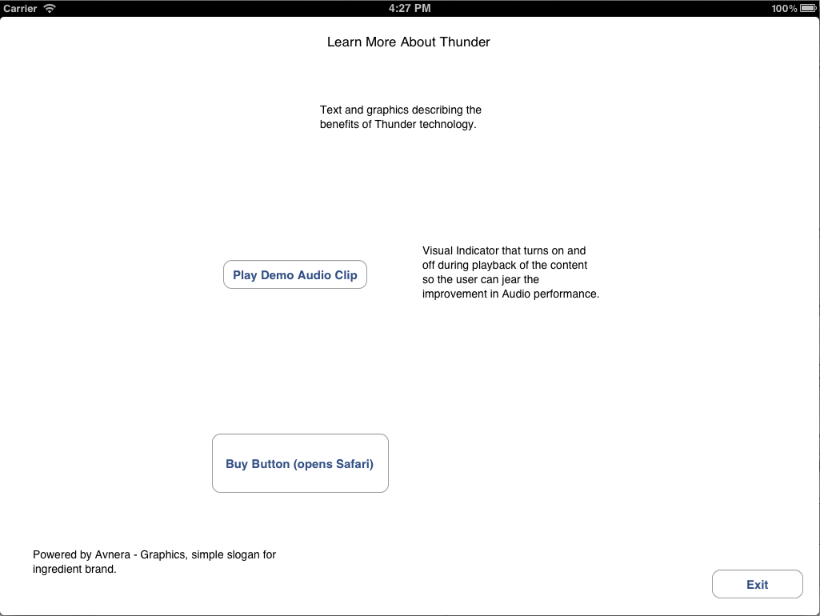

Fig. 4 – Learn More About Thunder

It this scene, the user has three choices:

1. Exit
2. If internet connectivity is detected, the user can be taken to a Safari browser where the user can purchase Thunder online.
3. Play the demo audio clip.

The demo audio clip will be pre-processed in 5 second intervals to demonstrate the increase in audio quality in Thunder. There will be a visual indicator icon that changes appearance at the same interval alerting the user when the enhanced portion of the audio is present.

1. Thunder Connected and Internet Connectivity

If the app establishes connectivity with the Thunder and the Thunder server, the next thing it will check is whether or not this (identified by UUID) is enrolled in the “Thunder Loyalty Program.” If it isn’t, the user will be presented with the scene in Figure 5 (Thunder Loyalty Program). If the user selects “No Thanks”, this scene will be presented on start-up four (4) more times at start-up before giving up.

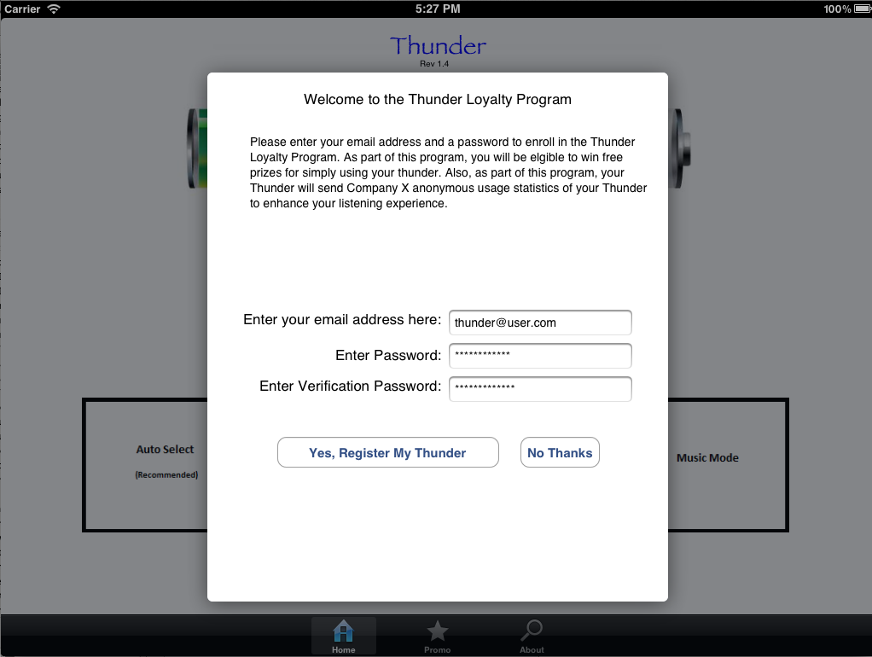

Fig. 5 – Thunder Loyalty Program

1. Thunder Connected and No Internet Connectivity

If connectivity to Thunder is established but cannot contact the Thunder server, the user would be taken directly to the Home Scene described in section III.

1. Home Scene

If Thunder connectivity detected and one of the following three conditions are met, the user will be taken directly to the Home Scene (Figure 6) on start-up:

1. No internet connectivity detected.
2. User has previously enrolled in the Thunder Loyalty Program.
3. User has previously opted out of Thunder Loyalty Program.

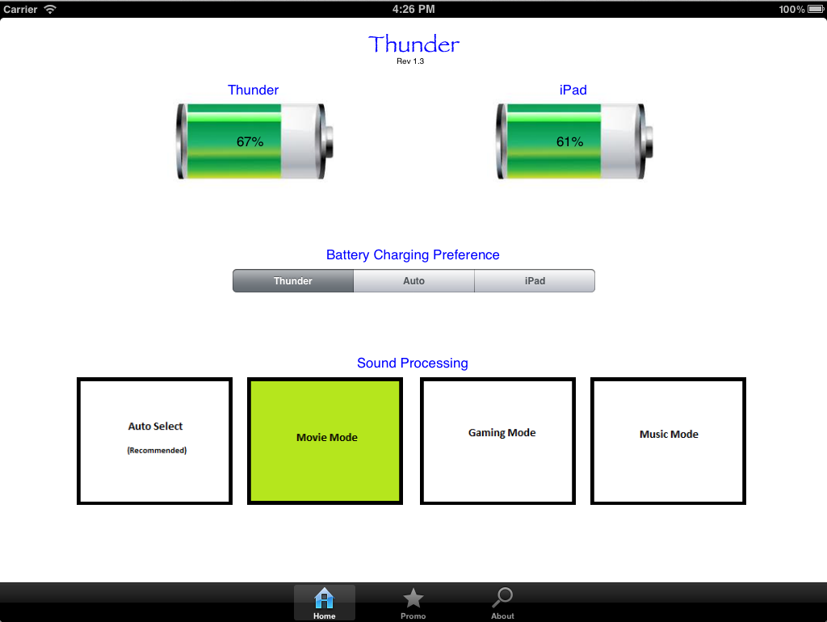

Fig. 6 – The Home Scene

This scene is the default scene and we expect the users to spend most of their time here. In this scene, the user can observe the battery status, choose/observe the battery charging method, and choose/observe the sound processing mode. The above scene shows the “Movie Mode” sound processing selected and “Thunder” charging method.

Note: Due to a quirk in how iOS works, the iPad battery percentage presented in the app can be up to 5% different than what the battery indicated on the iPad’s status bar. All battery apps have the same problem. Nigel W. has deemed this to be OK.

1. The Promo Scene

If the user presses the “Promo” tab, the user would be presented with an embedded browser pointed at timely HTML content located on the Thunder servers. As an example, Figure 7 (The Promo Scene) shows how this scene would look if pointed at [www.avnera.com](http://www.avnera.com):

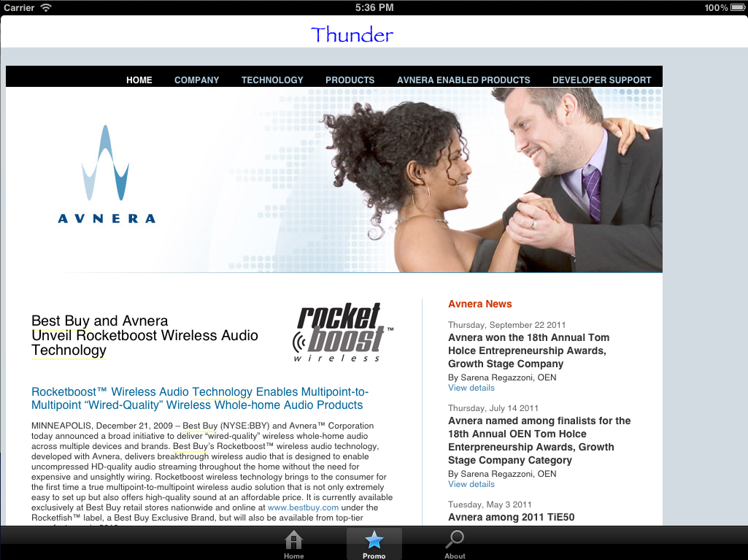

Fig. 7 – The Promo Scene

1. The About Scene

The About scene (Figure 8) will present the user with the following information:

1. Warranty activation date/time (if enrolled in loyalty program)
2. Thunder S/N
3. Thunder UUID
4. Product info on Thunder
5. Information on how to get support
6. Thunder statistics (if enrolled in loyalty program)

If the user has enrolled in the Thunder Loyalty Program, they would be able to access a portal on the web and redeem their “Hours of Use” presented in the Statistics for free prizes (prizes are TDB). The user could also reset the Thunder back to factory defaults.

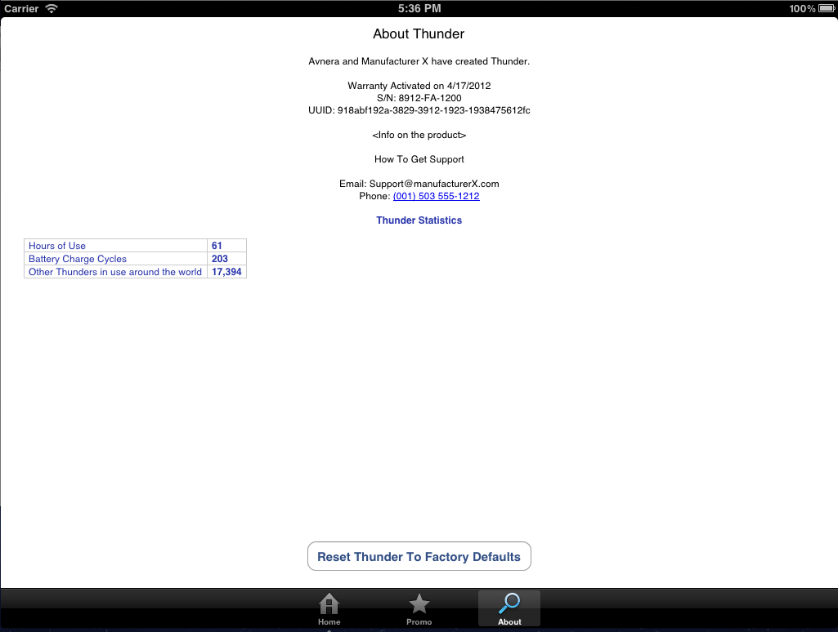

Fig. 8 – The About Scene

1. Firmware Upgrades

Figure 9 (Firmware Upgrade Flow) shows the basic flow for Normal and Forced firmware upgrades.

Fig. 9 – Firmware Upgrade Flow

1. Normal Firmware Upgrades

From time to time, enhanced firmware will be made available on the Thunder servers for download. This firmware would then be flashed into Thunder using this app. The app will check the firmware revision of the Thunder against the latest revision available on the servers. If there is a more recent revision available AND the user is connected to wall power (VDC), the user would be presented with the scene in Figure 10 (New Firmware Available). The user would be warned that audio will mute during this process.

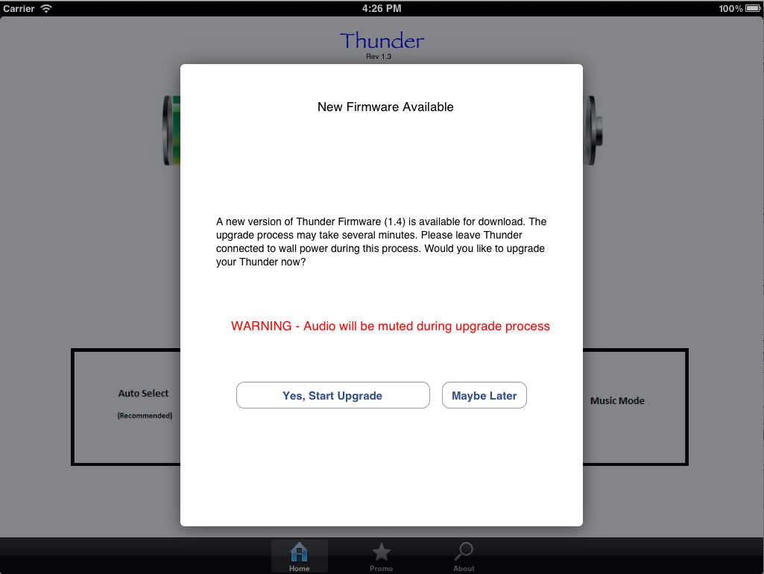

Fig. 10 – New Firmware Available

If connected to VDC and the user presses the “Yes” button, the firmware upgrade process would proceed as shown in Figure 11 (Firmware is Upgrading) and then to Figure 12 (Firmware Upgrade Complete). The Thunder would automatically reset after upgrading is complete.

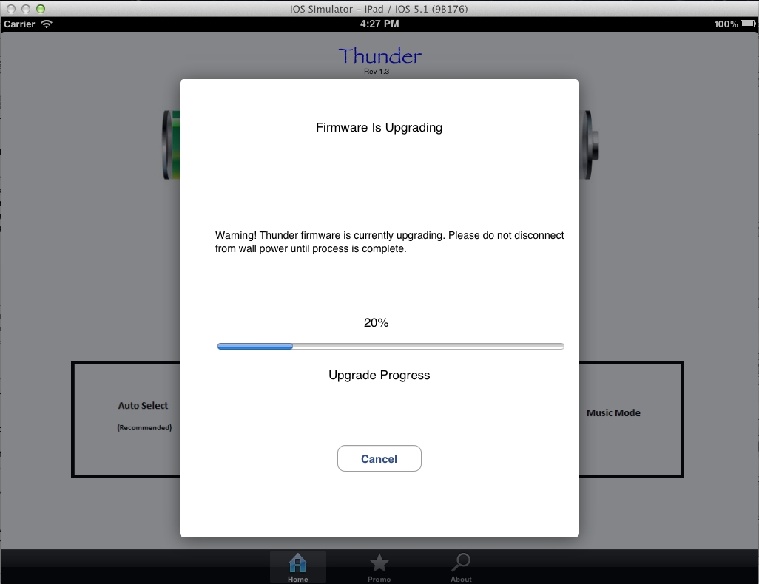

Fig. 11 – Firmware is Upgrading

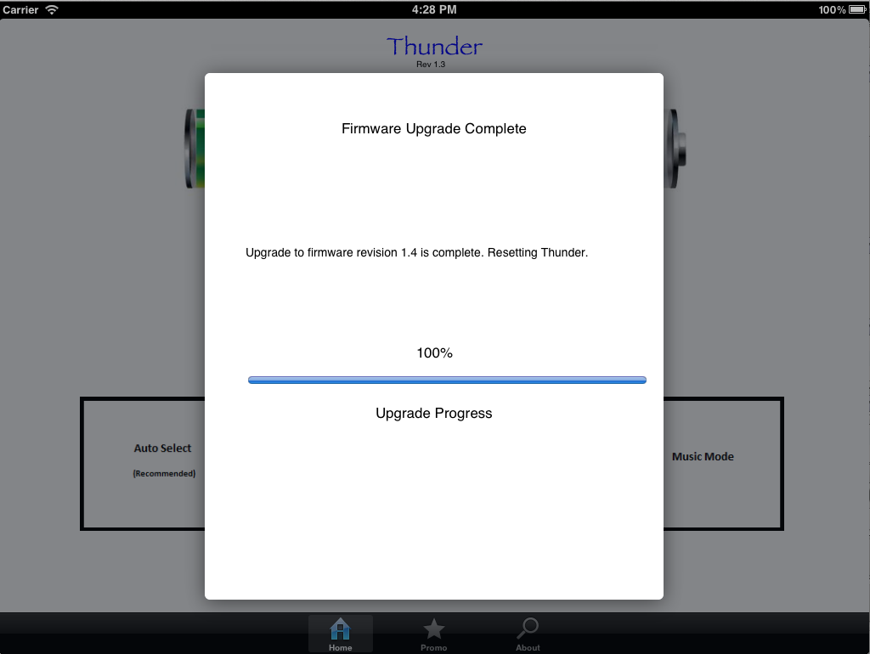

Fig. 12 – Firmware Upgrade Complete

1. Forced Firmware Upgrades

There may be cases where we may want to force the user into a firmware upgrade (e.g. a DMCA takedown). In this case, once the app has detected internet connectivity and determined a forced firmware upgrade is required, the user would be taken directly to Figure 11 (Firmware is Upgrading) scene with the “Cancel” button removed (skipping the New Firmware Available scene in Figure 10). Once complete, the user would be presented with Figure 12 (Firmware Upgrade Complete) and the Thunder would automatically reset.