# Sim Manager – Quick Start Guide

## Overview

This guide was developed for Windows and provides the minimum requirements for the operator to install and use Sim Manager. The software needs to be installed in “C:\SimManager” to function correctly. Operators can install the software in other locations, however they will need to refer to the full installation guide to change the configuration.

This guide also assumes no other services are running on the following ports: 80, 81, 3306, 8091, 8092, 8093.

## Base Software Setup

1. Obtain the following installation file.

|  |  |  |
| --- | --- | --- |
| **Type** | **Example** | **Source** |
| Container | Docker | <https://www.docker.com/products/docker-desktop> |

1. Install software in the following order with default options:
   1. Docker.
2. Download Sim Manager from XYZ and unzip to “C:\SimManager”.
3. Go to the Docker settings menu and select the Shared Drive option. The settings menu can be found by right clicking on the docker icon in the system tray . Provide docker access to your local drive to share with containers.

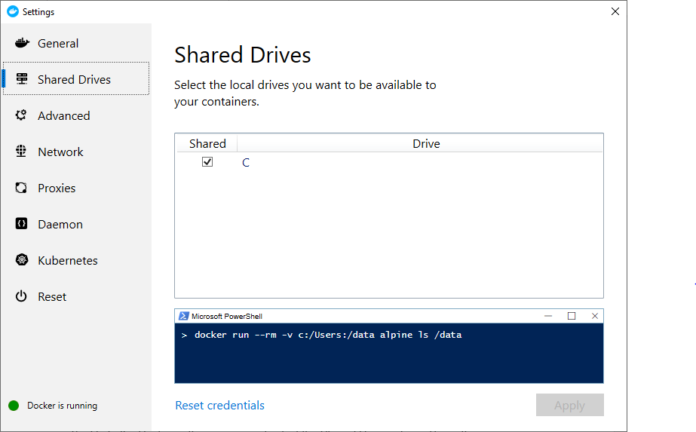

# Configuration and Start Up

1. Before running the install script you need to modify the following three files:
   1. C:\SimManager\Settings\PRODmanageexperiment.properties
   2. C:\SimManager\Settings\PRODrunexperiment.properties
   3. C:\SimManager\Settings\PRODviewexperiment.properties
2. Find the following line in each file “spring.datasource.url=jdbc:mysql://192.168.129.10:3306/sims” and change the IP address from 192.168.129.10 to your local machine IP address.
3. Start Sim Manager by running C:\SimManager\Scripts\QuickStart\InstallSimManager.bat. After Sim Manager is installed it can be stopped by using the script C:\SimManager\Scripts\QuickStart\StopSimManager.bat and started with C:\SimManager\Scripts\QuickStart\StartSimManager.bat.
4. Once Sim Manager is started the operator can access it by opening a web browser and going to http://localhost

# Run Example Simulations