Sim Manager – Quick Start Guide

Table of Contents

Overview 1

Base Software Setup 1

Configuration and Start Up 2

How To Run an Experiment 2

Examples and Experiments 3

# Overview

This guide was developed for Windows and provides the minimum requirements for the operator to install and use Sim Manager. The software needs to be installed in “C:\SimManager” to function using the default configuration. Operators can install the software in other locations, however they will need to refer to the full installation guide to change the configuration.

This guide also assumes no other services are running on the following ports: 80, 81, 3306, 8091, 8092, 8093.

# Base Software Setup

1. Sim Manager relies on the following list of software.

|  |  |  |
| --- | --- | --- |
| **Type** | **Example** | **Source** |
| Container | Docker | <https://www.docker.com/products/docker-desktop> |

1. Install software in the following order with default options:
   1. Docker.
2. Download the Sim Manager Quick Start package from <https://github.com/robbarwell123/SYSC5104/raw/master/SimManager.zip> and unzip it to “C:\”. This will create a directory called “C:\SimManager”.
3. Go to the Docker settings menu and select the Shared Drive option. The settings menu can be found by right clicking on the docker icon in the system tray . Provide docker access to your local drive to share with containers.

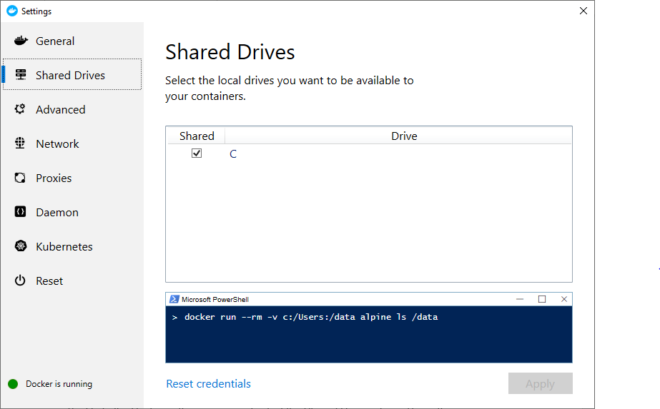

# Configuration and Start Up

1. Prior to running the install script you need to modify the following three files:
   1. Find the following line in each file “spring.datasource.url=jdbc:mysql://192.168.129.10:3306/sims” and change the IP address from 192.168.129.10 to your local machine IP address.
      1. C:\SimManager\Settings\PRODmanageexperiment.properties
      2. C:\SimManager\Settings\PRODrunexperiment.properties
      3. C:\SimManager\Settings\PRODviewexperiment.properties
2. Start Sim Manager by running C:\SimManager\Scripts\QuickStart\InstallSimManager.bat. After Sim Manager is installed it can be stopped by using the script C:\SimManager\Scripts\QuickStart\StopSimManager.bat and started with C:\SimManager\Scripts\QuickStart\StartSimManager.bat.
3. Once Sim Manager is started the operator can access it by opening a web browser and going to <http://localhost>.
4. Compile the common components before conducting any experiments by using the following command: <http://localhost:8092/ResetCommon>.

# How To Run an Experiment

1. Click on the hamburger menu in the top left corner of Sim Manager. Select the Create Experiment menu option.

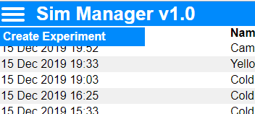

1. In the pop-up box give the experiment a name and add all the files. Remember to add both the XML files and data files required for your experiment. For the ABP example this includes: ABP.xml, Config.xml, input_adp_1.txt, Network.xml, and TOP.xml.

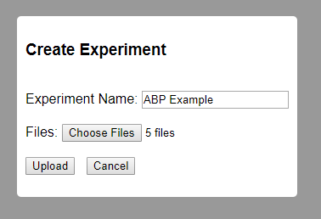

1. After the files are uploaded, the experiment can be run using the running person icon  in the options column for the experiment. A pop-up will prompt you for the top and config file. You can select these from the drop downs. Select Run and the experiment will compile and execute.

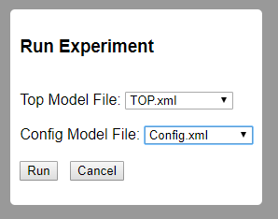

1. Logs can be downloaded using the download icon  or visualized in Sim Visualizer using the visualize icon .
2. If you no longer require your experiment or made a mistake you can use the delete icon  to remove it.

# Examples and Experiments

**IMPORTANT NOTE:** Please be patient while large experiments have their logs parsed for visualization.

1. All examples and experiments can be found in the documentations folder of C:\SimManager\Documentation either in Examples or Experiments.
2. The top file for each example and experiment is called TOP.xml and the configuration file is called Config.xml.
3. The following examples and experiments are available for the operator. Please use the instructions in the How To Run an Experiment section to view each one.
   1. Examples
      1. ABP
      2. StratAirliftTest
   2. Experiments – Explanations for experiments can be found in the final paper.
      1. Base
      2. ColdLakev1
      3. ColdLakev2
      4. ColdLakev3
      5. Yellowknife
      6. Cambridge Bay
4. The ABP example demonstrates ABP using XML. It does not use any mapping visualization features. Output can be verified using the download logs button.
5. The StratAirliftTest can be used to ensure the system is operating as expected. After running the experiment, select the visualizer and confirm the following:
   1. The scenario completed in 4305 minutes. This can be confirmed by dragging the slider all the way to the right.
   2. The playback produces the following:
      1. An aircraft that flies from Trenton to Paris and back;
      2. Another aircraft that flies to Casablanca and back to Paris; and
      3. The same aircraft will fly from Paris to Tallin and back.