# Problem description

## Carsharing:

Cambio is a Carsharing company. Costumers can book a car for a certain amount of time. When a reservation is made, Cambio will look for a car of them near you, and will give you the keys at the location. The cars are shared among all Cambio users and don’t have a personal owner.

## Problem description:

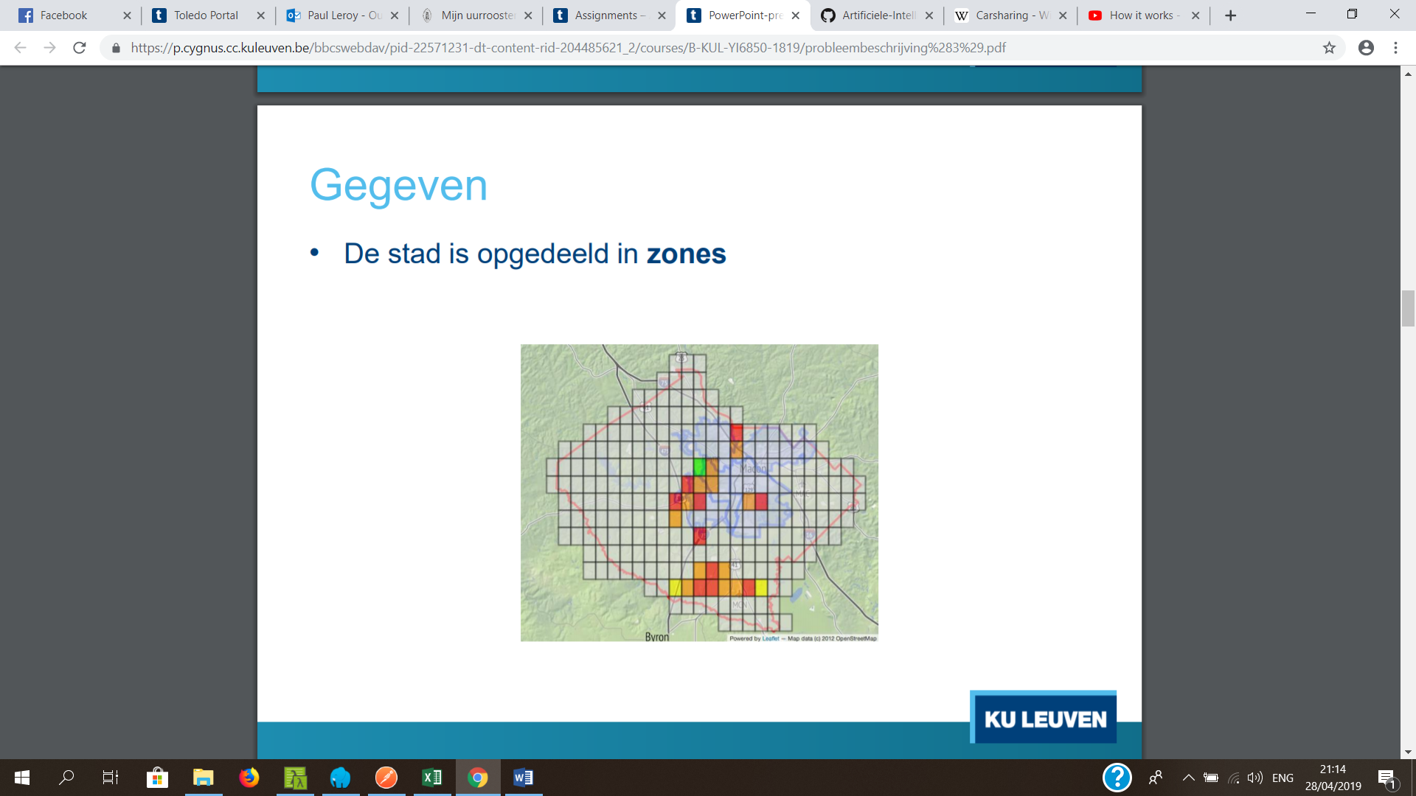

A city is divided into sections. A reservation is made in a certain section and can have a restriction on the type of the car. For example a patrol car or a electric car.

In the project we tackle two decisons:

* Which car do we place in which section.
* Which car do we choose for a particular reservation.

We also face restricions:

* The car we assign to a reservation has to be in the same or neighbouring zone of the reservation.
* We cannot assign the same car to reservations which happen on the same moment.

We want to assign sections and reservations to cars as efficiently as possible. This means we want a low cost which can be calculated with following formula:

cost = P1 x #non-assigned + P2 x #assigned-in-neighbouring-zones

In which P1 and P2 represent a weight.