Project PHP MySQL Quick Setup Guide

Author: peter

Date: 2014/07/03

Project PHP MySQL Quick Setup Guide 1

Author: peter 1

Date: 2014/07/03 1

Setup Linux 1

Platform: ubuntu12.4 TLS please update 2

git 2

HTTPD: Apache2 2

CGI: PHP5 2

DataBase: MySQL 2

DataBase Utility: phpmyadmin 3

Download source code 3

Setup httpd php 4

MySQL setup 4

Import Data base schema 4

MySQL Utility 4

Source code file 5

# Setup Linux

For Ubuntu 12.04

We should install some packages by “apt-get”

* Git: Our source code control for PHP/HTML
* PHP5: The project use PHP + MySQL as our GUI
* PHP5_MySQL: for PHP5 support MySQL engine
* MySQL server: MySQL server daemon
* MySQL client: MySQL client for PHP connect to MySQL server
* phpmyadmin: MySQL web administration tool

Platform: ubuntu12.4 TLS please update

git

Source code control: git

Apt-get install git

And check by “dpkg”

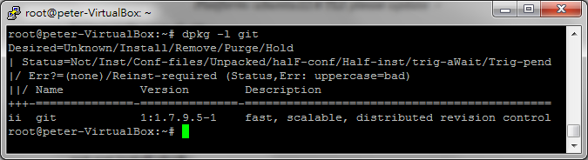

HTTPD: Apache2

Ubuntu 12.04 should already install apache2

CGI: PHP5

For MySQL in PHP5 support you need package “php5-mysql”

**apt-get install php5**

**apt-get install php5-mysql**

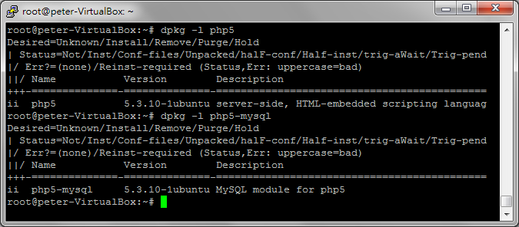

DataBase: MySQL

Install MySQL: use

**apt-get install mysql-server**

**apt-get install mysql-client**

**after install you can check by “dpkg”**

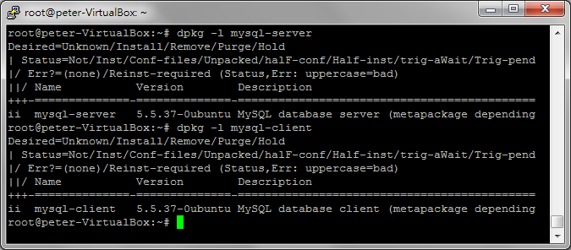

DataBase Utility: phpmyadmin

Install phpmyadmin:

apt-get install phpmyadmin

after install you can check by “dpkg”

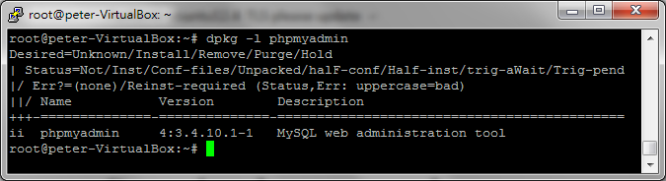

# Download source code

After the “git” installed, we can download GUI source, then copy/move to httpd documentation root, for example: Ubuntu 12.04 apache2 is “/var/www/” by default path.

**git clone** [**https://github.com/robberpen/fju.ee.git**](https://github.com/robberpen/fju.ee.git)

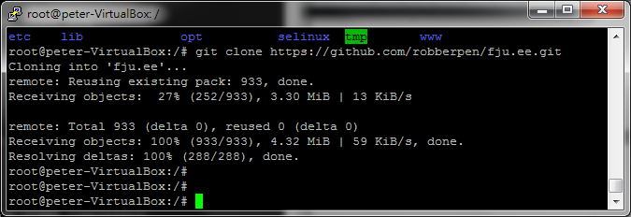

# Setup httpd php

# MySQL setup

Import Data base schema

The file “fju.ee/tools/fju.schema.sql” is current schema, it can load by mysqladmin command at first time setup

1. create new database, name is “fju” for match our config.php default DB name
2. use “mysqladmin” command or “phpmysqladmin” GUI to restore schema
3. optional, we can use toots/data.py for feed some data to DB for test GUI.  
   for example: **./data.py |mysql -u root fju**

## MySQL Utility

After install phpmyadmin, we can manage MySQL by GUI. We can use http://192.168.0.1/phpmyadmin for example to access.

Username: root (default)

Password: “” (empty)

Databse name: fju

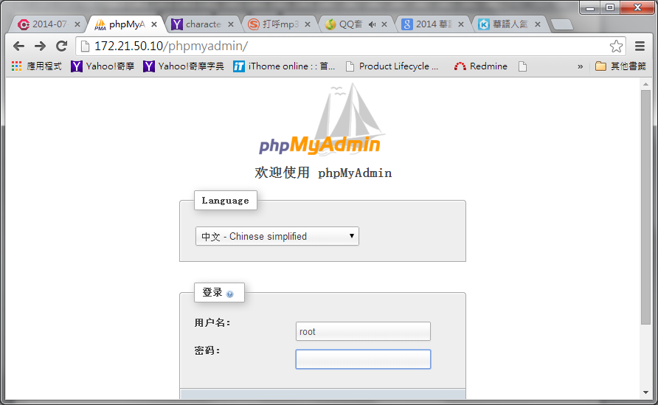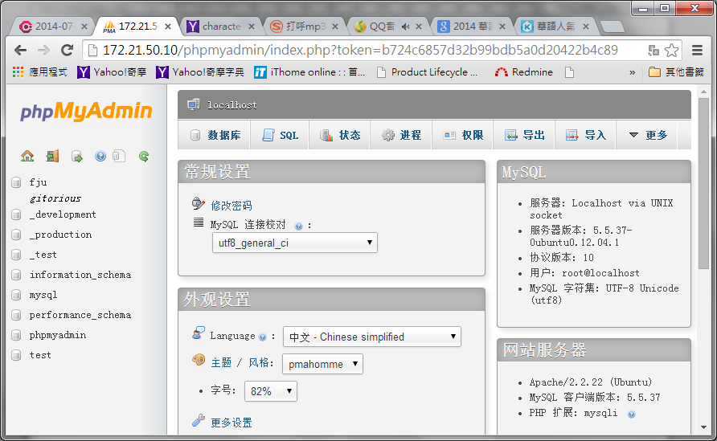

# Source code file

|  |  |
| --- | --- |
| Name | Description |
| index.html | Login home page |
| login.php | Check username/password from SQL |
| fju_layout.html | Main page |
| fju_mysql_adv.php | Access database for fju_layout.html |
| config.php | Store username, DB name etc… |
| fju_connect.php | Php mysql library connect to mysql |
| tools/fju.schema.sql | Backup/restore the DB schema |
| tools/data.py | Random Data Generator for test GUI.  For Example: root@peter-VirtualBox:/var/www/tools# ./data.py |mysql -u root fju |