**1. Requirements Analysis**

## 1.1 Function (for what)

This kind of software named ‘caterpillar’. It runs in JavaFX environment. The main purpose is providing a choice of entertainment for children to make them learn some easy related computer science knowledge in advance and think more logically.

## 1.2 Reason (why to do)

Background: Nowadays, games are becoming more and more popular and necessary in our daily life. Combine game and related computer science knowledge can teach kids some simple knowledge about computer science in advance and help kids to think logically and get interested in this field, which will finally prepare them for programming languages.

Method: After running, it is very necessary to develop a logic game for people to play on their computer. On the other hand, an interesting game can help people pass the leisure.

## 1.3 User (Who)

|  |  |  |  |
| --- | --- | --- | --- |
| **Stakeholders** | **Requirements** | **Potential influence** | |
| positive | negative |
| designers | To develop a game for children | Improve professional ability | Boring to make and the graphics have to be really well done to make up some drawbacks. |
| children | To learn programming language | Improve logical thinking ability | Possibly repeated too much, may get bored |

**2. Functional requirements**

## 2.1 Functional division

1. play game function
2. check instructions function
3. Leader border function
4. Multiple choice function
5. Set questions function
6. Quit question

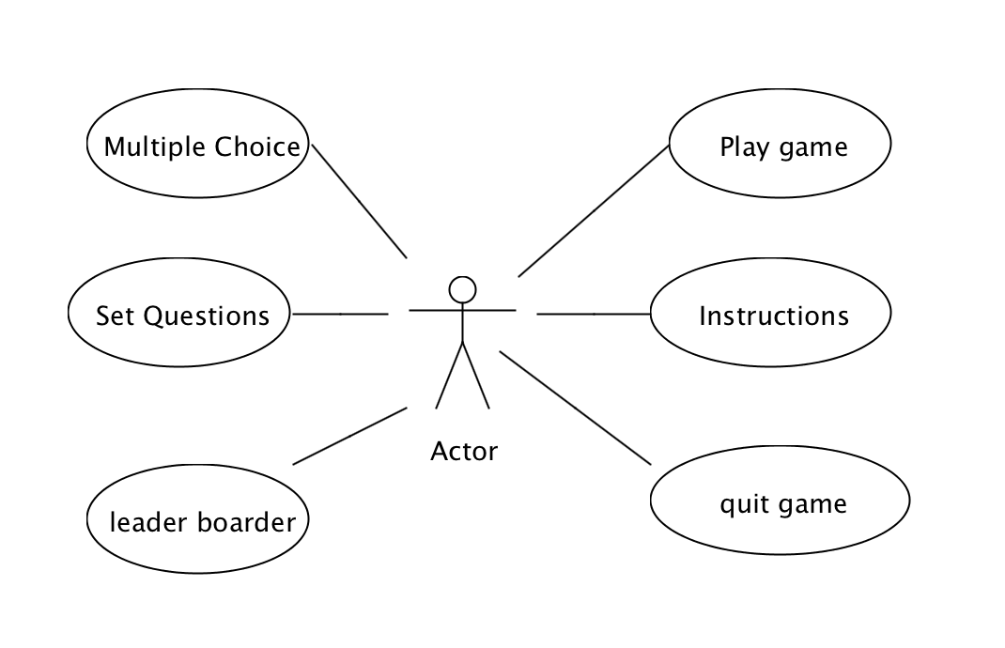

**2.2 Functional description**

2.2.1

Use case: **play game**

**Diagram:**

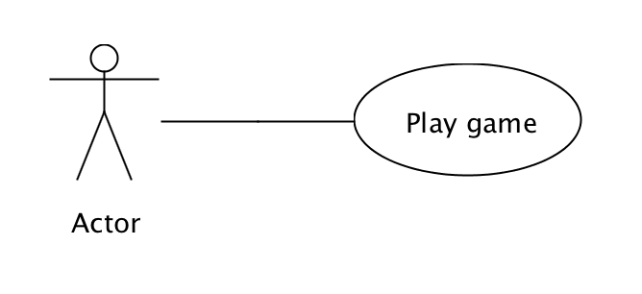

Game function:

Users plat this game on their smart phone to pass the leisure time. It is a game for children to eat fruits, apple represents ‘1’, eaten apple represents ‘0’, there are 4 bits represent different binary number, when the answer is true, then it will speed up, otherwise, cycling will slow down, finally it will jump to leader to record score.

2.2.2

Use case: **Instructions**

**Diagram:**

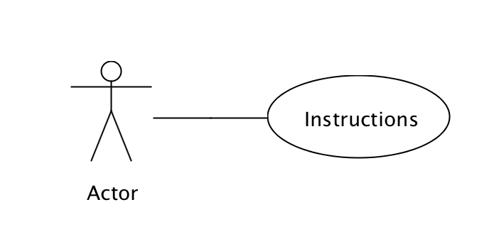

Game function:

Users check information about the history of this game, how to play it and some brief instructions about binary knowledge.

2.2.3

Use case: **Leader border**

**Diagram:**

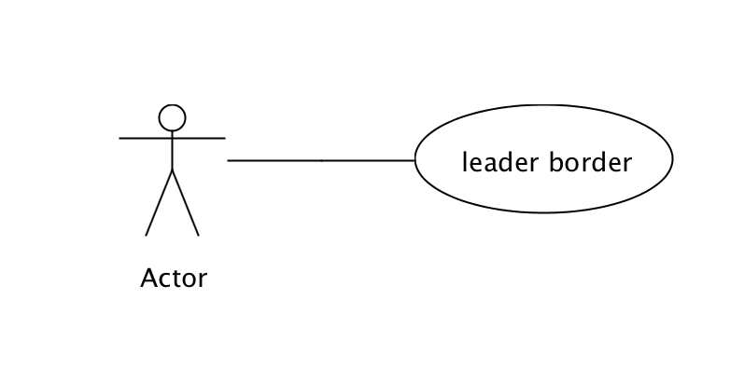

Game function: Here children can see score board different users play, and it is also flexible enough to sort by username and score, there are ‘back’ button, which is easily back to main menu interface.

2.2.4

Use case: **Set Questions**

**Diagram:**

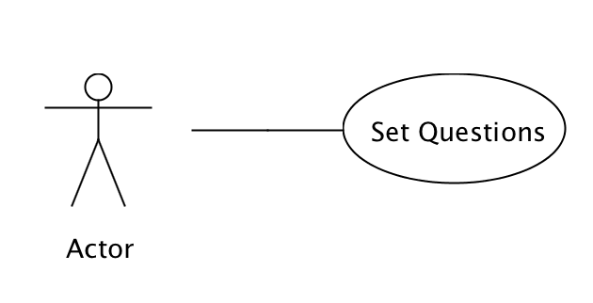

Game function: There are some questions default, and user can enter this interface and click ‘add’ button to set new questions and 4 answers which will be shown in the game interface.

2.2.5

Use case: **Multiple Choice**

**Diagram:**

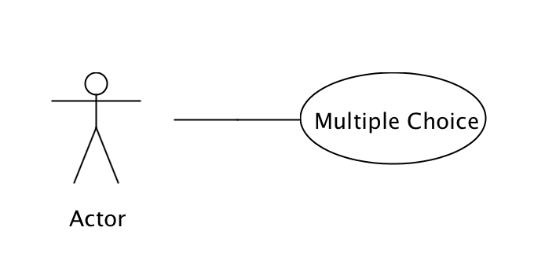

Game function: It is an extension or an extra illustrative game for children to play in advance, and understand about the rules, knowledge of binary, operations preparing for starting a formal game. In the game interface, there will be shown question every short time, 4 different answers need to be selected, and every time, game will judge whether users’ every operation is true or not.

2.2.6

Use case: **Quit**

**Diagram:**

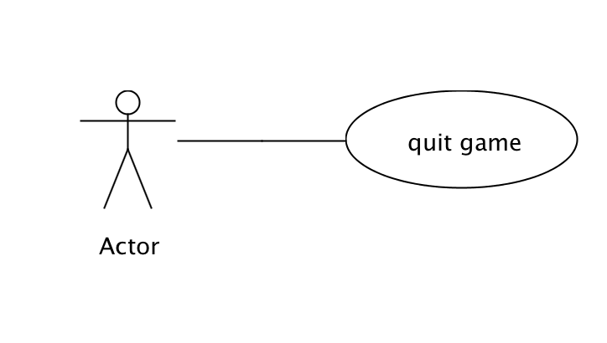

Game function:

Leave game

**3. The feasibility analysis**

## 3.1 Playability

It is the most important performance. As a game application, the playability must be the most important element. Only this game is very interesting, children will play this game again and again to make them more logical and compare with others.

## 3.2 Simplicity

This performance is also important. Many users like the old, they may not good at using mobile phone, but they need to play a easy but interesting game. So install this game must be simple to operating. This kind of game can be produced or used, every people can use it, and can make some positive effect.

## 3.3 Usability

This kind of game can be produced or used, every people can use it, and can make some positive effect. And the rule is also easy to understand.

## 3.4 Technical feasibility

More people can use it easily. Children can play this game easily and learn related computer science knowledge. Such as they will have a good concept about what is binary number, how to calculate them and so on. It is a beneficial software, not only for children but also for other people to pass the leisure time. And everybody can know how to use it easily. Besides, it can also make the people who are willing to start their journey on some related knowledge about computer science. After lay a solid foundation for this kind of software, it will have a bright prospect.

**4. SWOT Analysis**

|  |  |
| --- | --- |
| STRENGTH: | WEAKNESSES: |
| 1. Solid team have a uniformed target and have full confidence with this project  2. Team members have enough time to work on this project  3. Professional guidance from professor Ian  4. Flexible organization structure.  5. The idea can be taken as far as we want.  6. Could be extended to co-op | 1. Lack of experience for project management  2. Lack of JAVA development experience  3. Lack of financial support  4. Lack of hardware support  5. Lack of related experienced software engineers |
| OPPORTUNITIES: | THREATS: |
| 1. Game online is still a hot topic  2. Have a small amount of games on the markets  3. More and more parents focus on their children’s education.  3. Educational market is still a big cake | 1. There are many similar Game online  2. Our team have little experience on our project  3. Game may be simple  4. Our potential clients may choose other games for their entertainment.  5. Many youth well choose play games on their mobile phone  6. We should consider more about memory in terms of performance |