Password Hashing Application
JumpCloud – Interview Assignment
Test Plan

Document Change History
Version Number | Date | Contributor | Description
V1.0 | 06/05/21 | Robert Gregory | Initial draft

Introduction
This test approach document describes the appropriate strategies, process, workflows, and methodologies used to plan, organize, execute and manage testing of software projects.

Scope
Describe the current test approach scope based on your role and project objectives.

In Scope
The Password Hashing Application Test Plan defines the functional, integration, system, and regression testing approach. The test scope includes the following:
- Testing of all functional, application performance and use cases requirements listed in the Use Case document.
- Quality requirements.

Out of Scope
The following are considered out of scope for Password Hashing Application Test Plan and testing scope:
- Unit Tests and TDD
- Security Testing
- End-to-end testing and testing of interfaces of all systems that interact with the Password Hashing Application

Primary Objective
A primary objective of testing application systems is to: assure that the system meets the full requirements, including quality requirements (AKA: Non-functional requirements) and fit metrics for each quality requirement and satisfies the use case scenarios and maintain the quality of the product. At the end of the project development cycle, the user should find that the project has met or exceeded all of their expectations as detailed in the requirements.

Any changes, additions, or deletions to the requirements document, Functional Specification, or Design Specification will be documented and tested at the highest level of quality allowed within the remaining time of the project and within the ability of the test team.

Secondary Objective
The secondary objective of testing application systems will be to: identify and expose all issues and associated risks, communicate all known issues to the project team, and ensure that all issues are addressed in an appropriate matter before release. As an objective, this requires careful and methodical testing of the application to first ensure all areas of the system are scrutinized and, consequently, all issues (bugs) found are dealt with appropriately.

Roles and Responsibilities
Listed functions are for testing phase.

Developer
Responsibilities include:
(a) Develop the system/application
(b) Develop and Conduct Unit Testing
(c) Support User Acceptance Testing

QA Automation Engineer
Responsibilities include:
(a) Build functional and integration testing to support application
(b) Write automated tests and update existing automation framework as needed
(c) Support User Acceptance Testing
(d) Perform non-functional testing including performance and security as applicable

Test Cases (Overview)

Below are some minimum test cases required to support the roll-out of this new application.

Test Case # | Name | Preconditions | Data Required | Automated? | Test Result? | Defect #
1 | Launch application and validate availability for http connections | Application is available in environment | N/A | Yes | Pass | N/A
2 | Validate application is available per the port environment variable | Application is available in environment | N/A | No | Pass | N/A
3 | Application supports Post to Hash endpoint with password | Application is available in environment | Password - Example data: {“password”:”angrymonkey”} | Yes | Pass | N/A
4 | Successful post to Hash returns a job identifier immediately | Application is available in environment | Password - Example data: {“password”:”angrymonkey”} | No | Fail | 1.0
5 | Successful post to Hash results in hashing algorithm result of SHA512 | Application is available in environment | Password - Example data: {“password”:”angrymonkey”} | No | Pass | N/A
6 | Successful post to Hash waits 5 seconds and computes password hash | Application is available in environment | Password - Example data: {“password”:”angrymonkey”} | No | Pass | N/A
7 | Application supports Get to Hash endpoint | Application is available in environment | Job Identifier – Example:  http://127.0.0.1:8088/hash/1 | Yes | Pass | N/A
8 | Get to Hash endpoint accepts a job identifier | Application is available in environment | Job Identifier – Example:  http://127.0.0.1:8088/hash/1 | Yes | Pass | N/A
9 | Get to Hash endpoint with a valid job identifier returns a base64 encoded password hash for the corresponding POST request | Application is available in environment | Job Identifier – Example:  http://127.0.0.1:8088/hash/1 | No | Pass | N/A
10 | Get to Hash endpoint with an invalid job identifier does not return a base64 encoded password hash since no corresponding POST request | Application is available in environment | Job Identifier – Example:  http://127.0.0.1:8088/hash/12 | Yes | Pass | N/A
11 | Application supports Get to Stats endpoint | Application is available in environment | N/A | Yes | Pass | N/A
12 | Get to Stats endpoint accepts no data | Application is available in environment | N/A | Yes | Pass | N/A
13 | Get to Stats endpoint with no data returns a JSON data structure for the total hash requests since server started | Application is available in environment | N/A | Yes | Fail | 1.1
14 | Get to Stats endpoint with no data returns a JSON data structure with average time of a hash request in milliseconds | Application is available in environment | N/A | Yes | Fail | 1.2
15 | Software can process multiple connections simultaneously | Application is available in environment | Password - Example data: {“password”:”angrymonkey”} | Yes – usingpytest-xdist | Pass | N/A
16 | Software can shutdown gracefully upon request: Responds with 200 | Application is available in environment | N/A | No | Fail | 1.3
17 | Software can shutdown gracefully upon request: Allows in-flight password hashing to complete | Application is available in environment | Password - Example data: {“password”:”robertg12345”} | No | Fail | 1.3
18 | Software can shutdown gracefully upon request: Rejects new requests | Application is available in environment | Password - Example data: {“password”:”robertog12345”} | No | Fail | 1.3
19 | Software can shutdown gracefully upon request: Verify complete shutdown | Application is available in environment | N/A | No | Pass
20 | Validate software does not allow new password requests when shutdown is pending | Application is available in environment | Password - Example data: {“password”:”robertog1234567”} | No | Pass | NA
21 | Send post to Hash with no body – should not return a job identifier immediately | Application is available in environment | No data sent in payload | Yes | NA | NA
22 | Ensure that base64 encoded hash is unique per identifier created | Application is available in environment | “password”:”robertg12” | No | Passed | NA
23 | Send POST to Hash with no valid Password entry in JSON | Application is available in environment | “password”:”” | Yes | Fail | 1.5

Open Questions
(Note: These would be addressed during Planning Phase)

Below are some questions that would be asked during planning session to better understand requirements and to ensure there are no gaps with acceptance criteria:
  - Requirement: It should answer on the PORT specified in PORT environment variable
    - Question: How do we specify the PORT for this project? It is assumed it will always be set to 8088
  - Requirement: A POST to /hash should accept a password
    - Question: How should the software respond if no JSON body is sent?
  - Requirement: Successful post to Hash results in hashing algorithm result of SHA512
    - Question: How can we validate this correct algorithm is used? My understanding is that SHA-512 will create a hash, and if using Base54 (as we are doing here), the result should be 86 bytes and 88 with padding. Based on this analysis and test results, this is a SHA-512 and BASE64 output, but I would want to confirm with team.
    - Question: Should the POST request create a new base64 hash result each subsequent time the same payload is sent?
  - Requirement: Error codes
    - How should we handle error codes such as 400 Bad Request?

Sample Test Cases (with steps)
Below are some test cases with detailed steps:

Test Case # | Name | Step 1 | Step 2 | Step 3 | Step 4 | Step 5 | Result
1 | Launch application and validate availability for http connections | Start the application | Send Post request to /hash endpoint | Validate 200 response | NA | NA | Pass. See screenshot labelled 1.0
2 | Validate application is available per the port environment variable | Start the application | Validate PORT is set to 8088 | Send Post request to /hash endpoint with PORT 8088 | Validate 200 response | NA | Pass. See screenshot labelled 1.0
3 | Application supports Post to Hash endpoint with password | Start the application | Include valid JSON body/payload: {  "password": "angrymonkey"  } | Send Post request to /hash endpoint | Validate 200 response | NA | Pass. See screenshot labelled 1.0
4 | Successful post to Hash returns a job identifier immediately | Start the application | Send Post request to /hash endpoint with valid JSON body | Check that job identifier is returned immediately | NA | NA | Fail. The operations are out of sync as it waits 5 seconds then returns a valid identifier
5 | Successful post to Hash results in hashing algorithm result of SHA512 | Start the application | Send Post request to /hash endpoint with valid JSON body | Send GET call to /hash with job identifier | Check response body for 88 characters (if padding included) | NA | Pass. See screenshot labelled 1.1
6 | Successful post to Hash waits 5 seconds and computes password hash | Start the application | Send Post request to /hash endpoint with valid JSON body | Check response time | NA | NA | Pass. Tests consistently result is 5.01s with slight variation. See screenshot 1.2
7 | Application supports Get to Hash endpoint | Start the application | Send Get request to /hash with valid identifier  http://127.0.0.1:8088/hash/2 | Check response for 200 code | NA | NA | Pass
8 | Get to Hash endpoint accepts a job identifier | Start the application | Send Get request to /hash with valid identifier  http://127.0.0.1:8088/hash/4 | Check response for 200 code | NA | NA | Pass. See screenshot 1.3
9 | Get to Hash endpoint with a valid job identifier returns a base64 encoded password hash for the corresponding POST request | Start the application | Send Get request to /hash with valid identifier  http://127.0.0.1:8088/hash/4 | Check that response body includes a base64 encoded password hash based on the corresponding identifier | NA | NA | Pass. See screenshot 1.3
10 | Get to Hash endpoint with an invalid job identifier does not return a base64 encoded password hash since no corresponding POST request | Start the application | Send Get request to /hash with invalid identifier  http://127.0.0.1:8088/hash/40 | Check that response body DOES NOT include a base64 encoded password hash based on the corresponding identifier | NA | NA | Pass. See screenshot 1.4
11 | Application supports Get to Stats endpoint | Start the application | Send Get request to /stats with no body | Check for 200 response | NA | NA | Pass
12 | Get to Stats endpoint accepts no data | Start the application | Send Get request to /stats with JSON body | Check for error code since no data should be accepted | NA | NA | Fail. See screenshot 1.6. Data is allowed.
13 | Get to Stats endpoint with no data returns a JSON data structure for the total hash requests since server started | Start the application | Send Get request to /stats with no body | Check that body includes JSON data with total requests | Check requests matches up per number of identifiers | NA | Fail. See screenshot 1.5. Total requests is off by +2
14 | Get to Stats endpoint with no data returns a JSON data structure with average time of a hash request in milliseconds | Start the application | Send Get request to /stats with no body | Check that AverageTime is included | Check that and accurate time is listed in milliseconds | NA | Fail. AverageTime appears to pull inconsistently.
15 | Software can process multiple connections simultaneously | Start the application | Run test with more than one simultaneous request to POST in K6 | Check that more than one connection is allowed simultaenously | Validate 200 responses | NA | Pass. See screenshot 1.8
16 | Software can shutdown gracefully upon request: Responds with 200 | Start the application | Send Post request to /hash endpoint with valid JSON body | Shutdown the app | Validate 200 response | NA | Fail. See screenshot 1.9
17 | Software can shutdown gracefully upon request: Allows in-flight password hashing to complete | Start the application | Send Post request to /hash endpoint with valid JSON body | Shutdown the app | Validate new identifier returned | NA | Fail. See screenshot 1.9
18 | Software can shutdown gracefully upon request: Rejects new requests | Start the application | Shutdown the app | Send Post request to /hash endpoint with valid JSON body | Validate an error code relating to rejected request | NA | Fail. There is no graceful shutdown so no rejections can occur
19 | Software can shutdown gracefully upon request: Verify complete shutdown | Start the application | Shutdown the app | Verify app is shutdown by sending new GET request to STATS | Should get error | NA | Pass
20 | Validate software does not allow new password requests when shutdown is pending | Start the application | Shutdown the app | Send Post request to /hash endpoint with valid JSON body | Should not allow new requests | NA | Pass
21 | Send post to Hash with no body – should not return a job identifier immediately | Start the application | Remove JSON body and Send Post request to /hash endpoint | Check response | NA | NA | N/A – Not called out in reqs, but request just hangs
22 | Ensure that base64 encoded hash is unique per identifier created | Start the application | Send Post request to /hash endpoint with unique JSON body | Send GET call to /hash with job identifier | Validate that ecoded hash is unique for that identifier | NA | Passed
23 | Send POST to Hash with no valid Password entry in JSON | Start the application | Send Post request to /hash endpoint with no password value (NULL) in JSON | Validate error message since no valid data passed in JSON | Ensure this is not accepted with 200 |  | Fail

Test Results and Open Defects

Overview
The below list is a high-level summary of the findings and can be included as part of separate reporting to development team, leadership, business, and other applicable groups:

Summary:

- A total number of 23 test cases were identified:
- 15 tests passed
- 8 failed
- 6 defects were raised, but 1 was closed due to inability to replicate
- 3 Sev 1s
- 1 Sev 2
- 1 Sev 3
- 1 Defect Closed*
- *Note: Further regression testing needed to ensure 1 closed defect is not valid
- Functional testing was performed with Curl and Postman using Windows and Linux
- Performance testing was performed with K6
- Automated testing was performed with PyTest

Open Defects
Defect # | Summary | How to retest | Severity | Environment | Data Used | Screenshot
1.0 | Job identifier is not returned immediately following valid post to /hash | Follow steps outlined in test case #4 | 1 | LocalHost | body/payload: {  "password": "angrymonkey"  } | 1.2
1.1 | Get to STATS endpoint yields incorrect number of Total Requests | Note: This test failed one time but have not been able to replicate so may be non issue. | N/A - Closed | LocalHost | Notes: When running through testing, this scenario failed when count was off by 2. Have not been able to replicate since. | N/A
1.2 | Get to STATS endpoint yield inconsistent results for AverageTime | 1 Send successful POST to /hash  2 Send GET to STATS  3 Repeat Step 1 with unique body  4 Repeat Step 1 with unique body  5 Check average time  Expected: Should be greater than 0 and should take an average  Actual: Shows 0 | 1 | LocalHost | body/payload: {  "password": "robertg1234"  } | 1.6
1.3 | Get to STATS allows for data to be passed as payload | Follow steps in test case #12 | 2 | LocalHost | body/payload: {  "password": "robertg1234"  } | 1.7
1.4 | Application should shut down gracefully and allow for in-flight request *used POST | Follow steps in test case #16 | 1 | LocalHost | body/payload: {  "password": "robertg1234"  } | 1.9
1.5 | Post to Hash with NULL value for Password should not yield success response | Follow steps in test case #23 | 3 | Follow steps in test case #16 | body/payload: {  "password": ""  } | 1.10

Screenshots and Other Findings
Below are the relevant screenshots captured based on the testing completed during this project:

Screenshots:

# | Image #1 | Tool Used
1.0 | 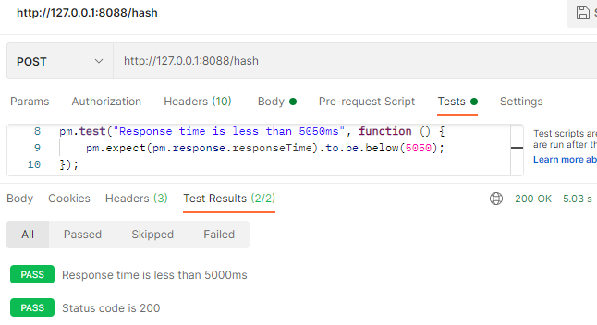 | Postman
1.1 | 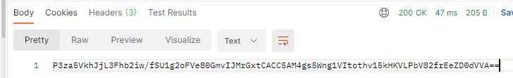  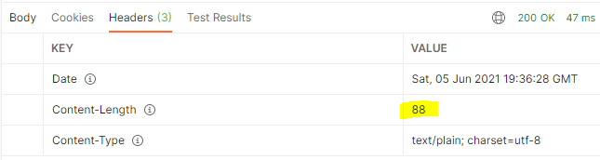 | Postman
1.2 | 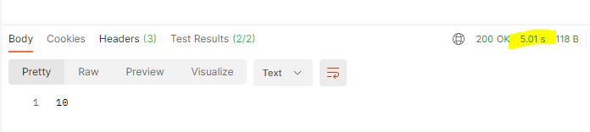 | Postman
1.3 | 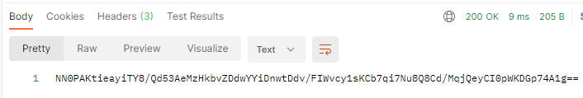 | Postman
1.4 | 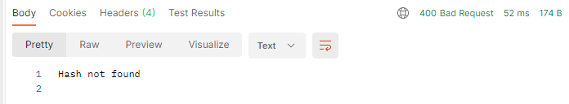 | Postman
1.5 | 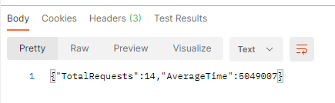  Expected 12 but got 14  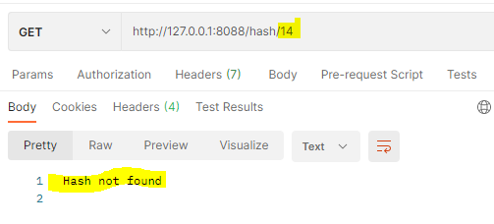 | Postman
1.6 | 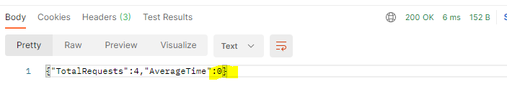 | Postman
1.7 | 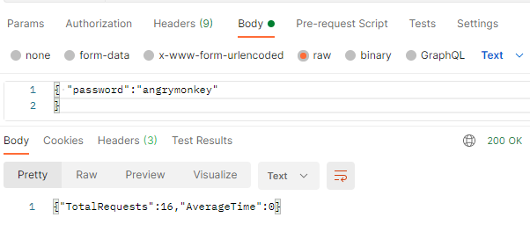 | Postman
1.8 | 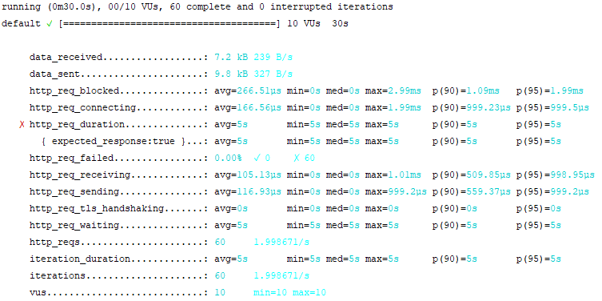 | K6
1.9 | 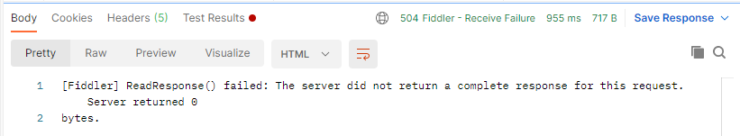 | Postman
1.10 | 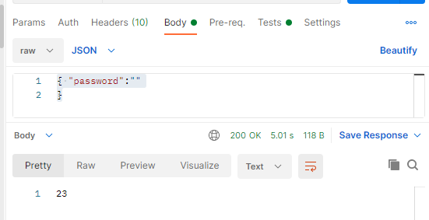 | Postman

Other Notes:

Testing using AWS Ec2 Instance

To ensure that responses and software behavior is similar regardless of OS, setup, etc., I created a new EC2 instance (Linux/UNIX) using my personal AWS account and (1) retrieved the broken hashing application (using wget --no-check-certificate --no-proxy
‘https://s3.amazonaws.com/qa-broken-hashserve/broken-hashserve.tgz’), (2) unzipped it in the EC2 instance from console, and executed the Linux version. Note: The above test results were achieved using a Windows installation of the project, so this validation helps ensure that the issues were not Windows specific.

Example requests:

However, the same issues, including the one with the graceful shutdown requirement were observed using the AWS EC2 instance for testing.

Example:

