Seasonal dynamics of all-cause mortality: a time series wavelet analysis

Robbie Parks¹, James Bennett, Ralf Toumi², Majid Ezzati^{1*}

¹ MRC-PHE Centre for Environment and Health, Department of Epidemiology and Biostatistics, School of Public Health, Imperial College London, London, United Kingdom
² Space and Atmospheric Physics, Imperial College London, London, United Kingdom

Robbie M Parks: robbie.parks@imperial.ac.uk
James E Bennett: j.e.bennett@imperial.ac.uk
Ralf Toumi: r.toumi@imperial.ac.uk
Majid Ezzati: majid.ezzati@imperial.ac.uk

* Corresponding author:
Majid Ezzati
Imperial College London
Norfolk Place
London W2 1PG, UK
E-mail: majid.ezzati@imperial.ac.uk
Tel: +44 (0)20 7594 0767

Background

Monthly death rates vary widely across a large country like the United States, which possesses distinct climate regions and socio-economic groupings.^{1,2} Monthly death rate patterns are often cyclical in nature,³⁻⁹, with some months of the year systematically possessing higher death rates than others. This creates a seasonality in mortality, in part due to localised phenomena such as weather,⁸ with social factors, such as state-legislated health care¹⁰ and education services,¹¹ also impacting on the outcomes. Further, the presence and degree of variation of seasonal mortality is constantly evolving, with potentially paradigmatic shifts over time in climate, lifestyle, and technology as important factors.¹² Understanding the dynamics of this seasonality will enable decision-makers to identify emergent at-risk groups, with policies actionable at an appropriate legislative sub-national level. It is thus necessary to create a comprehensive study framework which can identify the existence and the evolution of seasonality of mortality across appropriate space, age, gender, and time units.

Some studies, in one or more countries including the US, have examined patterns and trends in seasonality.^{3-9,13-23} The time period covered by these studies have ranged from a few years to 50 years.^{14,21} Regardless of duration, the methods – ranging from simple season and trend separation methods^{3,7} to fitting period basis functions^{5,13,15,16,18,21,23} – were unable to characterise the dynamics of seasonality over time; many also require a-priori assumptions on how frequently (e.g., every 12 months versus 6 months or another frequency) the repeated death rate patterns occur. Few of the previous studies have analysed seasonality by age and sex^{7,15,18,20}, even though due to key medical causes of death, and their physiological and behavioural determinants, seasonality of death rates can vary. Similarly, few studies have analysed seasonality for a comprehensive set of subnational units²⁰.

Previously, studies have invoked wavelet analysis to understand dynamics of infectious diseases.²⁴⁻³⁰ Here, we apply this method to all-cause mortality in the United States to identify 12-month seasonality.

Results

Having removed deaths with incomplete records (all from missing ages), we performed a wavelet analysis on the age-sex stratified mortality rates at the national level. Figure 1A shows that all but the 35-44 year olds possessed a significant 12-month seasonality in males. Instead, the 35-44 group instead displayed significant seasonality at 6 months. A significant 6-month period of seasonality was also evident in 5-14, 25-34, 45-54 year olds, in addition to the 12-month seasonality present. Figure 1B illustrates that women, contrasting with the male groups, demonstrated no significant 12-month seasonality in younger age groups (5-14,15-24,25-34 year olds). A constant 6-month seasonality was present in 5-14, 25-34, 35-44, and 45-54 age groups. 0-4 years in both sexes, and for 15-24 women, exhibited notable behaviour, as the time series began with significant 12-month seasonality, which then disappeared in the second half of each.
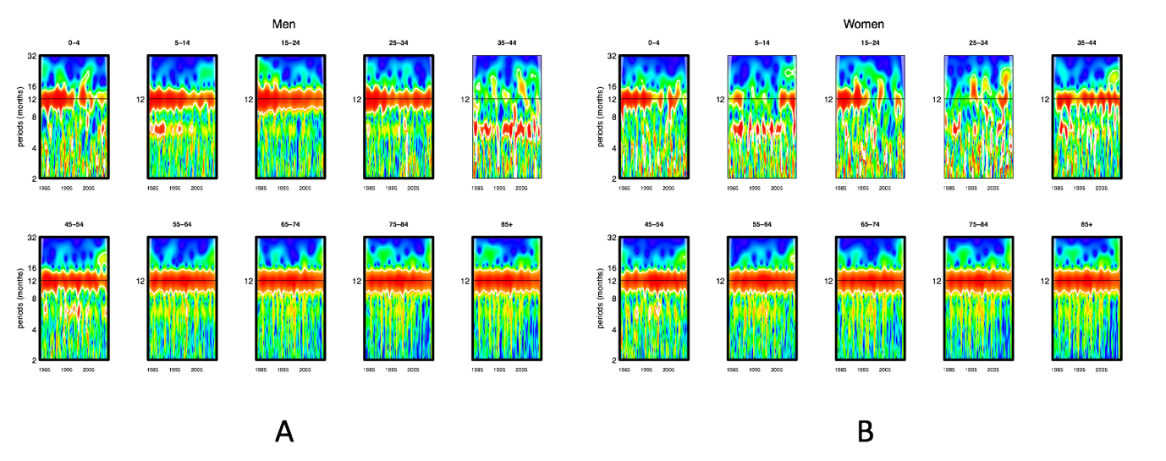
Figure 1: Wavelet power spectra for national time series data for 1982-2013, by age group for (A) men and (B) women. Wavelet power values increase from blue to red, with white contour lines indicating the 5% significance level. Age groups with significant 12-month periodicity for the entire period and for each period split into 2 are highlighted with a bold black box. The shaded regions at the left and right edge of each box indicate demarcate the cone of influence, where spectral analysis is less robust.

We performed a centre of gravity analysis on death rates to understand where the mean maximum and minimum mortality occurred within the year for groups with significant 12-month seasonality. The results of this are plotted in figure 2 and summarised in table x. In summary, Groups 45 years and above for men and 35 and above for women possessed a maximum mortality in the January/February, with a minimum in July/August.

The converse was true for younger men who possessed significant 12-month seasonality (5-14, 25-34, 25-34), where the peak of mortality occurred in June/July, with the minimum in the winter (December/January). The timing of 0-4 year olds for both sexes followed the same pattern as each other, with maximum mortality in February and minimum in August, indicating no significant difference between sexes at that stage in life.
Figure 2: Mean timing of national maximum and minimum all-cause mortality, by sex and age group for 1982-2013. Red dots indicate centre of gravity of maximum mortality, and green dots the centre of gravity for minimum mortality. Vertical segments represent 95% confidence intervals. Only age-sex groups with statistically significant 12-month seasonality are included.

For the national age-sex groups which demonstrated significant 12-month seasonality, we were interested in how the difference between maximum and minimum mortality within a year had changed from 1982 to 2013. We fitted a linear regression to the seasonal excess (the percentage difference between maximum and minimum mortality within a year) against year for the significant age-sex groups. The results, plotted in figure 3 and summarised in table y, demonstrate that older groups (45 and older, except for 45-54 (8.8% to 4.8%) men) in both sexes have exhibited no significant change in seasonal excess. Younger age groups, particularly 5-14 (39.2% to 12.6%), 15-24 (37.1% to 12.5%), 25-34 (14.6% to 7.3%) men, exhibit a statistically significant decline of seasonality during the period of study.
Figure 3: National seasonal excess mortality in 2013 versus 1982 by sex and age group. Each age-sex group is represented by a symbol. Age-sex groups with a statistically significant change at the 5% level are highlighted with a bold black outline.

We performed a centre of gravity analysis on death rates sub-nationally for groups which demonstrated significant 12-month period nationally. The national data were subdivided geographically by climate region, as described by the National Oceanic and Atmospheric Administration (NOAA). The results of this are plotted as maps on figure 4. Hawaii was included in the West region, and Alaska in the Northwest region for the analysis. The subnational patterns are consistent with the national values, indicating the timing of maximum and minimum mortality is largely independent of geography.
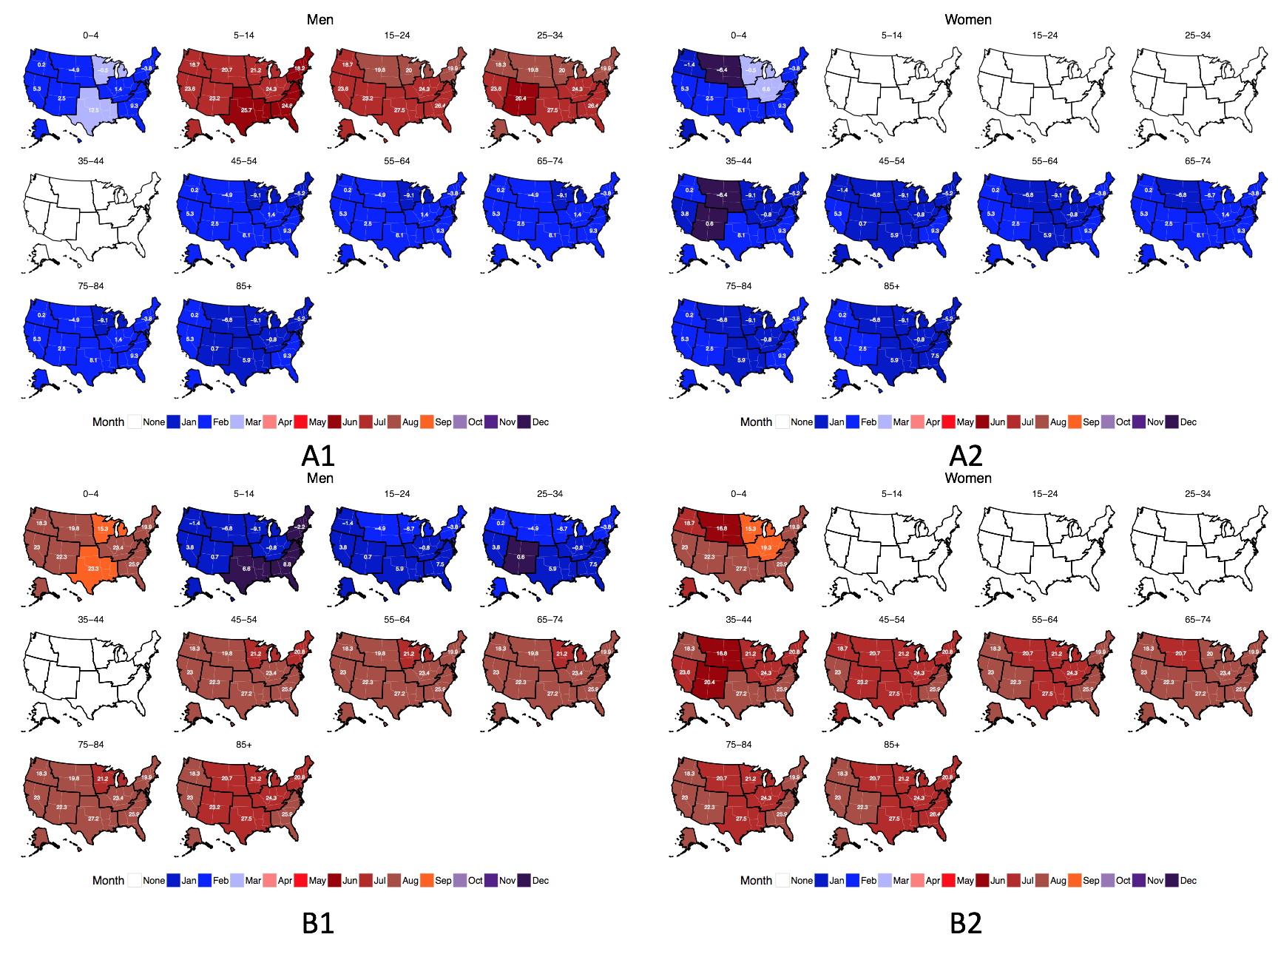
Figure 4: Mean timing of (A) maximum and (B) minimum all-cause mortality, by climate region, sex and age group for 1982-2013 Only groups which exhibited significant 12-month seasonality in the national analysis are included. Average temperatures (in degrees Celsius) are included in white for the corresponding month of maximum and minimum mortality for each climate region. Climate regions are shown in Figure S1.
In sensitivity analyses, our results were robust to analytical choices: Comparing the average power spectra in the national wavelet analysis to a red- instead of white-noise spectrum did not result in any different significant 12-month seasonality. Using death counts instead of death rates in the centre of gravity analysis presented similar results to those stipulated.

Discussion

The main innovation and contribution of our study is the application of wavelet and centre of gravity analysis to identify 12-month seasonality and timing of maximum and minimum mortality in national all-cause mortality time series, using comprehensive subnational units. As we have shown, wavelet analysis reveals the dynamics of seasonality in time series, with emergent or disappearing seasonality, as in certain age groups seen in figure 1. This kind of insight would not have been possible analysing data averaged over time or fixed to particular frequencies. Additionally, by constructing comprehensive subnational units, we were able to identify distinct behaviour of age-sex groups, particularly with the distinction of the timing of mortality between younger and older male age groups. This distinction is also broadly consistent sub-nationally, as shown in figure 4.

There are some limitations to our study…

Our study framework and methods can also be applied to other countries with geo-coded monthly mortality records. This is now available in many high-income and some middle-income countries. It would be of further interest to distinguish behaviour between urban and rural inhabitants, or to explore how socio-economic status influences the amount of variation of mortality rates within a year. Also, examining the consistency of a relationship between temperature and climate variables (such as local temperature) over time, using wavelet analysis, would help to understand the effect of climate and climate change on variation of mortality within a year. Data on environmental variables at appropriate scales can be obtained via several means, including reanalysis models such as ERA-Interim.

Analysis of the dynamics of 12-month seasonality over time by comprehensive subnational units allows for decision-makers to better organise interventions for vulnerable and emergently-vulnerable groups.

Methods

Data
We obtained US data on all 73,804,561 deaths in the USA for the years 1982-2013 from the National Center for Health Statistics (NCHS). Age, sex, state of residence, and month of death were available for each record.

Yearly population counts were available from NCHS for 1990 to 2013 and from the US Census Bureau prior to 1990.³¹ We inferred monthly population counts through linear interpolation, assigning each yearly count to July.

Data were divided by sex and age in the following 10 age groups: 0-4, 5-14, 25- 34, 35-44, 45-54, 55-64, 65-74, 75-84, 85+ years. We calculated monthly death rates for each age and sex group, both nationally and for sub-national climate regions.¹ Death rate calculations accounted for varying length of months by multiplying by appropriate factors to ensure each month’s death count for 31 days.

Statistical methods
We used wavelet analysis to establish the presence of seasonality, both nationally and sub-nationally, for each age-sex group. In summary, wavelet analysis uncovers the presence, and frequency, of repeated maxima and minima in each age-sex-specific death rate time series.

Further, wavelet analysis allows representing dynamic seasonal behaviour, e.g., the potential for the periodicity of death rates to disappear, emerge, or change over time, which is not possible in other methods such as a standard Fourier analysis or fitting a statistical model with a period basis function. In brief, a Morlet wavelet, described in detail elsewhere,³² is equivalent to using a moving window on the death rate time series and analysing periodicity in each window using a short-form Fourier transform, hence generating a dynamic spectral analysis. The results can be presented on a two-dimensional plot of time against frequency coefficients (Figure 1).

We identified age-sex groups whose wavelet power spectrum differed from that of a white noise spectrum, which represents random fluctuations, at 5% significance level. We used the R package WaveletComp for the wavelet analysis. In preparation for the wavelet analysis, we logarithmically-transformed, detrended by polynomial regression, and normalised each all-cause mortality death rate time series.

For inclusion in further analysis, each time series was required to possess a significant frequency coefficient at 12 months not only for the entire time of study (1982-2013), but also from separate wavelet analyses for the two further split time periods (1982-1997,1998-2013). This was a stricter condition which would require a consistent seasonality over the majority of the time series.

For age-sex groups which fulfilled these conditions, we calculated the centre of gravity and the negative centre of gravity. We also calculated the seasonal excess for the groups throughout the time of study. For age-sex groups with statistically significant seasonality, we calculated when maximum mortality occurred with a year using the entire time series, using centre of gravity analysis, in which each month is weighted by its death rate.²⁷

We define the negative centre of gravity here as the mean month of minimum mortality within a year. We calculate an alternative death rate by subtracting the death rate within each month from the maximum death rate in any month. We then use the same process as finding the centre of gravity, but with the alternative death rate.

Due to the cyclical nature of the data, with December neighbouring January, circular statistics was used to compute both the centre of gravity and the negative centre of gravity for each age-sex group. Along with each circular mean, a 95% confidence interval (CI) was calculated by using 1000 bootstrap samples. The R package CircStats was used for this purpose.

We calculated proportional (percentage) excess death rate in the maximum and minimum mortality months for each analysis. We fitted a linear regression to this seasonal excess mortality for each age and sex group, inversely weighted by the standard error on the seasonal excess, and compared the estimated values at the beginning and end of the analysis period, as a measure of how magnitude of the seasonality of death rates changed over time. Changes in seasonality excess were identified by a 5% significance level on the gradient of the linear regression, weighted by population, against the null hypothesis that the gradient was zero.

References

1 Karl, T. & Koss, W. J. Regional and national monthly, seasonal, and annual temperature weighted by area, 1895-1983. (National Climatic Data Center, 1984).
2 Williams, D. R. & Collins, C. Us Socioeconomic and Racial-Differences in Health - Patterns and Explanations. Annu Rev Sociol 21, 349-386, doi:DOI 10.1146/annurev.so.21.080195.002025 (1995).
3 Rosenwaike, I. Seasonal variation of deaths in the United States, 1951–1960. Journal of the American Statistical Association 61, 706-719 (1966).
4 Rogot, E., Fabsitz, R. & Feinleib, M. Daily variation in USA mortality. American journal of epidemiology 103, 198-211 (1976).
5 Seto, T. B., Mittleman, M. A., Davis, R. B., Taira, D. A. & Kawachi, I. Seasonal variation in coronary artery disease mortality in Hawaii: observational study. Bmj 316, 1946-1947 (1998).
6 Davis, R. E., Knappenberger, P. C., Novicoff, W. M. & Michaels, P. J. Decadal changes in heat-related human mortality in the eastern United States. Climate Research 22, 175-184 (2002).
7 Feinstein, C. A. Seasonality of deaths in the US by age and cause. Demographic Research 6, 469-486 (2002).
8 Davis, R. E., Knappenberger, P. C., Michaels, P. J. & Novicoff, W. M. Seasonality of climate-human mortality relationships in US cities and impacts of climate change. Climate Research 26, 61-76 (2004).
9 Kalkstein, A. J. Regional similarities in seasonal mortality across the United States: an examination of 28 metropolitan statistical areas. PloS one 8, e63971 (2013).
10 Weiss, K. B. Seasonal trends in US asthma hospitalizations and mortality. JAMA 263, 2323-2328 (1990).
11 Robine, J. M. Seasonality in human mortality. A demographic approach. Eur J Popul 24, 125-127, doi:10.1007/s10680-007-9139-1 (2008).
12 Barreca, A., Clay, K., Deschenes, O., Greenstone, M. & Shapiro, J. S. Adapting to Climate Change: The Remarkable Decline in the US Temperature-Mortality Relationship over the Twentieth Century. Journal of Political Economy 124, 105-159, doi:doi:10.1086/684582 (2016).
13 Mackenbach, J., Kunst, A. & Looman, C. Seasonal variation in mortality in The Netherlands. Journal of Epidemiology and Community Health 46, 261-265 (1992).
14 Lerchl, A., Simoni, M. & Nieschlag, E. Changes in Seasonality of Birth-Rates in Germany from 1951 to 1990. Naturwissenschaften 80, 516-518, doi:Doi 10.1007/Bf01140808 (1993).
15 Green, M. S., Harari, G. & Kristal-Boneh, E. Excess winter mortality from ischaemic heart disease and stroke during colder and warmer years in Israel. The European Journal of Public Health 4, 3-11 (1994).
16 LAAKE, K. & SVERRE, J. M. Winter excess mortality: a comparison between Norway and England plus Wales. Age and ageing 25, 343-348 (1996).
17 Trudeau, R. Monthly and daily patterns of death. HEALTH REPORTS-STATISTICS CANADA 9, 43-52 (1997).
18 Gemmell, I., McLoone, P., Boddy, F. A., Dickinson, G. J. & Watt, G. C. M. Seasonal variation in mortality in Scotland. International Journal of Epidemiology 29, 274-279, doi:10.1093/ije/29.2.274 (2000).
19 Healy, J. D. Excess winter mortality in Europe: a cross country analysis identifying key risk factors. Journal of Epidemiology and Community Health 57, 784-789, doi:10.1136/jech.57.10.784 (2003).
20 Rau, R. & Doblhammer, G. Seasonal mortality in Denmark: the role of sex and age. Demographic Research 9, 197-222 (2003).
21 Nakaji, S. et al. Seasonal changes in mortality rates from main causes of death in Japan. European journal of epidemiology 19, 905-913 (2004).
22 Brown, G., Fearn, V. & Wells, C. Exploratory analysis of seasonal mortality in England and Wales, 1998 to 2007. Health Statistics Quarterly, 58 (2010).
23 Marti-Soler, H. et al. Seasonal Variation of Overall and Cardiovascular Mortality: A Study in 19 Countries from Different Geographic Locations. Plos One 9, 13, doi:10.1371/journal.pone.0113500 (2014).
24 Grenfell, B., Bjørnstad, O. & Kappey, J. Travelling waves and spatial hierarchies in measles epidemics. Nature 414, 716-723 (2001).
25 Broutin, H., Guégan, J.-F., Elguero, E., Simondon, F. & Cazelles, B. Large-scale comparative analysis of pertussis population dynamics: periodicity, synchrony, and impact of vaccination. American journal of epidemiology 161, 1159-1167 (2005).
26 Broutin, H. et al. Comparative study of meningitis dynamics across nine African countries: a global perspective. International journal of health geographics 6, 1 (2007).
27 Paireau, J., Chen, A., Broutin, H., Grenfell, B. & Basta, N. E. Seasonal dynamics of bacterial meningitis: a time-series analysis. Lancet Global Health 4, E370-E377 (2016).
28 Agier, L. et al. Seasonality of meningitis in Africa and climate forcing: aerosols stand out. Journal of the Royal Society Interface 10, 20120814 (2013).
29 Alonso, W. J. et al. Seasonality of influenza in Brazil: a traveling wave from the Amazon to the subtropics. American journal of epidemiology 165, 1434-1442 (2007).
30 Thai, K. T. et al. Dengue dynamics in Binh Thuan province, southern Vietnam: periodicity, synchronicity and climate variability. PLoS Negl Trop Dis 4, e747 (2010).
31 Ingram, D. D. et al. United States Census 2000 population with bridged race categories. Vital and health statistics. Series 2, Data evaluation and methods research, 1-55 (2003).
32 Cazelles, B. et al. Wavelet analysis of ecological time series. Oecologia 156, 287-304 (2008).

