Seasonal dynamics of mortality in the United States from 1982 to 2013

Robbie M Parks^{1,2}, James E Bennett^{1,2,3}, Kyle J Foreman^{1,2,4}, Ralf Toumi⁵, Majid Ezzati^{1,2,3*}
¹ MRC-PHE Centre for Environment and Health, Imperial College London, London, United Kingdom
² Department of Epidemiology and Biostatistics, School of Public Health, Imperial College London, London, United Kingdom
³ WHO Collaborating Centre on NCD Surveillance and Epidemiology, Imperial College London, London, United Kingdom
⁴ Institute for Health Metrics and Evaluation, University of Washington, Seattle, USA
⁵ Space and Atmospheric Physics, Imperial College London, London, United Kingdom

Robbie M Parks: robbie.parks@imperial.ac.uk
James E Bennett: j.e.bennett@imperial.ac.uk
Kyle Foreman: kfor@uw.edu
Ralf Toumi: r.toumi@imperial.ac.uk
Majid Ezzati: majid.ezzati@imperial.ac.uk

* Corresponding author:
Majid Ezzati
Imperial College London
Norfolk Place
London W2 1PG, UK
E-mail: majid.ezzati@imperial.ac.uk
Tel: +44 (0)20 7594 0767
Supplementary Methods
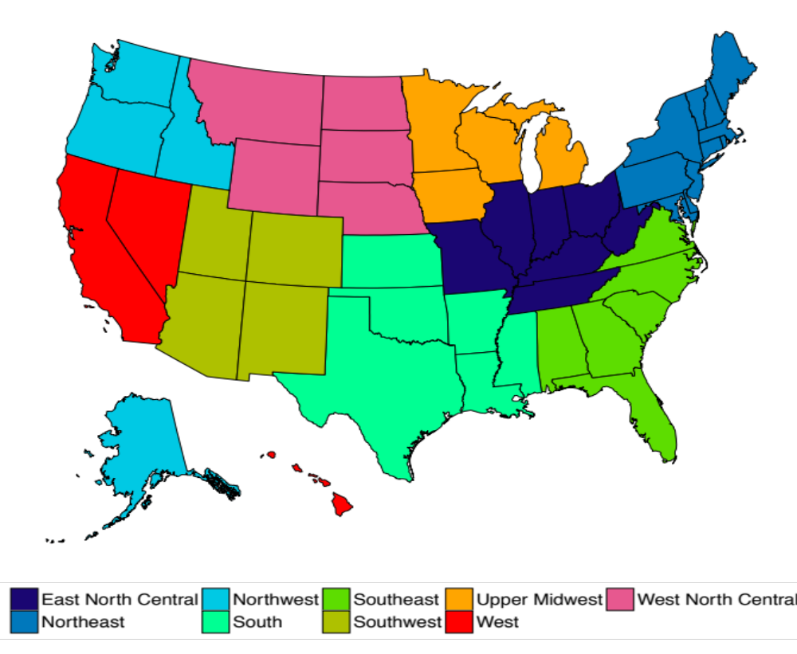
Figure S1. Climate regions of the United States.

