WIoT

## PreLab 1: Wireshark and your local network

## What to submit?

Please use this document as a template, add your responses directly, and export it as a PDF to Gradescope.

## Individual or group?

Lab 1 is done individually. After this lab, we’ll group up.

# 

# B: Get comfortable with Wireshark

**Q1–HW Variation:**

1. **[1pt] Describe briefly the operating system and hardware of your computer:**

I own a 2019 MacBook pro with an Intel x86 CPU, 16 GB of DDR 4 RAM, and a dedicated AMD Radeon Pro 5300M 4 GB Graphics Card. The operating system is macOS Monterey (12.5.1). I know that MacOS is based on the POSIX standards but is not fully compatible in a way like the Linux Operating System is.

**b.) [2pts] Make a table of all the interfaces on your machine.**

|  |  |
| --- | --- |
|  | Do you know what this is offhand (don’t look anything up yet)? |
| en0 | Yes. Wifi |
| Lo0 | N – I know what a loopback file or device is tho |
| Llw0 | N |
| Gif0 | N |
| Stf0 | N |
| En5 | N |
| Ap1 | N |
| awdlo | N |
| En1 | Yes. Thunderbolt |
| En3 | Yes. Thunderbolt |
| En4 | Yes. Thunderbolt |
| En2 | Yes. Thunderbolt |
| Bridge0 | I think this is for connection to some I/O like keyboard |
| Utun0 | N |
| Utun1 | N |
| Utun2 | N |

**Q2–Common Interfaces:**

**[2 pts] Update the table below to identify which interface corresponds to traditional hardware.**

*If you have a slightly different configuration (e.g., multiple ethernet interfaces?), feel free to update the table, but generally you shouldn’t need to add any rows, the question is ‘when folks say WiFi, what interface does that mean on your machine’.*

|  |  |
| --- | --- |
|  | Which interface is it, how did you know? “I’ve looked into this before” is a fine answer if appropriate, or whatever website you found the info on. |
| WiFi | En0 |
| Ethernet | En7 |

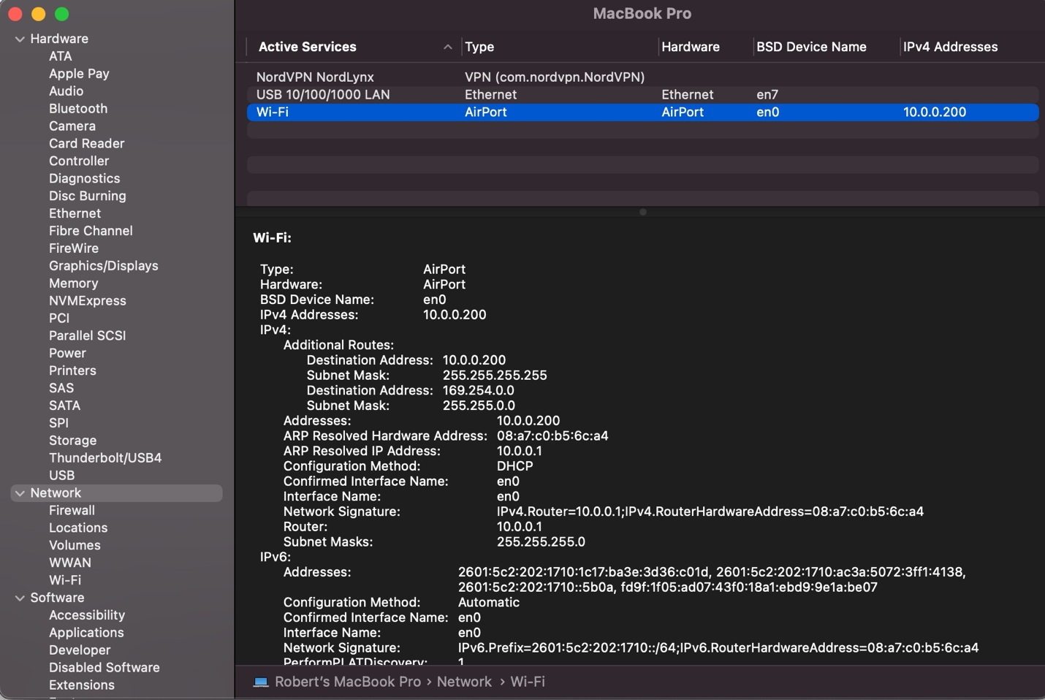

Found using this link: https://discussions.apple.com/thread/7536788

**Q3–Other Interfaces:**

**[3 pts] Pick three other interfaces from the list in Q1(b) that you did not assign a role in Q2. Explain in simple terms what the interface corresponds to.**

*If your machine doesn’t have three additional interfaces, use one of the names from the screenshot in the lab manual of my machine (which is a Mac Pro in that screenshot).*

**i.)** en1-4. These are the interfaces for the Thunderbolt ports on my computer. These are high data throughput ports to support data transfer, power the computer, and can run an external display

**ii.)** Llw0. This is a WLAN low latency interface used to enable the Apple Airdrop feature (https://apple.stackexchange.com/questions/394047/what-is-the-network-interface-llw0)

**iii.)** Utun0-2. These interfaces are used to establish VPN connections, I have Nord VPN, and the UVA VPN useful what was the third VPN I installed was lol. (https://superuser.com/questions/1510854/what-is-utun0-and-utun1-in-network-interfaces)