Preliminary Report
ECM3175
Title: Sport Injury Biomechanics: an instrumented headform study of how ball speed, inflation pressure and neck coupling affect head acceleration in football heading
[confirm the title with your supervisor, then remove this note]
Date of submission: 4 December 2026
Student Name: [fill in]
Programme: [fill in]
Student number: [fill in]
Candidate number: [fill in]

Supervisor: [fill in]

HOW TO USE THIS TEMPLATE (delete this box before you submit)
Each section is split into paragraph slots. A slot shows a label, a word target and the papers to cite, then grey ✎ notes listing the points to make.
Write your paragraph in place of the yellow text (the start of a sentence is there to get you going). Then delete the label and grey notes.
The word targets add up to about 1,050 words. That is what fits in 5 pages with the figures, tables and references (cover page included).
Write in your own words and read each paper before citing it. Check which GenAI category applies to ECM3175 and acknowledge AI help if required.
Work through 8_preliminary_report_CHECKLIST.docx alongside this template.

Introduction
✎ ≈200 words in total. Say what you will do, why and how, then give the aim and objectives (module slide: “Introduce the project. What are you going to do? Why?”).
Paragraph 1: Why it matters ≈60 words · cite [1], [2], [10], [11]
✎ Health concern with numbers: former professional players were about 3.5× more likely to die with neurodegenerative disease [1]. Goalkeepers were not at raised risk; defenders were highest [2], so heading is the main suspect. The FA now limits heading in training and youth football [10, 11].
Repeated heading of the ball in football has been linked to …
Paragraph 2: The engineering problem ≈50 words · cite [3], [4]
✎ A single header gives only about 16–20 g at 9–12 m/s, far below concussion level [4], but a routine heading session causes short-term changes in brain function [3]. Heading will not disappear from the game, so the question is which engineering factors (ball speed, inflation pressure, neck coupling) control how hard the head is accelerated.
Although a single header produces only …
Paragraph 3: What this project will do ≈30 words
✎ How: a low-cost instrumented headform rig plus a mathematical model of the ball–head impact, with no human participants.
This project will design, build and validate …
Aim and objectives ≈60 words · aim = the overall goal; objectives = specific, measurable steps
✎ Suggested aim (reword it): To quantify how ball speed, inflation pressure and neck coupling affect head acceleration in football heading, using a validated instrumented headform and a mathematical model, to inform safer equipment and practice.
The aim of this project is [one sentence]
The objectives are to:
- [objective] e.g. review heading biomechanics, head-injury measures and ball properties
- [objective] e.g. develop a ball–head impact model and check it against published measurements
- [objective] e.g. design, build and calibrate a headform–neck rig (±200 g sensor, ≥3 kHz, repeatable ball speeds of 5–15 m/s)
- [objective] e.g. measure peak head acceleration, contact time and HIC15 for ≥3 pressures × 3 speeds × 2 neck stiffnesses (5 repeats each)
- [objective] e.g. compare the measurements with the model and recommend ball-pressure or practice changes

Background and literature review
✎ ≈410 words. What has been done before, how it shapes your project, and the gap you fill (the module asks you to show a novel contribution). Be critical: for each key study give what it found AND a limitation. Use the numbered references consistently; copying text is plagiarism.

Heading and brain health
Paragraph ≈75 words · cite [1], [2], [3], [10], [11]
✎ Cohort evidence [1]; risk by position and career length, and no change in risk for players born 1910–1969 [2]; acute effects of routine heading [3]; the resulting FA guidance [10, 11]. Critical point: these studies show associations, not which impact properties matter.
Evidence that heading may affect long-term brain health comes mainly from …

How severe is a single header?
Paragraph ≈65 words · cite [4], [9]
✎ Measured head accelerations of 158 m/s² (≈16 g) at 9 m/s and 199 m/s² (≈20 g) at 12 m/s; HIC and GSI well below injury levels [4]. Injury measures: peak linear acceleration, HIC and rotational acceleration [9]. Critical: [4] tested only four subjects; this project measures linear acceleration first (a limitation to state).
Naunheim et al. [4] measured …

The ball
Paragraph ≈85 words · cite [5], [12], [13], [14]
✎ Law 2 limits: 68–70 cm, 410–450 g, 0.6–1.1 atm [12]. A ball behaves like a pressurised membrane, with contact force ≈ pressure × contact area and energy loss described by the coefficient of restitution [13, 14]. Halving pressure reduced head response by 10–31% and construction changed it by up to 15% [5]. Critical: [5] used a numerical model and three subjects, and did not vary neck coupling.
The Laws of the Game allow a ball pressure of …

The neck
Paragraph ≈65 words · cite [6], [7], [8]
✎ Neck strength imbalance is linked to higher head acceleration [6]; head/neck size and neck strength explain about 22% and 13–17% of the variation [7]; a systematic review links stronger necks to lower head acceleration [8]. Critical: these are correlations from human studies; how much neck coupling matters during a 10–14 ms impact has not been tested mechanically.
Several studies link neck strength to …

Test methods
Paragraph ≈45 words · cite [5], [15]
✎ Human-subject tests are realistic but variable and need ethics approval; surrogate headforms such as the Hybrid III are repeatable [5]; low-cost high-g MEMS accelerometers [15] now make an affordable rig possible.
Head impacts can be studied with volunteers or with …

Research gap and contribution
Paragraph ≈75 words
✎ No low-cost, validated rig that varies pressure, speed and neck coupling together; the neck mechanism is untested; extension: whether old water-logged leather balls were more severe, relevant to [2]. Finish with the research questions or hypotheses your project tests.
The review shows that …

Preliminary work
✎ ≈265 words + figures. The analytical, experimental and design work you have already done, and how you will take it further.
Literature search ≈25 words
✎ Where you searched (University library, Google Scholar), the keywords you used and how many sources you kept.
A literature search was carried out using …
Mathematical model ≈95 words · cite [13], [14]
✎ Ball (0.43 kg), head (4.5 kg) and torso (30 kg) in a line; contact force = internal pressure × contact area, with adiabatic pressure rise and Hunt–Crossley damping set from the ball’s COR; neck = spring + damper; solved with 4th-order Runge–Kutta in Python. Results (Figure 1): ≈19 g at 9 m/s to ≈48 g at 20 m/s (0.85 atm); 1.1 → 0.6 atm lowers peak acceleration by 19–24%, in line with [5]; contact 11–14 ms; HIC15 below 60. With a free head the model is 20–30% above [4]; it matches if the neck coupling is ≈1.2×10⁵ N/m, a hypothesis for the rig.
A lumped-parameter model of the ball–head impact was written in Python …
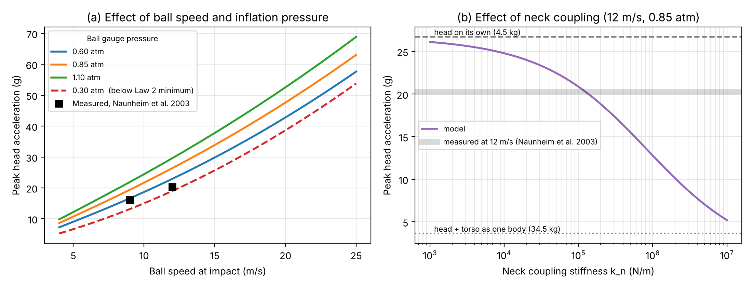
Figure 1 Model predictions: (a) peak head acceleration vs ball speed for three Law 2 pressures and one below-range pressure, with measurements from [4]; (b) effect of neck coupling stiffness (12 m/s, 0.85 atm).
Design implications ≈25 words · cite [15]
✎ Peaks under 60 g and 11–14 ms contacts, so a ±200 g accelerometer (ADXL375) sampling at 3.2 kHz captures ≈35 points per impact; the rig must deliver 5–15 m/s balls.
The model results set the requirements for the test rig: …
Ball-drop experiment ≈65 words
✎ Method: ball dropped from 2.0 m onto a hard floor at 0.6, 0.85 and 1.1 atm, 5 drops each, filmed; COR = √(rebound height / drop height). Give the results (Table 1 and Figure 2) and say how you used the measured COR to recalibrate the model.
To calibrate the model, a football was dropped from 2.0 m …
Table 1 Ball-drop results (mean ± SD of 5 drops).
Pressure (atm) | COR mean | COR SD | Contact time (ms)
0.60 | [ ] | [ ] | [ ]
0.85 | [ ] | [ ] | [ ]
1.10 | [ ] | [ ] | [ ]

Rig concept ≈35 words
✎ Headform of 4.5 kg with the sensor at its centre of mass; swappable neck elements on a heavy base; ball delivered by drop, pendulum or launcher; speed measured with slow-motion video (Figure 3).
The proposed test rig (Figure 3) consists of …
Insert Figure 2: figures/ball_drop_results.png (from ball_drop_analysis.py with YOUR data) | Insert Figure 3: photo of your rig concept sketch
Figure 2 Ball COR against inflation pressure. | Figure 3 Concept sketch of the test rig.
Next steps ≈20 words
✎ Build and validate the rig against the model and [4], then run the full test matrix.
The next stage is to …

Project plan, methodology and management
✎ ≈165 words + Gantt chart + risk table. Module slide: methodologies, resources, deliverables, Gantt chart, expected activities, risk assessment, sustainability, health & safety, project-management procedures.
Methodology ≈60 words
✎ Five stages: (1) rig design and CAD (Dec); (2) build and instrument (Jan–Feb); (3) calibrate and validate (Feb); (4) test matrix of 3 pressures × 3 speeds × 2–3 necks × 5 repeats ≈ 90–135 impacts (Feb–Mar); (5) statistics and model refinement (Mar).
The project will proceed in five stages. First, …
Resources and deliverables ≈35 words
✎ £75 departmental budget, with parts ordered through the department Order Form (target ≤£65); borrowed microcontroller and footballs; workshop and technician support. Deliverables: validated rig, impact dataset, validated model, recommendations, final report.
The work will use …
Project management ≈30 words
✎ Weekly supervisor meetings with written actions; logbook; Gantt chart (Table 2) reviewed weekly; code and data on GitHub with OneDrive backups; decision gates, e.g. rig validated by 19 February.
The project will be managed through …
Risk, health & safety, ethics and sustainability ≈40 words
✎ RAMS (risk assessment + method statement) approved by the supervisor and module convenor before any lab work; the main hazards and controls are in Table 3; no human participants; sustainability: reuse and borrow kit, low-power electronics, minimal waste.
Before any laboratory work, a risk assessment and method statement …
Table 2 Time management scheme is provided in the form of a Gantt chart:
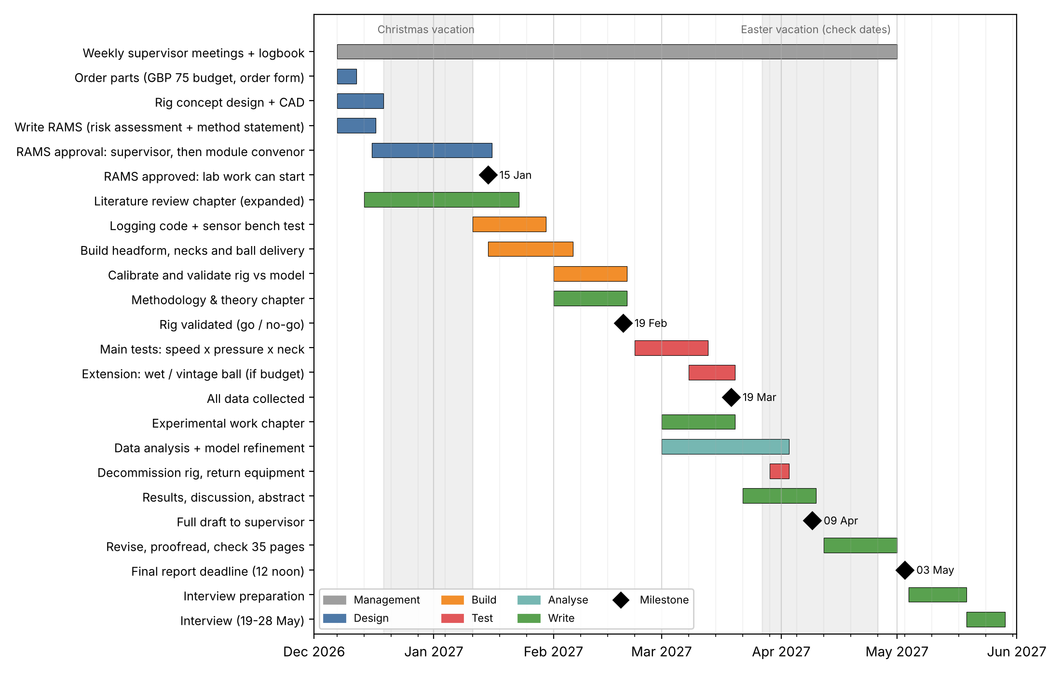
Table 3 Risk evaluation for the future work (adapt from your RAMS).
Risk | Likelihood | Impact | Mitigation
Rig takes longer to build | Medium | High | Simple gravity-driven version first; upgrade only if time allows
Sensor saturates or fails | Medium | High | Bench test in December; ±200 g range vs <60 g predicted; spare sensor
Ball speed not repeatable | Medium | Medium | Drop or pendulum delivery; measure every impact speed on video
RAMS approval or parts late | Medium | Medium | Submit RAMS and order by 18 Dec; do coding and writing meanwhile
Results differ from model | Medium | Low | Still a finding: explain the difference, then refine the model

References
✎ Keep only the papers you cite, numbered in the order they first appear. Check every detail against the paper (6_references.docx shows which still need checking). Add the date you accessed each web page.
[1] Mackay, D.F., Russell, E.R., Stewart, K., MacLean, J.A., Pell, J.P. and Stewart, W. (2019) "Neurodegenerative disease mortality among former professional soccer players", New England Journal of Medicine, 381(19), 1801–1808.
[2] Russell, E.R., Mackay, D.F., Stewart, K., MacLean, J.A., Pell, J.P. and Stewart, W. (2021) "Association of field position and career length with risk of neurodegenerative disease in male former professional soccer players", JAMA Neurology, 78(9), 1057–1063.
[3] Di Virgilio, T.G., Hunter, A., Wilson, L., et al. (2016) "Evidence for acute electrophysiological and cognitive changes following routine soccer heading", EBioMedicine, 13, 66–71.
[4] Naunheim, R.S., Bayly, P.V., Standeven, J., Neubauer, J.S., Lewis, L.M. and Genin, G.M. (2003) "Linear and angular head accelerations during heading of a soccer ball", Medicine & Science in Sports & Exercise, 35(8), 1406–1412.
[5] Shewchenko, N., Withnall, C., Keown, M., Gittens, R. and Dvorak, J. (2005) "Heading in football. Part 3: Effect of ball properties on head response", British Journal of Sports Medicine, 39(Suppl 1), i33–i39.
[6] Dezman, Z.D.W., Ledet, E.H. and Kerr, H.A. (2013) "Neck strength imbalance correlates with increased head acceleration in soccer heading", Sports Health, 5(4), 320–326.
[7] Caccese, J.B., Buckley, T.A., Tierney, R.T., et al. (2018) "Head and neck size and neck strength predict linear and rotational acceleration during purposeful soccer heading", Sports Biomechanics, 17(4), 462–476.
[8] Peek, K., Elliott, J.M. and Orr, R. (2020) "Higher neck strength is associated with lower head acceleration during purposeful heading in soccer: a systematic review", Journal of Science and Medicine in Sport, 23(5), 453–462.
[9] Rowson, S. and Duma, S.M. (2013) "Brain injury prediction: assessing the combined probability of concussion using linear and rotational head acceleration", Annals of Biomedical Engineering, 41(5), 873–882.
[10] The Football Association (2021) Heading guidance, https://www.englandfootball.com/learn/Brain-Health/Heading-in-Football, last accessed [date].
[11] The Football Association (2024) New heading rules for grassroots football youth matches, https://www.englandfootball.com/articles/2024/May/17/New-heading-rules-for-grassroots-football-youth-matches, last accessed [date].
[12] IFAB (2026) Laws of the Game 2026/27, Law 2 – The Ball, https://www.thefa.com/football-rules-governance/lawsandrules/laws/football-11-11/law-2---the-ball, last accessed [date].
[13] Cross, R. (1999) "The bounce of a ball", American Journal of Physics, 67(3), 222–227.
[14] Hunt, K.H. and Crossley, F.R.E. (1975) "Coefficient of restitution interpreted as damping in vibroimpact", Journal of Applied Mechanics, 42(2), 440–445.
[15] Analog Devices, ADXL375 3-axis ±200 g digital MEMS accelerometer data sheet, https://www.analog.com/en/products/adxl375.html, last accessed [date].

