Preliminary Report
ECM3175

Title: Sport Injury Biomechanics: an instrumented headform study of how ball speed, inflation pressure and neck coupling affect head acceleration in football heading
Date of submission: 4 December 2026
Student Name: [fill in]
Programme: [fill in]
Student number: [fill in]
Candidate number: [fill in]

Supervisor: [fill in]

HOW TO USE THIS OUTLINE (delete this box before submitting)
- Grey ✎ notes say what each section needs and roughly how many words. Delete them all.
- Bullets are the points to make, with the papers that support them. Turn them into your own paragraphs: do not paste bullet lists into the final report.
- Yellow [boxes] are things only you can fill in (your details, your experiment results, your sketch).
- Limit: 5 pages including this cover page and the references, so keep prose tight (about 1,700 words in total).
- Read each reference yourself before citing it (see references.md). Check which GenAI category applies to ECM3175 and acknowledge AI help if required.

Introduction
✎ ≈250 words. Overview of why, what and how; finish with the aim and objectives (aims = general strategy, objectives = specific tactics).
- Why: former professional footballers are about 3.5× more likely to die with neurodegenerative disease than matched controls [1]; goalkeepers are not at raised risk while defenders are at the highest [2], pointing at repeated heading.
- A single header accelerates the head by only ≈16–20 g at 9–12 m/s, far below concussion levels [4], but a routine heading session causes measurable short-term changes in brain function [3]. Governing bodies now limit heading in training and youth football [10, 11].
- Engineering problem: heading will not disappear from the game, so which engineering factors (ball speed, inflation pressure, neck coupling) control how hard the head is accelerated, and by how much?
- How: design, build and validate a low-cost instrumented headform rig, supported by a mathematical model of the ball–head impact.
- Aim: to quantify how ball speed, inflation pressure and neck coupling affect head acceleration in football heading, using a validated instrumented headform and a mathematical model, to inform safer equipment and practice.
- Objectives: (O1) review heading biomechanics, head-injury measures and ball properties; (O2) develop and validate a ball–head impact model; (O3) design, build and calibrate a headform–neck rig (±200 g sensor, ≥3 kHz, repeatable ball speeds 5–15 m/s); (O4) measure peak acceleration, contact time and HIC15 for ≥3 pressures × 3 speeds × 2 neck stiffnesses, 5 repeats each; (O5) compare with the model and recommend ball pressure / practice changes. Extension: wet leather vs modern ball.

Background and literature review
✎ ≈700 words. What is known, what is missing, and so what your novel contribution is. This becomes the literature review of the final report. Use the numbered references consistently.
- Heading and brain health: cohort evidence [1]; risk by position and career length, and the risk did not change for players born 1910–1969 [2]; acute effects of routine heading [3]; resulting guidance [10, 11].
- How severe is one header? Measured head accelerations [4]; injury measures (peak linear acceleration, HIC, rotational acceleration [9]). Single headers sit far below injury thresholds, so the aim is to reduce the size of each of many repeated impacts.
- The ball: Law 2 limits (68–70 cm, 410–450 g, 0.6–1.1 atm) [12]; a ball behaves like a pressurised membrane, with contact force ≈ pressure × contact area and energy loss measured by the coefficient of restitution [13, 14]. Halving pressure reduced head response by 10–31% [5], but that study used a numerical model and only three subjects.
- The neck: neck strength and strength imbalance are linked to lower or higher head acceleration [6, 7, 8], but these are correlations from human studies; the mechanism (how much neck coupling is needed) is untested.
- Test methods: human-subject tests are realistic but variable and need ethics approval; surrogate headforms (e.g. Hybrid III) are repeatable [5]; low-cost MEMS high-g accelerometers [15] now make an affordable rig possible.
- Gap / novel contribution: no low-cost, validated rig that varies pressure, speed and neck coupling together; mechanism of the neck effect untested; (extension) whether old water-logged leather balls were more severe, relevant to [2].

Preliminary work
✎ ≈400 words + figures. What you have already done (analysis, experiments, design) and how you will take it further.
- Literature review started (about 15 sources; see References).
- Mathematical model (Python, written for this project): ball (0.43 kg), head (4.5 kg) and torso (30 kg) in line; contact force = internal pressure × contact area of two spheres, with adiabatic pressure rise and Hunt–Crossley damping set from the ball's coefficient of restitution [13, 14]; neck = spring + damper.
- Model results (Figure 1): peak head acceleration rises from ≈19 g at 9 m/s to ≈48 g at 20 m/s (0.85 atm). Lowering pressure from 1.1 to 0.6 atm reduces it by 19–24%, in line with [5]. Contact lasts 11–14 ms; HIC15 stays below 60, far below injury levels, consistent with [4].
- Validation: with a free head the model is 20–30% above the measurements of [4]; it matches them if the neck couples head and torso with ≈1.2×10⁵ N/m, which becomes a hypothesis for the rig to test (Figure 1b).
- Design implications: a ±200 g accelerometer (ADXL375 [15]) sampling at 3.2 kHz captures ≈35 points per impact; the rig must deliver 5–15 m/s balls.
- Ball-drop experiment: [your results: COR at 0.6 / 0.85 / 1.1 atm, mean ± SD of 5 drops each, from ball_drop_analysis.py; say how you recalibrated the model].
- Rig concept: [insert your sketch: headform, neck, base, ball delivery, sensor position].
- Next: build and validate the rig against the model and [4], then run the full test matrix.
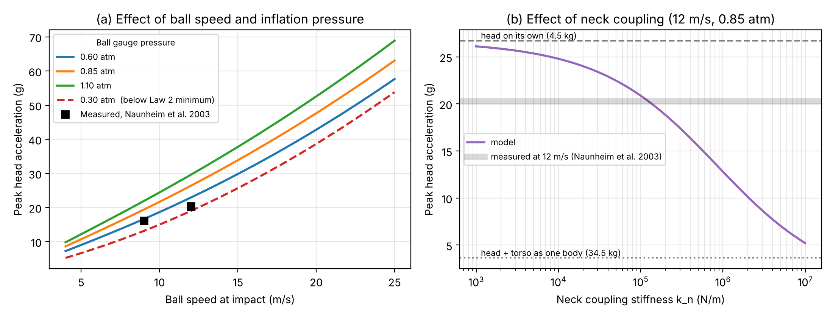
Figure 1 Preliminary model predictions. (a) Peak head acceleration against ball speed for three Law 2 pressures and one below-range pressure, with the measurements of Naunheim et al. [4]. (b) Effect of neck coupling stiffness at 12 m/s and 0.85 atm.
[Figure 2: your ball-drop results (figures/ball_drop_results.png)]

Project plan, methodology and management
✎ ≈350 words + Gantt chart + risk table. Methodology, resources, deliverables, management procedures, risk, health & safety and sustainability.
- Methodology: (1) rig design and CAD (Dec); (2) build and instrument: ADXL375 + microcontroller logging at 3.2 kHz, Python analysis of peak g, contact time and HIC15 (Jan–Feb); (3) calibrate and validate: repeatability and comparison with the model and [4] (Feb); (4) test matrix: 3 pressures × 3 speeds × 2–3 necks × 5 repeats ≈ 90–135 impacts, plus dry/wet leather ball (Feb–Mar); (5) statistics (regression / ANOVA) and model refinement (Mar).
- Resources: workshop and technician time; sensor, microcontroller, headform materials, balls and pump (≈£100–150) [confirm budget]; phone slow-motion camera; [equipment your supervisor confirms].
- Deliverables: validated rig; impact dataset; validated model; recommendations; final report.
- Management: weekly supervisor meetings with written actions; logbook; Gantt chart reviewed weekly; code and data version-controlled on GitHub and backed up to OneDrive.
- Health & safety: projectile balls (eye protection, exclusion zone), falling masses (guarding), pinch points, manual handling, low-voltage electronics only; lab inductions and departmental risk assessment before testing. Ethics: no human participants [confirm with supervisor]. Sustainability: reuse balls and lab kit, reclaimed / 3D-printed parts, low-power electronics.
Table 1 Time management scheme is provided in the form of a Gantt chart:
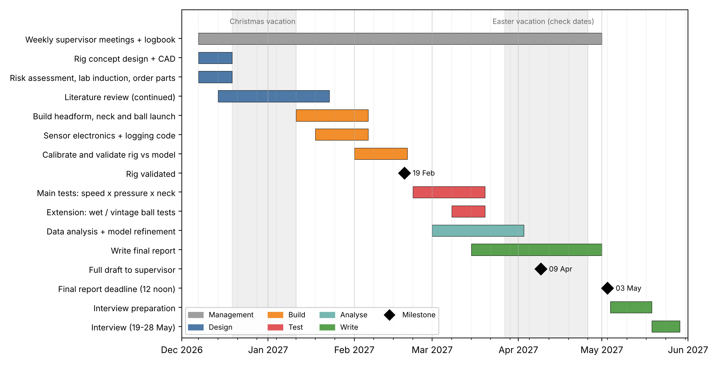
Table 2 Risk evaluation for the future work.
Risk | Likelihood | Impact | Mitigation
Rig takes longer to build | Medium | High | Simple gravity-driven version first; upgrades only if time allows
Sensor saturates or fails | Medium | High | Bench test in Dec; ±200 g vs <60 g predicted; spare sensor
Ball speed not repeatable | Medium | Medium | Drop/pendulum delivery; measure every impact speed on video
No launcher/headform available | Medium | Medium | Home-made headform; gravity-driven delivery
Results differ from model | Medium | Low | Still a finding: explain, then refine the model
Illness / other deadlines | Low | Medium | Two-week buffer; weekly meetings catch slippage

References
✎ Only list what you cite. Check every detail against the paper (see references.md for which entries still need checking).
[1] Mackay, D.F., Russell, E.R., Stewart, K., MacLean, J.A., Pell, J.P. and Stewart, W. (2019) "Neurodegenerative disease mortality among former professional soccer players", New England Journal of Medicine, 381(19), 1801–1808.
[2] Russell, E.R., Mackay, D.F., Stewart, K., MacLean, J.A., Pell, J.P. and Stewart, W. (2021) "Association of field position and career length with risk of neurodegenerative disease in male former professional soccer players", JAMA Neurology, 78(9), 1057–1063.
[3] Di Virgilio, T.G., Hunter, A., Wilson, L., et al. (2016) "Evidence for acute electrophysiological and cognitive changes following routine soccer heading", EBioMedicine, 13, 66–71.
[4] Naunheim, R.S., Bayly, P.V., Standeven, J., Neubauer, J.S., Lewis, L.M. and Genin, G.M. (2003) "Linear and angular head accelerations during heading of a soccer ball", Medicine & Science in Sports & Exercise, 35(8), 1406–1412.
[5] Shewchenko, N., Withnall, C., Keown, M., Gittens, R. and Dvorak, J. (2005) "Heading in football. Part 3: Effect of ball properties on head response", British Journal of Sports Medicine, 39(Suppl 1), i33–i39.
[6] Dezman, Z.D.W., Ledet, E.H. and Kerr, H.A. (2013) "Neck strength imbalance correlates with increased head acceleration in soccer heading", Sports Health, 5(4), 320–326.
[7] Caccese, J.B., Buckley, T.A., Tierney, R.T., et al. (2018) "Head and neck size and neck strength predict linear and rotational acceleration during purposeful soccer heading", Sports Biomechanics, 17(4), 462–476.
[8] Peek, K., Elliott, J.M. and Orr, R. (2020) "Higher neck strength is associated with lower head acceleration during purposeful heading in soccer: a systematic review", Journal of Science and Medicine in Sport, 23(5), 453–462.
[9] Rowson, S. and Duma, S.M. (2013) "Brain injury prediction: assessing the combined probability of concussion using linear and rotational head acceleration", Annals of Biomedical Engineering, 41(5), 873–882.
[10] The Football Association (2021) Heading guidance, https://www.englandfootball.com/learn/Brain-Health/Heading-in-Football, last accessed [date].
[11] The Football Association (2024) New heading rules for grassroots football youth matches, https://www.englandfootball.com/articles/2024/May/17/New-heading-rules-for-grassroots-football-youth-matches, last accessed [date].
[12] IFAB (2026) Laws of the Game 2026/27, Law 2 – The Ball, https://www.thefa.com/football-rules-governance/lawsandrules/laws/football-11-11/law-2---the-ball, last accessed [date].
[13] Cross, R. (1999) "The bounce of a ball", American Journal of Physics, 67(3), 222–227.
[14] Hunt, K.H. and Crossley, F.R.E. (1975) "Coefficient of restitution interpreted as damping in vibroimpact", Journal of Applied Mechanics, 42(2), 440–445.
[15] Analog Devices, ADXL375 3-axis ±200 g digital MEMS accelerometer data sheet, https://www.analog.com/en/products/adxl375.html, last accessed [date].

