FA_c18_pre : c -> output rise and fall delay and fall delay)
a | b | c | s | co | rise delay (ns) | fall delay (ns)
0 | 0 | 0 -> 1  1 -> 0 | 0 -> 1  1 -> 0 | 0 | c -> s  0.0401042375980 | c -> s  0.0406455829348
0 | 1 | 0 -> 1  1 -> 0 | 1 -> 0  0 -> 1 | 0 -> 1  1 -> 0 | c -> s  0.0698023894816  c -> co  0.0705725974731 | c -> s  0.0419516433692  c -> co  0.0326027300817
1 | 0 | 0 -> 1  1 -> 0 | 1 -> 0  0 -> 1 | 0 -> 1  1 -> 0 | c -> s  0.0855084975092  c -> co  0.0623687061024 | c -> s  0.0423759955776  c -> co  0.0320057779057
1 | 1 | 0 -> 1  1 -> 0 | 0 -> 1  1 -> 0 | 1 | c -> s  0.1899805077548 | c -> s  0.0326532690704
c -> s (rise_max) =0.1899805077548 ns, c -> s (fall_max) =0.0423759955776
c -> co (rise_max) = 0.0705725974731 ns, c -> co (fall_max) = 0.0326027300817

FA_c18_pre / FA_c18_post | rise delay (ns) | fall delay (ns)
a->s | 0.0688 / 0.1028 | 0.0424 / 0.0677
a->co | 0.0722 / 0.0953 | 0.0333 / 0.0478
b->s | 0.0859 / 0.1229 | 0.0450 / 0.0711
b->co | 0.0835 / 0.1089 | 0.0321 / 0.0469
c->s | 0.1899 / 0.2499 | 0.0423 / 0.0694
c->co | 0.0705 / 0.0940 | 0.0326 / 0.0483

 | max. delay (ns) | area (um2)
FA_c18_syn | 0.18 | 252.763202
FA_t18_syn | 0.28 | 126.403203
FA_c18_post | 0. 1923 | 267.56
FA_t18_addf | 0.3410 | 69.8544
FA_c18_cmos | 0.2499 | 96.4656

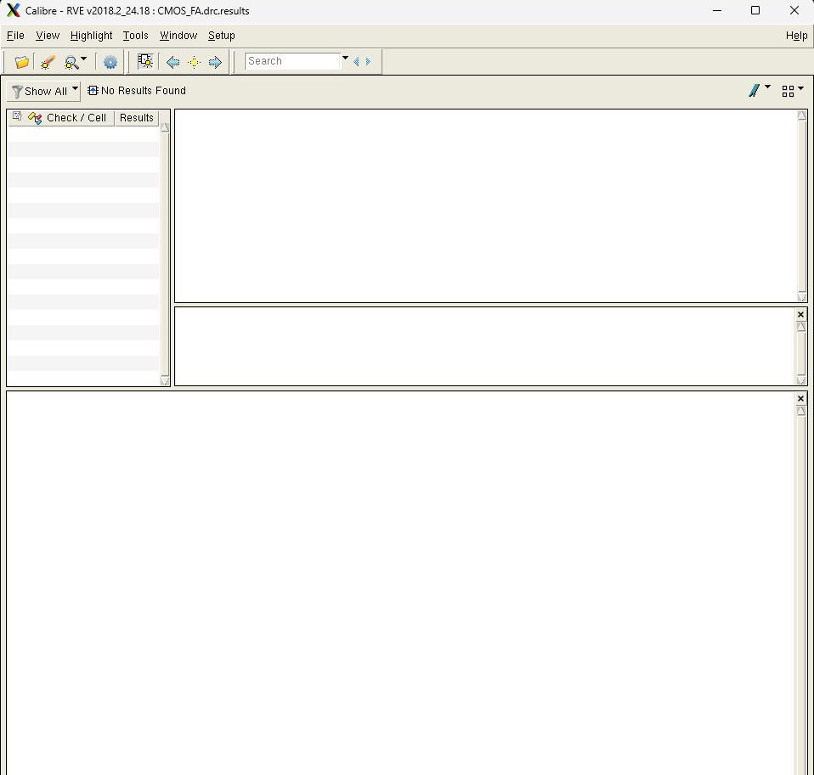
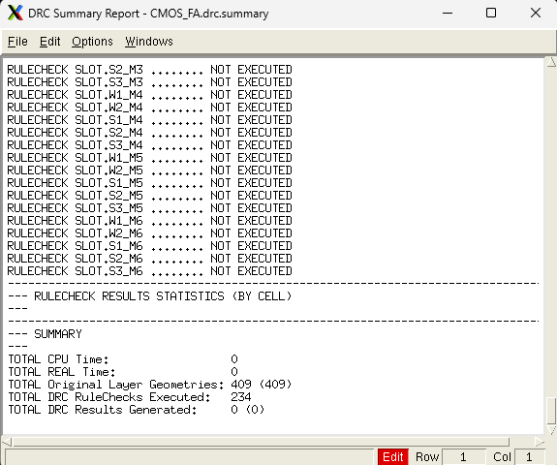
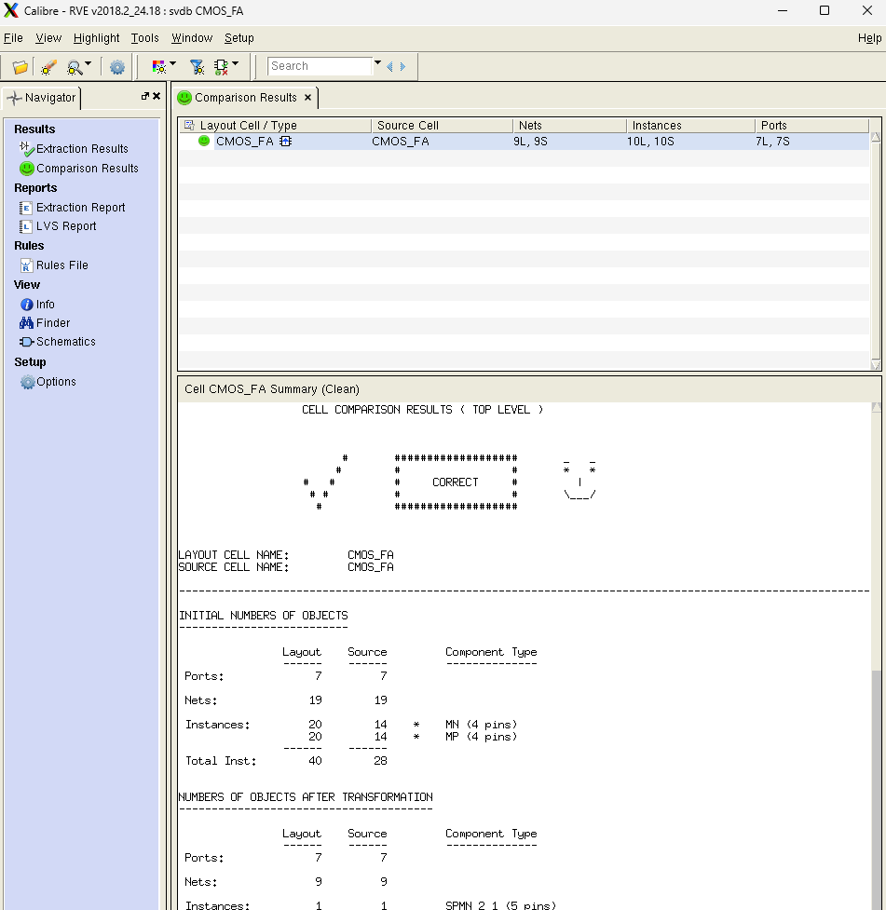
FA_c18_pre : c -> output rise and fall delay and fall delay)
a | b | c | s | co | rise delay (ns) | fall delay (ns)
0 | 0 | 0 -> 1  1 -> 0 | 0 -> 1  1 -> 0 | 0 | c -> s  0.0638639863234 | c -> s  0.0621949741964
0 | 1 | 0 -> 1  1 -> 0 | 1 -> 0  0 -> 1 | 0 -> 1  1 -> 0 | c -> s  0. 1033067534703  c -> co  0.0940272365778 | c -> s  0.0705919823443  c -> co  0.0483997672695
1 | 0 | 0 -> 1  1 -> 0 | 1 -> 0  0 -> 1 | 0 -> 1  1 -> 0 | c -> s  0. 1243682695306  c -> co  0.0851962444193 | c -> s  0.0694486250488  c -> co  0.0475676708284
1 | 1 | 0 -> 1  1 -> 0 | 0 -> 1  1 -> 0 | 1 | c -> s  0. 2499307859658 | c -> s  0.0548283684554
c -> s (rise_max) = 0. 2499307859658 ns, c -> s (fall_max) =0.0694486250488
c -> co (rise_max) = 0.0940272365778 ns, c -> co (fall_max) = 0.0483997672695

