1.
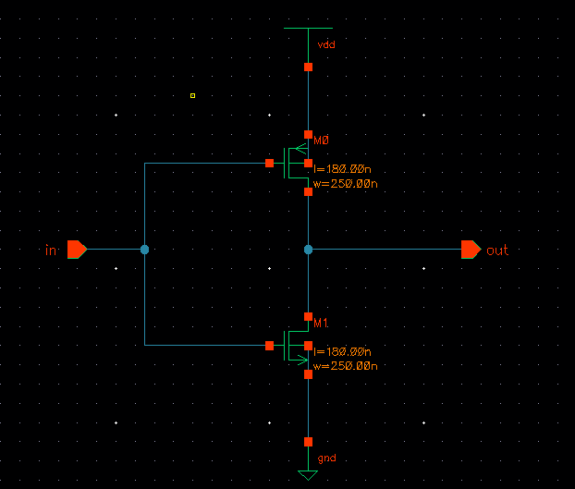
INV_XL  (TT) | TT
 | propagation delay |  |  |  |  |  | transition time |  | power
load  (pF) | rise  (ns) | Ki  (ns/pF) | K  (ns/pF) | fall  (ns) | Ki  (ns/pF) | K  (ns/pF) | rise  (ns) | fall  (ns) | min_power | src_power
0 | 0.0234674892569 | - | - | 0.0078469519167 |  |  | 0.0322807863187 | 0.0213310418455 | 40.3511549860e-6 | 2.5503923686e-3
0.01 | 0.1729846125514 |  |  | 0.0602176615056 |  |  | 0.3469075862576 | 0.1131789091839 | 40.3511556786e-6 | 19.1475933993e-3
0.02 | 0.3228627259497 |  |  | 0.1114359669515 |  |  | 0.6632130206626 | 0.2164046822175 | 40.3511548993e-6 | 35.6309053372e-3
0.03 | 0.4734853412692 |  |  | 0.1631883723018 |  |  | 0.9770135757961 | 0.3209144048259 | 40.3511556966e-6 | 52.1464360566e-3
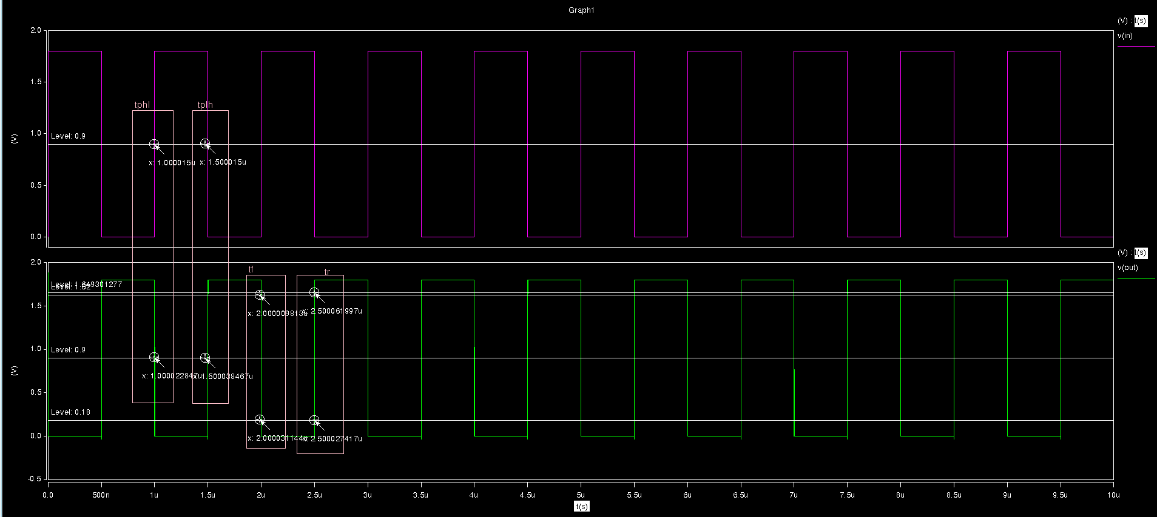

2.
INV_XL  (SS) | SS
 | propagation delay |  |  |  |  |  | transition time |  | power
load  (pF) | rise  (ns) | Ki  (ns/pF) | K  (ns/pF) | fall  (ns) | Ki  (ns/pF) | K  (ns/pF) | rise  (ns) | fall  (ns) | min_power | src_power
0 | 0.0469732831559 | - | - | 0.0193964483600 |  |  | 0.0667356846050 | 0.0275985833037 | 185.6465056589e-9 | 2.8407307349e-3
0.01 | 0.3533624598043 |  |  | 0.1390639740042 |  |  | 0.7112953372837 | 0.2692612557857 | 185.6465100360e-9 | 19.4523927272e-3
0.02 | 0.6539460915957 |  |  | 0.2552023326791 |  |  | 1.3595982238 | 0.5093658918281 | 185.6465134568e-9 | 35.9027951710e-3
0.03 | 0.9545087217079 |  |  | 0.3720681802432 |  |  | 2.0042350697 | 0.7538484586319 | 185.6465275973e-9 | 52.3225783996e-3
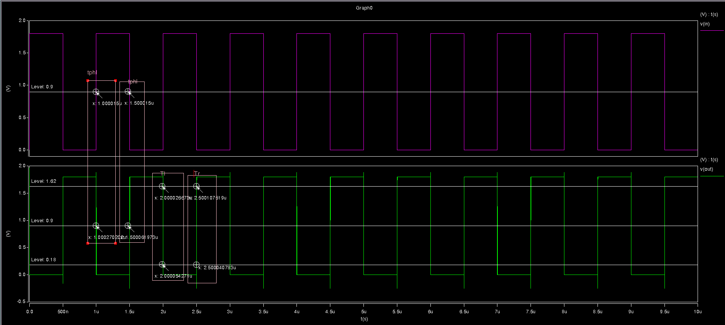
3.
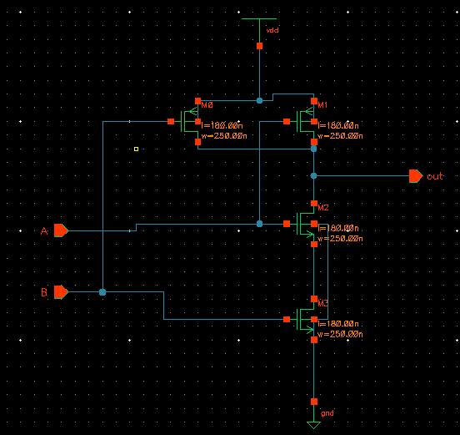
NAND_XL  (TT) | TT
 | propagation delay |  |  |  |  |  | transition time |  | power
load  (pF) | rise  (ns) | Ki  (ns/pF) | K  (ns/pF) | fall  (ns) | Ki  (ns/pF) | K  (ns/pF) | rise  (ns) | fall  (ns) | min_power | src_power
0(a-y) | 0.02932800520879 | - | - | 0.0162900174887 |  |  | 0.0447920117058 | 0.0289492449118 | 185.6465056589e-9 | 2.8407307349e-3
0.01(a-y) | 0.1803528503214 |  |  | 0.0969896101621 |  |  | 0.3509475975153 | 0.1917169543656 | 185.6465100360e-9 | 19.4523927272e-3
0.02(a-y) | 0.3286451155733 |  |  | 0.1789483535608 |  |  | 0.6566545290707 | 0.3585413228630 | 185.6465134568e-9 | 35.9027951710e-3
0.03(a-y) | 0.4785409180595 |  |  | 0.2594853931168 |  |  | 0.9674096506495 | 0.5222964977752 | 185.6465275973e-9 | 52.3225783996e-3
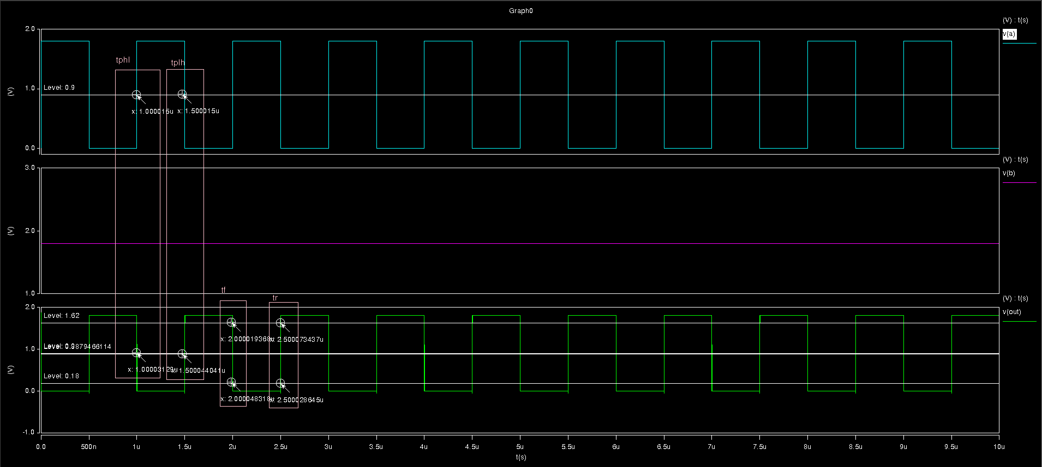
NAND_XL  (TT) | TT
 | propagation delay |  |  |  |  |  | transition time |  | power
load  (pF) | rise  (ns) | Ki  (ns/pF) | K  (ns/pF) | fall  (ns) | Ki  (ns/pF) | K  (ns/pF) | rise  (ns) | fall  (ns) | min_power | src_power
0(b-y) | 0.0468367676783 | - | - | 0.0227895518011 |  |  | 0.0698620247964 | 0.0306721025260 | 44.3535355615e-6 | 4.8864358837e-3
0.01(b-y) | 0.1971414472795 |  |  | 0.1042233943118 |  |  | 0.3784514868732 | 0.1921609441207 | 44.3463037847e-6 | 20.9683674469e-3
0.02(b-y) | 0.3445034592939 |  |  | 0.1853577500349 |  |  | 0.6855293737365 | 0.3579117389468 | 44.3582373557e-6 | 36.9554292077e-3
0.03(b-y) | 0.4950674064225 |  |  | 0.2680075517248 |  |  | 0.9911914025084 | 0.5254061239742 | 44.3481680941e-6 | 53.0738921634e-3

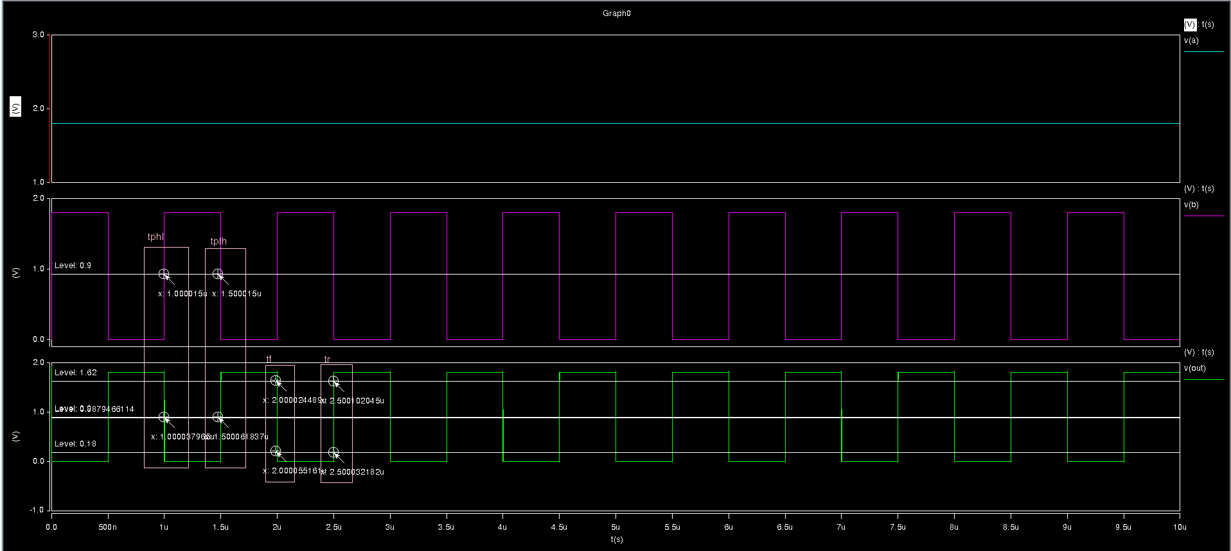

4.
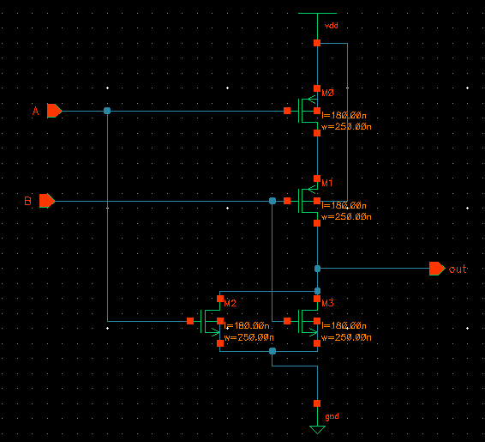
NOR_XL  (TT) | TT
 | propagation delay |  |  |  |  |  | transition time |  | power
load  (pF) | rise  (ns) | Ki  (ns/pF) | K  (ns/pF) | fall  (ns) | Ki  (ns/pF) | K  (ns/pF) | rise  (ns) | fall  (ns) | min_power | src_power
0(a-y) | 0.0693750071157 | - | - | 0.0137929545810 |  |  | 0.0953007533347 | 0.0293632142535 | 75.8470849745e-6 | 4.7818934064e-3
0.01(a-y) | 0.3552175001896 |  |  | 0.0672141306824 |  |  | 0.6775240501181 | 0.1227081768186 | 75.8494003325e-6 | 21.0280672015e-3
0.02(a-y) | 0.6375266498922 |  |  | 0.1182426644591 |  |  | 1.2600784619 | 0.2223005092409 | 75.8510087404e-6 | 37.1010917890e-3
0.03(a-y) | 0.9221968425529 |  |  | 0.1699215259529 |  |  | 1.8411578835 | 322.1901243851 | 75.8515038915e-6 | 53.0803644599e-3
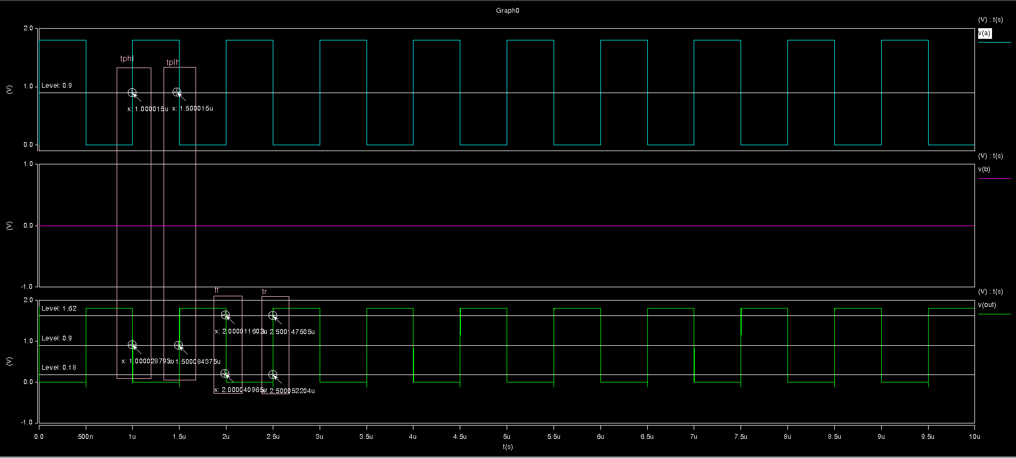
NOR_XL  (TT) | TT
 | propagation delay |  |  |  |  |  | transition time |  | power
load  (pF) | rise  (ns) | Ki  (ns/pF) | K  (ns/pF) | fall  (ns) | Ki  (ns/pF) | K  (ns/pF) | rise  (ns) | fall  (ns) | min_power | src_power
0(b-y) | 0.0500213330716 | - | - | 0.0116772615188 |  |  | 0.0932875958120 | 0.0232961729178 | 70.8905773876e-6 | 3.4609373927e-3
0.01(b-y) | 0.3346821850064 |  |  | 0.0623447181840 |  |  | 0.6763551318628 | 0.1146865373119 | 70.8914153011e-6 | 19.6345882926e-3
0.02(b-y) | 0.6155042362582 |  |  | 0.1129951393043 |  |  | 1.2588756068 | 0.2147045961308 | 70.8956492746e-6 | 35.7327005604e-3
0.03(b-y) | 0.8985176479362 |  |  | 0.1643282781569 |  |  | 1.8433999038 | 0.3158509721384 | 70.8969254282e-6 | 51.7884742665e-3
