VLSI_hw3
- FA
 | Delay(ns) | Area(um²)
FA_c18_syn | 0.18 | 252.763202
FA_t18_syn | 0.28 | 126.403203
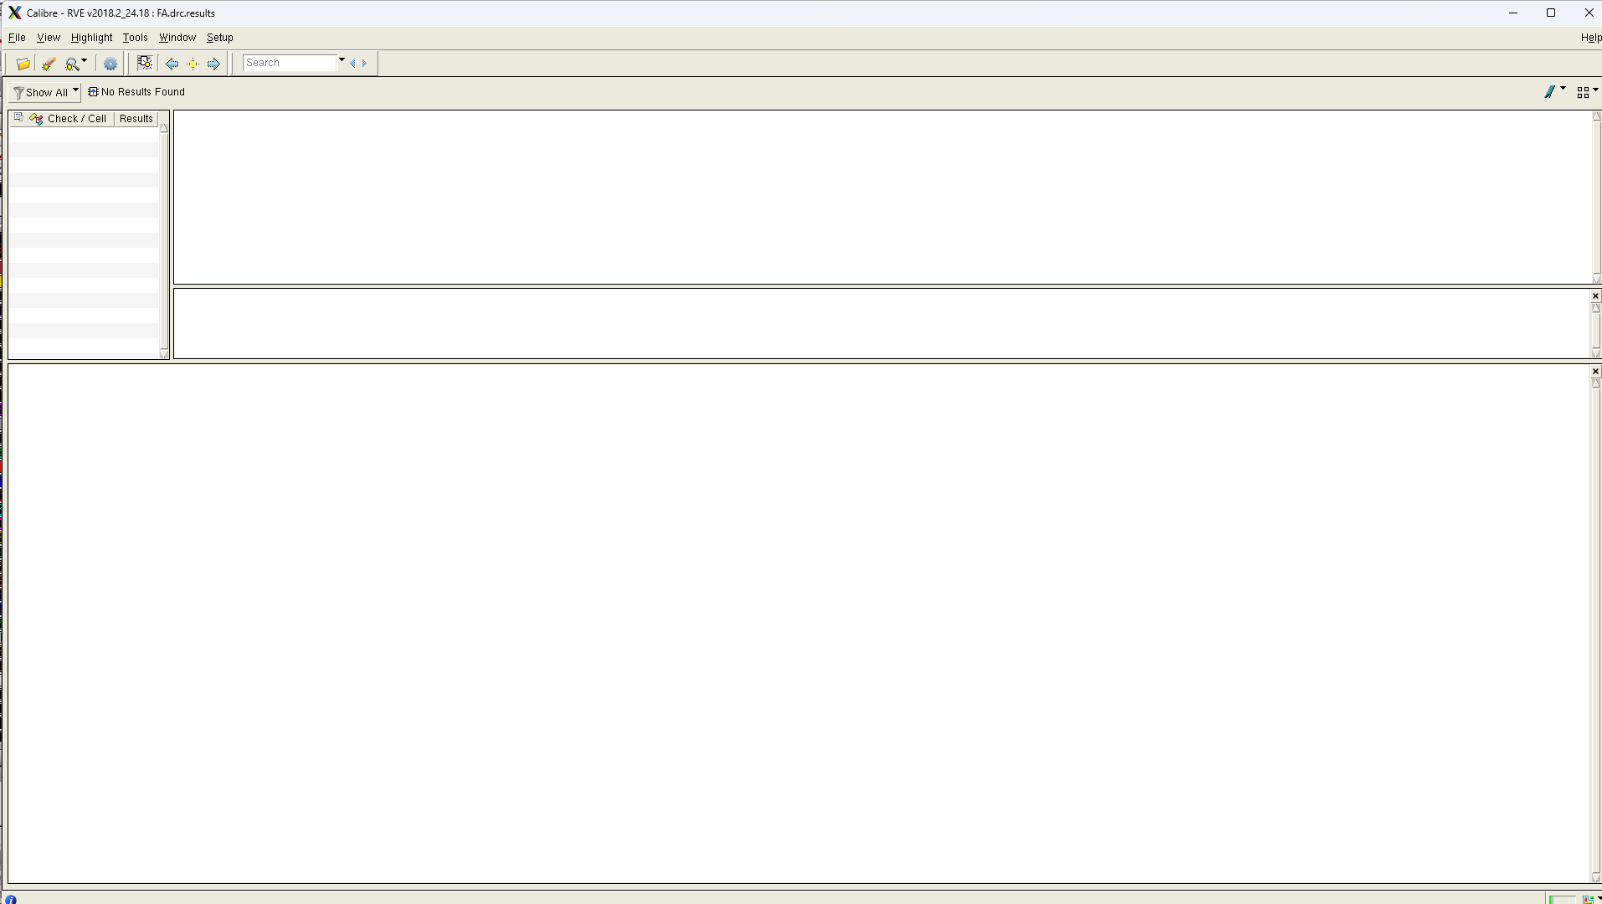
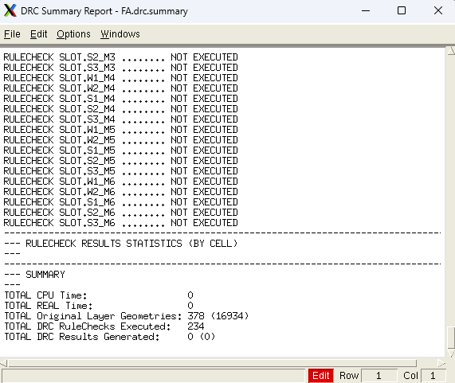
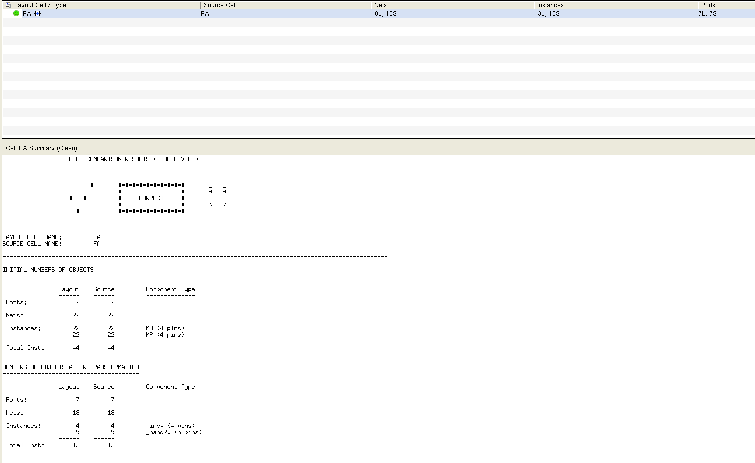
Pre_layout:
FA_c18_pre : c -> output rise and fall delay and fall delay)
a |  | b | c | s | co |  | rise delay (ns) |  | fall delay (ns)
0 |  | 0 | 0 -> 1  1 -> 0 | 0 -> 1  1 -> 0 | 0 |  | c -> s  65.6182245762p |  | c -> s  35.5205003166p
0 |  | 1 | 0 -> 1  1 -> 0 | 1 -> 0  0 -> 1 | 0 -> 1  1 -> 0 |  | c -> s  44.9104052499p  c -> co  66.1336115066p |  | c -> s  34.0878030352p  c -> co  31.8302112624p
1 |  | 0 | 0 -> 1  1 -> 0 | 1 -> 0  0 -> 1 | 0 -> 1  1 -> 0 |  | c -> s  44.9103108379p  c -> co  66.1336880157p |  | c -> s  36.8742418780p  c -> co  31.8302560204p
1 |  | 1 | 0 -> 1  1 -> 0 | 0 -> 1  1 -> 0 | 1 |  | c -> s  65.6182181709p |  | c -> s  35.5204609215p
c -> s (rise_max) = 0.0656182245762 ns, c->s (fall_max) = 0.0368742418780 ns
c->co (rise_max) = 0.0661336880157 ns, c->co (fall_max) = 0.0318302560204 ns
 | FA_c18_pre: pre-layout delay |  |  |  |  | rise delay (ns) |  | fall delay (ns)
 | a->s |  |  |  |  | 46.6833484190ps |  | 33.2877157921ps
 | a->co |  |  |  |  | 44.3806707222ps |  | 32.1694688862ps
 | b->s |  |  |  |  | 46.2300774393ps |  | 33.1763380399ps
 | b->co |  |  |  |  | 44.3940292441ps |  | 36.5702120935ps
 | c->s |  |  |  |  | 65.6182245762ps |  | 36.8742418780ps
 | c->co |  |  |  |  | 66.1336880157ps |  | 31.8302560204ps

 | max. delay (ns)
FA_c18_syn | 0.18
FA_t18_syn | 0.28
FA_t18_addf | 0.3410
FA_c18_pre | 0.06613

Post layout:
FA_c18_pre : c -> output rise and fall delay and fall delay)
a |  | b | c | s | co |  | rise delay (ns) |  | fall delay (ns)
0 |  | 0 | 0 -> 1  1 -> 0 | 0 -> 1  1 -> 0 | 0 |  | c -> s  174.2757804900p |  | c -> s  111.2922505008p
0 |  | 1 | 0 -> 1  1 -> 0 | 1 -> 0  0 -> 1 | 0 -> 1  1 -> 0 |  | c -> s  191.3822644334p  c -> co  153.6466025583p |  | c -> s  104.4774092862p  c -> co  102.1421422047p
1 |  | 0 | 0 -> 1  1 -> 0 | 1 -> 0  0 -> 1 | 0 -> 1  1 -> 0 |  | c -> s  191.3822346526p  c -> co  153.6862020338p |  | c -> s  104.4414253437p  c -> co  102.1420558734p
1 |  | 1 | 0 -> 1  1 -> 0 | 0 -> 1  1 -> 0 | 1 |  | c -> s  174.1554882281p |  | c -> s  111.2923028749p
c -> s (rise_max) = 0.1913822644334 ns, c->s (fall_max) = 0.1112923028749 ns
c->co (rise_max) = 0.1536862020338 ns, c->co (fall_max) = 0.1021421422047 ns
 | FA_c18_pre: pre-layout delay |  |  |  |  | rise delay (ns) |  | fall delay (ns)
 | a->s |  |  |  |  | 192.1639544427ps |  | 107.2611681049ps
 | a->co |  |  |  |  | 171.8796431252ps |  | 96.7570121488ps
 | b->s |  |  |  |  | 192.3980656723ps |  | 107.2895642305ps
 | b->co |  |  |  |  | 171.8296595983ps |  | 94.4191159884ps
 | c->s |  |  |  |  | 191.3822644334ps |  | 104.4774092862ps
 | c->co |  |  |  |  | 153.6862020338ps |  | 102.1421422047fps

 | max. delay (ns) | area (um2)
FA_c18_syn | 0.18 | 252.763202
FA_t18_syn | 0.28 | 126.403203
FA_t18_addf | 0.3410 | 69.8544
FA_c18_pre | 0.0661 | 252.763202
FA_c18_post | 0. 1923 | 267.56

- RCA8
 | Delay(ns) | Area(um²)
FA_c18_syn | 1.2 | 1456.682418
FA_t18_syn | 0.51 | 1663.200041
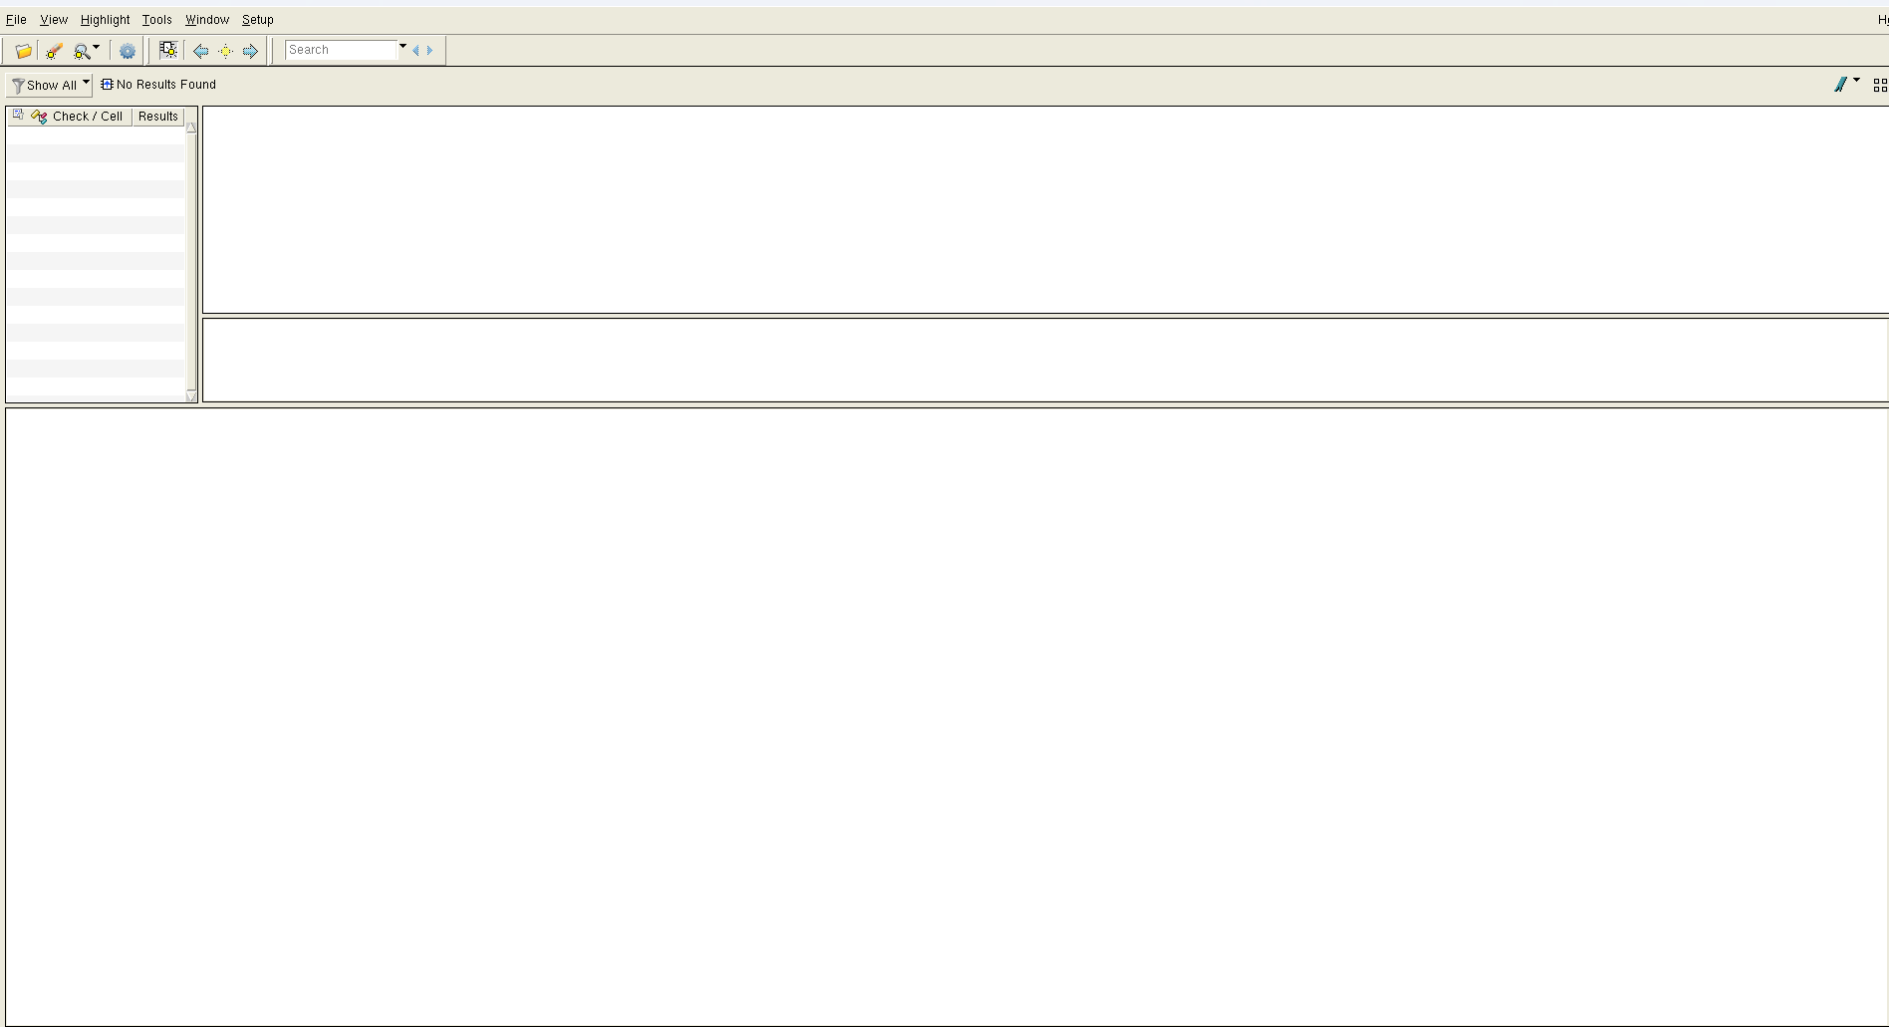
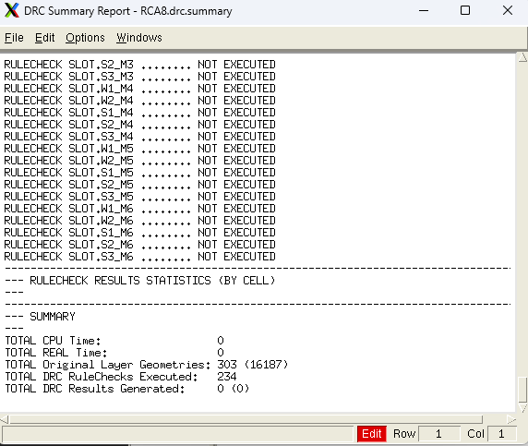
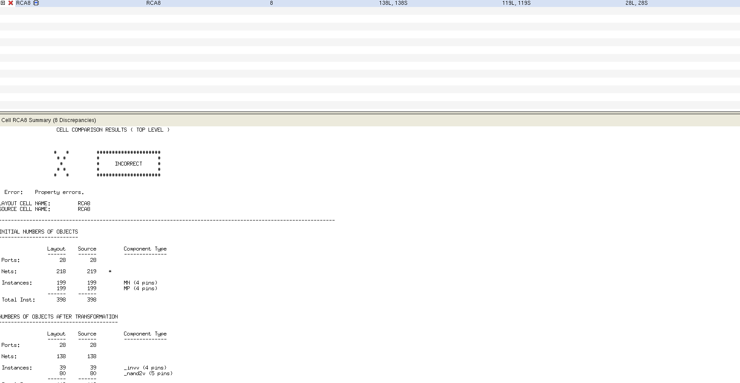
Lvs一直報我一個nandx1跟nandx2寬度不對，但我檢查了schemetic與layout都是正常的。實在找不出原因。
Pre layout

FA_c18_pre : c -> output rise and fall delay and fall delay)
a[7:0] | b[7:0] | cin | s[7:0] | cout | cin -> s[7] | cin -> cout
11111111 | 00000000 | 0 -> 1 | 111111111-> 00000000 | 0->1 | ( fall )  26.8492443587ps | ( rise )  48.2949359245ps
11111111 | 00000000 | 1 -> 0 | 00000000->  111111111 | 1 -> 0 | ( rise )  33.5580177462ps | ( fall )  38.6816599094ps

Post layout

FA_c18_pre : c -> output rise and fall delay and fall delay)
a[7:0] | b[7:0] | cin | s[7:0] | cout | cin -> s[7] | cin -> cout
11111111 | 00000000 | 0 -> 1 | 111111111-> 00000000 | 0->1 | ( fall )  75.7069896390ps | ( rise )  186.3264138977ps
11111111 | 00000000 | 1 -> 0 | 00000000->  111111111 | 1 -> 0 | ( rise )  94.6401359266ps | ( fall )  103.4533748658ps

 | max. delay (ns) | area (um 2 )
RCA8_c18_syn | 1.2 | 1456.682418
RCA8_t18_syn | 0.51 | 1663.200041
RCA8_c18_pre | 0.0482 | 1456.682418
RCA8_c18_post | 0. 1863 | 2155.296

- MAD
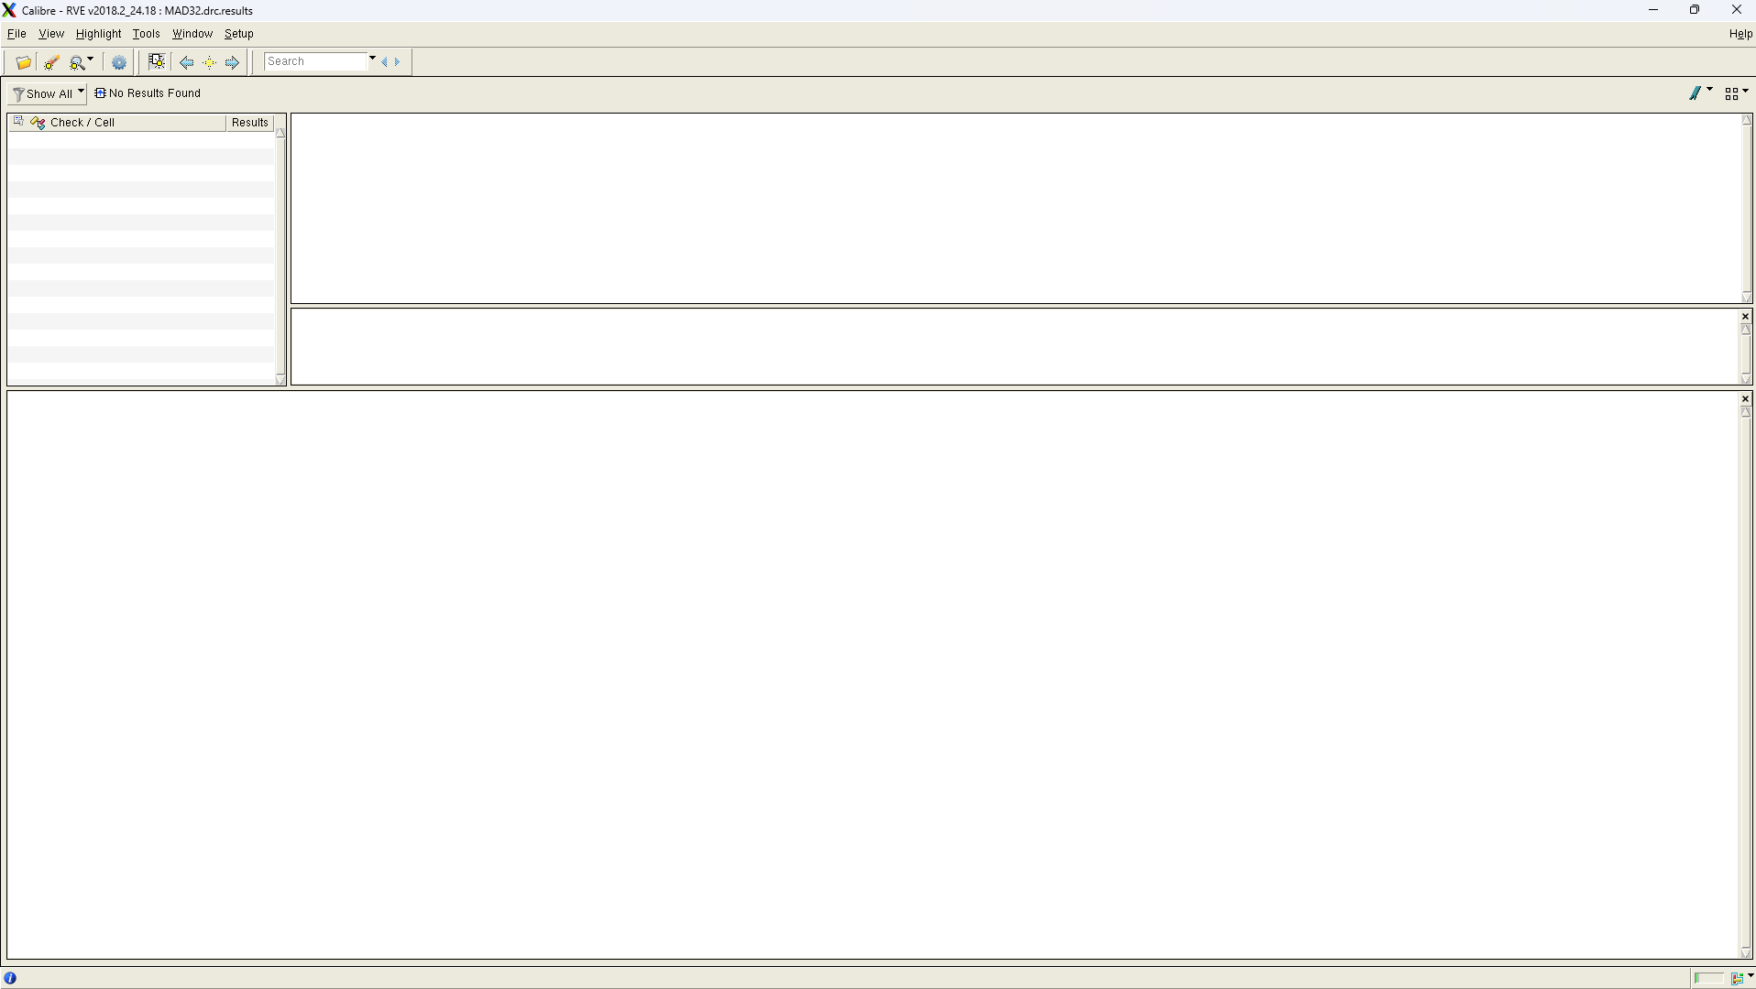
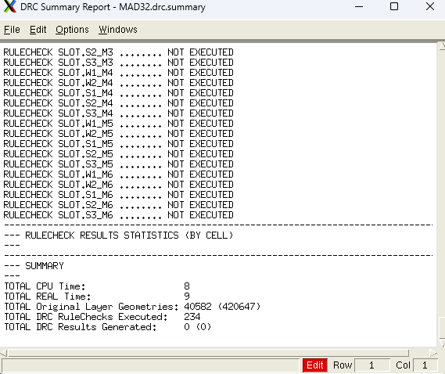
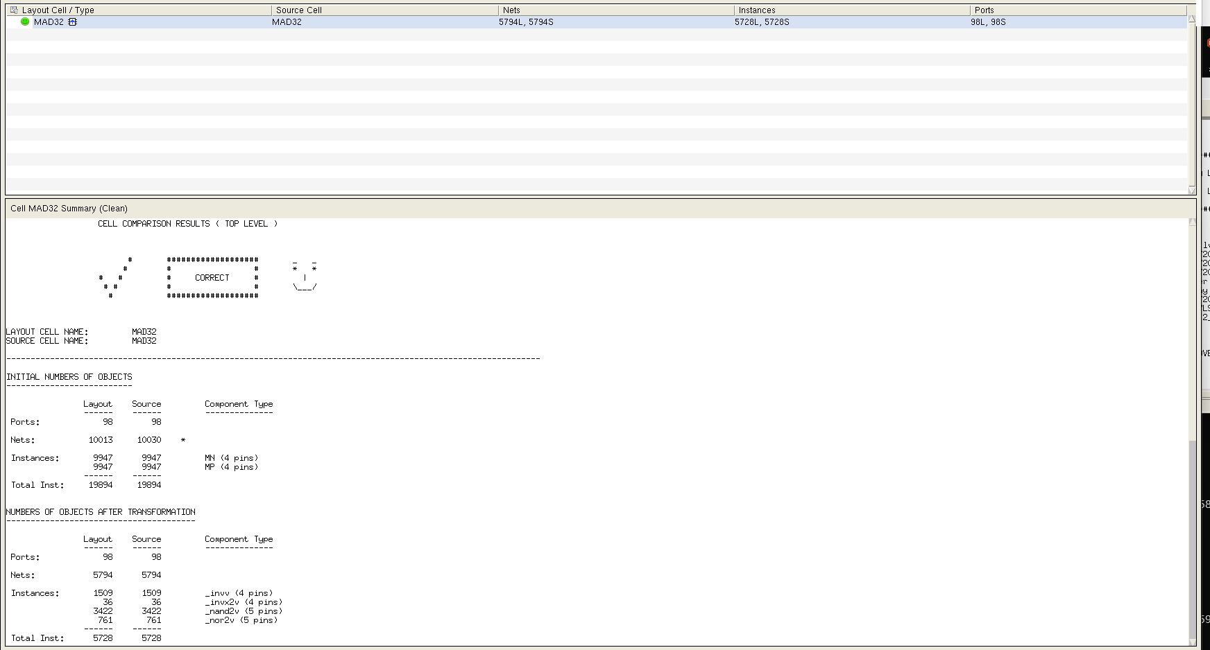
 | area (um 2 )
MAD32_c18_syn | 78638.018862
MAD32_t18_syn | 61162.517941
MAD32_c18_pre | 78638.018862
MAD32_c18_post | 113057.04

