**Assignment 6**

The variables I chose to analyze in this assignment were gender, race, socioeconomic status and plans after high school. I chose to look at the interaction between gender and race and the interaction between socioeconomic status and plans after high school. All of these independent variables were analyzed to note changes and differences in the dependent variable—tenth grade math scores.

In Graph 1, the interaction of race and gender are displayed in a bar graph with the average math score of each gender within each racial category. As the graph shows, male students tend to outperform female students on the tenth grade math test. However, this is not the case within the American Indian population. Graph 2 displays the same information but in a different format.

In Graph 3, the interaction of socioeconomic status and plans after high school are displayed using linear predictions. As the graph shows, students who plan to attend a four-year college or university perform the highest on tenth grade math tests, and those who do not have plans after high school perform the lowest. As socioeconomic status increases, so do tenth grade math scores. Interestingly the tenth grade math scores for students that plan to attend a two-year college and those without plans begin to merge as socioeconomic status increases.

In Graph 4, the confidence intervals for these linear predications are provided. The confidence intervals for those planning to attend a four-year college are more narrow than the other student plans after high school. This displays more stability in the prediction of math scores for those planning to attend a four-year college across socioeconomic status. The confidence interval for those without plans after high school have the widest intervals, indicating instability in the prediction of math scores for this population of students across socioeconomic status.

Tables 5 and 6 display predictions of math scores based on the four variables and the interaction of these variables. As the tables show, there are differences in math scores based on race, gender, socioeconomic status and plans after high school. Male students are predicted to outperform female students in all categories, except for those in the American Indian population. White and Asian students are predicted to have the highest scores and Black students are predicted to have the lowest. The average socioeconomic status is employed throughout this table. For students with higher aspirations after high school (four-year college), there is a predicted higher math score. With all of this taken into account, White and Asian male students with plans to go to college would be expected to have the highest math scores. Black female students with no plans to attend college of any kind would be expected to have the lowest math scores.

**Graph 1.**

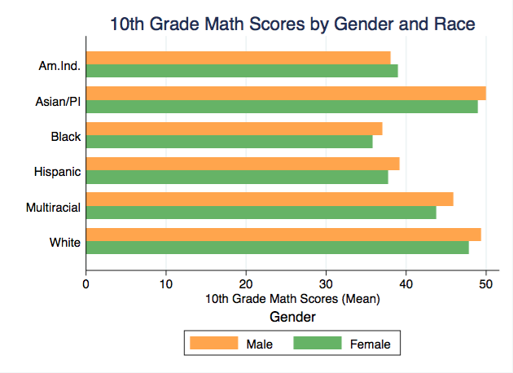

**Graph 2.**

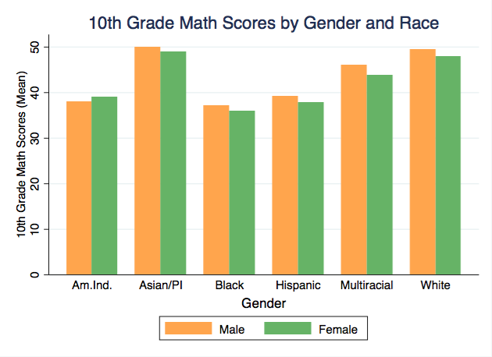

**Graph 3.**

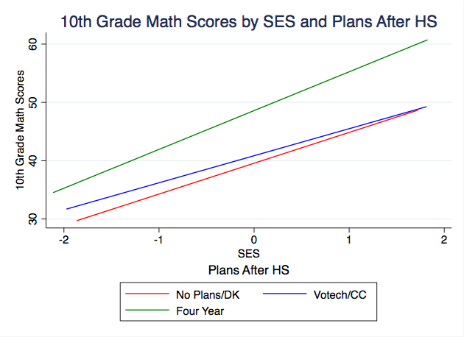

**Graph 4.**

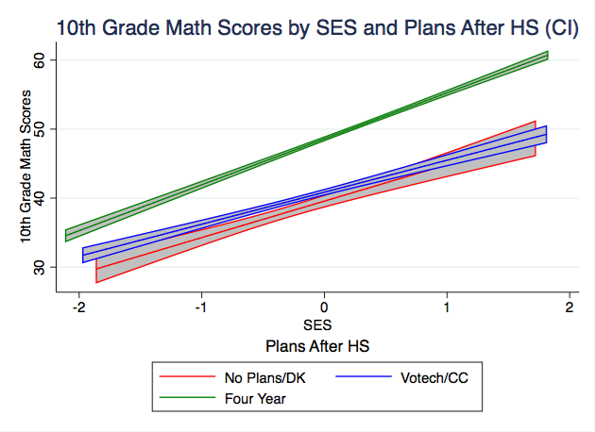

**Table 1. Predicted 10th Grade Math Scores**

|  |  |
| --- | --- |
|  | Math Scores |
|  |  |
| No Plans, Avg. SES, Male, Native/Ind. | 33.06 |
|  | [28.94,37.18] |
| Votech/CC, Avg. SES. Male, Native/Ind. | 35.22 |
|  | [31.27,39.17] |
| Four Years, Avg. SES, Male, Native/Ind. | 42.87 |
|  | [38.90,46.83] |
| No Plans, Avg. SES, Male, Asian | 42.96 |
|  | [41.06,44.85] |
| Votech/CC, Avg. SES, Male, Asian | 45.12 |
|  | [43.57,46.67] |
| Four Years, Avg. SES, Male, Asian | 52.77 |
|  | [51.28,54.25] |
| No Plans, Avg. SES, Male, Black | 31.57 |
|  | [29.92,33.21] |
| Votech/CC, Avg. SES, Male, Black | 33.73 |
|  | [32.51,34.95] |
| Four Years, Avg. SES, Male, Black | 41.38 |
|  | [40.21,42.54] |
| No Plans, Avg. SES, Male, Hispanic | 36.59 |
|  | [35.01,38.17] |
| Votech/CC, Avg. SES, Male, Hispanic | 38.75 |
|  | [37.46,40.04] |
| Four Years, Avg. SES, Male, Hispanic | 46.40 |
|  | [45.17,47.62] |
| No Plans, Avg. SES, Male, Multiracial | 39.45 |
|  | [37.25,41.66] |
| Votech/CC, Avg. SES, Male, Multiracial | 41.62 |
|  | [39.65,43.58] |
| Four Years, Avg. SES, Male, Multiracial | 49.26 |
|  | [47.29,51.22] |
| No Plans, Avg. SES, Male, White | 42.34 |
|  | [40.98,43.71] |
| Votech/CC, Avg. SES, Male, White | 44.51 |
|  | [43.88,45.13] |
| Four Years, Avg. SES, Male, White | 52.15 |
|  | [51.58,52.72] |
| No Plans, Avg. SES, Female, Native/Ind. | 33.73 |
|  | [30.14,37.32] |
| Votech/CC, Avg. SES. Female, Native/Ind. | 35.89 |
|  | [32.50,39.28] |
| Four Years, Avg. SES, Female, Native/Ind. | 43.54 |
|  | [40.17,46.90] |
| No Plans, Avg. SES, Female, Asian | 41.66 |
|  | [39.49,43.84] |
| Votech/CC, Avg. SES, Female, Asian | 43.83 |
|  | [42.01,45.64] |
| Four Years, Avg. SES, Female, Asian | 51.47 |
|  | [49.72,53.22] |
| No Plans, Avg. SES, Female, Black | 29.96 |
|  | [28.38,31.54] |
| Votech/CC, Avg. SES, Female, Black | 32.12 |
|  | [31.12,33.12] |
| Four Years, Avg. SES, Female, Black | 39.76 |
|  | [38.80,40.72] |
| No Plans, Avg. SES, Female, Hispanic | 34.09 |
|  | [32.63,35.55] |
| Votech/CC, Avg. SES, Female, Hispanic | 36.25 |
|  | [35.23,37.28] |
| Four Years, Avg. SES, Female, Hispanic | 43.90 |
|  | [42.98,44.81] |
| No Plans, Avg. SES, Female, Multiracial | 36.53 |
|  | [34.48,38.57] |
| Votech/CC, Avg. SES, Female, Multiracial | 38.69 |
|  | [36.93,40.45] |
| Four Years, Avg. SES, Female, Multiracial | 46.33 |
|  | [44.62,48.04] |
| No Plans, Avg. SES, Female, White | 40.13 |
|  | [38.76,41.50] |
| Votech/CC, Avg. SES, Female, White | 42.29 |
|  | [41.68,42.91] |
| Four Years, Avg. SES, Female, White | 49.94 |
|  | [49.45,50.43] |
| Observations | 13055 |

95% confidence intervals in brackets

|  |  |  |  |  |  |  |
| --- | --- | --- | --- | --- | --- | --- |
|  | **Am. Ind.** | **Asian/PI** | **Black** | **Hispanic** | **Multiracial** | **White** |
|  |  |  |  |  |  |  |
| No Plans & Avg SES, Male | 33.06 | 42.96 | 31.57 | 36.59 | 39.45 | 42.34 |
|  | [28.94,37.18] | [41.06,44.85] | [29.92,33.21] | [35.01,38.17] | [37.25,41.66] | [40.98,43.71] |
| Votech/CC & Avg SES, Male | 35.22 | 45.12 | 33.73 | 38.75 | 41.62 | 44.51 |
|  | [31.27,39.17] | [43.57,46.67] | [32.51,34.95] | [37.46,40.04] | [39.65,43.58] | [43.88,45.13] |
| Four Year & Avg SES, Male | 42.87 | 52.77 | 41.38 | 46.40 | 49.26 | 52.15 |
|  | [38.90,46.83] | [51.28,54.25] | [40.21,42.54] | [45.17,47.62] | [47.29,51.22] | [51.58,52.72] |
| No Plans & Avg SES, Female | 33.73 | 41.66 | 29.96 | 34.09 | 36.53 | 40.13 |
|  | [30.14,37.32] | [39.49,43.84] | [28.38,31.54] | [32.63,35.55] | [34.48,38.57] | [38.76,41.50] |
| Votech/CC & Avg SES, Female | 35.89 | 43.83 | 32.12 | 36.25 | 38.69 | 42.29 |
|  | [32.50,39.28] | [42.01,45.64] | [31.12,33.12] | [35.23,37.28] | [36.93,40.45] | [41.68,42.91] |
| Four Year & Avg SES, Female | 43.54 | 51.47 | 39.76 | 43.90 | 46.33 | 49.94 |
|  | [40.17,46.90] | [49.72,53.22] | [38.80,40.72] | [42.98,44.81] | [44.62,48.04] | [49.45,50.43] |
| Observations | 13055 | 13055 | 13055 | 13055 | 13055 | 13055 |

**Table 2. Predicted 10th Grade Math Scores**

95% confidence intervals in brackets